**Week8 Practice (CS290_Web Development)**

**Woohyuk Yang**

[yangwo@oregonstate.edu](mailto:yangwo@oregonstate.edu)

This week the most difficult concept I think is to understand Same Origin Policy and Cross Origin Resource Sharing. I only had been dealing with one client and one sever program so I could not grasp the concept about several servers and clients intuitively and took a while to understand what it is clearly. I totally forgot the fact that servers do communicate each other. I thought myself I understand well about how web works but I was only seeing little part of whole web world.I have never learnt how sessions work before so I thought sessions and cookies are totally different at first. I realized sessions are used via cookies because identifier is stored in cookie technically. I could understand relation between cookies and sessions when I get to read reading material of this week twice. When I tried to do practice myself before making a “todo list applicaation” like suggested, I made a huge mistake which came out of not knowing what req parameter does at the serverside. When I was practicing ‘The Get Handler’, I typed

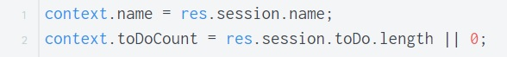

Instead of

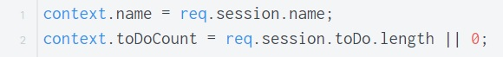;

I did not know what the session is and I did not know whether I can use req at serverside at first. That was a major mistake I did write a wrong code at first. I forgot ending sessions at first so my “todo list application” did not work as I expected. Google Chrome Browser helped me a lot to trace the error. I kept emptying cookie lists because I want to practice my session realted program in an cookie-refreshed envrionment. The most frequently-happening reason which stopped my program work properly was my mistype. I could fix lots of mistyped code using the browser.

I thought I know enough things I learnt last week at first but when I had to use both skills I learnt last week and this week, I got so confused. I had to read through reading materials from the last week again though to remember how to use exprss and template(handlebars) first. I made a “to do list application” as suggested to practice and get to know how to make sessions and how to end the session properly. I also used openweathermap and httpbin.org to test and practice how to send a request from the severside using Express. Writing a code that first getting data from the sever(openweathermap.org) via GET and posting data back to httpbin.org via POST in using call back functions, I could learn how to get data from one server and to post data to oher server from the server side. Through this experiment and practice, I could understand ecology of web clearer. I made one page getting data from forms. Those forms will submit different data to the page even though the page only has a single URL. The display goes different even though the URL is same as long as the submitted form is different. At first, I did not care about the case the user put wrong URL. So I did not care about any exceptional cases like server responses with 400 error but I realized I need to handle process errors with a wrog URL. It was quite hard to trace the logic of asynchronous requests but I divided the functions and wrote down the order of functions being called so I could trace and understand their flow

Having finished practice, and writing a shor report, now I realized my term is getting over and I was told as soon as I learn about database then I would have learnt every single basic concepts I need to know to make and run a web service. I am glad and I think I need more practice not to forget this precious skills I learnt from this term.