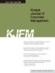 | Print ISSN: 2093-9582
 | Online ISSN 2508-4593
 | http://dx.doi.org/10.21871/KJFM.XXXX
(abstract)

