


Technical Safety Concept Lane Assistance
Document Version: 1.0
Template Version 1.0, Released on 2017-06-21



Document history

Date | Version | Editor | Description
2017-08-23 | 1.0 | Y.Wiyogo | Initial Document
2017-08-24 | 1.1 | Y.Wiyogo | Complete LKA requirements and warning
2017-08-26 | 1.2 | Y.Wiyogo | Correct ASIL of LKA and extend the description of the EPS ECU elements

Table of Contents

Document history
Table of Contents
Purpose of the Technical Safety Concept
Inputs to the Technical Safety Concept
Functional Safety Requirements
Refined System Architecture from Functional Safety Concept
Functional overview of architecture elements
Technical Safety Concept
Technical Safety Requirements
Refinement of the System Architecture
Allocation of Technical Safety Requirements to Architecture Elements
Warning and Degradation Concept

Purpose of the Technical Safety Concept

The purpose of the technical safety concept is to specify the realization of the defined functional safety concept.

Inputs to the Technical Safety Concept

Functional Safety Requirements

ID | Functional Safety Requirement | ASIL | Fault Tolerant Time Interval | Safe State
Functional  Safety  Requirement  01-01 | The lane keeping item shall ensure that the lane departure oscillating torque amplidute is below Max_Torque_Amplitude | C | 50 ms | Turn off LDW
Functional  Safety  Requirement  01-02 | The lane keeping item shall ensure that the lane departure oscillating torque frequency is below Max_Torque_Frequency | C | 50 ms | Turn off LDW
Functional  Safety  Requirement  02-01 | The electronic power steering ECU shall ensure that the lane keeping assistance torque is applied for only Max_Duration. | B | 500 ms | Turn off LKA

Refined System Architecture from Functional Safety Concept

[Instructions: Provide the refined system architecture from the functional safety concept]

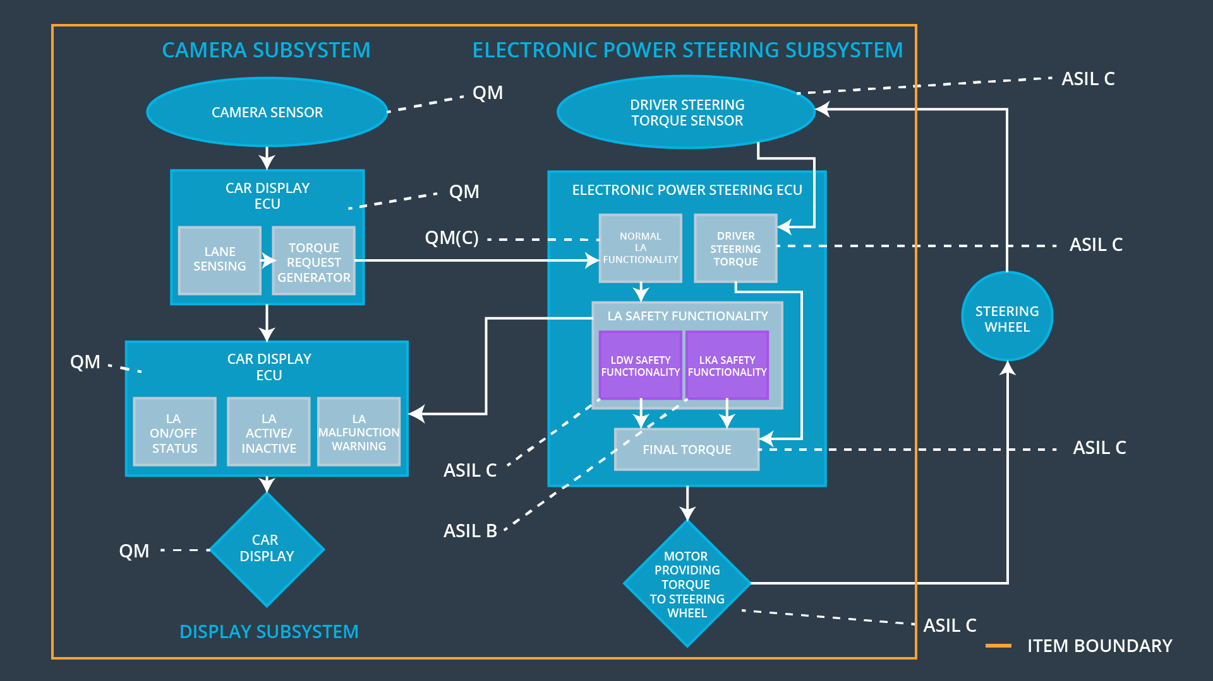

Functional overview of architecture elements
[Instructions: Provide a description for each functional safety element; what is each element's purpose in the lane assistance item? ]

Element | Description
Camera Sensor | A sensor for aquiring environment information as image.
Camera Sensor ECU - Lane Sensing | A function that extracts the lane detection
Camera Sensor ECU - Torque request generator | A function that generates
Car Display | A display device for visualizing the activation of the function to the driver.
Car Display ECU - Lane Assistance On/Off Status | A function to control the on/off status on the display
Car Display ECU - Lane Assistant Active/Inactive | A function to control the active/inactive status on the display
Car Display ECU - Lane Assistance malfunction warning | A function to control the malfunction warning on the display
Driver Steering Torque Sensor | A sensor that acquires the torque value of the steering wheel
Electronic Power Steering (EPS) ECU - Driver Steering Torque | A processor chip for processing data from camera sensor ECU and torque sensor.
EPS ECU - Normal Lane Assistance Functionality | A function to process the data from the torque request generator
EPS ECU - Lane Departure Warning Safety Functionality | A function to ensure the LDW safety functionality
EPS ECU - Lane Keeping Assistant Safety Functionality | Sends LKA_Torque_Request and LKA_Activation_Status to the EPS ECU Final Torque.  The LKA_Torque_Request tells about the torque to be applied and the LKA_Activation_Status tells about whether LKA
EPS ECU - Final Torque | Find the final torque that needs to be applied to the steering wheel. Takes into account the inputs from LDW Safety, LKA Safety, Data Transmission and Integrity Check.
Motor | An electric motor that interpret the EPS ECU data to control the steering wheel

Technical Safety Concept

Technical Safety Requirements

Lane Departure Warning (LDW) Requirements:

Functional Safety Requirement 01-01 with its associated system elements
(derived in the functional safety concept)
ID | Functional Safety Requirement | Electronic Power Steering ECU | Camera ECU | Car Display ECU
Functional  Safety  Requirement  01-01 | The lane keeping item shall ensure that the lane departure oscillating torque amplitude is below Max_Torque_Amplitude | X

Technical Safety Requirements related to Functional Safety Requirement 01-01 are:
ID | Technical Safety Requirement | ASIL | Fault Tolerant Time Interval | Architecture Allocation | Safe State
Technical  Safety  Requirement  01 | The LDW safety component shall ensure that the amplitude of the 'LDW_Torque_Request' sent to the 'Final electronic power steering Torque' component is below 'Max_Torque_Amplitude. | C | 50 ms | LDW safety | LDW_Torque_Output= 0
Technical  Safety  Requirement  02 | The validity and integrity of the data transmission for 'LDW_Torque_Request' signal shall be ensured. | C | 50 ms | Data Transmission Integrity Check | N/A
Technical  Safety  Requirement  03 | As soon as a failure is detected by the LDW function, it shall deactivate the LDW feature and the LDW_Torque_Request shall be set to zero | C | 50 ms | LDW safety | LDW_Torque_Output= 0
Technical  Safety  Requirement  04 | As soon as the LDW function deactivates the LDW feature, the LDW Safety software block shall send a signal to the car display ECU to turn on a warning light | C | 50 ms | LDW Safety | LDW_Torque_Output= 0
Technical  Safety  Requirement  05 | Memory test shall be conducted at start up of the EPS ECU to check for any faults in memory | A | ignition cycle | Memory test | LDW_Torque_Output= 0

Functional Safety Requirement 01-2 with its associated system elements
(derived in the functional safety concept)
ID | Functional Safety Requirement | Electronic Power Steering ECU | Camera ECU | Car Display ECU
Functional  Safety  Requirement  01-02 | The lane keeping item shall ensure that the lane departure oscillating torque frequency is below Max_Torque_Frequency | X

Technical Safety Requirements related to Functional Safety Requirement 01-02 are:
ID | Technical Safety Requirement | ASIL | Fault Tolerant Time Interval | Architecture Allocation | Safe State
Technical  Safety  Requirement  01 | The LDW safety component shall ensure that the frequency of the 'LDW_Torque_Request' sent to the 'Final electronic power steering Torque' component is below 'Max_Torque_Frequency. | C | 50 ms | LDW safety | LDW_Torque_Output = 0
Technical  Safety  Requirement  02 | The validity and integrity of the data transmission for 'LDW_Torque_Request' signal shall be ensured. | C | 50 ms | Data Transmission Integrity Check | N/A
Technical  Safety  Requirement  03 | As soon as a failure is detected by the LDW function, it shall deactivate the LDW feature and the LDW_Torque_Request shall be set to zero | C | 50 ms | LDW safety | LDW_Torque_Output = 0
Technical  Safety  Requirement  04 | As soon as the LDW function deactivates the LDW feature, the 'LDW Safety' software block shall send a signal to the car display ECU to turn on a warning light. | C | 50 ms | LDW Safety | LDW_Torque_Output = 0
Technical  Safety  Requirement  05 | Memory test shall be conducted at start up of the EPS ECU to check for any faults in memory | A | ignition cycle | Memory test | LDW_Torque_Output= 0

Lane Departure Warning (LDW) Verification and Validation Acceptance Criteria:

[OPTIONAL: For each technical safety requirement, identify both the verification and validation acceptance criteria. “Validation” asks whether or not you chose the appropriate parameters. “Verification” involves testing to make sure the vehicle behaves as expected when the parameter value is crossed. There is not necessarily one right answer. Look at your verification and validation acceptance criteria from the functional safety concept for inspiration.]

Lane Keeping Assistance (LKA) Requirements:

Functional Safety Requirement 02-1 with its associated system elements
(derived in the functional safety concept)

ID | Functional Safety Requirement | Electronic Power Steering ECU | Camera ECU | Car Display ECU
Functional  Safety  Requirement  02-01 | The lane keeping item shall ensure that the lane keeping assistance torque is applied for only Max_Duration | X

Technical Safety Requirements related to Functional Safety Requirement 02-01 are:
ID | Technical Safety Requirement | ASIL | Fault Tolerant Time Interval | Allocation to Architecture | Safe State
Technical  Safety  Requirement  01 | The LKA safety component shall ensure that the active duration time is below Max_Duration. | B | 500 ms | LKA safety | LKA_Torque_Output = 0
Technical  Safety  Requirement  02 | The validity and integrity of the data transmission for 'LKA_Torque_Request' signal shall be ensured. | B | 500 ms | Data Transmission Integrity Check | N/A
Technical  Safety  Requirement  03 | As soon as a failure is detected by the LKA function, it shall deactivate the LKA feature and the “LKA_Torque_Request” shall be set to zero. | B | 500 ms | LKA safety | LKA_Torque_Output = 0
Technical  Safety  Requirement  04 | As soon as the LKA function deactivates the LKA feature, the 'LKA Safety' software block shall send a signal to the car display ECU to turn on a warning light. | B | 500 ms | LKA safety | LKA_Torque_Output = 0
Technical  Safety  Requirement  05 | Memory test shall be conducted at start up of the EPS ECU to check for any faults in memory | A | 500 ms | Memory Test | LKA_Torque_Output = 0

Lane Keeping Assistance (LKA) Verification and Validation Acceptance Criteria:
[OPTIONAL: For each technical safety requirement, identify both the verification and validation acceptance criteria. “Validation” asks whether or not you chose the appropriate parameters. “Verification” involves testing to make sure the vehicle behaves as expected when the parameter value is crossed. There is not necessarily one right answer. Look at your verification and validation acceptance criteria from the functional safety concept for inspiration.]

Refinement of the System Architecture

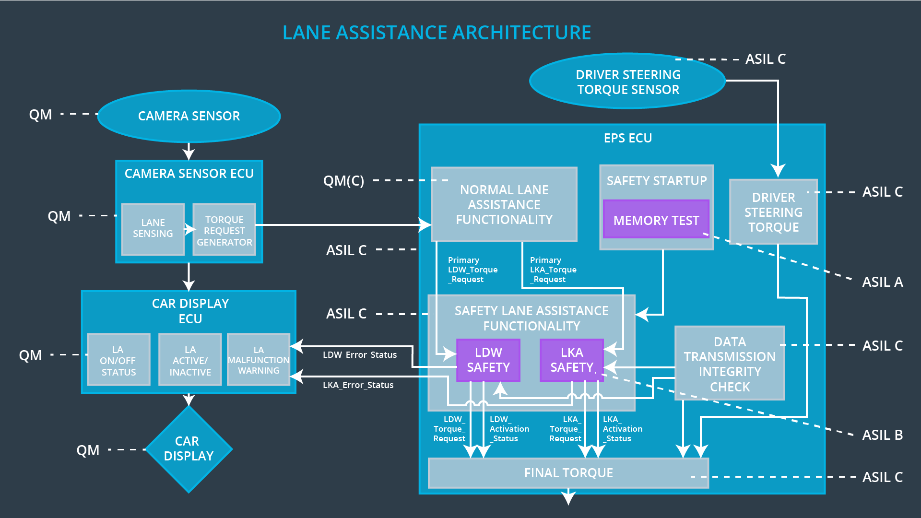

Allocation of Technical Safety Requirements to Architecture Elements

Based on the above tables, all technical safety requirements are allocated to the Electronic Power Steering ECU.

Warning and Degradation Concept

The technical safety requirements have not changed how functionality will be degraded or what the warning will be. Thus, the warning and degradation concept is the same for the technical safety requirements as for the functional safety requirements.

ID | Degradation Mode | Trigger for Degradation Mode | Safe State invoked? | Driver Warning
WDC-01 | turn off the function | Is_Max_Torque_Exceeded | Yes | Turn on warning light on car display
WDC-02 | turn off the function | Is_Max_Duration_Exceeded | Yes | Turn on warning light on car display

