


Functional Safety Concept Lane Assistance
Document Version:1.0
Template Version 1.0, Released on 2017-06-21



Document history
[Instructions: Fill in the date, version and description fields. You can fill out the Editor field with your name if you want to do so. Keep track of your editing as if this were a real world project.

For example, if this were your first draft or first submission, you might say version 1.0. If this is a second submission attempt, then you'd add a second line with a new date and version 2.0]

Date | Version | Editor | Description
21.08.2017 | 1.0 | Y.Wiyogo | Initial document
23.08.2017 | 1.1 | Y.Wiyogo | Complete the functional safety concept tables

Table of Contents
[Instructions: We have provided a table of contents. If you change the document structure, please update the table of contents accordingly. The table of contents should show each section of the document and page numbers or links. Most word processors can do this for you. In Google Docs, you can use headings for each section and then go to Insert > Table of Contents. Microsoft Word has similar capabilities]

Document history
Table of Contents
Purpose of the Functional Safety Concept
Inputs to the Functional Safety Analysis
Safety goals from the Hazard Analysis and Risk Assessment
Preliminary Architecture
Description of architecture elements
Functional Safety Concept
Functional Safety Analysis
Functional Safety Requirements
Refinement of the System Architecture
Allocation of Functional Safety Requirements to Architecture Elements
Warning and Degradation Concept

Purpose of the Functional Safety Concept
The purpose of the functional safety concept is to provide a safety concept for avoiding an accident by determining and reducing all the possible risks to an acceptable level.
[Instructions: Answer what is the purpose of a functional safety concept?]

Inputs to the Functional Safety Concept

Safety goals from the Hazard Analysis and Risk Assessment

[Instructions:
REQUIRED:
Provide the lane departure warning and lane keeping assistance safety goals as discussed in the lessons and derived in the hazard analysis and risk assessment.

OPTIONAL:
If you expanded the hazard analysis and risk assessment to include other safety goals, include them here.
]

ID | Safety Goal
Safety_Goal_01 | The oscillating steering torque from the lane departure warning shall be limited
Safety_Goal_02 | The lane keeping assistance function shall be time limited and the additional steering torque shall end after a given time interval so that the driver cannot misuse the system for a autonomous driving.
Safety_Goal_03 | The lane detection shall not be activated if the detection for a certain environment is not reliable.
Safety_Goal_04 | A sudden strong torque shall be avoided.

Preliminary Architecture
[Instructions: Provide a preliminary architecture for the lane assistance item. Hint: See Lesson 3: Item Definition]
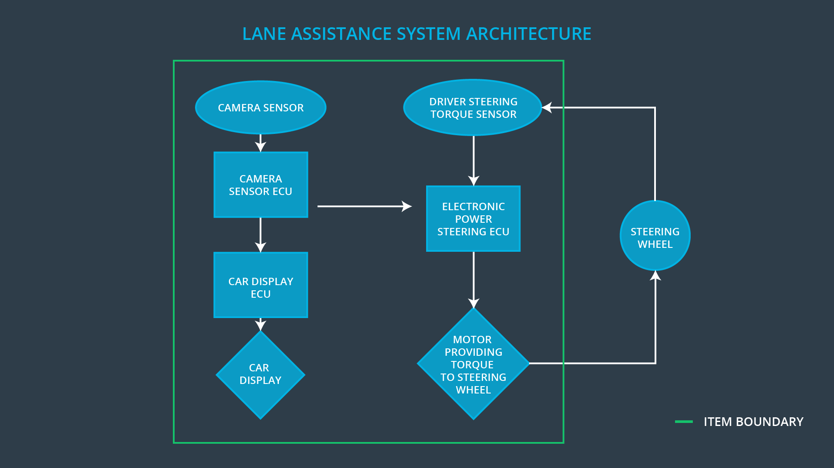

Description of architecture elements
[Instructions: Provide a description for each of the item elements; what is each element's purpose in the lane assistance item? ]

Element | Description
Camera Sensor | A sensor for aquiring environment information as image.
Camera Sensor ECU | A processor chip for processing the acquired image data.
Car Display | A display device for visualizing the activation of the function to the driver.
Car Display ECU | A processor chip for processing the data from the camera sensor ECU
Driver Steering Torque Sensor | A sensor that acquires the torque value of the steering wheel
Electronic Power Steering ECU | A processor chip for processing data from camera sensor ECU and torque sensor.
Motor | An electric motor that interpret the EPS ECU data to control the steering wheel

Functional Safety Concept
The functional safety concept consists of:
- Functional safety analysis
- Functional safety requirements
- Functional safety architecture
- Warning and degradation concept

Functional Safety Analysis

[Instructions: Fill in the functional safety analysis table below.]

Malfunction ID | Main Function of the Item Related to Safety Goal Violations | Guidewords (NO, WRONG, EARLY, LATE, MORE, LESS) | Resulting Malfunction
Malfunction_01 | Lane Departure Warning (LDW) function shall apply an oscillating steering torque to provide the driver a haptic feedback | MORE | The lane departure warning function applies an oscillating torque with very high torque amplitude (above limit)
Malfunction_02 | Lane Departure Warning (LDW) function shall apply an oscillating steering torque to provide the driver a haptic feedback | MORE | The lane departure warning function applies an oscillating torque with very high torque frequency (above limit)
Malfunction_03 | Lane Keeping Assistance (LKA) function shall apply the steering torque when active in order to stay in ego lane | NO | The lane keeping assistance function is not limited in time duration which leads to misuse as an autonomous driving function.

Functional Safety Requirements
[Instructions: Fill in the functional safety requirements for the lane departure warning ]

Lane Departure Warning (LDW) Requirements:

ID | Functional Safety Requirement | ASIL | Fault Tolerant Time Interval | Safe State
Functional  Safety  Requirement  01-01 | The lane keeping item shall ensure that the lane departure oscillating torque amplidute is below Max_Torque_Amplitude | C | 50 ms | Turn off LDW
Functional  Safety  Requirement  01-02 | The lane keeping item shall ensure that the lane departure oscillating torque frequency is below Max_Torque_Frequency | C | 50 ms | Turn off LDW

Lane Departure Warning (LDW) Verification and Validation Acceptance Criteria:

ID | Validation Acceptance  Criteria and Method | Verification Acceptance  Criteria and Method
Functional  Safety  Requirement  01-01 | Set oscillating torque amplitude to Max_Torque_Amplitude causes the light warning to be turned on | when the torque amplitude crosses the limit, the lane assistance output is set to zero within the 50 ms fault tolerant time interval
Functional  Safety  Requirement  01-02 | Set oscillating torque frequency to Max_Torque_Frequency causes the warning light to be turned on | when the torque frequency crosses the limit, the lane assistance output is set to zero within the 50 ms fault tolerant time interval

[Instructions: Fill in the functional safety requirements for the lane keeping assistance]

Lane Keeping Assistance (LKA) Requirements:

ID | Functional Safety Requirement | ASIL | Fault Tolerant Time Interval | Safe State
Functional  Safety  Requirement  02-01 | The electronic power steering ECU shall ensure that the lane keeping assistance torque is applied for only Max_Duration. | D | 500 ms | Turn off LKA

Lane Keeping Assistance (LKA) Verification and Validation Acceptance Criteria:

ID | Validation Acceptance  Criteria and Method | Verification Acceptance  Criteria and Method
Functional  Safety  Requirement  02-01 | Let the LKA active until the Max_Duration, and the warning light has to be turned on | when the time duration exceeds the limit, the lane assistance output is set to zero within the 500 ms fault tolerant time interval

Refinement of the System Architecture
[Instructions: Include the refined system architecture. Hint: The refined system architecture should include the system architecture from the end of the functional safety lesson including all of the ASIL labels.]
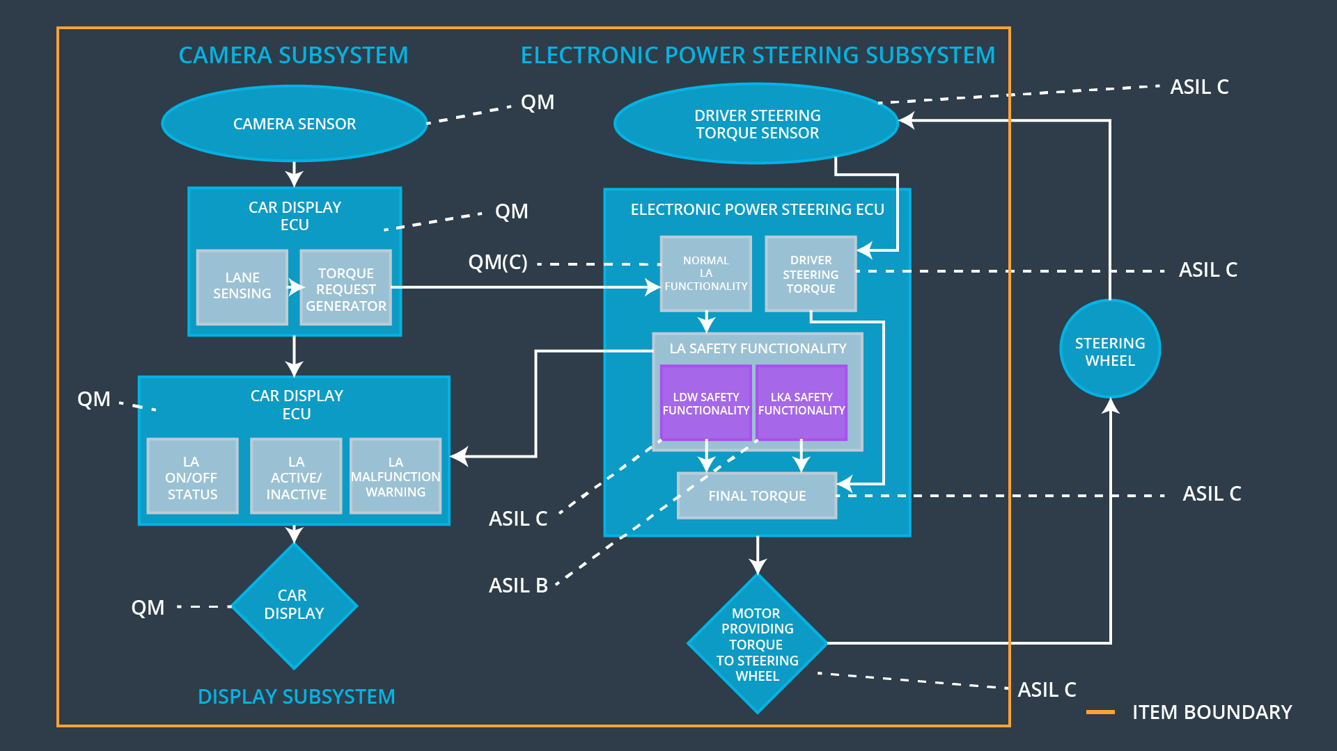

Allocation of Functional Safety Requirements to Architecture Elements
[Instructions: Mark which element or elements are responsible for meeting the functional safety requirement. Hint: Only one ECU is responsible for meeting all of the requirements.]

ID | Functional Safety Requirement | Electronic Power Steering ECU | Camera ECU | Car Display ECU
Functional  Safety  Requirement  01-01 | The lane keeping item shall ensure that the lane departure oscillating torque amplidute is below Max_Torque_Amplitude. | x
Functional  Safety  Requirement  01-02 | The lane keeping item shall ensure that the lane departure oscillating torque frequency is below Max_Torque_Frequency. | x
Functional  Safety  Requirement  02-01 | The electronic power steering ECU shall ensure that the lane keeping assistance torque is applied for only Max_Duration. | x

Warning and Degradation Concept
[Instructions: Fill in the warning and degradation concept.]

ID | Degradation Mode | Trigger for Degradation Mode | Safe State invoked? | Driver Warning
WDC-01 | turn off the function | Is_Max_Torque_Exceeded | Yes | Turn on warning light on car display
WDC-02 | turn off the function | Is_Max_Duration_Exceeded | Yes | Turn on warning light on car display

