温州大学瓯江学院理工分院
《python爬虫项目》 实验报告
实验名称： | 实验2移动、云及数字化工具
班 级： | 16计算机2班 | 姓 名： | 喻文军 | 学 号： | 16219111210
实验地点： |  | 日 期： | 2019年4月22日

一、实验目的：
[实验目的和要求]
1．静态与动态爬虫
2．DJANGO
3. 12306验证码识别登陆

二、实验环境：
1、python,pychram,mysql
三、实验内容和要求：
1.静态爬虫
2.动态爬虫
3.制作DJANGO网站

四、实验步骤与结果：
（对实验步骤的说明应该能够保证根据该说明即可重复完整的实验内容，得到正确结果。）
1．
步骤：
- 确认要爬取的网站，确认URL
- 使用requests与beautifiulsoup库获取网页源代码
- 使用浏览器查看源码，分析需要爬取的标题等的特征
- 获取数据存入列表中
- 将得到的数据存入数据库
截图：
静态爬虫 （网易云热歌榜）
爬虫代码：
import requests
import re
from bs4 import BeautifulSoup
import pymysql
singer=[]
zhuanji=[]
dict={
'歌名':'',
'专辑':'',
'歌手':''
}
def get_html(url):
header = {
'User-Agent': 'Mozilla/5.0 (Windows NT 10.0; WOW64) AppleWebKit/537.36 (KHTML, like Gecko) Chrome/73.0.3683.86 Safari/537.36'}
try:
response=requests.get(url,headers=header)
if response.status_code==200:
html = response.text.encode(response.encoding).decode('utf-8', 'ignore')
return html
if response.status_code==302:
print('302')
except ConnectionError:
return get_html(url)
def get_info():
html=get_html("http://music.163.com/discover/toplist?id=3778678")
soup=BeautifulSoup(html,'lxml')
tag=soup.find_all('ul',attrs=('class','f-hide'))
singname=re.findall(r'<li><a href="/song.*?id=\d+">(.*?)</a></li>',str(tag))
singid=re.findall(r'<li><a href="/song.*?id=(.*?)">.*?</a></li>',str(tag))
for i in range(len(singid)):
newhtml=get_html("https://music.163.com/song?id="+singid[i])
newsoup=BeautifulSoup(newhtml,'lxml')
tag2=newsoup.find_all("p",attrs=('class','des s-fc4'))
singer.append(re.findall(r'<span title="(.*?)">',str(tag2)))
zhuanji.append(re.findall(r'<a class="s-fc7" href="/album\?id=\d+">(.*?)</a>',str(tag2)))
dict['专辑']=zhuanji[i]
dict['歌手']=singer[i]
s="".join(singname[i].split())
dict['歌名'] =s
get_db()
def get_db():
conn = pymysql.connect(
host='localhost',
port=3306,
user='root',
passwd='123456',
db='sy',
)
cur = conn.cursor()
# 插入一条数据
sql = "INSERT INTO `bbb_yinyue`(singname,singer,zhuanji) values (%s,%s,%s)"
cur.execute(sql, [dict["歌名"], dict['歌手'], dict['专辑']])
conn.commit()
cur.close()
conn.close()
def main():
get_info()
main()
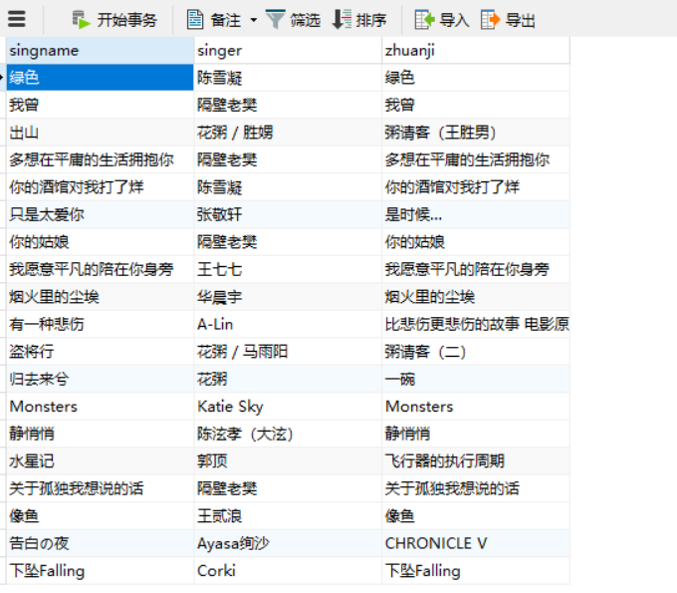
2.动态网页：
动态爬虫 （淘宝手机畅销的店铺）
爬虫代码：
from selenium import webdriver
from lxml import etree
import time
import pymysql
driver = webdriver.Chrome()
driver.maximize_window()
if __name__ == "__main__":
url = 'https://login.taobao.com/member/login.jhtml'
driver.get(url)
driver.implicitly_wait(10)
# 让程序休眠10秒，在这期间，弹出登录界面之后，使用你的手机扫码登录淘宝
time.sleep(10)
# 定位搜索框，并将其清除
driver.find_element_by_id('q').clear()
# 在搜索框内输入“充电宝'
driver.find_element_by_id('q').send_keys('手机')
# 休息两秒，免得被发现为爬虫
time.sleep(2)
# 点击搜索按钮
driver.find_element_by_xpath('//*[@id="J_TSearchForm"]/div[1]/button').click()
# 休息两秒
time.sleep(2)
# 点击来源于“ 天猫 ” 按钮
driver.find_element_by_xpath('//*[@id="tabFilterMall"]').click()
# 休息两秒
time.sleep(2)
# 点击 “ 销量最高按钮 ”
driver.find_element_by_xpath('//*[@id="J_relative"]/div[1]/div/ul/li[2]/a').click()
# 休息两秒
time.sleep(2)
# 打印当前页面的URL
print(driver.current_url)
# 解析网页
html = etree.HTML(driver.page_source)
# 利用xpath寻找大循环。
items = html.xpath('//div[@class="item J_MouserOnverReq "]')
la = []
for item in items:
# 利用xpath 进行小循环，打印销量排名靠前的店家名称
shop = item.xpath('div[2]/div[3]/div[1]/a/span[2]/text()')[0]
#将数据加到la列表
la.append(shop)
#将列表la中重复的数据去除
def deleteDuplicatedElementFromList(listA):
return sorted(set(listA), key=listA.index)
a = deleteDuplicatedElementFromList(la)
print(a)
for i in range(len(a)):
conn = pymysql.connect(host='localhost', user='root', password='123456', db='sy', charset="utf8")
cur = conn.cursor()
sql = "insert into bbb_shouji (name)values('{0}')".format(a[i])
cur.execute(sql)
conn.commit()
cur.close()
conn.close()
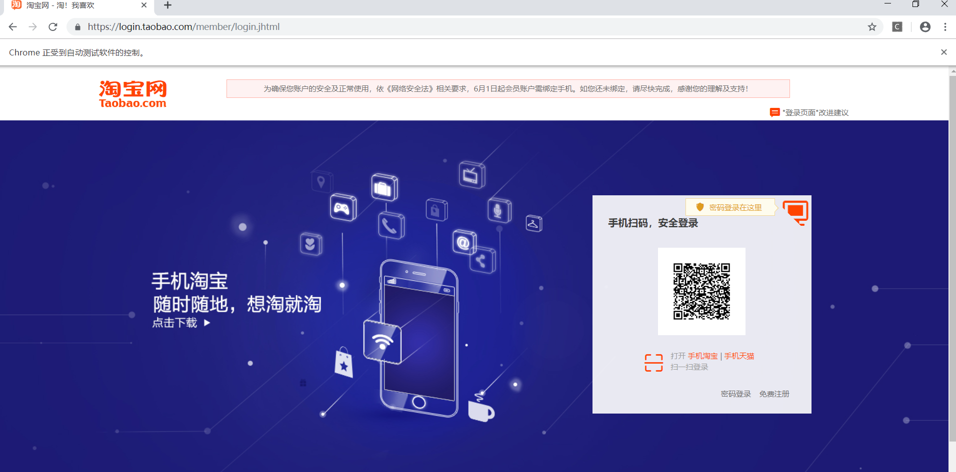
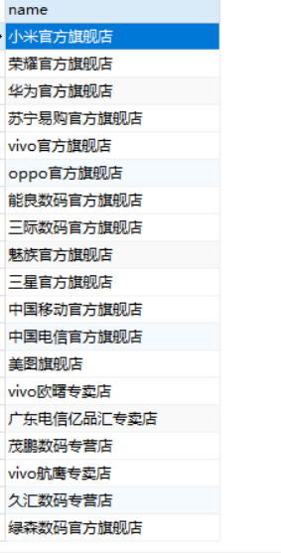

3.django
步骤：
- 使用pycharm创建项目
- 在setting.py文件中通过DATABASES选项进行数据库配置，在_init_.py中配置
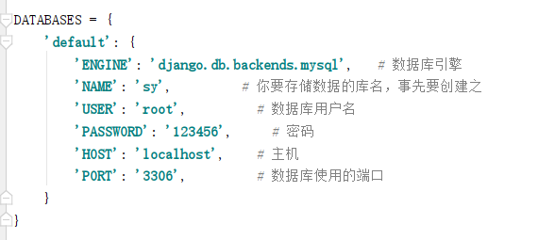
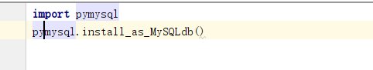
- 在urls.py中写两个PATH一个跳转到网易云，一个跳转到淘宝
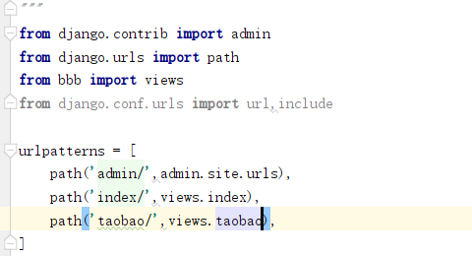

- 在models.py中建立两张表
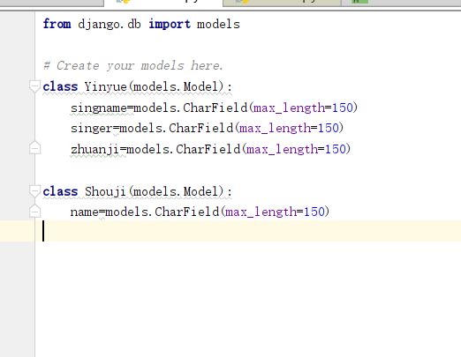
然后在数据库中生成数据表，进行数据迁移
Python manage.py makemigrations
Python manage.py migrate

- 编写views.py
Views.py
from django.shortcuts import render
import pymysql
from bbb.models import Yinyue
from bbb.models import Shouji
from django.shortcuts import HttpResponse
from django.core.paginator import Paginator,PageNotAnInteger,EmptyPage
def index(request):
yinyue_list = Yinyue.objects.all().order_by("id") # 一定要排序
paginator = Paginator(yinyue_list, 12) # 每页15条记录
page = request.GET.get('page') # 获取第一页数据，从1开始
try:
customer=paginator.page(page)
except PageNotAnInteger:
customer=paginator.page(1)
except EmptyPage:
customer=paginator.page(paginator.num_pages)
return render(request, 'index.html',{"yinyue_list":customer} )
def taobao(request):
shouji_list = Shouji.objects.all().order_by("id") # 一定要排序
paginator = Paginator(shouji_list, 12) # 每页15条记录
page = request.GET.get('page') # 获取第一页数据，从1开始
try:
customer = paginator.page(page)
except PageNotAnInteger:
customer = paginator.page(1)
except EmptyPage:
customer = paginator.page(paginator.num_pages)
return render(request, 'taobao.html', {"shouji_list": customer})
- 再详细页中使用获取的字典，显示数据
html文件
index.html(网易云)
{% load staticfiles %}
<!DOCTYPE html>
<html lang="en">
<head>
<meta charset="UTF-8">
<title>Title</title>
<link href="{% static 'css/bootstrap.min.css' %}" rel="stylesheet">
<link href="{% static 'css/style.css' %}" rel="stylesheet">
</head>
<body>
<div class="container" style="margin-top:50px;">
<h1 align="center"><b>云音乐热歌榜</b></h1>
<table class="table">
<thead class="thead-dark">
<tr>
<th scope="col">排名</th>
<th scope="col">歌曲名称</th>
<th scope="col">歌手</th>
<th scope="col">专辑</th>
</tr>
</thead>
{% for music in yinyue_list %}
<tr>
<td scope="row">{{music.id}}</td>
<td>{{music.singname}}</td>
<td>{{music.singer}}</td>
<td>{{music.zhuanji}}</td>
</tr>
{% endfor %}
</table>
<div class="row justify-content-center">
<ul class="pagination">
{% for pg in yinyue_list.paginator.page_range %}
{% if yinyue_list.number == pg %}
<li class="page-item"><a class="page-link" href="?page={{ pg }}">{{ pg }}</a></li>
{% else %}
<li><a class="page-link" href="?page={{ pg }}">{{ pg }}</a></li>
{% endif %}
{% endfor %}
</ul>
</div>
</div>
<link href="{% static 'js/jquery-3.3.1.min.js' %}" rel="stylesheet">
<link href="{% static 'js/bootstrap.min.js' %}" rel="stylesheet">
</body>
</html>
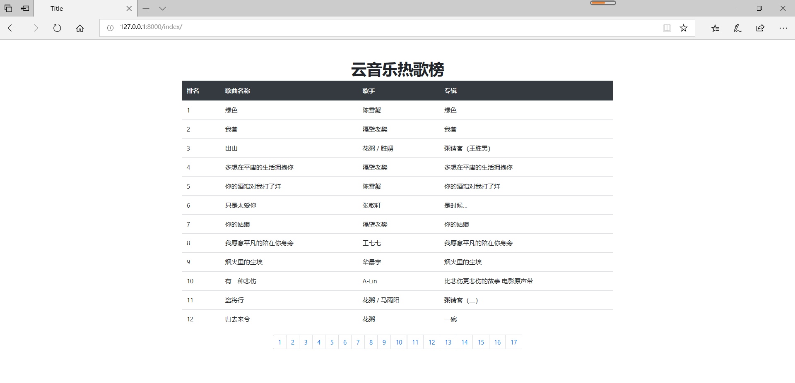
taobao.html（淘宝界面）
{% load staticfiles %}
<!DOCTYPE html>
<html lang="en">
<head>
<meta charset="UTF-8">
<meta name="viewport" content="width=device-width, initial-scale=1, shrink-to-fit=no">
<title>taobao</title>
<link href="{% static 'css/bootstrap.min.css' %}" rel="stylesheet">
<link href="{% static 'css/style.css' %}" rel="stylesheet">
</head>
<body>
<div class="container" style="margin-top:50px;">
<h1 align="center"><b>手机销量店铺排名</b></h1>
<table class="table">
<thead class="thead-dark">
<tr>
<th scope="col">排名</th>
<th scope="col">店铺名</th>
</tr>
</thead>
{% for i in shouji_list %}
<tr>
<td scope="row">{{i.id}}</td>
<td>{{i.name}}</td>
</tr>
{% endfor %}
</table>
<div class="row justify-content-center">
<ul class="pagination">
{% for pg in shouji_list.paginator.page_range %}
{% if shouji_list.number == pg %}
<li class="page-item"><a class="page-link" href="?page={{ pg }}">{{ pg }}</a></li>
{% else %}
<li><a class="page-link" href="?page={{ pg }}">{{ pg }}</a></li>
{% endif %}
{% endfor %}
</ul>
</div>
</div>
<link href="{% static 'js/jquery-3.3.1.min.js' %}" rel="stylesheet">
<link href="{% static 'js/bootstrap.min.js' %}" rel="stylesheet">
</body>
</html>
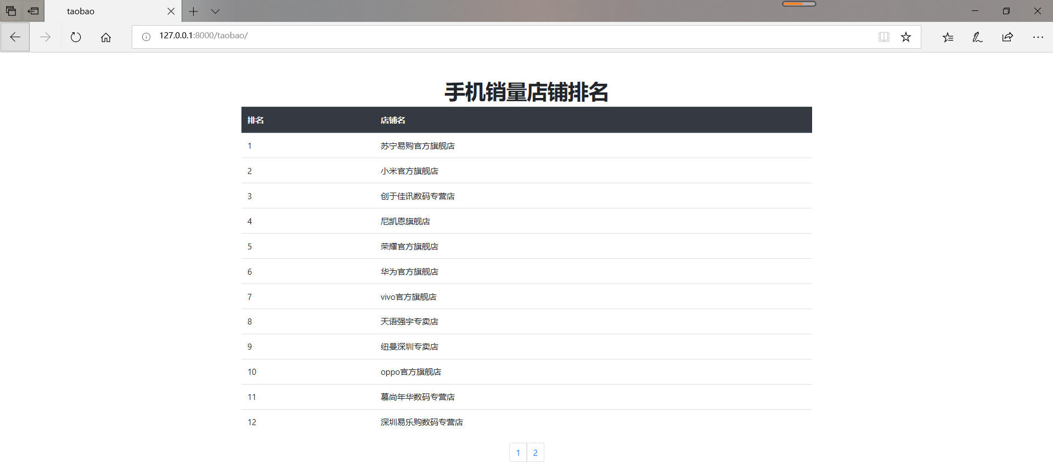

12306验证码识别登陆
代码
from selenium import webdriver
from selenium.webdriver.common.keys import Keys
from selenium.webdriver.common.by import By
from selenium.webdriver.support.ui import WebDriverWait
from selenium.webdriver.support import expected_conditions as EC
from selenium.webdriver.common.action_chains import ActionChains
import requests
import base64
import re
import time
class Demo():
def __init__(self,username,password):
self.coordinate=[[-105,-20],[-35,-20],[40,-20],[110,-20],[-105,50],[-35,50],[40,50],[110,50]]
self.username=username
self.password=password
def login(self):
login_url="https://kyfw.12306.cn/otn/resources/login.html"
driver = webdriver.Chrome()
driver.set_window_size(1200, 900)
driver.get(login_url)
account=driver.find_element_by_class_name("login-hd-account")
account.click()
userName=driver.find_element_by_id("J-userName")
userName.send_keys(self.username)
password=driver.find_element_by_id("J-password")
password.send_keys(self.password)
self.driver=driver
def getVerifyImage(self):
try:
img_element =WebDriverWait(self.driver, 100).until(
EC.presence_of_element_located((By.ID, "J-loginImg"))
)
except Exception as e:
print(u"网络开小差,请稍后尝试")
base64_str=img_element.get_attribute("src").split(",")[-1]
imgdata=base64.b64decode(base64_str)
with open('verify.jpg','wb') as file:
file.write(imgdata)
self.img_element=img_element
def getVerifyResult(self):
url="http://littlebigluo.qicp.net:47720/"
response=requests.request("POST",url,data={"type":"1"},files={'pic_xxfile':open('verify.jpg','rb')})
result=[]
print(response.text)
for i in re.findall("<B>(.*)</B>",response.text)[0].split(" "):
result.append(int(i)-1)
self.result=result
print(result)
def moveAndClick(self):
try:
Action=ActionChains(self.driver)
for i in self.result:
Action.move_to_element(self.img_element).move_by_offset(self.coordinate[i][0],self.coordinate[i][1]).click()
Action.perform()
except Exception as e:
print(e.message())
def submit(self):
self.driver.find_element_by_id("J-login").click()
def __call__(self):
self.login()
time.sleep(3)
self.getVerifyImage()
time.sleep(1)
self.getVerifyResult()
time.sleep(1)
self.moveAndClick()
time.sleep(1)
self.submit()
time.sleep(10000)
Demo('11111','222222')()

