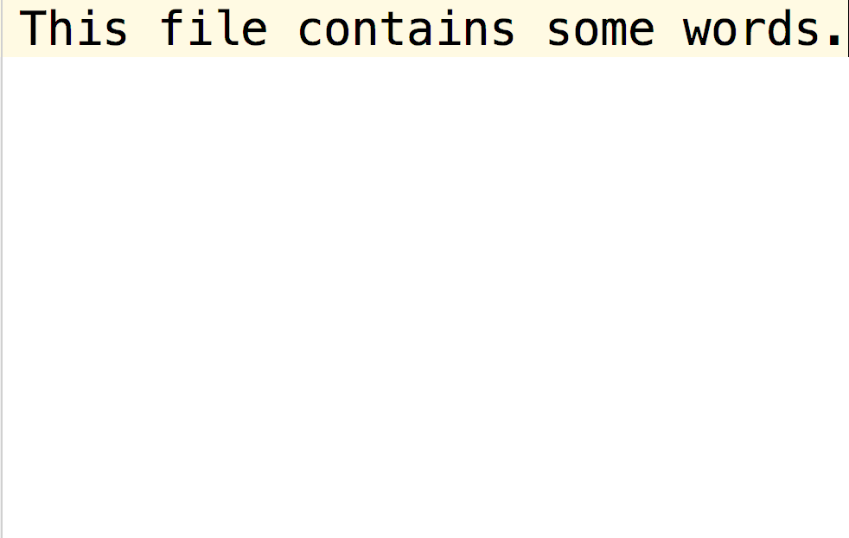

**This file also contains text.**

This second part of the text is in Page 2