宜宾学院
软件设计模式与体系结构设计报告书

学 院: 人工智能与大数据学部 班 级: 2018级9班
学生姓名: 杨雪 学 号: 200109327
设计地点（单位） 6305
设计题目: 软件设计模式与体系结构实验4
完成日期： 2021年 4 月 29 日

软件设计模式与体系结构实验3

实验一
现假设有Android手机和IOS手机两个系列，众所周知，两个手机使用的数据线AndroidConnector和IOSConnector接口是不一致的，请开发适配器，使其能让对应的数据线能连接不同手机。
UML图：
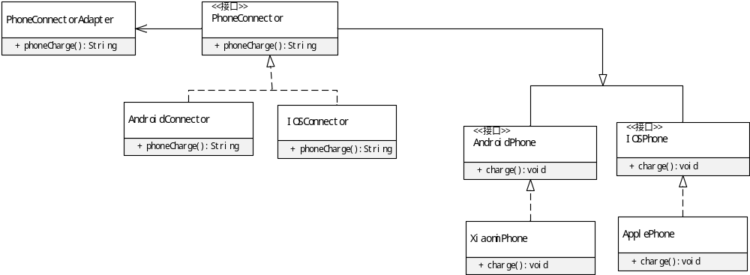
图 1 实验一UML图
代码框架：
/**
* 实验1：
* 现假设有Android手机和IOS手机两个系列，众所周知，
* 两个手机使用的数据线AndroidConnector和IOSConnector接口是不一致的，
* 请开发适配器，使其能让对应的数据线能连接不同手机。
* @author Moppet
*
*/

/*
* 手机数据线接口
*/
interface PhoneConnector{
/*
* 手机充电
*/
String phoneCharge();
}

/*
* AndroidConnector接口
*/
class AndroidConnector implements PhoneConnector{

@Override
public String phoneCharge() {
return "正在使用AndroidConnector接口充电";
}

}

/*
* IOSConnector接口
*/
class IOSConnector implements PhoneConnector{

@Override
public String phoneCharge() {
return "正在使用IOSConnector接口充电";
}
}

/*
* 手机接口适配器
*/
class PhoneConnectorAdapter implements PhoneConnector{

private PhoneConnector phoneConnector;

public PhoneConnectorAdapter(PhoneConnector phoneConnector) {
this.phoneConnector = phoneConnector;
}
@Override
public String phoneCharge() {

return phoneConnector.phoneCharge();
}

}

/*
* IOS手机
*/
interface IOSPhone {
void charge(PhoneConnector phoneConnector);
}

/*
* Android手机
*/
interface AndroidPhone {
void charge(PhoneConnector phoneConnector);
}

/*
* Xiaomi手机
*/
class ApplePhone implements IOSPhone{

@Override
public void charge(PhoneConnector phoneConnector) {
System.out.println("小米手机" + phoneConnector.phoneCharge());
}
}

/*
* Xiaomi手机
*/
class XiaomiPhone implements AndroidPhone{

@Override
public void charge(PhoneConnector phoneConnector) {
System.out.println("小米手机" + phoneConnector.phoneCharge());
}
}

public class AdapterTest{
public static void main(String[] args) {
/*
* 安卓手机测试
*/
XiaomiPhone xiaomiPhone = new XiaomiPhone();
xiaomiPhone.charge(new PhoneConnectorAdapter(new IOSConnector()));
/*
* IOS手机测试
*/
ApplePhone applePhone = new ApplePhone();
applePhone.charge(new PhoneConnectorAdapter(new AndroidConnector()));
}
}

测试截图：
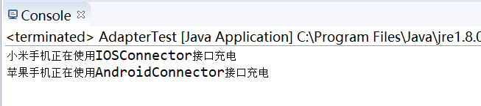
图 2 测试截图

实验二
现假设一个毕业生需要在如图所示的四个部门分别办理手续才能毕业，请使用外观模式简化整个操作
UML图：
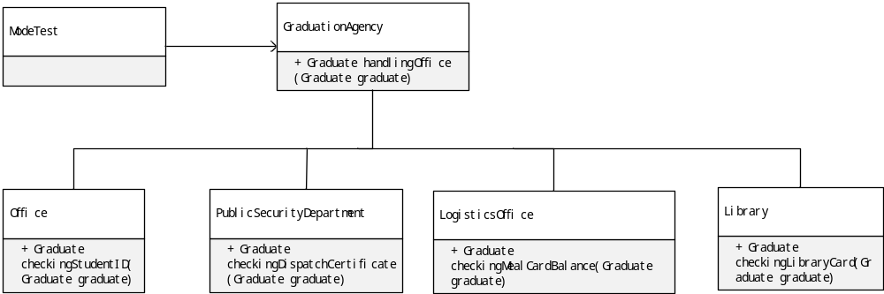
图 3 实验二UML图
代码框架：
/**
* 实验二
* 现假设一个毕业生需要在如图所示的四个部门分别办理手续才能毕业，请使用外观模式简化整个操作
* @author Moppet
*
*/
class Graduate {
/*
* 学生证
*/
private String studentID;
/*
* 身份证
*/
private String identityCard;
/*
* 毕业证
*/
private String diploma;
/*
*学位证
*/
private String certificateOfDegree;
/*
* 派遣证
*/
private String dispatchCertificate;
/*
* 饭卡
*/
private String mealCard;
/*
* 饭卡余额
*/
private String mealCardBalance;
/*
* 借卡证
*/
private String libraryCard;
/*
* 借书证押金
*/
private String libraryCardDeposit;

public String getStudentID() {
return studentID;
}
public void setStudentID(String studentID) {
this.studentID = studentID;
}
public String getIdentityCard() {
return identityCard;
}
public void setIdentityCard(String identityCard) {
this.identityCard = identityCard;
}
public String getLibraryCard() {
return libraryCard;
}
public void setLibraryCard(String libraryCard) {
this.libraryCard = libraryCard;
}
public String getMealCard() {
return mealCard;
}
public void setMealCard(String mealCard) {
this.mealCard = mealCard;
}
public String getDiploma() {
return diploma;
}
public void setDiploma(String diploma) {
this.diploma = diploma;
}
public String getCertificateOfDegree() {
return certificateOfDegree;
}
public void setCertificateOfDegree(String certificateOfDegree) {
this.certificateOfDegree = certificateOfDegree;
}
public String getDispatchCertificate() {
return dispatchCertificate;
}
public void setDispatchCertificate(String dispatchCertificate) {
this.dispatchCertificate = dispatchCertificate;
}
public String getMealCardBalance() {
return mealCardBalance;
}
public void setMealCardBalance(String mealCardBalance) {
this.mealCardBalance = mealCardBalance;
}
public String getLibraryCardDeposit() {
return libraryCardDeposit;
}
public void setLibraryCardDeposit(String libraryCardDeposit) {
this.libraryCardDeposit = libraryCardDeposit;
}
@Override
public String toString() {
return "学生证:" + studentID + ", 身份证:" + identityCard + ", 借书证:" + libraryCard
+ ", 饭卡:" + mealCard + ", 毕业证 :" + diploma + ", 学位证:" + certificateOfDegree
+ ", 派遣证:" + dispatchCertificate + ", 饭卡余额:" + mealCardBalance
+ ", 借书证押金:" + libraryCardDeposit + "";
}
}

/*
* 图书馆
* 图书馆根据学生的借书证，退还押金
*/

class Library {
/*
* 大学毕业生验证借书证并领取借书证押金
*/
public static Graduate checkingLibraryCard(Graduate graduate) {
if(!graduate.getLibraryCard().isEmpty()) {
return grantDeposit(graduate);
}
return notGrantDeposit(graduate);
}
/*
* 图书馆退还押金
*/
public static Graduate grantDeposit(Graduate graduate) {
graduate.setLibraryCardDeposit("退还押金为100");
return graduate;
}

/*
* 借书证丢失，不退还押金
*/
public static Graduate notGrantDeposit(Graduate graduate) {
graduate.setLibraryCardDeposit("借书证丢失，不退还押金");
return graduate;
}
}

/*
* 后勤处
* 教务处给毕业生退还饭卡余额
*/
class LogisticsOffice {
/*
* 查看饭卡余额，退还余额
*/
public static Graduate checkingMealCardBalance(Graduate graduate) {
if(!graduate.getMealCard().isEmpty()) {
return grantBalance(graduate);
}
return notGrantBalance(graduate);
}
/*
* 完整退还饭卡余额10
*/
public static Graduate grantBalance(Graduate graduate) {
graduate.setMealCardBalance("饭卡余额还剩10.0");
return graduate;
}

/*
* 完整退还饭卡余额0
*/
public static Graduate notGrantBalance(Graduate graduate) {
graduate.setMealCardBalance("饭卡余额还剩0.0");
return graduate;
}
}

/*
* 教务处
* 教务处给毕业生颁发毕业证、学位证
*/
class Office {
/*
* 大学毕业生验证学生证并获取毕业证，学位证
*/
public static Graduate checkingStudentID(Graduate graduate) {
if(!graduate.getStudentID().isEmpty()) {
return grantCertificate(graduate);
}
return notGrantCertificate(graduate);
}
/*
* 教务处发放毕业证、学生证
*/
public static Graduate grantCertificate(Graduate graduate) {
graduate.setDiploma("颁发毕业证");
graduate.setCertificateOfDegree("颁发学位证");
return graduate;
}

/*
* 教务处不发放毕业证、学生证
*/
public static Graduate notGrantCertificate(Graduate graduate) {
graduate.setDiploma("不给予毕业");
graduate.setCertificateOfDegree("不给予毕业");
return graduate;
}
}

/*
* 公安处
* 公安处给毕业生颁发派遣证
*/
class PublicSecurityDepartment {
/*
* 大学毕业生验证身份证、学位证并获取派遣证
*/
public static Graduate checkingDispatchCertificate(Graduate graduate) {
if(!graduate.getIdentityCard().isEmpty() && !graduate.getCertificateOfDegree().isEmpty()) {
return grantDispatch(graduate);
}
return notGrantDispatch(graduate);
}
/*
* 公安处发放派遣证
*/
public static Graduate grantDispatch(Graduate graduate) {
graduate.setDispatchCertificate("发放派遣证");
return graduate;
}

/*
* 公安处不发放派遣证
*/
public static Graduate notGrantDispatch(Graduate graduate) {
graduate.setDispatchCertificate("信息有误，不发派遣证");
return graduate;
}
}

/*
* 代办处
*/
class GraduationAgency {
public Graduate handlingOffice (Graduate graduate){
officeAgency(graduate);
publicSecurityAgency(graduate);
logisticsAgency(graduate);
libraryAgency(graduate);
return graduate;

}
/*
* 教务处代办
*/
private void officeAgency(Graduate graduate) {
Office.checkingStudentID(graduate);
}
/*
* 公安处派遣证代办
*/
private void publicSecurityAgency(Graduate graduate) {
PublicSecurityDepartment.checkingDispatchCertificate(graduate);
}
/*
* 饭卡余额代办
*/
private void logisticsAgency(Graduate graduate) {
LogisticsOffice.checkingMealCardBalance(graduate);
}
/*
* 借书证押金代办
*/
private void libraryAgency(Graduate graduate) {
Library.checkingLibraryCard(graduate);

}
}

public class ModeTest{
public static void main(String[] args) {
Graduate graduate = new Graduate();
//学生证
graduate.setStudentID("1234567");
//饭卡
graduate.setMealCard("2012345");
//借书证
graduate.setLibraryCard("123456");
//身份证
graduate.setIdentityCard("520986188911227183");

GraduationAgency angency = new GraduationAgency();
angency.handlingOffice(graduate);

System.out.println(graduate);

}
}
测试截图：
图 4 实验二 测试截图

