Project 2
Yiyang Xue
2025-11-17
Table of Contents

1 Plots

1.1 Figure 1. Monthly Mean CO and Ozone (O3) Concentrations with 95% Confidence Intervals, 2018–2020
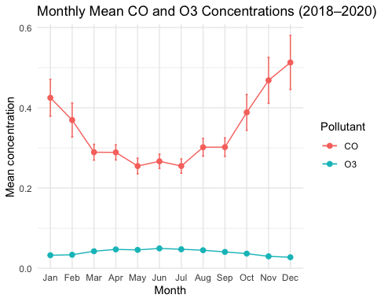

1.2 Monthly Mean PM2.5 Concentrations by Year (2018–2020)
