2020EXP

1 导入数据

需要将excel转化为多个utf-8编码的csv文件后导入

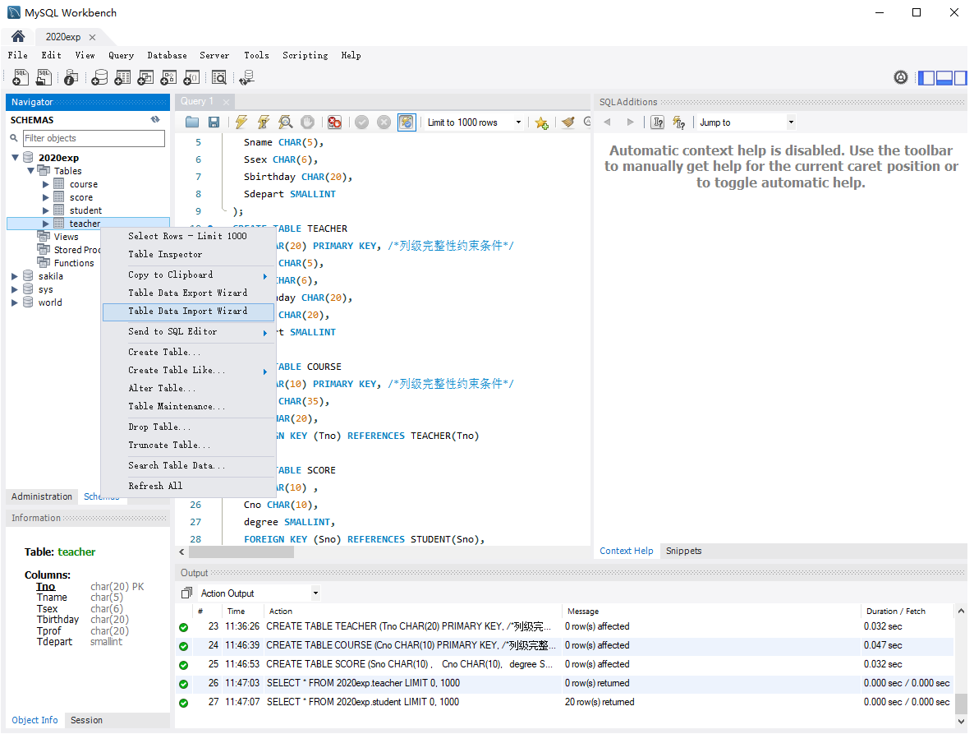

CMD\\\

CD C:\Program Files\MySQL\MySQL Server 8.0\bin

mysql --local-infile -u root -p 123456

load data local INfile 'C:/Users/LTofDYX/Desktop/teacher.csv' into table `2020exp1`.TEACHER fields terminated by ',' lines terminated by '\n';

load data local INfile 'C:/Users/LTofDYX/Desktop/students.csv' into table `2020exp1`.STUDENT fields terminated by ',' lines terminated by '\n';

load data local INfile 'C:/Users/LTofDYX/Desktop/course.csv' into table `2020exp1`.COURSE fields terminated by ',' lines terminated by '\n';

load data local INfile 'C:/Users/LTofDYX/Desktop/score.csv' into table `2020exp1`.SCORE fields terminated by ',' lines terminated by '\n';