**Introduce Jmeter**

The Apache JMeter™ application is open source software, a 100% pure Java application designed to load test functional behavior and measure performance. It was originally designed for testing Web Applications but has since expanded to other test functions.

(API test, Web automated test, jdbc test, java test, etc)

**Basic Process**

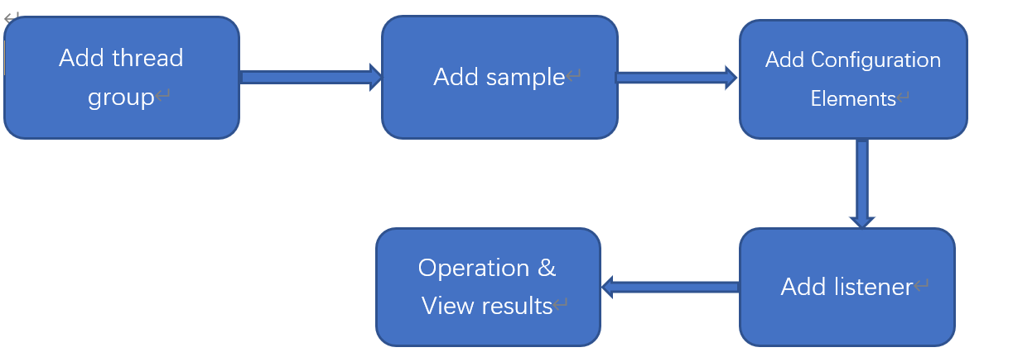

**Actual Operation**

Download: <https://jmeter.apache.org/>

JAVA api:

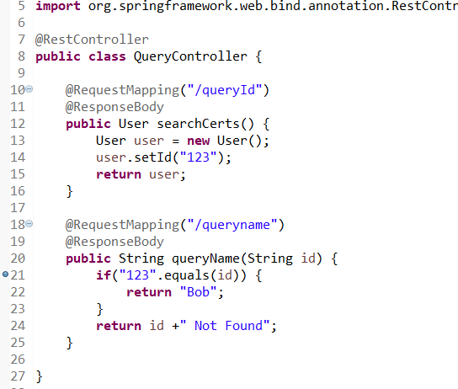

Start jmeter.bat :

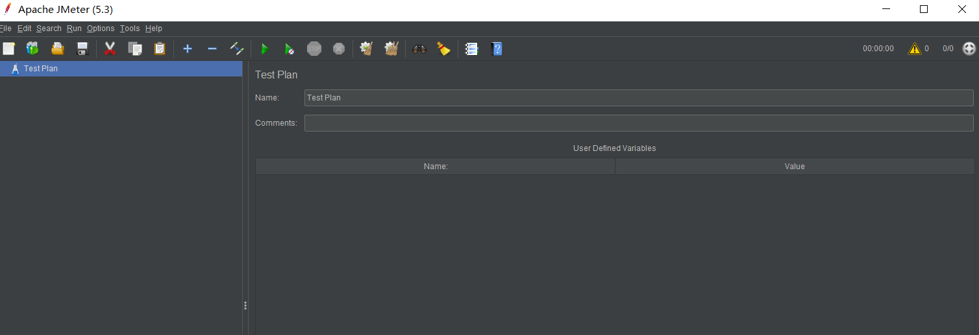

Add 🡪Threads(Users)🡪Thread Group

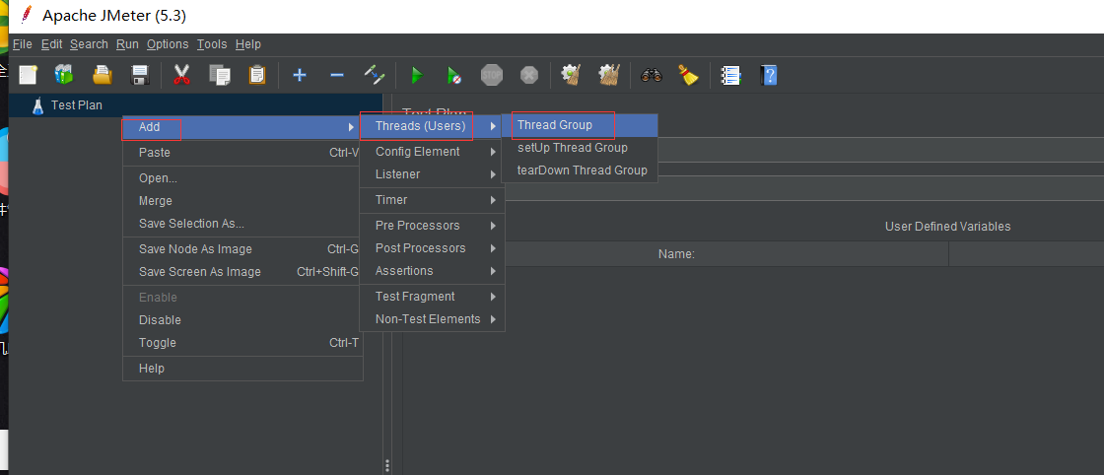

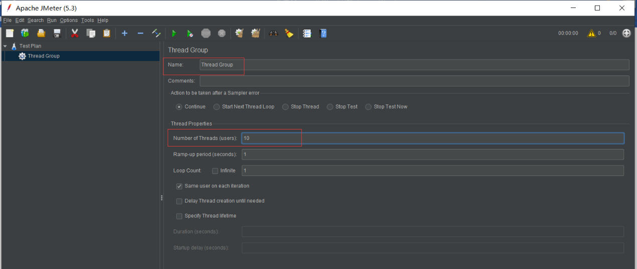

Ramp-Up Period(seconds) is set to 0: concurrent request

Add 🡪Sample🡪HTTP Request

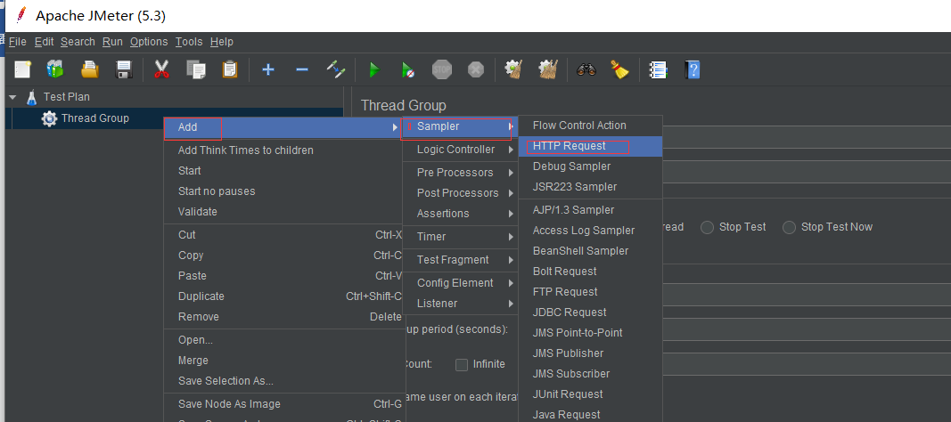

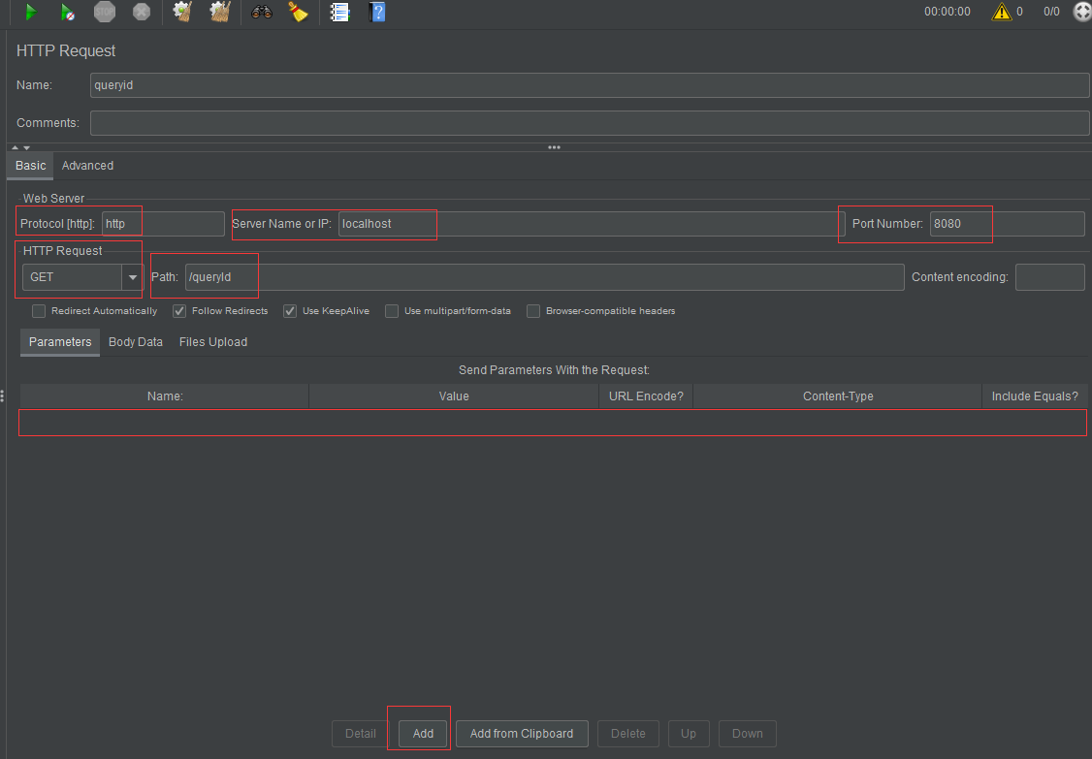

Some API need set header or cookie etc, Add🡪Config Element🡪HTTP Header Manager

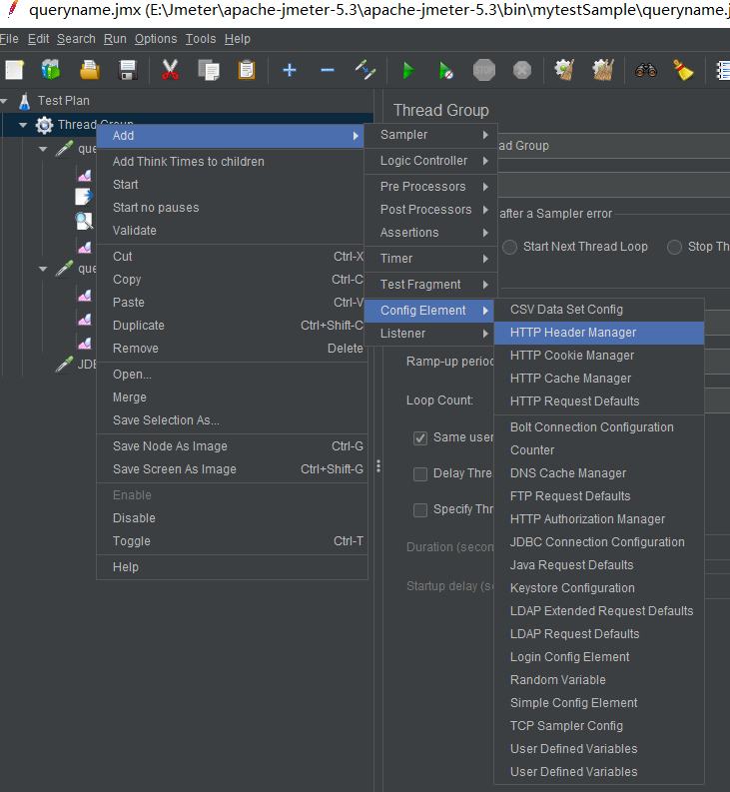

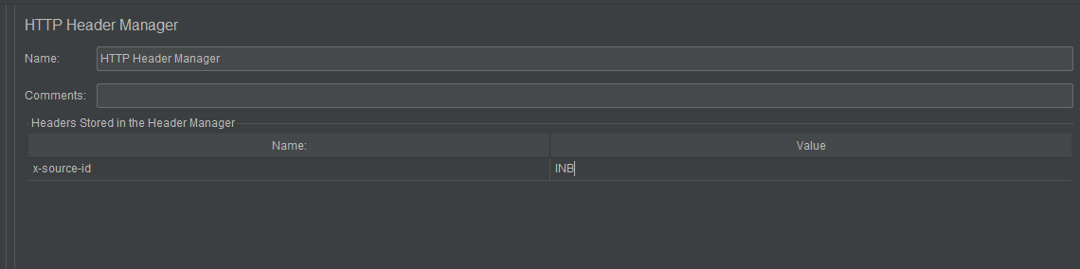

View result

Add🡪Listener🡪View Results Tree

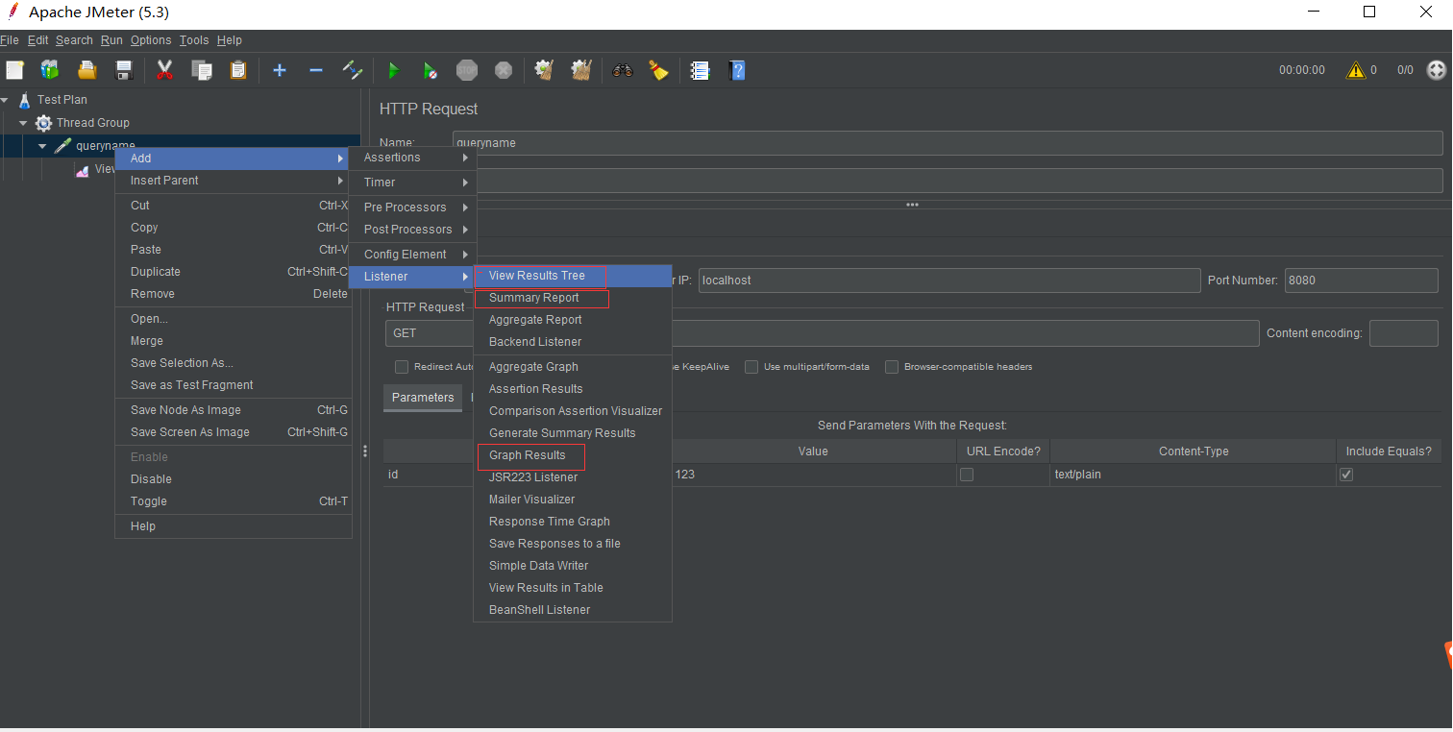

Summary Reort:

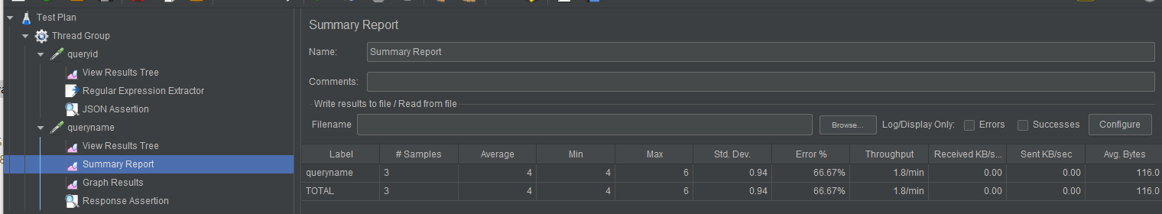

Graph Results:

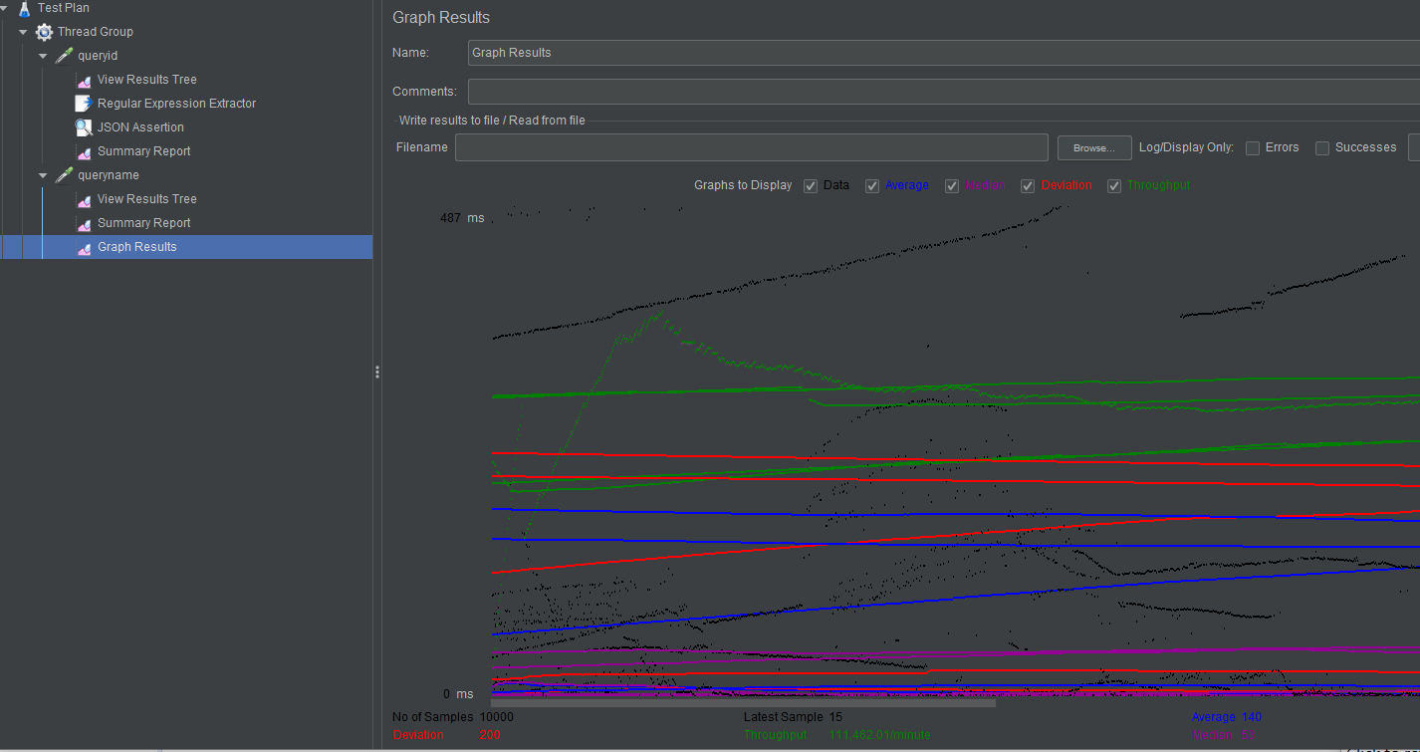

View Results in Table:

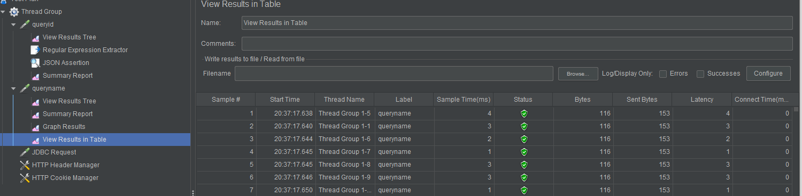

Assertions:

Add🡪Assertions🡪JSON Assertion:

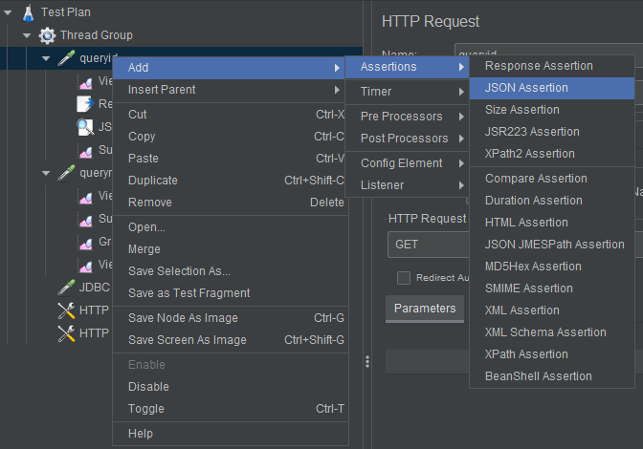

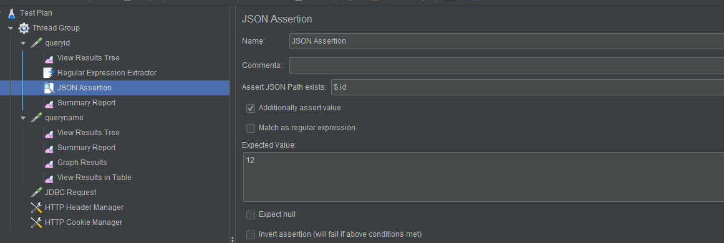

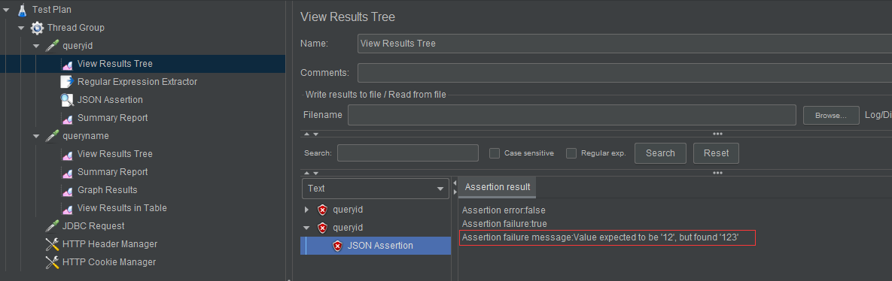

**Regular Expression Extractor:**

Add🡪Post Processors🡪Regular Expression Extractor

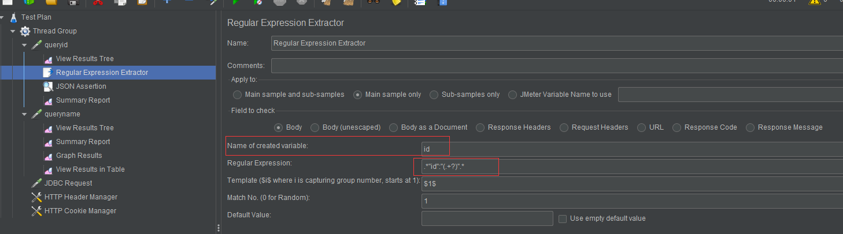

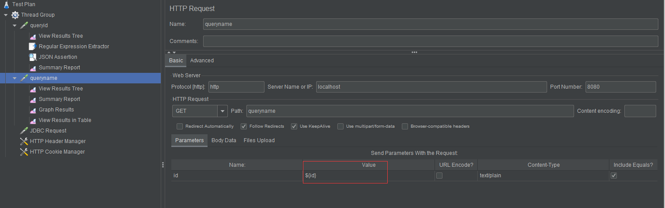

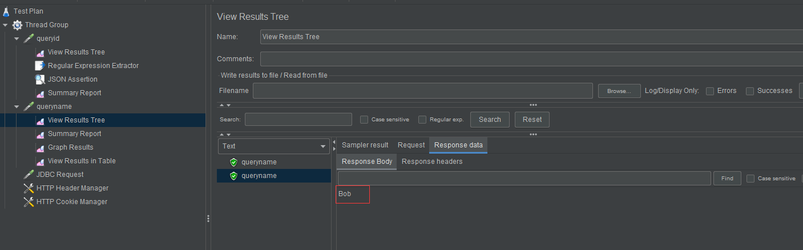

**JSON Extractor:**

