## 一．头条屏幕适配方式

<https://mp.weixin.qq.com/s/d9QCoBP6kV9VSWvVldVVwA>

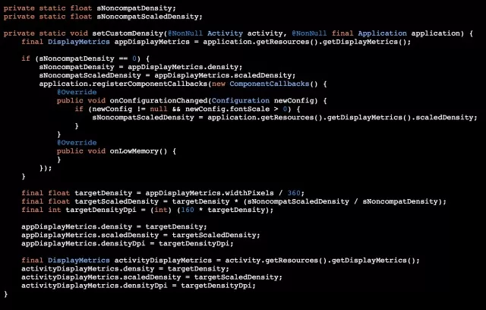

拓展

<https://juejin.im/post/5b6250bee51d451918537021>

<https://www.jianshu.com/p/4aa23d69d481>

<https://github.com/JessYanCoding/AndroidAutoSize>

## 二．smallestWidth适配

<https://www.jianshu.com/p/a4b8e4c5d9b0>