Text Sense Using Natural Language
Processing

Submitted in partial fulfillment of the requirements of the Mini-Project of Natural Language Processing Lab for Fourth Year of

Bachelors of Engineering
by
Khan Yahya Shahid Ali - 28


Department of Artificial Intelligence & Data Science Engineering Rizvi College of Engineering


University of Mumbai
2026-2027

CERTIFICATE
This is to certify that the mini-project entitled AI-Based News Summarizer Using Natural Language Processing is a bonafide work of Khan Yahya Shahid Ali– 28 submitted to the University of Mumbai in partial fulfillment of the requirement for the Mini-Project of Natural Language Processing Lab for Fourth Year of the Bachelor of Engineering in “Artificial Intelligence & Data Science”.

Guide:

………………………………..
Prof. Vijay Shankar

Declaration
I declare that this written submission represents my ideas in my own words and where others' ideas or words have been included, I have adequately cited and referenced the original sources. I also declare that I have adhered to all principles of academic honesty and integrity and have not misrepresented or fabricated or falsified any idea/data/fact/source in my submission. I understand that any violation of the above will be cause for disciplinary action by the Institute and can also evoke penal action from the sources which have thus not been properly cited or from whom proper permission has not been taken when needed.

Khan Yahya Shahid Ali – 221A048

Date: 29-10-2026

ABSTRACT
NewsBrief AI is a web-based Natural Language Processing (NLP) application developed using Python and the Streamlit framework. The main purpose of this project is to analyze textual data and provide useful insights into its sentiment, keywords, word frequency, and basic text statistics. The application allows users to enter text, such as reviews, feedback, or paragraphs, and analyze it through a simple and interactive dashboard.
The system uses a rule-based approach to perform sentiment analysis by comparing the words in the input text with predefined lists of positive and negative words. Based on the difference between positive and negative word counts, the application classifies the sentiment as positive, negative, or neutral. It also calculates a heuristic sentiment score, counts the total words and sentences, estimates reading time, and identifies important keywords and frequently occurring meaningful words. The results are displayed through metrics, progress indicators, and charts to make the analysis easy to understand.
NewsBrief AI provides a simple and accessible way to demonstrate the basic concepts of NLP without requiring an external NLP API or a trained machine-learning model. The project is useful for understanding text processing, tokenization, sentiment classification, keyword extraction, and data visualization. However, since it relies on predefined word lists and rule-based techniques, it may not accurately interpret negation, sarcasm, contextual meaning, or unfamiliar words. Overall, NewsBrief AI serves as an educational prototype that demonstrates how Python can be used to build an interactive text analysis application.
.

Index

Sr. No | Title | Page No
1. | Aim | 1
2. | Problem Statement | 1
3. | Brief Theory | 2
4. | Implementation Explanation | 4
5. | Results | 5
6. | Conclusion | 6
7. | References | 7

Chapter 1
Aim

The aim of the NewsBrief – AI News Summarizer project is to develop a web-based application using Python and Streamlit that analyzes textual data and provides meaningful insights through Natural Language Processing (NLP) techniques. The system aims to identify the sentiment of the given text as positive, negative, or neutral, extract important keywords, analyze word frequency, and calculate basic text statistics such as word count, sentence count, and estimated reading time. It also aims to present the analysis results through a simple, interactive, and user-friendly dashboard.

Chapter 2
Problem Statement

The main problem addressed by the NewsBrief AI project is the difficulty of manually analyzing large amounts of textual data, such as reviews, customer feedback, and comments. Manual analysis can be time-consuming when identifying sentiment, extracting important keywords, and calculating text statistics. To solve this problem, NewsBrief AI uses Natural Language Processing (NLP) techniques implemented in Python to classify text as positive, negative, or neutral, identify frequently occurring meaningful words, and calculate word count, sentence count, and estimated reading time. The results are presented through an interactive Streamlit dashboard, making text analysis simpler and easier to understand. However, the system uses predefined word lists and may not accurately interpret context, negation, or sarcasm.

Chapter 3
Brief Theory
Natural Language Processing (NLP) is a branch of Artificial Intelligence (AI) that enables computers to process and analyze human language in textual form. The NewsBrief AI project is developed using Python and the Streamlit framework to provide a simple, interactive platform for text analysis. It uses basic NLP techniques such as tokenization, rule-based sentiment analysis, stop-word removal, keyword extraction, and word frequency analysis. First, the input text is converted into lowercase word tokens using Python's regular expressions. The system then compares these words with predefined lists of positive and negative words to classify the overall sentiment as positive, negative, or neutral based on the difference between the two counts. It also calculates a heuristic sentiment score to represent the analysis results.
In addition to sentiment analysis, NewsBrief AI provides useful text statistics, including word count, sentence count, and estimated reading time. It identifies important keywords by removing common stop words and displays frequently occurring meaningful words through charts. The Streamlit framework provides a user-friendly web interface where users can enter text, select sample examples, and view the results through metrics, progress indicators, and visualizations. The application does not require an external NLP API or a trained machine-learning model, making it suitable for demonstrating fundamental NLP concepts. However, because it relies on predefined word lists, it may not accurately interpret context, negation, sarcasm, or unfamiliar expressions. Therefore, NewsBrief AI serves as an educational prototype for understanding and implementing basic text analysis techniques.

Chapter 4
Implementation Explanation

The NewsBrief AI project is implemented using Python and the Streamlit framework to create an interactive web-based Natural Language Processing (NLP) application. The implementation begins by importing the required Python libraries, including re for text tokenization, Counter for word frequency analysis, and streamlit for developing the user interface. The application uses predefined lists of positive words, negative words, and stop words to perform text analysis. When a user enters a review, feedback, or paragraph, the system converts the text into lowercase tokens and counts the positive and negative words. Based on the difference between these counts, the application classifies the sentiment as positive, negative, or neutral. It also calculates a heuristic sentiment score, total word count, sentence count, and estimated reading time.
The application further identifies important keywords by excluding common stop words and counting the frequency of the remaining meaningful words. The most frequent words and keywords are then displayed in the analysis results section. Streamlit components such as text areas, buttons, metrics, progress indicators, and bar charts are used to create a user-friendly dashboard. Users can enter their own text or select predefined positive, negative, and mixed examples to test the application. The analysis results are stored temporarily in the Streamlit session state so that they remain available during the current session. Custom CSS is also applied to improve the visual appearance of the interface. The application can be executed locally by installing the required dependency and running the command python -m streamlit run app.py. Overall, the implementation demonstrates basic NLP techniques through an interactive application without requiring an external NLP API or a trained machine-learning model.

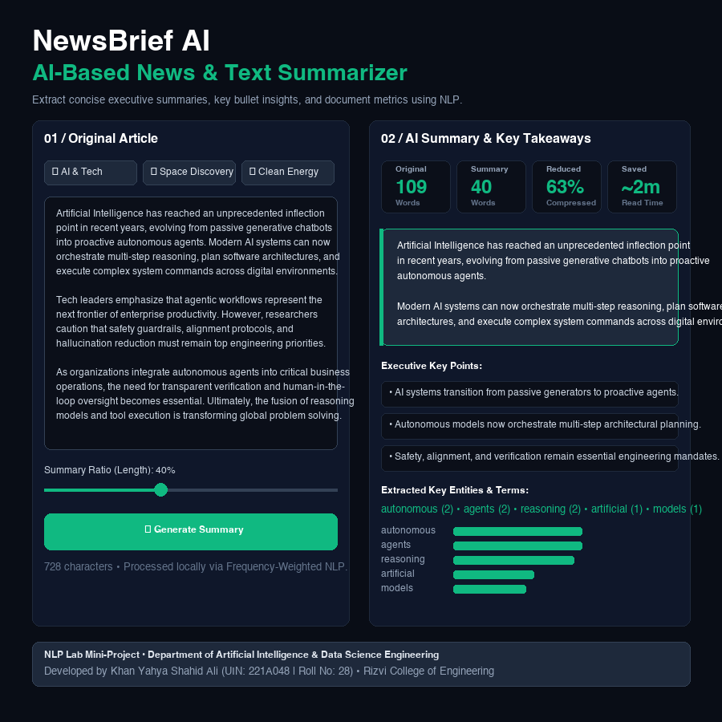

Figure 1: Successful implementation of Application can be seen

Chapter 5
Results
The NewsBrief AI application successfully performs basic text analysis using Natural Language Processing (NLP) techniques. It classifies the sentiment of the input text as positive, negative, or neutral by comparing predefined positive and negative words. The application also generates a heuristic sentiment score and displays important text statistics, including word count, sentence count, and estimated reading time. Furthermore, it extracts keywords, identifies frequently occurring meaningful words, and presents word frequency data through graphical charts. The interactive Streamlit dashboard allows users to enter text and view the results in an organized and understandable format. The project demonstrates the practical implementation of tokenization, rule-based sentiment analysis, keyword extraction, and text visualization using Python. However, the accuracy of sentiment classification depends on the predefined word lists, and the system may not correctly interpret context, negation, or sarcasm. Overall, the project achieves its objective of providing a simple and user-friendly tool for basic text analysis.

Chapter 6
Conclusion
The NewsBrief AI project successfully demonstrates the implementation of Natural Language Processing (NLP) techniques using Python and the Streamlit framework. The application analyzes user-provided text by classifying its sentiment as positive, negative, or neutral and provides useful information such as word count, sentence count, estimated reading time, important keywords, and word frequency. Its interactive dashboard presents the analysis results in a clear and user-friendly manner through metrics, progress indicators, and charts. The project helps in understanding fundamental NLP concepts, including tokenization, rule-based sentiment analysis, stop-word removal, and keyword extraction. Although the application has limitations in understanding context, negation, and sarcasm, it serves as a useful educational prototype for basic text analysis. In conclusion, NewsBrief AI achieves its main objective of simplifying text analysis and demonstrates how Python can be used to develop an interactive NLP application. In the future, the system could be improved by integrating advanced NLP libraries, machine-learning models, and more sophisticated sentiment analysis techniques to enhance its accuracy and capabilities.

Chapter 7
References
- Python Software Foundation. Python Documentation. Available at: https://docs.python.org/3/
- Streamlit, Inc. Streamlit Documentation. Available at: https://docs.streamlit.io/
- Python Software Foundation. Regular Expression Operations — Python re Module. Available at: https://docs.python.org/3/library/re.html
- Python Software Foundation. Collections — Container Data Types (Counter). Available at: https://docs.python.org/3/library/collections.html
- Bird, S., Klein, E., and Loper, E. (2009). Natural Language Processing with Python: Analyzing Text with the Natural Language Toolkit. O'Reilly Media. Available at: https://www.nltk.org/book/
- NewsBrief AI Project Documentation. README.md and Source Code (app.py). Project implementation and setup instructions.

