Error Ellipse Computation

Introduction
This paper is intended to provide both an intuitive and mathematical insight into error ellipses, and ellipsoids.
An “error ellipse” is often used as a visual aid or performance measure to depict the accuracy or performance of an estimator, or other stochastic system. It implies that there are two (or more) variables involved, and that they are normally (Gaussian) distributed with known covariance.

It really is an ellipse.
Consider a 2-D zero-mean random variable, 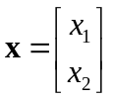. Since the r.v. is Guassian with covariance matrix 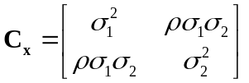, it has a probability density function (with 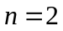),
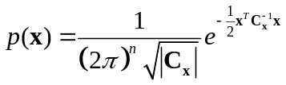
Note that
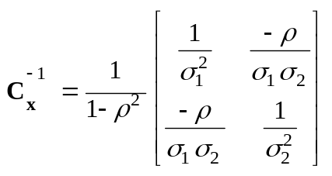
Written out in terms of the two separate variables, we have,
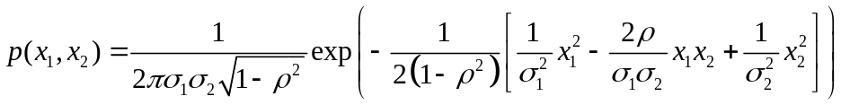
While this form is cumbersome it serves to show that, for a constant value of 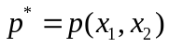, we have an ellipse, as shown below.
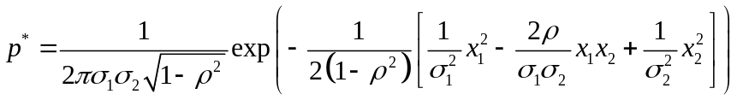
Which can be written as
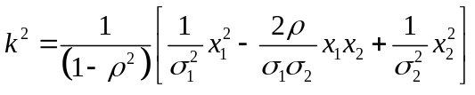
Where 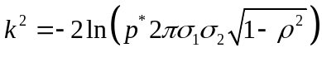.
The selection of determines the size of the ellipse. This will be discussed more, below.

A more practical way to describe the error ellipse is in terms of matrices. is re-written as
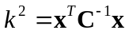
For a fixed value of , the locus of points, 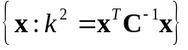, which solves the equation is the error ellipse.

Stretching the circle
Recall the properties of multivariate transformation. If is a random vector (of variables) with covariance 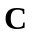, and 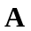 is an matrix, then 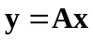 is a random vector (of variables) with covariance 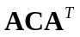. (Assume is invertible.)

Let’s say that we desire ’s components to be independent standard normal, e.g. 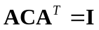. What should be set to? For this, we turn to Eigendecompsition, which allows any square matrix to be expressed as
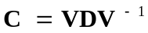
Where 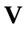 is an orthonormal square matrix (of eigenvectors), and  is a diagonal matrix (of eigenvalues). We will use the shorthand 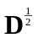 to refer to a diagonal matrix contains the square roots of the eigenvalues such that 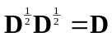.
The we have 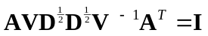 which is satisfied if 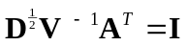 (although other solutions may exist). Thus, setting
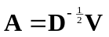
allows to have a stand normal distribution, where and are the eigenvalues and eigenvectors of the covariance matrix, . Moreover, the inverse transform, 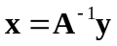, allows the original variables to be restored. (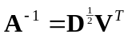, using the property that 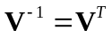.)

Working with is much easier that working with because is has standard normal distribution; the error ellipse is a circle, and so on. The selection of for a desired confidence interval, , becomes easier too, and can be computed in few different ways. The probability that a point lies with in a circle of a given radius has a Rayleigh distribution, that is, the random variable 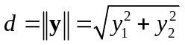 has a Rayleigh distribution. The square of the distance, 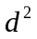 has a chi-square order-2 distribution.
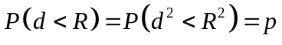
We know the desired confidence interval, , and that has a chi-square(2) distribution, 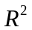 can be determined by computed the quantile of the chi-square(2) distribution at , or 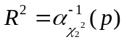.  then defines the radius of the circle defining the confidence interval, .
If 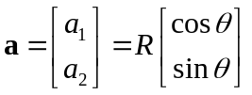 is a point on the circle of radius R at any arbitrary , then 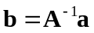 lies on the error ellipse.
Summarizing, 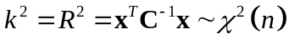, where is the number of dimensions (1 for an interval, 2 for an error ellipse, 3 for an ellipsoid). For various confidence regions, assign as required:
Confidence Region,  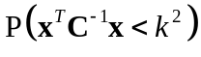 | (approx.)   | (approx.) | (approx.)  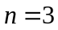
19.87% |  |  | 1.000
39.34% |  | 1.000
50.0% | 0.674 | 1.177 | 1.538
68.27% | 1.000
90.0% | 1.645 | 2.146 | 2.500
95.0% | 1.960 | 2.448 | 2.795
99.0% | 2.576 | 3.035 | 3.368
99.9% | 3.290 | 3.717 | 4.033
99.99% | 3.889 | 4.292 | 4.598
 | 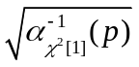 | 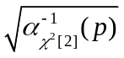 | 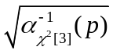

Summary of the error ellipse generation
- Given a covariance matrix of a normal bi-variatiate random variable, compute the eigenvalues, , and eigenvectors, .
- Compute the transform matrix, , and its inverse, .
- For a set of angles, 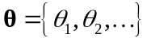, compute some points around a circle, 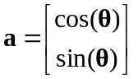.
- Transform the points on the circle to points on the error ellipse, .
- Plot the points of . If desired, offset by the mean () of the variables, if it is not zero-mean.

Error ellipsoid
For three dimensions, the concept is the same, with few differences. The differences are:
- is a 3x3 covariance matrix, instead of 2x2.
- The variable is distributed chi-square order-3 instead of order-2, which affects the computation of , based on a desired confidence interval.
- Choosing points on the unit sphere can be tricky; see Matlab function ellipsoid for more information.

Caveats
If the covariance matrix for a (normally distributed) data set is not known, it can be estimated, as the “sample covariance matrix.” However, this is in itself a random variable, having a Wishart Distribution. Further more, if the data is not zero-mean and the mean is unknown, it too can be estimated and removed. If either case, the error ellipse described in this paper becomes only an approximation, increasing in accuracy as the number of data points increases.

Relationship among ellipse properties
Consider the un-rotated ellipse,
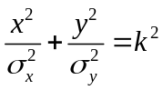 .
Its companion matrix form is
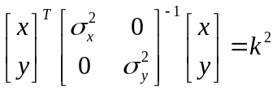.
To remain consistent with prior notation, we let 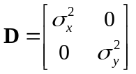, and therefore 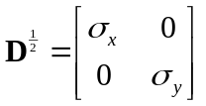 .
Now consider a rotation of angle , and define the rotation matrix
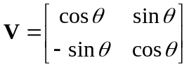,
Such that
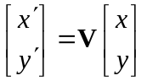.
Note that is orthogonal, i.e. .
The rotated ellipse equation (in matrix form) is:
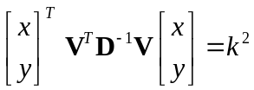.
This provides a method of create covariance matrix having “major” and “minor” ellipse axes of 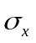 and 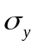 with a (counterclockwise) rotation angle of , by defining
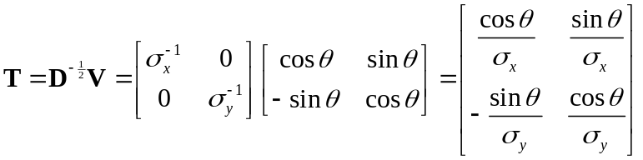
And
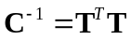.
This is easily invertible, defining

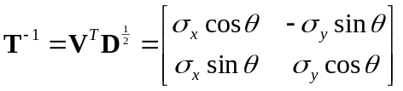
And
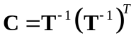 .
To test is a point 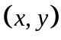 is inside the matrix, we apply the test
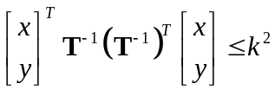
If we define
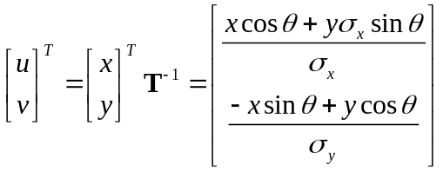
Then
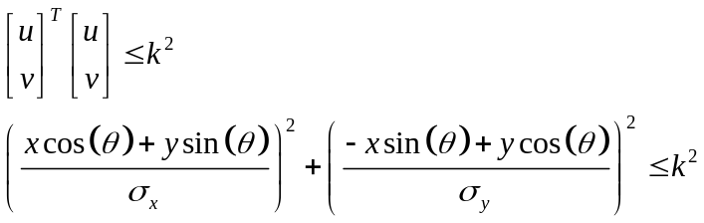

Matlab code
function h=error_ellipse(varargin)
% ERROR_ELLIPSE - plot an error ellipse, or ellipsoid, defining confidence region
% ERROR_ELLIPSE(C22) - Given a 2x2 covariance matrix, plot the
% associated error ellipse, at the origin. It returns a graphics handle
% of the ellipse that was drawn.
%
% ERROR_ELLIPSE(C33) - Given a 3x3 covariance matrix, plot the
% associated error ellipsoid, at the origin, as well as its projections
% onto the three axes. Returns a vector of 4 graphics handles, for the
% three ellipses (in the X-Y, Y-Z, and Z-X planes, respectively) and for
% the ellipsoid.
%
% ERROR_ELLIPSE(C,MU) - Plot the ellipse, or ellipsoid, centered at MU,
% a vector whose length should match that of C (which is 2x2 or 3x3).
%
% ERROR_ELLIPSE(...,'Property1',Value1,'Name2',Value2,...) sets the
% values of specified properties, including:
% 'C' - Alternate method of specifying the covariance matrix
% 'mu' - Alternate method of specifying the ellipse (-oid) center
% 'conf' - A value betwen 0 and 1 specifying the confidence interval.
% the default is 0.5 which is the 50% error ellipse.
% 'scale' - Allow the plot the be scaled to difference units.
% 'style' - A plotting style used to format ellipses.
% 'clip' - specifies a clipping radius. Portions of the ellipse, -oid,
% outside the radius will not be shown.
%
% NOTES: C must be positive definite for this function to work properly.

default_properties = struct(...
'C', [], ... % The covaraince matrix (required)
'mu', [], ... % Center of ellipse (optional)
'conf', 0.5, ... % Percent confidence/100
'scale', 1, ... % Scale factor, e.g. 1e-3 to plot m as km
'style', '', ... % Plot style
'clip', inf); % Clipping radius

if length(varargin) >= 1 & isnumeric(varargin{1})
default_properties.C = varargin{1};
varargin(1) = [];
end

if length(varargin) >= 1 & isnumeric(varargin{1})
default_properties.mu = varargin{1};
varargin(1) = [];
end

if length(varargin) >= 1 & isnumeric(varargin{1})
default_properties.conf = varargin{1};
varargin(1) = [];
end

if length(varargin) >= 1 & isnumeric(varargin{1})
default_properties.scale = varargin{1};
varargin(1) = [];
end

if length(varargin) >= 1 & ~ischar(varargin{1})
error('Invalid parameter/value pair arguments.')
end

prop = getopt(default_properties, varargin{:});
C = prop.C;

if isempty(prop.mu)
mu = zeros(length(C),1);
else
mu = prop.mu;
end

conf = prop.conf;
scale = prop.scale;
style = prop.style;

if conf <= 0 | conf >= 1
error('conf parameter must be in range 0 to 1, exclusive')
end

[r,c] = size(C);
if r ~= c | (r ~= 2 & r ~= 3)
error(['Don''t know what to do with ',num2str(r),'x',num2str(c),' matrix'])
end

x0=mu(1);
y0=mu(2);

% Compute quantile for the desired percentile
k = sqrt(qchisq(conf,r)); % r is the number of dimensions (degrees of freedom)

hold_state = get(gca,'nextplot');

if r==3 & c==3
z0=mu(3);

% Make the matrix has positive eigenvalues - else it's not a valid covariance matrix!
if any(eig(C) <=0)
error('The covariance matrix must be positive definite (it has non-positive eigenvalues)')
end

% C is 3x3; extract the 2x2 matricies, and plot the associated error
% ellipses. They are drawn in space, around the ellipsoid; it may be
% preferable to draw them on the axes.
Cxy = C(1:2,1:2);
Cyz = C(2:3,2:3);
Czx = C([3 1],[3 1]);

[x,y,z] = getpoints(Cxy,prop.clip);
h1=plot3(x0+k*x,y0+k*y,z0+k*z,prop.style);hold on
[y,z,x] = getpoints(Cyz,prop.clip);
h2=plot3(x0+k*x,y0+k*y,z0+k*z,prop.style);hold on
[z,x,y] = getpoints(Czx,prop.clip);
h3=plot3(x0+k*x,y0+k*y,z0+k*z,prop.style);hold on

[eigvec,eigval] = eig(C);

[X,Y,Z] = ellipsoid(0,0,0,1,1,1);
XYZ = [X(:),Y(:),Z(:)]*sqrt(eigval)*eigvec';

X(:) = scale*(k*XYZ(:,1)+x0);
Y(:) = scale*(k*XYZ(:,2)+y0);
Z(:) = scale*(k*XYZ(:,3)+z0);
h4=surf(X,Y,Z);
colormap gray
alpha(0.3)
camlight
if nargout
h=[h1 h2 h3 h4];
end
elseif r==2 & c==2
% Make the matrix has positive eigenvalues - else it's not a valid covariance matrix!
if any(eig(C) <=0)
error('The covariance matrix must be positive definite (it has non-positive eigenvalues)')
end

[x,y,z] = getpoints(C,prop.clip);
h1=plot(scale*(x0+k*x),scale*(y0+k*y),prop.style);
set(h1,'zdata',z+1)
if nargout
h=h1;
end
else
error('C (covaraince matrix) must be specified as a 2x2 or 3x3 matrix)')
end
%axis equal

set(gca,'nextplot',hold_state);

%---------------------------------------------------------------
% getpoints - Generate x and y points that define an ellipse, given a 2x2
% covariance matrix, C. z, if requested, is all zeros with same shape as
% x and y.
function [x,y,z] = getpoints(C,clipping_radius)

n=100; % Number of points around ellipse
p=0:pi/n:2*pi; % angles around a circle

[eigvec,eigval] = eig(C); % Compute eigen-stuff
xy = [cos(p'),sin(p')] * sqrt(eigval) * eigvec'; % Transformation
x = xy(:,1);
y = xy(:,2);
z = zeros(size(x));

% Clip data to a bounding radius
if nargin >= 2
r = sqrt(sum(xy.^2,2)); % Euclidian distance (distance from center)
x(r > clipping_radius) = nan;
y(r > clipping_radius) = nan;
z(r > clipping_radius) = nan;
end

%---------------------------------------------------------------
function x=qchisq(P,n)
% QCHISQ(P,N) - quantile of the chi-square distribution.
if nargin<2
n=1;
end

s0 = P==0;
s1 = P==1;
s = P>0 & P<1;
x = 0.5*ones(size(P));
x(s0) = -inf;
x(s1) = inf;
x(~(s0|s1|s))=nan;

for ii=1:14
dx = -(pchisq(x(s),n)-P(s))./dchisq(x(s),n);
x(s) = x(s)+dx;
if all(abs(dx) < 1e-6)
break;
end
end

%---------------------------------------------------------------
function F=pchisq(x,n)
% PCHISQ(X,N) - Probability function of the chi-square distribution.
if nargin<2
n=1;
end
F=zeros(size(x));

if rem(n,2) == 0
s = x>0;
k = 0;
for jj = 0:n/2-1;
k = k + (x(s)/2).^jj/factorial(jj);
end
F(s) = 1-exp(-x(s)/2).*k;
else
for ii=1:numel(x)
if x(ii) > 0
F(ii) = quadl(@dchisq,0,x(ii),1e-6,0,n);
else
F(ii) = 0;
end
end
end

%---------------------------------------------------------------
function f=dchisq(x,n)
% DCHISQ(X,N) - Density function of the chi-square distribution.
if nargin<2
n=1;
end
f=zeros(size(x));
s = x>=0;
f(s) = x(s).^(n/2-1).*exp(-x(s)/2)./(2^(n/2)*gamma(n/2));

%---------------------------------------------------------------
function properties = getopt(properties,varargin)
%GETOPT - Process paired optional arguments as 'prop1',val1,'prop2',val2,...
%
% getopt(properties,varargin) returns a modified properties structure,
% given an initial properties structure, and a list of paired arguments.
% Each argumnet pair should be of the form property_name,val where
% property_name is the name of one of the field in properties, and val is
% the value to be assigned to that structure field.
%
% No validation of the values is performed.
%
% EXAMPLE:
% properties = struct('zoom',1.0,'aspect',1.0,'gamma',1.0,'file',[],'bg',[]);
% properties = getopt(properties,'aspect',0.76,'file','mydata.dat')
% would return:
% properties =
% zoom: 1
% aspect: 0.7600
% gamma: 1
% file: 'mydata.dat'
% bg: []
%
% Typical usage in a function:
% properties = getopt(properties,varargin{:})

% Process the properties (optional input arguments)
prop_names = fieldnames(properties);
TargetField = [];
for ii=1:length(varargin)
arg = varargin{ii};
if isempty(TargetField)
if ~ischar(arg)
error('Propery names must be character strings');
end
f = find(strcmp(prop_names, arg));
if length(f) == 0
error('%s ',['invalid property ''',arg,'''; must be one of:'],prop_names{:});
end
TargetField = arg;
else
% properties.(TargetField) = arg; % Ver 6.5 and later only
properties = setfield(properties, TargetField, arg); % Ver 6.1 friendly
TargetField = '';
end
end
if ~isempty(TargetField)
error('Property names and values must be specified in pairs.');
end

If the random variance is not zero-mean, the mean, , can be removed by subtracting the mean from the variable.
Any symmetric decomposition can be used. For example, Cholesky decomposition may be used instead of Eigendecompsition, since the covariance matrix is assume to be square, symmetric, and positive definite. In this case, 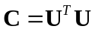, and then 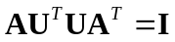, and 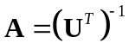, and 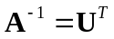. Other possibilities include Takagi's factorization.

