2. Literature Review and Conceptual Framework
This chapter develops the conceptual basis for examining gentrification through residential migration. It conceptualises gentrification as a heterogeneous form of neighbourhood restructuring, distinguishes displacement from observable mobility, and reviews how existing research measures different dimensions of their relationship. It then examines the gap between neighbourhood outcomes and the processes producing them, introduces migration as relational redistribution, situates London within a wider national migration system, and defines the research gap addressed by this study.

2.1 Gentrification as heterogeneous neighbourhood restructuring
Gentrification originally described the transformation of working-class neighbourhoods through middle-class settlement, capital reinvestment and the displacement of existing residents (Glass, 1964). Economic theories emphasised reinvestment opportunities created by undervalued urban land, while cultural explanations highlighted changing class structures and the residential preferences of an expanding professional middle class. Although causally distinct, both connect gentrification with social and material neighbourhood transformation.

Contemporary gentrification is more varied than this classical model. It may arise through gradual household-led settlement, large-scale development, state intervention or renewed transformation of already upgraded areas. Butler and Lees (2006), for example, identified super-gentrification in Barnsbury, where globally connected financial elites further transformed an already affluent inner-London neighbourhood. Unlike pioneer gentrification, this occurs near the top of the housing and socioeconomic hierarchy rather than at an initial reinvestment frontier. State-led redevelopment represents another pathway. Demolition and reconstruction of council estates can reorganise neighbourhood populations through institutionally managed relocation rather than incremental middle-class entry, as in the London estate-tracing research discussed in Section 2.3 (Reades et al, 2022).

Gentrification also overlaps with incumbent upgrading, reurbanisation, persistent affluence and other socioeconomic trajectories. Yee and Dennett (2022) used multidimensional neighbourhood indicators to distinguish mainstream, marginal and super-gentrification from adjacent forms of change. Patias et al. (2021) similarly showed that neighbourhood change is multidimensional and path-dependent, with present conditions embedded in longer trajectories of progress, decline or persistence.

Gentrification should therefore be treated as a family of related transformation rather than a uniform process. Socioeconomic ascent, physical change and population replacement may coincide, but their relative importance varies across places and stages of change. Displacement must consequently be investigated rather than assumed.

2.2 Displacement and residential mobility
Displacement is central to gentrification debates but cannot be inferred directly from an observed residential move. Marcuse (1985) distinguished several forms of displacement. Direct displacement occurs when households are physically or economically forced from their homes, chain displacement accounts for successive removals from the same dwelling, and exclusionary displacement prevents households from accessing housing that would previously have been available to them. Displacement therefore concerns both removal and changing possibilities of entry or remaining.

Residential mobility is therefore an incomplete indicator of displacement. Households may leave for ordinary life-course reasons, while others may remain despite pressures that constrain their ability to stay (Marcuse, 1985; Slater, 2009). Apparently voluntary moves may also occur under restricted residential choices. Atkinson’s (2000) research in central London illustrated both the social significance and empirical difficulty of displacement. Its effects extend beyond residential departure, while departing residents are difficult to trace and moves may have several overlapping causes.

This requires carefully separating three distinct analytical concepts. Migration is an observed change of residence. Displacement is a causally constrained loss of residential or neighbourhood access. Neighbourhood restructuring is area-level transformation generated by multiple housing, social and population processes.

2.3 What existing displacement research measures
Quantitative findings remain mixed partly because studies measure related but distinct outcomes. Some infer displacement from compositional change or net migration (Atkinson, 2000; Freeman, 2005), while others test whether residents of gentrifying areas experience elevated exit rates (Ellen and O’Regan, 2010). More recent work examined out-migration destinations and subsequent neighbourhood conditions. Because these questions are related but not equivalent, they naturally yield different results.

Atkinson’s (2000) analysis of Greater London combined cross-sectional census indicators with longitudinal records to identify net out-migration patterns among working-class, economically inactive, and elderly residents. While these patterns were consistent with displacement, the study could not fully distinguish displacement from ordinary migration, replacement, or broader demographic change. In contrast, Freeman et al. (2015) addressed a narrower causal question using event-history and quasi-experimental methods for England and Wales. After accounting for life-course and housing characteristics, they found little evidence that residents were more likely to leave when living in gentrifying areas. Ultimately, these findings do not directly contradict Atkinson (2000). One study examined neighbourhood-level population succession, while the other estimated individual mobility relative to a counterfactual.

Neighbourhood recomposition also does not require unusually high exit rates. Ordinary turnover combined with selective replacement may change an area’s socioeconomic composition, while exclusionary displacement may alter who can enter without increasing departures among current residents.

Destination research asks where departing residents relocate. Freeman et al. (2023) found limited average differences between destinations reached by residents leaving gentrifying and comparable non-gentrifying neighbourhoods, although results vary between metropolitan areas. In London, Reades et al. (2022) found that most residents traced from redeveloped councils estates remained within the city and often within the same borough, while a smaller share moved farther afield.

Existing studies therefore address several related but distinct outcomes, which are whether residents leave, whether gentrification causes additional mobility, where movers relocate, and how these patterns vary between social groups and urban contexts. Mixed findings reflect differences in the outcome measured, the available data and counterfactual adopted, rather than a simple opposition between displacement and non-displacement.

Quantifying displacement remains difficult because residential movement does not reveal the causes or constraints behind a move, while exclusionary and psychosocial forms may produce no observable departure. Easton et al. (2019) therefore argued that existing quantitative methods rarely enumerate displaced households reliably, although they can identify patterns consistent with displacement pressure. Migration evidence should consequently be interpreted as evidence of population redistribution rather than proof that particular households were displaced by gentrification.

2.4 From neighbourhood outcomes to population processes
Large-scale studies commonly identify gentrification through changes in socioeconomic composition, housing conditions, and the built environment. These indicators summarise accumulated neighbourhood transformation, while multidimensional approaches avoid reducing a complex process to one measure. Yee and Dennett’s (2022) classification used such an approach to distinguish varied London trajectories.

Attribute-based measures nevertheless describe neighbourhood states or trajectories, rather than population processes producing them. Socioeconomic ascent may result from selective migration, changes among existing residents, physical development or several processes together. Bailey et al. (2017) demonstrated that neighbourhoods income composition could change through selective migration, in-situ income mobility, and entries to and exits from wider urban populations. Cities cannot always be treated as closed systems, nor can residents’ socioeconomic positions be assumed fixed. The same neighbourhood outcome may therefore arise through different processes.

Origin-destination research provides a relational perspective by examining the residential connections between places rather than neighbourhood attributes alone. However, the relationship between attribute-defined neighbourhood trajectories and residential redistribution remains unresolved. The former describes accumulated change within areas, while the latter describe movement between them. They may correspond, but neither can be treated as a direct substitute for the other.

2.5 Migration as relational redistribution
Migration is inherently relational because every flow connects an origin and destination. Lee’s (1966) framework explained movement through conditions at both ends, intervening obstacles and individual characteristics, while migration streams may generate counterstreams. Neighbourhood change should therefore be examined through paired inflows and outflows rather than either side alone.

Internal migration redistributes population across the wider system, since an arrival in one area is simultaneously a departure from another. Areas with little net change may still experience substantial exchange, and differences between entrants and leavers may produce important compositional change (Champion, 2005).

Dennett and Stillwell (2008a; 2008b) distinguished net migration from measures of population exchange and stability. Net migration captures the balance between inflows and outflows. Turnover records their combined volume, while churn additionally incorporates moves within an area. Their broader point is that similar net balances can conceal very different levels of population exchange. Such exchange can facilitate substantial recomposition without marked population growth or decline.

Selective mobility redistributes households between unequal places and can thereby reshape segregation and neighbourhood inequality. Research on spatial sorting similarly shows that selective mobility can redistribute households between unequal places, reshaping segregation and neighbourhood inequality (Sarkar et al., 2024).

A socioeconomic hierarchy provides one way to represent these relations by comparing origins and destinations according to their relative area positions. This remains ecological. A person leaving a less deprived area is not necessarily affluent, and someone moving towards a more deprived area is not necessarily disadvantaged.

The proposed connection with gentrification is therefore a hypothesis about neighbourhood relations. Classical theories (Glass, 1964; Marcuse, 1985) associate gentrification with the entry of more advantaged residents and the departure or exclusion of less advantaged groups. Yet existing evidence does not establish whether these processes occur together, at the same spatial scale or with comparable prominence.

2.6 London as an open migration system
London’s neighbourhood migration is embedded within wider regional migration and life-course systems. The city attracts many young adults while losing families and older residents, producing strongly age-selective population exchange (Champion, 2005). Fielding’s (1992) escalator-region model links geographical and social mobility. London and South East England attract potentially upwardly mobile young adults, support occupational advancement and later lose some residents as they “step off” the escalator. Although regional rather than neighbourhood-based, the model shows that movement towards and away from London may reflect wider career and life-course processes rather than gentrification alone.

Champion (2011) further found that outward migration is not restricted to retirement. Many leavers are younger adults, and some earlier arrivals leave after relatively short periods. London’s outflows therefore combine several life-course and adjustment processes. A movement within London and a departure from London may follow a similar socioeconomic direction while representing different spatial processes. A move from a London neighbourhood towards a more deprived destination may therefore represent redistribution within the city, life-course suburbanisation or departure from the London system altogether. Similar hierarchy directions can consequently encode different migration processes.

2.7 Research gap
Existing research has made substantial progress in identifying neighbourhood trajectories, estimating resident exit rates and tracing selected relocation processes. Yet these strands remain only partly connected. Attribute-based studies do not directly observe the origin-destination relations accompanying neighbourhood change, while mobility studies usually focus on selected residents or redevelopment settings rather than the complete inflow and outflow structure of every neighbourhood.

Three questions therefore remain.
- Are independently identified forms of neighbourhood ascent accompanied by distinctive migration across the socioeconomic hierarchy?
- Do arrivals from more advantaged areas and departures towards less advantaged areas form a consistent combined structure, or do their relative contributions vary across forms and stages of neighbourhood change?
- How does this structure change when London is treated as an open national migration system rather than a closed internal system?

This study addresses these questions using Census origin-destination flows. It does not identify displaced individuals or define gentrification through migration. Instead, it examines whether relational population redistribution corresponds with independently measured neighbourhood transformation. Chapter 3 translates this question into a hierarchy-based flow framework and comparative design.

3. Methodology

3.1 Research Design
This study used Census origin-destination (O-D) migration data to test whether hierarchy-crossing residential flows correspond with independently identified neighbourhood transformation. The analysis is conducted at MSOA level for London in 2011 and 2021 and proceeds through a sequence of linked analytical stages.

Sections 3.2–3.4 first describe the study area, data sources, and spatial harmonisation on which the framework rests. The framework then proceeds in six stages, each occupying one section of this chapter. A fixed deprivation hierarchy is first constructed from the 2010 Index of Multiple Deprivation (IMD) (Section 3.5). Every recorded migration is then classified, relative to that hierarchy, into one of four elementary flow types (Section 3.6), from which parallel suites of cascade and counter-cascade indicators are derived (Section 3.7). Neighbourhoods are classified into flow regimes on the basis of those indicators (Section 3.8), and all metrics and classifications are recomputed under three reference frames that separate the effect of changing the decile ladder from the effect of adding flows that cross London’s boundary (Section 3.9). A mechanism tree then decomposes the most theoretically loaded regime into distinct generating processes (Section 3.10). Finally, the resulting classification is evaluated against independent measures of neighbourhood change (Section 3.11), and the limitations of the design are discussed (Section 3.12).

The stages map directly onto the research questions posed in Section 2.7, addressed in reverse order of their statement because each question requires the analytical apparatus built for the one below it. The reference-frame design (Section 3.9) addresses RQ3 by making explicit the dependence of the results on the choice of deprivation ladder and on London’s boundary. Building on frames, the mechanism tree (Section 3.10) addresses RQ2 by testing whether the cascade structure is general or internally heterogeneous. The comparative design (Section 3.11) then addresses RQ1, the study’s central question, by testing correspondence between flow classifications and independently measured neighbourhood change at both aggregate and mechanism level.

The design separates measurement from comparison. IMD 2010 is used only to construct the baseline hierarchy, while IMD 2019 and Yee and Dennett classification enter only at the comparative stage. Because deprivation is observed for areas rather than individuals, the resulting measures represent neighbourhood-scale mobility structures rather than direct observations of displacement or mover characteristics.

3.2 Study Area and Temporal Scope
The study covers Greater London, comprising 32 London boroughs and the City of London. The unit of analysis is the Middle Layer Super Output Area (MSOA), which provides neighbourhood-scale geography while retaining sufficient migration volumes for O-D analysis. Residential migration recorded in 2011 and 2021 Censuses is compared on a harmonised 2011 MSOA geography, producing 982 consistent analytical zones.

3.3 Data Sources
The analysis uses three principal sources. Residential migration is derived from Census O-D data. Safeguarded 2011 Table MF01EW was accessed at Output Area level through WICID, and 2021 Table RM097 was accessed at MSOA level, the most granular level, through NOMIS. Each record identifies an origin, destination and migration count but contains no information on mover’s socio-economic characteristics. Flow direction is therefore defined from the relative deprivation positions of origin and destination areas.

Neighbourhood deprivation is measured using 2010 and 2019 IMD. IMD 2010 is used exclusively to construct the fixed baseline hierarchy, while IMD 2019 enters only as an independent neighbourhood-trajectory indicator.

The principal attribute-based comparison is the LSOA-level neighbourhood classification developed by Yee and Dennett (2022), which distinguishes gentrifying and other neighbourhood trajectories over 2001-2011. A supplementary comparison with occupational change is reported in Appendix F.

3.4 Spatial Harmonisation and Data Processing
All datasets are harmonised to 2011 MSOA geography before flow measures are constructed. The 2011 OA-level O-D records are aggregated to MSOAs, while 2021 MSOAs are mapped back to their 2011 equivalents using official ONS correspondences. Where 2021 units split or merged relative to 2011 geography, their flows are aggregated to reconstruct the corresponding 2011 analytical zone. This produces 982 temporally consistent MSOAs. The earlier geography is retained because backward aggregation preserved observed flow totals, whereas mapping 2011 flows onto later split areas would require an unobserved allocation of origins and destinations.

Both IMD releases are aggregated from LSOA to MSOA scale using population-weighted mean scores before being re-ranked. This preserved the use of cardinal deprivation scores during aggregation while producing an ordinal hierarchy at the analytical scale.

A flow is retained in the London-internal data set when both endpoints correspond to different London MSOAs with valid deprivation classifications. Within-MSOA moves are excluded because they cannot be positioned across the neighbourhood hierarchy. Flows with one London endpoint and one non-London endpoint are retained separately, with all non-London locations represented by a synthetic external node. An earlier processing build produced apparent zero-flow records for 20 analytical MSOAs because the 2021-to-2011 geography reconstruction was incomplete. Re-running the correspondence and aggregation procedure restored valid migration records for all 982 MSOAs. The final dataset therefore contains no excluded or separately suppressed analytical zones. Detailed correspondence checks, exclusions and weighting diagnostics are reported in Appendix A.

3.5 Neighbourhood Classification: The Deprivation Hierarchy
Each MSOA is positioned within a fixed deprivation hierarchy derived from its 2010 IMD score. Neighbourhoods are divided into deciles, with Decile 1 representing the most deprived 10% and Decile 10 the least deprived. These baseline positions are held constant for both census periods so that differences between 2011 and 2021 reflect changes in migration rather than reclassification of the hierarchy. The fixed baseline also preserves non-circularity by reserving IMD 2019 for the comparative stage.

Two versions of the hierarchy are constructed. The London-relative ladder ranks 982 study MSOAs against one another, while the England-wide ladder ranks London MSOAs within the national distribution. The first represents movement within London’s internal hierarchy, and the latter enables effects of changing the reference ladder and including migration across London’s boundary to be isolated in Section 3.9. The deciles are treated as relational area positions rather than direct classifications of gentrification or mover status.

3.6 Flow Classification: Four Elementary Flows
With the baseline hierarchy fixed, every migration between different deprivation deciles is classified from the perspective of the focal MSOA into one of four elementary flows. “Inflow_Wealthier” comprises arrivals from less deprived neighbourhoods, “Outflow_Poorer” comprises departures towards more deprived neighbourhoods, “Outflow_Wealthier” comprises departures towards less deprived neighbourhoods, and “Inflow_Poorer” comprises arrivals from more deprived neighbourhoods. These labels refer to the relative deprivation positions of areas, not to the characteristics of individual movers.

“Inflow_Wealthier” and “Outflow_Poorer” form the proposed cascade direction, while “Outflow_Wealthier” and “Inflow_Poorer” form the counter-cascade direction. Measuring both symmetrically allows the analysis to test which direction dominates rather than presuming that all hierarchical migration expresses gentrification pressure.

Moves between neighbourhoods in the same decile are lateral by construction. They are excluded from the directional flows but retained in total migration volumes used for normalisation. Alternative treatments of same-decile movement are examined in Appendix D.

3.7 Metric Construction
The four elementary flows are first summarised through a wider diagnostic suite capturing directional balance, volume, co-occurrence and composition. Full definitions are reported in Appendix B. The neighbourhood classification itself is based on two derived measures that distinguish flow direction from flow intensity.

“Cascade_Dominance” measures the relative balance between the two directional suites:
CFI-ChurnCFI-Churn + Counter-Churn
where “CFI_Churn” is the sum of “Inflow_Wealthier” and “Outflow_Poorer”, and “Counter_Churn” is the sum of “Outflow_Wealthier” and “Inflow_Poorer”. Values above 0.5 indicate that cascade-direction flows predominate, while values below 0.5 indicate counter-cascade predominance.

“Cross_Decile_Share” measures the proportion of all recorded migration involving movement between difference deprivation deciles:
CFI-Churn + Counter-ChurnTotal-Migration
It distinguishes neighbourhoods with substantial hierarchy-crossing mobility from those whose migration is primarily lateral. Together, the two measures represent the direction and intensity of hierarchical migration without defining either dimension as gentrification.

3.8 Flow-Regime Typology
Two derived measures are combined into a coarse flow-regime typology that classifies each MSOA by the direction and intensity of its hierarchy-crossing migration (Table 3.1). The rules are applied sequentially. MSOAs below the 25th percentile of “Cross_Decile_Share” are first classified as “Lateral”, indicating that relatively little of their recorded migration crosses deprivation-decile boundaries. The remaining MSOAs are classified according to “Cascade_Dominance”, where values above 0.52 define “Cascade-led” regimes, values below 0.48 define “Counter-led” regimes, and values within the symmetric band of 0.48-0.52 define “Symmetric” regimes.

Type | Rule | Interpretation
Lateral | “Cross_Decile_Share” below the 25th percentile | Relatively little migration across decile boundaries
Cascade-led | “Cascade_Dominance” > 0.52 | Cascade-direction flows predominate
Counter-led | “Cascade_Dominance” < 0.48 | Counter-cascade flows predominate
Symmetric | 0.48 ≤ “Cascade_Dominance” ≤ 0.52 | Neither direction clearly predominates
Table 3.1. Flow-regime typology. The Lateral rule is applied before the direction dominance rules.
The symmetric band of ±0.02 around the midpoint distinguishes clear directional predominance from near balance, while the 25th-percentile threshold separates neighbourhoods with limited hierarchy-crossing migration from those in which directional classification is substantively meaningful. Under alternative reference frames, the “Cross_Decile_Share” threshold is recalculated within each frame. All 982 MSOAs have valid flow measures and enter the frame-specific threshold calculation, and each is consequently assigned to one of four regimes.

Sensitivity tests showed that including same-decile outflows altered the typology substantially. Adding them only to the cascade arm inflated “Cascade-led” membership, while adding them symmetrically removed the “Lateral” distinction. The baseline hierarchy-crossing specification was therefore retained, with full results reported in Appendix D.

This typology is deliberately coarse. It identifies the prevailing structure of hierarchy-crossing migration but does not establish that Cascade-led neighbourhoods are gentrifying, nor does it distinguish whether the classification is generated primarily by inflows, internal outflows or boundary-crossing departures. Its correspondence with independent measures of neighbourhood change is tested in Section 3.11, while its internal heterogeneity is examined through the reference-frame and mechanism analyses in Section 3.9 and 3.10.

3.9 Reference-Frame Design
The flow measures and typology are initially defined using London-internal migration and a London-relative deprivation hierarchy. This combines two analytical choices, where the geographical boundary determines which flows are included and the reference population determines neighbourhoods’ deprivation positions. A direct comparison between a London and national specification would therefore conflate the effect of changing the deprivation ladder with that of adding migration across London’s boundary.

To separate these effects, all measures and classifications are recomputed under three reference frames (Table 3.2).

Frame | Flows included | Decile ladder | Role
A | London-internal flows | London-relative | Primary London-internal perspective
B | London-internal flows | England-wide | Isolates ladder reclassification
C | London-internal and boundary-crossing flows | England-wide | Isolates the addition of external flows
Table 3.2. Three-frame design. The A-B comparison isolates the effect of changing the deprivation ladder, while the B-C comparison isolates the effect of including migration across London’s boundary.
Frame A ranks London MSOAs relative to one another and includes only flows occurring within London. It provides the primary analytical perspective because movements are interpreted within London’s internal neighbourhood hierarchy. Frame B retains the same London-internal flows but replaces the London-relative ladder with the England-wide hierarchy. Any difference between Frames A and B is therefore attributable to the reclassification of otherwise identical flows.

Frame C retains the England-wide hierarchy and adds the boundary-crossing flows described in Section 3.4. The synthetic external node is assigned national Decile 6, corresponding to the rounded mean deprivation position of non-London MSOAs. Any difference between Frames B and C is therefore attributable to the inclusion of migration across London’s boundary. The external-node assignment is assessed against the deprivation distribution of London’s observed migration partners, with diagnostic reported in Appendix A.

Frame A remains the primary substantive lens, while Frames B and C are used to identify whether observed patterns depend on the reference hierarchy or on migration across London’s boundary. In all three frames, classifications are assigned only to London MSOAs.

3.10 The Time-Symmetric Mechanism Tree
The Frame C “Cascade-led” category may be produced by different combinations of inflow and outflow. Just as the same neighbourhood outcome can arise through different population processes (Section 2.4), the same directional flow regime can arise through different migration mechanisms. A time-symmetric mechanism tree therefore decomposes this coarse category using only observed flow composition and reference-frame robustness. Each census is classified independently, and no branch depends on the census year or on external neighbourhood-change labels.

Each Frame C “Cascade-led” MSOA is first classified by its “cascade-inflow-share”:
Cascade-inflow-share = Inflow-WealthierInflow-Wealthier + Outflow-Poorer
This measure identifies the proportion of cascade churn contributed by arrivals from less deprived neighbourhoods. MSOAs with a “cascade-inflow-share” of at least 0.25 are classified as inflow-led. They are then divided according to whether they also remain “Cascade-led” under Frame A. Those retaining this classification form the “inflow-driven”, “frame-robust” leaf, while the remainder form the “frame-sensitive” inflow leaf.

MSOAs with a cascade-inflow share below 0.25 are classified as outflow-dominated. They are further divided using the “external-arm-share”, defined as the proportion of poorer-directed outflow connected to the synthetic external node:
External-arm-share = External component of Outflow-PoorerOutflow-Poorer
An “external-arm-share” of at least 0.50 defines the “outflow-external-majority” leaf, and lower values define the “outflow-internal-majority” leaf. The “external-arm-share” is calculated only where the external node lies below the focal MSOA on the national deprivation hierarchy and can therefore contribute to its poorer-directed outflow arm.

Two thresholds have different justifications. The 0.25 “cascade-inflow-share” threshold lies within an empty internal separating two modes in both census periods, so any cutoff within this interval produces the same classification (Figure 3.1). The 0.50 “external-arm-share” threshold is a majority rule, identifying cases in which external departures constitute at least half of the poor-directed outflow arm. Sensitivity tests varying this threshold by ±0.05 leave the qualitative classifications unchanged (Figure 3.2).

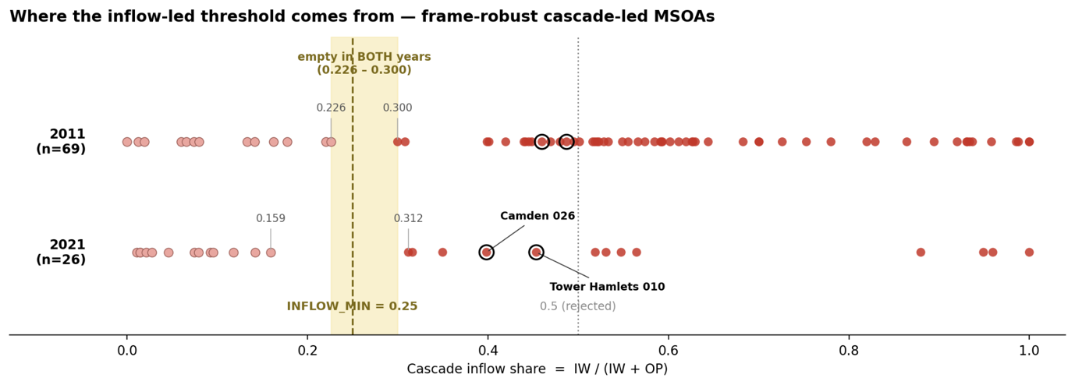
Figure 3.1. Distribution of cascade -inflow-share among Frame C Cascade-led MSOAs, 2011 and 2021, showing the empty interval containing the 0.25 threshold.

The tree therefore distinguishes four measurable profiles within the coarse Frame C “Cascade-led” category, which are “inflow-driven” and “frame-robust”, “frame-sensitive” inflow, “outflow-external-majority”, and “outflow-internal-majority”. These classes are defined without reference to external benchmarks or substantive neighbourhood-change labels. Their correspondence with attribute-defined gentrification and other indicators of neighbourhood restructuring is examined in Section 3.11.

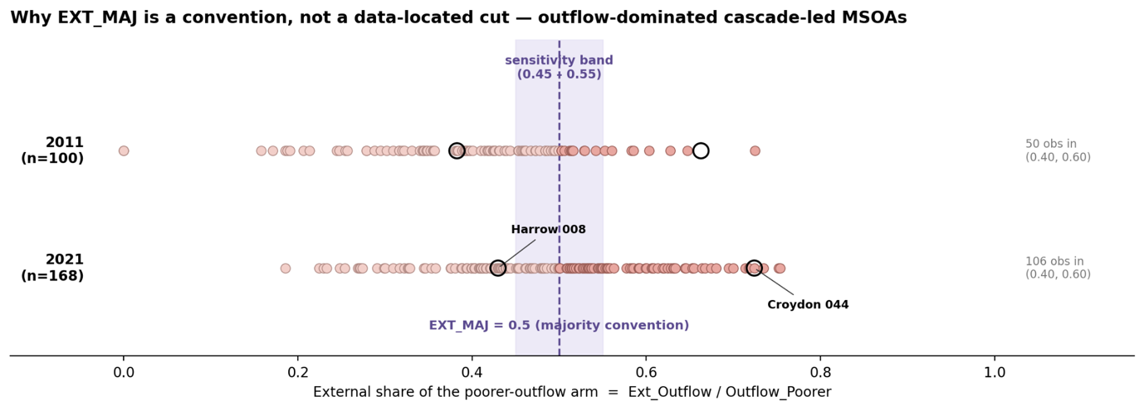
Figure 3.2. Sensitivity of mechanism-leaf membership to the external-arm-share threshold (0.45-0.55).

3.11 Comparative Design

3.11.1 IMD trajectory
IMD percentile change is calculated as the difference in national deprivation percentile between IMD 2010 and 2019. Because the 2019 release does not enter the construction of the flow measures, it provides an independent indicator of neighbourhood trajectory. Associations with continuous flow measures are assessed using Spearman correlations, with baseline deprivation controlled through partial correlations. Differences across flow regimes are assessed using Kruskal-Wallis tests. These comparisons test correspondence with neighbourhood ascent rather than causal or consistently lagged effects, because the temporal relationship differs between 2011 and 2021 migration periods.

3.11.2 Yee and Dennett comparison
Yee and Dennett’s (2022) LSOA labels are aggregated to MSOA level using a modal rule, with an any-labelled-LSOA specification used as a sensitivity test. The 2011 inflow period provides the closest contemporaneous comparison with their 2001-2011 classification, while the 2021 comparison examines whether later migration structures remain associated with the earlier neighbourhood trajectory.

Aggregate correspondence is assessed through cross-tabulation and categorical association statistics. The mechanism profiles are then compared with Yee and Dennett’s (2022) overlapping mainstream, marginal and super-gentrification indicators. For each profile-subtype combination, the within-profile proportion is calculated as the number of MSOAs in that mechanism profile containing at least one LSOA with the relevant label, divided by the total number of MSOAs in that profile. This is compared with the London-wide proportion, calculated as the number of labelled MSOAs divided by the full sample of 982 London MSOAs. The difference between these proportions, expressed in percentages, indicates whether the subtype is over or under-represented within the profile.

3.11.3 Case diagnostics
Selected MSOAs are examined through alluvial flow decompositions to illustrate how different migration compositions can produce the same coarse regime.

3.12 Methodological Scope and Limitations
The framework is subject to four principal limitations. Deprivation is observed for areas rather than individuals, so directional labels are ecological proxies and do not identify movers’ socio-economic characteristics, motivations or experiences of displacement. This is the framework’s fundamental scope condition and is revisited when interpreting results in Chapter 5.

Only moves crossing deprivation deciles are classified directionally. Same-decile relocation and within-MSOA movement may accompany neighbourhood restructuring but remain outside the cascade definition here.

Also, the resulting classification is conditional on the analytical geography deprivation hierarchy and London boundary. The three-frame design makes two of these dependencies explicit, while the synthetic external node necessarily simplifies the heterogeneity of destinations outside London.

Finally, 2021 Census records migration during an exceptional pandemic period, and is affected by disclosure control and changing data conditions. Comparisons therefore prioritise relative spatial structure over absolute cross-year volumes, and two census observations cannot establish whether the observed change represents a temporary shock or a durable transition.

4. Results
This chapter reports the structure of hierarchy-crossing migration, the resulting flow regimes, and their sensitivity to the deprivation ladder and London boundary, before comparing flow classifications with independent neighbourhood-change measures at aggregate and mechanism level.

Three research questions are addressed in the order the analysis requires. The chapter first establishes the structure of hierarchy-crossing migration and the resulting flow regimes. It then examines their sensitivity to deprivation ladders and London boundary, compares the coarse classification with independent indicators of neighbourhood change, and decomposes the “Cascade-led” regime to assess whether correspondence varies by underlying migration mechanism.

4.1 Structure of hierarchy-crossing migration
Migration measures varied systematically across the baseline deprivation hierarchy in both census periods. Directional and compositional measures generally declined from the most deprived to the least deprived deciles, while cascade and counter-cascade churn followed inverted-U profiles, with the largest hierarchy-crossing volumes concentrated in the middle deciles. These profiles were highly stable between 2011 and 2021 despite the decline in recorded London-internal migration from approximately 852,000 to 766,000 person-moves.

“Cascade_Dominance” and “Cross_Decile_Share” represented related but distinct dimensions. Their correlations were approximately 0.53 in 2011 and 0.46 in 2021, indicating that clearer directional predominance tended to occur where more migration crossed the hierarchy, but that direction and intensity were not equivalent.

London-internal migration was counter-cascade dominant in both periods (Figure 4.1). Mean “Cascade_Dominance” declined from approximately 0.48 in 2011 to 0.46 in 2021, while the proportion of MSOAs below 0.5 midpoint increased from 67.6% to 80.9%. The aggregate counter-to-cascade churn ratio increased from 1.06 to 1.13. The decade therefore represented an intensification of an existing counterward pattern rather than a reversal from cascade to counter-cascade dominance.

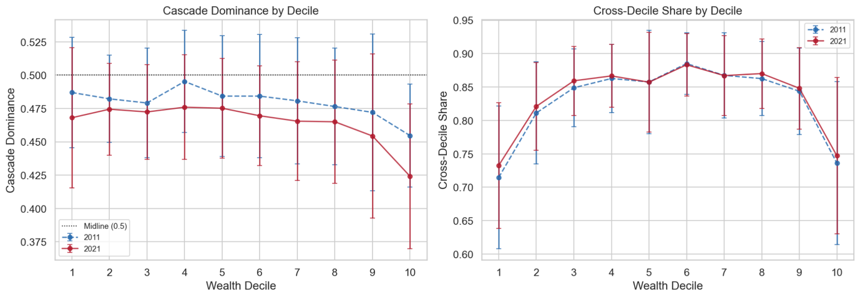
Figure 4.1. “Cascade_Dominance” and “Cross_Decile_Share” across deprivation deciles, 2011 and 2021.

4.2 Flow regimes and temporal change
The joint distribution of “Cascade_Dominance” and “Cross_Decile_Share” was continuous rather than clustered. The typology therefore discretises graded differences in hierarchical migration rather than identifying naturally separated neighbourhood groups.

Under Frame A, “Counter-led” was the largest regime in both periods and increased from 339 MSOAs in 2011 to 416 in 2021. “Cascade-led” areas declined from 129 to 76, while “Symmetric” MSOAs fell from 268 to 244. The “Lateral” category contained 246 MSOAs in each period because its threshold was recalculated at the 25th percentile within each year (Table 4.1).

Regime | 2011 | 2021 | Change
Cascade-led | 129 | 76 | -53
Counter-led | 339 | 416 | +77
Symmetric | 268 | 244 | -24
Lateral | 246 | 246 | 0
Total | 982 | 982 | -
Table 4.1. Flow-regime typology counts under Frame A.
Spatially, “Cascade-led” MSOAs were concentrated mainly in inner southern and western London in 2011. By 2021, this pattern had contracted and fragmented, while “Counter-led” coverage expanded across much of outer northern and eastern London (Figure 4.2).

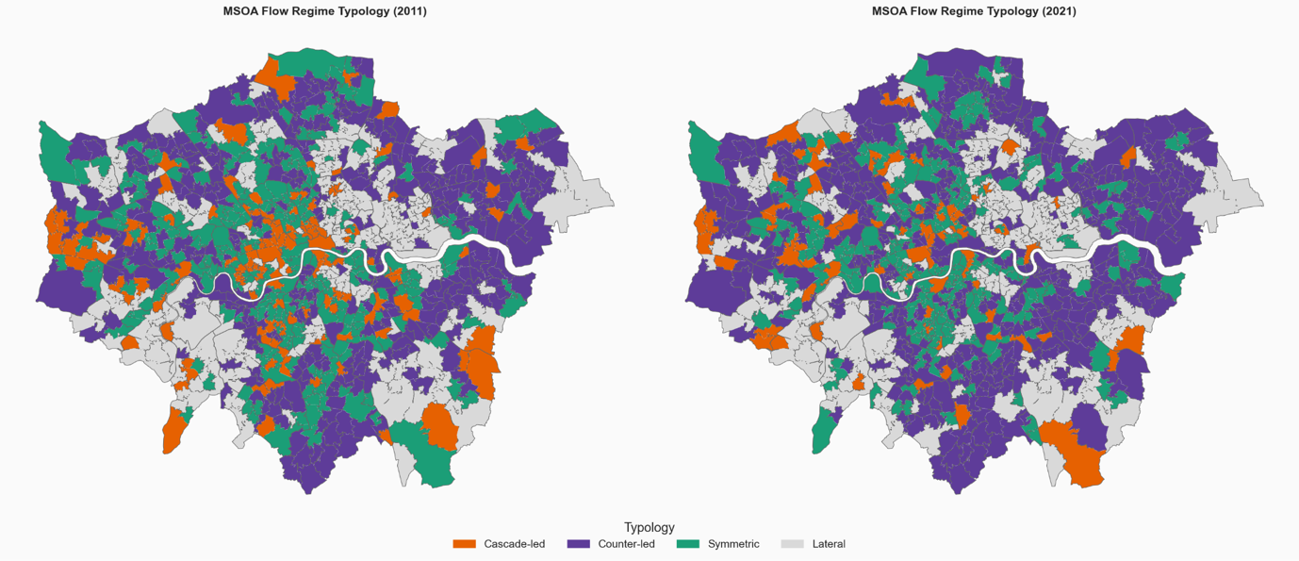
Figure 4.2. Flow-regime typology map under Frame A, 2011 and 2021.
Across the full sample, 596 MSOAs retained the same regime. The most common exits from “Cascade-led” were to “Symmetric”, involving 55 MSOAs, and to “Counter-led”, involving 39. Reverse transitions were less frequent. The coarse classification therefore records a contraction of cascade-direction predominance but does not reveal which components of migration produced “Cascade-led” typology.

4.3 Reference-frame effects
Changing from the London-relative to the England-wide deprivation ladder while retaining London-internal flows produced a modest reclassification effect. Cross-decile migration declined by approximately 16-21%, because some movements crossing London-relative deciles became lateral under the nationally compressed distribution of London neighbourhoods. Changes in “Cascade_Dominance” were small and centred close to zero (Figure 4.3).

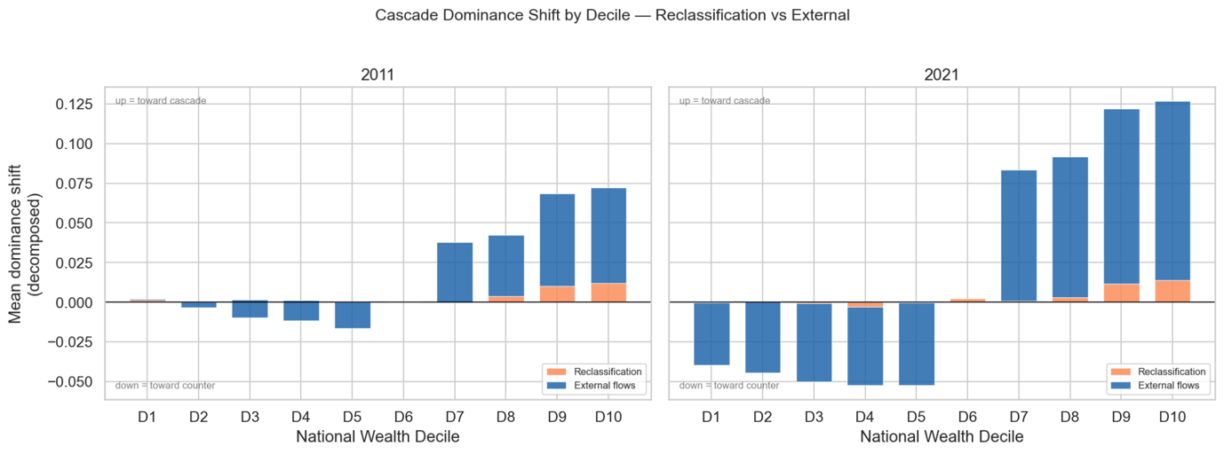
Figure 4.3. “Cascade_Dominance” shifts by decile across Frames A, B and C, 2011 and 2021.
Adding migration across London’s boundary produced much larger effects (Figure 4.3). Between two periods, external inflows declined by 17.8%, while external outflows increased by 51.3%. By 2021, London recorded negative net external migration across every national deprivation decile.

The decomposition of the temporal change attributed 85,737 additional counter-direction person-moves to London-to-external migration, compared with 22,326 generated by changing internal London flows. External inflows declined by a further 9,764 person-moves. The citywide counterward shift was therefore driven principally by outward migration across London’s boundary.

Mean “Cascade_Dominance” under Frame C fell from 0.486 in 2011 to 0.455 in 2021. External flows accounted for approximately 73% of the difference between Frames A and C in 2011 and 111% in 2021, the latter exceeding 100% because ladder reclassification partly offset the boundary effect.

Regime membership changed substantially across frames. Frame C contained 213 “Cascade-led” MSOAs in 2011 and 195 in 2021, compared with 129 and 76 under Frame A. “Counter-led” areas increased from 280 to 452, while “Symmetric” case declined from 243 to 89 (Table 4.2).

Regime | Frame A 2011 | Frame A 2021 | Frame C 2011 | Frame C 2021
Cascade-led | 129 | 76 | 213 | 195
Counter-led | 339 | 416 | 280 | 452
Symmetric | 268 | 244 | 243 | 89
Lateral | 246 | 246 | 246 | 246
Total | 982 | 982 | 982 | 982
Table 4.2. Flow-regime counts under Frames A and C.
The larger Frame C “Cascade-led” category cannot therefore be read as a stronger general cascade pattern. The external frame allows the same label to be generated by different combinations of inflow and outflow.

4.4 Aggregate correspondence with neighbourhood change
Associations between flow measures and IMD percentile change were weak. The largest correlations occurred for cascade and counter-cascade churn, at approximately 0.25-0.28. “Cascade_Dominance” correlated with IMD change at only 0.049 using 2011 flows and 0.093 using 2021 flows. Controlling for baseline deprivation produced little change.

Neighbourhood improvement was therefore associated more strongly with the volume of hierarchy-crossing migration than with whether flows favoured the cascade or counter-cascade direction.

IMD change differed statistically across the coarse regimes, but the effect was small (H = 34.5, p < 0.001 for 2011 classification and H = 28.9, p < 0.001 for 2021), with ϵ² roughly 0.03 in each case and substantial overlap between distributions. “Counter-led” MSOAs recorded the most negative median trajectory, “Cascade-led” MSOAs lay close to zero, and “Lateral” MSOAs recorded the most positive median change. A direct comparison provided no evidence that “Cascade-led” MSOAs improved more than “Counter-led” MSOAs.

Overall agreement with Yee and Dennett (2022) classification was also weak (Figure 4.4). Under 2011 Frame C comparison, only 15 MSOAs were classified as both modal-GEN and “Cascade-led”, compared with 26 GEN-only and 198 Cascade-led-only cases. Together with the low Cramer’s V (χ² = 5.59, p = 0.018, V = 0.075) and adjusted Rand index (0.036), this indicates that the coarse “Cascade-led” category did not reproduce the attribute-defined gentrification classification, although the weak positive association was statistically distinguishable from independence.

The joint IMD comparison produced a similar result. GEN MSOAs without a “Cascade-led” classification recorded mean percentile improvement of roughly +0.043, compared with +0.017 among MSOAs carrying both labels. A cascade classification was therefore neither necessary for nor consistently associated with attribute-defined neighbourhood ascent.

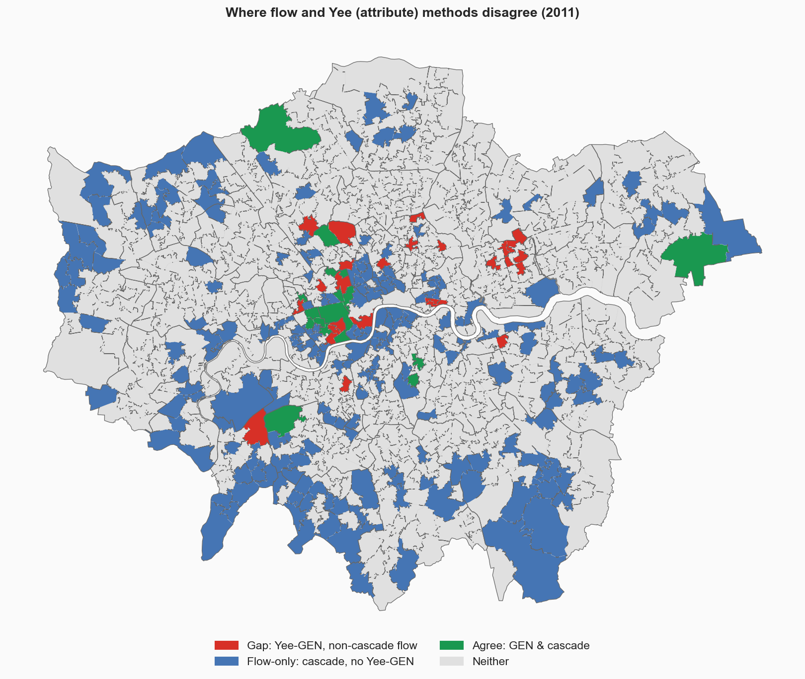
Figure 4.4. Spatial overlap between 2011 Frame C Cascade-led and modal-GEN classifications.
The aggregate evidence therefore provides little support for a universal equivalence between “Cascade-led” migration and attribute-defined gentrification (RQ1). The next stage examines whether this weak pooled relationship reflects heterogeneity within the “Cascade-led” category (RQ2).

4.5 Mechanisms within the “Cascade-led” category
Applying the time-symmetric mechanism tree to Frame C “Cascade-led” MSOAs produced four profiles with sharply different temporal trajectories.

The composition of the category changes much more than its total size (Table 4.3). Inflow-led profiles (“Inflow-driven, frame-robust” and “Frame-sensitive inflow”) accounted for 113 of 213 “Cascade-led” MSOAs in 2011 but only 27 of 195 in 2021. Outflow-led profiles (“Outflow-external-majority” and “Outflow-internal-majority”) increased from 100 to 168 and constituted ~86% of the 2021 category.

Mechanism Leaf | 2011 | 2021 | Change
Inflow-driven, frame-robust | 56 | 13 | -43
Frame-sensitive inflow | 57 | 14 | -43
Outflow-external-majority | 19 | 78 | +59
Outflow-internal-majority | 81 | 90 | +9
Table 4.3. Mechanism composition of Frame C “Cascade-led” MSOAs.

“Inflow-driven, frame-robust” cases were concentrated mainly in inner London in 2011 and became much rarer in 2021. “Outflow-external-majority” cases expanded across outer London, particularly in north-western, south-western and southern boroughs. “Outflow-internal-majority” cases occurred across both inner and outer areas.

Case decompositions confirmed that these leaves represented distinct flow compositions (Figure 4.5). Camden 026 and Tower Hamlets 010 combined substantial wealthier inflows with poorer-directed outflows and remained “Cascade-led” under Frame A. By contrast, Harrow 008 and Harrow 029 had very low “cascade-inflow-share”, with their Frame C cascade arms generated predominately by external poorer-directed departures.

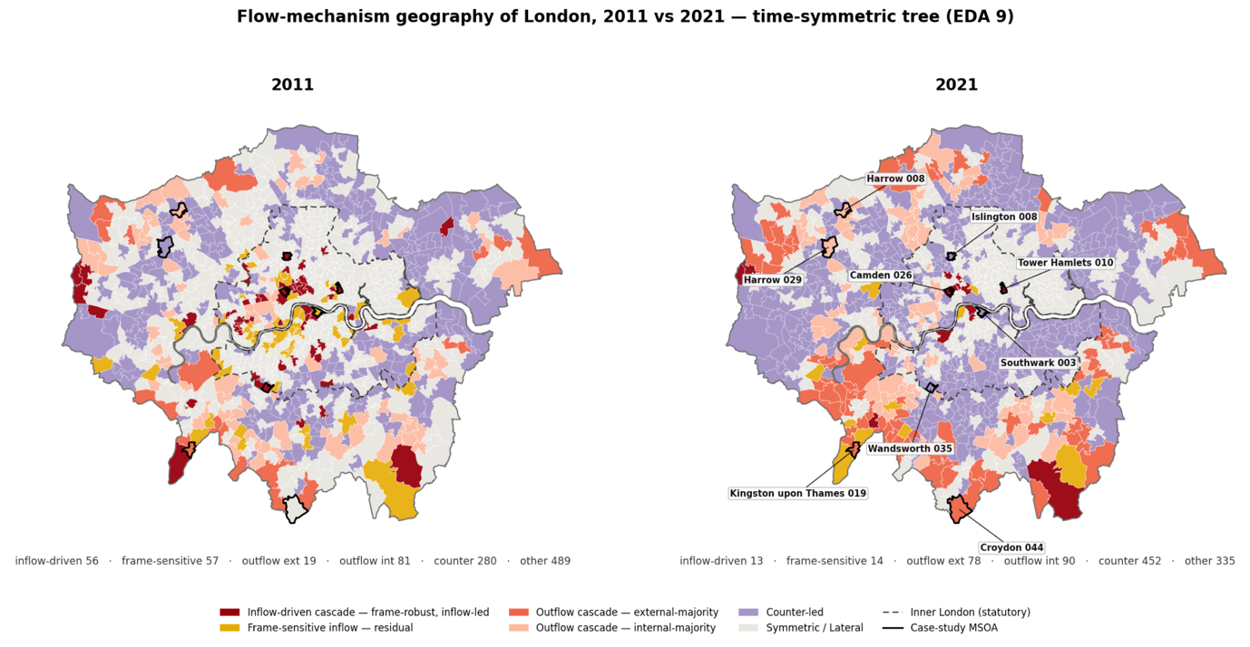
Figure 4.5. Spatial distributions of Frame C cascade mechanism profiles, 2011 and 2021.

4.6 Mechanism-level correspondence
The weak aggregate relationship became more differentiated when the “Cascade-led” category was decomposed. No mechanism profile corresponded with attribute-defined gentrification as a whole. Instead, particular flow structures were associated with particular gentrification subtypes, while 2021 “outflow-external-majority” profiles showed comparatively little correspondence with gentrification under either the overall or subtype definition (Table 4.4). Throughout this section, subtype indicators are the overlapping any-LSOA measures defined in Section 3.11.2, where an MSOA carries a subtype label when it contains at least one LSOA with that label.

Super-gentrification was most clearly concentrated within the “outflow-internal-majority” group. In the contemporaneous 2011 comparison, 18 of 81 cases contained at least one super-gentrification LSOA (22.2%), compared with 9.6% of all London MSOAs. In the 2021 comparison, 29 of 90 “outflow-internal-majority” MSOAs contained at least one super-gentrification LSOA (32.2%). The differences from the London-wide prevalence were therefore +12.6% and +22.6% respectively. Although the 2021 comparison concerns persistence against an earlier attribute classification rather than contemporaneous change, the concentration of super-gentrification within this profile was present in both censuses.

Mainstream gentrification showed a different and more temporally specific pattern. In 2011, 5 of 56 “inflow-driven, frame-robust” MSOAs contained at least one mainstream-gentrification LSOA (8.9%), compared with 4% of all London MSOAs. This concentration was not reproduced in the 2021 comparison. The inflow-driven profile therefore corresponded selectively with mainstream gentrification in the contemporaneous period, rather than providing a general or persistent representation of attribute-defined gentrification.

The “outflow-external-majority” profile showed the opposite pattern in 2021. Only 7 of its 78 MSOAs (9.0%) contained any gentrifying labelled LSOA, compared with 21.1% of London MSOAs overall. Marginal gentrification was similarly uncommon, occurring in 2 of 78 cases (2.6%), compared with a London-wide prevalence of 10.3%. These differences of -12.1% and -7.7% indicate that the rapidly expanding “outflow-external-majority” group had comparatively little correspondence with the earlier gentrification geography.

Comparison | Mechanism profile | Subtype/Label | Cases | Within-profile proportion | London-wide proportion | Differences from London-wide prevalence
2011 | Outflow-internal-majority | Super-gentrification | 18/81 | 22.2% | 9.6% | +12.6%
2021 | Outflow-internal-majority | Super-gentrification | 29/90 | 32.2% | 9.6% | +22.6%
2011 | Inflow-driven, frame-robust | Mainstream gentrification | 5/56 | 8.9% | 4.0% | +4.9%
2021 | Outflow-external-majority | Any gentrification | 7/78 | 9.0% | 21.1% | -12.1%
2021 | Outflow-external-majority | Marginal gentrification | 2/78 | 2.6% | 10.3% | -7.7%
Table 4.4 Selected mechanism-level comparison with Yee and Dennett’s (2022) gentrification labels. Subtypes are overlapping any-LSOA indicators; an MSOA is counted when it contains at least one LSOA carrying the relevant label. The within-profile proportion uses the number of MSOAs in the specified mechanism profile as its denominator; London-wide proportions use all 982 study MSOAs. Differences are reported in percentages.
The mechanism-level results qualify rather than overturn the weak aggregate comparison. The “inflow-driven, frame-robust” groups corresponded selectively with contemporaneous mainstream gentrification, while the “outflow-internal-majority” profile consistently contained a higher proportion of super-gentrification neighbourhoods. By contrast, the expanding 2021 “outflow-external-majority” case contained substantially less attribute-defined gentrification than London overall. The correspondence between the flow and attribute classifications was therefore conditional on the migration mechanism represented within the coarse “Cascade-led” regime.

4.7 Empirical synthesis
The findings can be summarised against three research questions. For RQ1, the coarse “Cascade-led” classification showed weak correspondence with both IMD percentile change and Yee and Dennett classification. Hierarchy-crossing migration volume was more consistently associated with neighbourhood improvement than the direction in which those flows were organised.

On RQ2, the “Cascade-led” category did not represent a single migration structure. Its overall size changes relatively little under Frame C, but its composition shifted from predominantly inflow-led profiles in 2011 to predominantly outflow-led groups in 2021. Mechanism-level comparisons also showed that correspondence varies across gentrification subtypes rather than concentrating consistently within one flow profile.

For RQ3, changing the deprivation ladder produces modest effects, whereas including migration across London’s boundary substantially altered both citywide directional patterns and neighbourhood classifications. The 2011-2021 counterward shift was associated principally with increased outward migration from London, and much of the 2021 Frame C “Cascade-led” category was generated by outflow-dominated groups.

Chapter 5 interprets these findings in relation to cascade accounts of displacement, relational measures of neighbourhood restructuring and the distinction between flow-based and attribute-based representations of gentrification.

5. Discussion
This study examined whether residential migration across London’s deprivation hierarchy provides a meaningful relational representation of gentrification-related neighbourhood restructuring. The results do not support a universal equivalence between the proposed cascade signature and attribute-defined gentrification. At aggregate level, “Cascade-led” neighbourhoods showed weak correspondence with either subsequent IMD improvement or Yee and Dennett’s (2022) neighbourhood classification.

Once the coarse category was decomposed, however, particular flow profiles displayed selective relationships with particular gentrification subtypes, while the expanding 2021 “outflow-external-majority” profile showed comparatively little correspondence with gentrification. The central finding is therefore one of conditional rather than general correspondence, where migration flows reveal restructures through which the urban hierarchy is reshuffled, but their substantive meaning depends on the combination of inflow, internal outflow and boundary-crossing migration that produces them.

The discussion first interprets the aggregate test of the cascade proposition, then considers the role of the spatial reference frame and finally examines the mechanisms concealed within the coarse “Cascade-led” category. It concludes by assessing the contribution, limitations and implications of the framework.

5.1 Aggregate correspondence and limits of a universal cascade
The study began from an open proposition. If gentrification-related displacement commonly takes the form of a migration cascade, neighbourhoods receiving arrivals from less deprived areas while losing residents towards more deprived areas should correspond with independently observed neighbourhood ascent and attribute-defined gentrification. However, the aggregate association reported in Chapter 4 offered little support for this expectation. “Cascade-led” neighbourhoods were neither necessary nor sufficient for attribute-defined ascent, and directional dominance added little explanatory power for neighbourhood trajectory.

This weak correspondence should not be interpreted simply as the failure of one measure against another. The two approaches observe different, although potentially related, dimensions of neighbourhood transformation. Attribute-based classifications identify accumulated changes in neighbourhood composition and conditions. The flow framework instead records migration relations between areas occupying different positions in the deprivation hierarchy. One describes what changed within neighbourhoods, and the other describes how neighbourhoods were connected to population redistribution across the wider urban system. Outcomes and migration structures may therefore overlap without being equivalent.

The joint comparison reinforces this distinction. Attribute-defined neighbourhood ascent could occur without the specific combination of wealthier-area inflows and poorer directed outflows represented by the cascade measure. Possible explanations include in-situ socio-economic change, within-decile mobility, or residential replacement without a clearly downward relocation chain, and processes occurring below the spatial resolution of the analysis. Existing distinctions between displacement, exclusion, replacement and broader compositional change likewise suggest that neighbourhood ascent need not produce one observable migration sequence.

The ecological construction of the measure provides a further explanation for divergence. Area deprivation is only an imperfect proxy for individual socio-economic position. A move from a less deprived origin cannot be assumed to represent the arrival of an affluent household, nor can departure towards a more deprived destination be assumed to represent the displacement of a disadvantaged resident. These remain plausible explanations rather than mechanisms demonstrated directly by the data.

The IMD comparison further suggests that restructuring intensity matters more consistently than directional dominance. Neighbourhood improvement was more closely associated with the overall volume of hierarchy-crossing migration than with whether cascade or counter-cascade flows predominated. Socio-economic change may therefore accompany heightened mobility across the urban hierarchy without following a single directional sequence. High churn may reflect replacement, filtering, tenure change or life-course mobility, helping explain why the coarse directional typology showed limited correspondence with neighbourhood ascent.

The typology should consequently be interpreted as a descriptive partition of a continuous flow space rather than as a set of naturally separated social types. Because the same “Cascade-led” label may be generated by substantial wealthier-area inflow, poorer-directed outflow or both, aggregate classification alone cannot establish its substantive meaning.

5.2 Reference frames and migration beyond London
The reference-frame analysis demonstrates that flow classifications are relational, not intrinsic properties of neighbourhoods. They depend on both the hierarchy used to rank areas and the spatial system within which movement is observed. Changing from the London-relative to the national deprivation ladder produced comparatively modest effects, suggesting that the central pattern was not simply an artefact of neighbourhood re-ranking. The more consequential choice is whether London was treated as a closed system or embedded within a wider migration field.

Treating London as closed foregrounds redistribution among its neighbourhoods. Including boundary-crossing flows instead places those movements within the wider national hierarchy. Poorer-directed outflow may therefore refer to relocation towards more deprived areas within London under the internal frame, but to departure from the city once external migration is included. The same directional regime may consequently represent different processes depending on which flows enter the calculation.

The boundary is therefore not simply a technical decision about data inclusion. It defines the migration system within which relational movement is interpreted. Including London’s external exchanges revealed a much stronger role for outward movement, particularly in 2021. The observed temporal shift was therefore driven principally by boundary-crossing departure rather than by changing movement among London neighbourhoods alone.

The three-frame design makes these dependencies explicit. The comparison between Frames A and B separates the effect of changing the deprivation ladder, while the comparison between Frames B and C isolates the effect of adding migration across London’s boundary. This shows that substantive interpretation must follow, rather than precede, the specification of the spatial system.

The 2021 pattern may reflect temporary pandemic disruption or a more durable outward-oriented shift associated with remote working, housing affordability and household decentralisation. Two census observations cannot distinguish these interpretations, but the results show that boundary-crossing migration is essential to understanding London’s changing flow structure.

5.3 Mechanism-level correspondence
Decomposing Frame C “Cascade-led” MSOA reveals that their relationship with gentrification depends on the flow component generating the classification. The three substantively important profiles represent different forms of neighbourhood restructuring rather than variants of a single universal cascade process.

The “inflow-driven, frame-robust” profile showed selective correspondence with mainstream gentrification in the contemporaneous 2011 comparison. This is consistent with the proposition that an active period of mainstream neighbourhood transition may be accompanied by observable arrivals from less deprived areas alongside poorer-directed outflow. The association was based on few cases and did not persist in the later comparison, so it should not be treated as a general signature of gentrification. It instead identifies one flow structure that corresponded with mainstream gentrification when the migration and attribute periods were most closely aligned.

Super-gentrification showed a different relationship. It was concentrated most clearly within the “outflow-internal-majority” profile in both periods. This suggests that, in already advantaged neighbourhoods, internal outflow composition may be more informative than the constrained wealthier-inflow arm. At the upper end of the hierarchy, few or no less deprived neighbourhoods remain available as origins, reducing the capacity of these areas to register as inflow-led. The alignment is therefore partly substantive and partly conditioned by hierarchy position. It supports the presence of a distinctive outflow signature but cannot establish who moved, why they left or whether departures were caused by super-gentrification.

The 2021 “outflow-external-majority” profile showed the opposite pattern. It was comparatively depleted of attribute-defined gentrification and expanded rapidly across outer London. Without mechanism decomposition, it would remain hidden inside the broad Frame C “Cascade-led” category despite representing a substantively different migration process. This profile can reasonably be interpreted as part of the 2021 London exodus, although “exodus” is an interpretation of the measured structure rather than a rule defining the class. The mechanism tree itself is time-symmetric and applies the same criteria in both periods. The exodus interpretation is strongest in 2021 because of the wider expansion of outward migration and the profile’s spatial growth.

The mechanism findings therefore qualify rather than overturn the aggregate result. No individual profile reproduces attribute-defined gentrification as a whole. Instead, inflow-driven movement corresponded selectively with contemporaneous mainstream gentrification, outflow-internal dominance with super-gentrification, and outflow-external dominance with a process largely separate from the earlier gentrification geography. Aggregate correspondence was weak partly because these distinct structures were pooled under the same “Cascade-led” label.

5.4 Contribution of the flow framework
The results position the framework as a complement to, rather than a substitute for, attribute-based measures. The analysis does not show that migration flows provide a superior method of identifying gentrification, nor does weak aggregate correspondence mean that the relational approach failed. The two approaches answer different questions. Attribute classifications identify accumulated neighbourhood transformation, and the flow framework identifies how neighbourhoods are connected to migration across the deprivation hierarchy during a specific period.

This distinction refines the cascade proposition. The expected combination of advantaged inflow and poorer-directed outflow was observable in some neighbourhoods, but it was not a universal expression of gentrification. Different variants corresponded with different arms of the migration structure, while many “Cascade-led” classifications represented processes unrelated to gentrification. The appropriate analytical object is therefore the mechanism producing directional dominance rather than the broad regime alone.

The framework also extends attention beyond neighbourhoods conventionally classified as gentrifying. Migration is relational, where departures from one area necessarily connect it to another destination. The present analysis cannot identify harm or involuntary displacement at those destinations, but it suggests that research should examine both transforming neighbourhoods and the areas receiving poorer-directed departures. Following those connections may reveal consequences obscured when analysis remains confined to the neighbourhood experiencing compositional ascent.

5.5 Limitations and future research
The most fundamental limitation is ecological inference, established in Section 3.12. The framework establishes movement between differently positioned neighbourhoods but cannot determine whether an advantaged household arrived, a disadvantaged resident was displaced or any move was involuntary. What remains for future research is the data that would resolve it. Linked longitudinal microdata would allow mover characteristics to be compared directly with origin and destination conditions, while survey or qualitative evidence would be needed to distinguish voluntary relocation from displacement.

The framework captures only migration crossing deprivation-decile boundaries. Same -decile and within-MSOA moves may accompany housing pressure and neighbourhood change but fall outside the cascade definition. This preserves the distinction between vertical and lateral mobility, while preventing the framework from estimating the full volume of displacement-related relocation. Future work would examine lateral movement as a separate mechanism.

The results are also conditional on spatial scale, hierarchy construction and boundary definition. MSOAs may conceal smaller neighbourhood processes, while deciles simplify continuous deprivation differences and constrain the possible flow structure at the top and bottom of the hierarchy. Multi-scalar analysis or continuous origin-destination differences could test whether patterns persist under alternative specifications.

The synthetic external node simplifies substantial variation among non-London destinations. Departures to commuter areas, regional cities and distant rural locations may represent different processes. Future analysis could retain major external destinations separately or classify them by deprivation, distance and housing-market relationship.

Uneven temporal comparisons further limit the analysis. Yee and Dennett’s (2022) classification covers 2001-2011, making the 2011 flow period the closest contemporaneous comparison. The 2021 analysis instead tests persistence against an earlier gentrification geography and should not be interpreted as validation against contemporaneous attribute change. A more recent neighbourhood classification would provide a stronger comparison.

The 2021 Census also records an exceptional pandemic period and was produced under different disclosure-control conditions. Relative spatial structure is therefore more reliable than absolute cross-year magnitude. Post-2021 migration data would be needed to determine whether the “outflow-external-majority” group contracted or persisted.

Finally, the analysis is descriptive rather than causal and does not fully account for spatial dependence. Spatial regression, network models or spatially constrained tests could strengthen inference, while replication in other cities would show whether the identified mechanisms are London-specific or more general.

5.6 Discussion synthesis
Migration across the deprivation hierarchy does not reproduce attribute-defined gentrification through one universal cascade signature. Aggregate correspondence is weak, and neighbourhood ascent relates more consistently to hierarchy-crossing intensity than to directional dominance. Yet the mechanism decomposition reveals selective and theoretically meaningful relationships between particular flow structures and particular gentrification subtypes, while distinguishing these from the expanding 2021 “outflow-external-majority” process. These relationships are also conditioned more by whether boundary-crossing migration is included than by the choice of deprivation ladder. Taken together, these findings answer three research questions by showing that correspondence is weak in aggregate, selective at mechanism level and dependent on the spatial frame of observation. The flow framework therefore contributes not as a direct gentrification proxy, but as relational evidence about the migration mechanisms through which neighbourhood restructuring is expressed.

