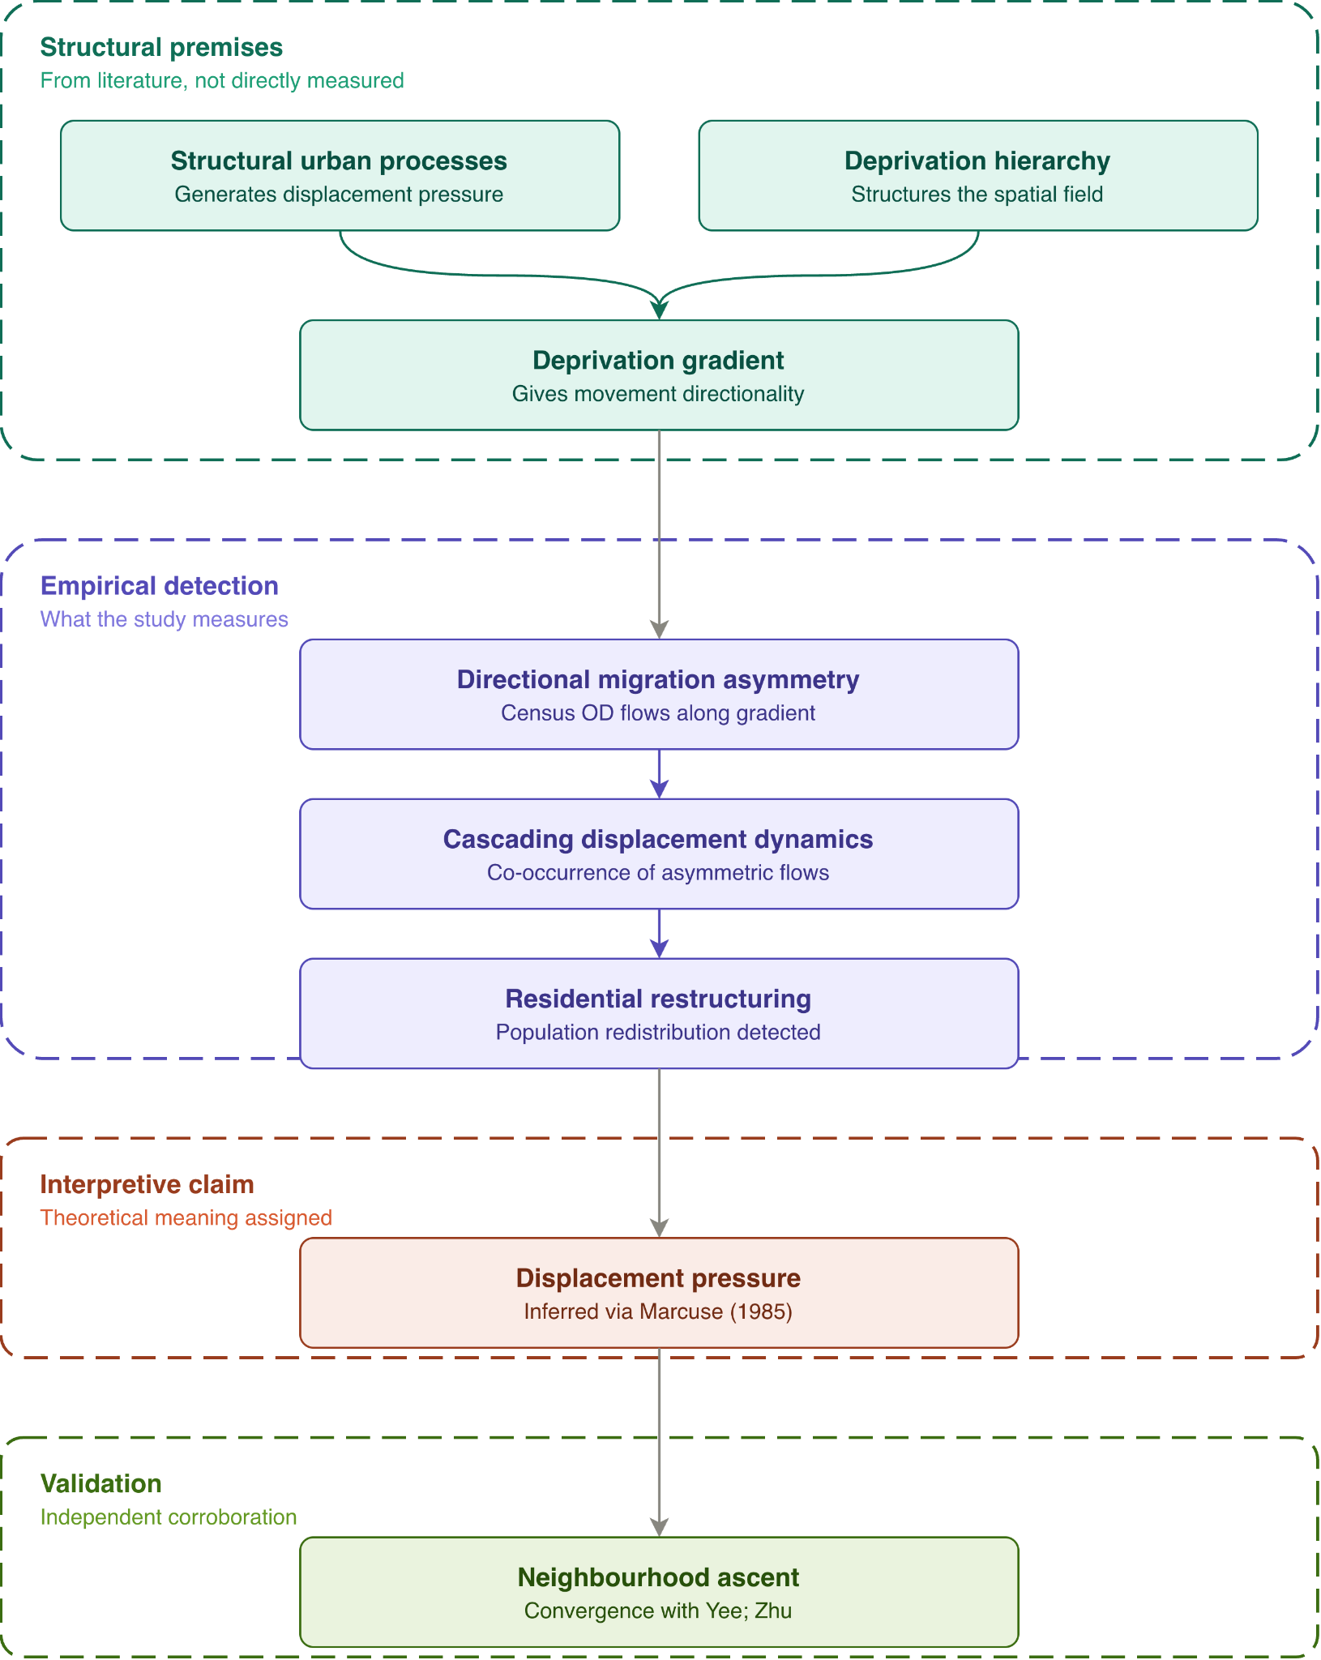

Gentrification operates fundamentally as a process of residential restructuring in which neighbourhood socio-economic compositions are transformed through the interaction of housing market dynamics, capital investment, and population movement. Inherently linked to this restructuring is the phenomenon of displacement, which extends beyond observable instances of forced removal. As Marcuse (1985) argues, displacement encompasses a broader spectrum of structural pressures, including direct last-resident displacement, direct chain displacement, exclusionary displacement, and the anticipatory pressure experienced by residents as neighbourhood conditions transform.
Despite this theoretical complexity, existing quantitative studies of neighbourhood change in London, including Yee and Dennett (2022) and subsequent extension by Hong and Dennett (2023), primarily conceptualise restructuring through changes in neighbourhood attributes such as housing prices, occupational composition, demographic transition, and residential turnover. These approaches primarily capture the outcomes of neighbourhood restructuring once socio-economic upgrading becomes observable in the characteristics of places and populations. Because attribute-level upgrading may lag behind underlying migration restructuring processes, areas experiencing asymmetric inflows from less deprived neighbourhoods alongside disproportionate outflows toward more deprived areas may not yet exhibit sufficiently visible socio-economic transformation to register within conventional gentrification classifications.
To address this methodological gap, this study develops a flow-centred framework across London’s socio-economic hierarchy designed to identify restructuring pressures prior to their full materialisation in neighbourhood composition. Specifically, the framework conceptualises displacement pressure as a relational mobility structure observable through asymmetric migration flows between neighbourhoods positioned differently within the urban deprivation hierarchy. As illustrated in the diagram, this framework translates structural urban processes (e.g. gentrification) into empirically observable migration patterns that can subsequently be evaluated against independent measures of neighbourhood socio-economic change.
1. Structural Premises
The framework begins with a set of macro-level structural conditions derived from theories of urban restructuring and displacement. Although these processes are not directly measured by the study, they establish the broader urban context within which neighbourhood transformation occurs. Structural processes, such as gentrification, uneven urban development reinvestment, and disinvestment, generate differentiated housing pressure across the urban system and contribute to the restructuring of residential space.

These pressures operate within an existing socio-economic hierarchy structured though uneven distributions of deprivation and advantage. In this study, this hierarchy is operationalised using the Index of Multiple Deprivation (IMD), which provides a relational ordering of neighbourhoods across London’s urban structure.

The deprivation hierarchy conditions the spatial pathways through which displacement-related mobility may occur. Population movements are therefore not treated as spatially random, but as structured by directional relationship across the urban socio-economic gradient. Within this framework, the deprivation hierarchy functions not merely as a descriptive classification system, but as the broader structural field through which cascading residential restructuring unfolds.
2. Empirical Detection
The empirical component of the framework focuses on the observation of directional migration structures across the deprivation hierarchy. Using Census origin-destination migration data, this study analyses flows between neighbourhoods relative to a fixed deprivation baseline in order to identify directional migration asymmetries across London’s socio-economic structure.

Within this framework, inflows from less deprived neighbourhoods and outflows toward more deprived neighbourhoods represent distinct directional movements across urban hierarchy. The simultaneous co-occurrence of these asymmetric flows constitutes the empirical signature of cascading mobility structures associated with residential restructuring.

Rather than observing displacement directly, the framework identifies aggregate migration patterns consistent with cascading displacement dynamics operating at neighbourhood scale. Residential restructuring is therefore conceptualised as an empirically observable redistribution of population across the depreciation hierarchy, manifested through the concentration, circulation, or dispersal of socio-economic advantage and disadvantage between neighbourhoods.

By tracing the progression from directional migratory asymmetry to broader cascading mobility structures, the framework places relational population movement at the empirical centre of neighbourhood restructuring analysis.
3. Interpretive Claim
The transition from empirical observation to theoretical interpretation constitutes the interpretive component of the framework. The migration asymmetries and cascading mobility structures identified by the study are treated as empirical signatures of residential restructuring rather than direct observations of involuntary displacement itself. This distinction is epistemically important because the study measures aggregate migration flows and interprets their structure through the lens of displacement theory rather than claiming to observe individual forced moves directly.

Drawing on Marcuse’s (1985) typology of displacement, the framework conceptualises displacement not as a singular event but as a broader relational process embedded within urban restructuring. While Marcuse (1985) identifies multiple forms of displacement, including direct last-resident displacement and exclusionary displacement, the present framework is primarily concerned with displacement pressure and chain displacement operating at neighbourhood scale.

Displacement pressure extends beyond households that have already moved by altering affordability, accessibility, and social conditions of neighbourhood life. Because these pressures operate structurally and cumulatively, they are more likely to generate observable migration asymmetries and cascading mobility structures within aggregate origin-destination data. The study therefore interprets persistent directional asymmetries across the depreciation hierarchy as indicators consistent with broader processes of displacement pressure and cascading residential restructuring.
4. Validation
The final component of the framework introduced an independent validation layer linking migration restructuring to subsequent neighbourhood socio-economic change. If the cascading mobility structures identified in the empirical stage genuinely reflect broader processes of residential restructuring, then neighbourhoods exhibiting strong cascade signatures would be expected to independently demonstrate socio-economic ascent over the same period.

Following the approaches of Yee and Dennett (2022) and Zhu and Dennett (2023), who identify ascending and gentrifying neighbourhoods through composite socio-economic indicators, this study validates its flow-based framework against changes in the Index of Multiple Deprivation between 2010 and 2019.

Importantly, neighbourhood socio-economic ascent functions as a separate corroboration mechanism rather than part of the metric construction process itself. This separation reduces conceptual circularity by ensuring that the migration indicators are derived entirely from directional mobility structures rather than from the neighbourhood outcome.

The methodology developed in the following chapter operationalises this conceptual framework by translating directional migration asymmetries across the deprivation hierarchy into a series of measurable cascade indicators defined to capture distinct dimensions of residential restructuring.

