3.1 Research Design
This study develops a flow-centred framework for identifying residential restructuring and displacement pressure in London through directional migration asymmetries across the urban deprivation hierarchy between 2011 and 2021. Rather than operationalising gentrification directly through neighbourhood upgrading indicators, the study conceptualises displacement pressure as a relational mobility structure observable through the simultaneous co-occurrence of upward-directed inflows and downward-directed outflows between neighbourhoods positioned differently within London’s socio-economic hierarchy.
The analytical framework proceeds in four interconnected stages. The process begins by classifying all London MSOAs into a fixed deprivation hierarchy using IMD 2010 scores. With this baseline established, Census origin–destination migration flows are subsequently mapped according to their movement across the hierarchy. This categorization facilitates the construction of a suite of Cascading Flow Index (CFI) metrics to quantify the direction, intensity, and co-occurrence of hierarchical mobility flows. These inferred restructuring dynamics are subsequently evaluated against independent measures of neighbourhood socio-economic change between 2010 and 2019.
A central methodological principle of the study is the separation between the measurement of migration restructuring and the measurement of neighbourhood outcomes. The CFI framework is derived entirely from origin–destination migration asymmetries, while subsequent neighbourhood ascent functions as an external validation layer rather than as part of the metric construction process itself. This separation reduces conceptual circularity and enables the study to evaluate whether neighbourhoods exhibiting strong cascade signatures also display trajectories consistent with broader socio-economic restructuring.
Importantly, the study does not claim that all downward movement constitutes forced displacement across the deprivation hierarchy. Census migration data capture residential mobility patterns rather than the motivations underlying individual household moves. The framework therefore interprets persistent directional asymmetries and cascading mobility structures as indicators of structural displacement pressure operating at the neighbourhood scale rather than direct observations of involuntary displacement events.
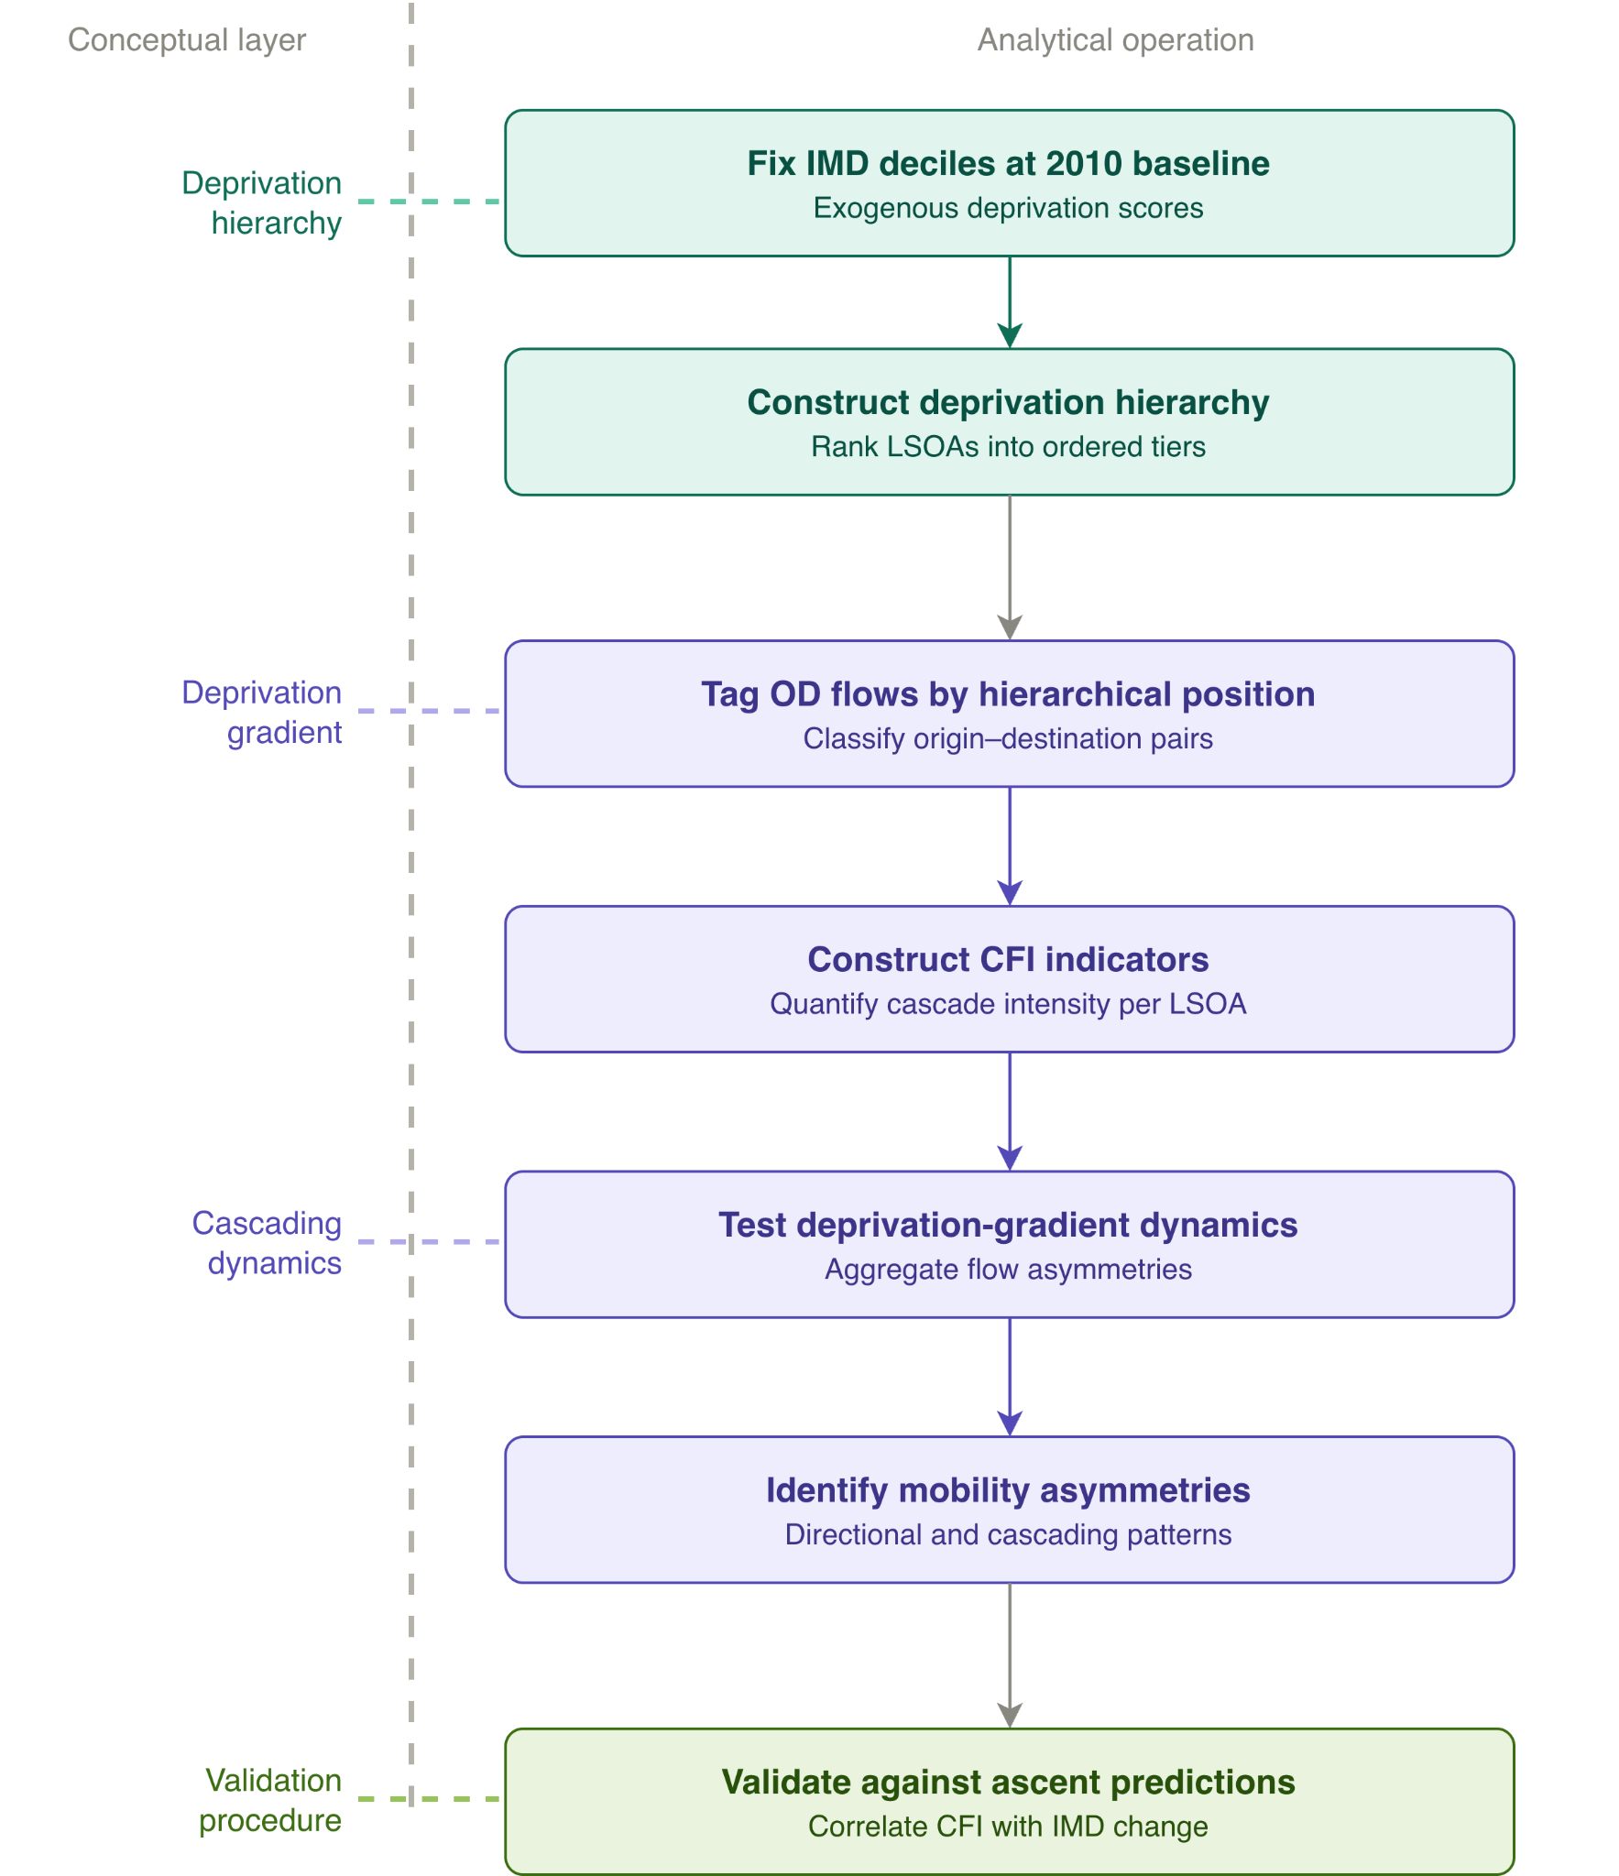

3.2 Study Area and Temporal Scope
The study area comprises Greater London, defined as the 33 local authority districts consisting of the 32 London boroughs and the City of London. The unit of analysis is the Middle Layer Super Output Area (MSOA), a census geography designed to contain approximately 7,200 residents and 2,800 households (ONS, 2011). MSOAs provide an appropriate neighbourhood-scale unit for analysing residential restructuring because they are sufficiently granular to capture localised migration dynamics while remaining large enough to contain statistically meaningful migration volumes.
All datasets are harmonised to 2011 MSOA boundaries to ensure longitudinal consistency across the study period. The 2021 Census introduced revised MSOA geographies, including a number of boundary splits and mergers. To maintain temporal comparability, only one-to-one correspondences between 2011 and 2021 MSOAs are retained. Following harmonisation and the exclusion of split or merged areas, the final analytical dataset comprises 983 temporally consistent MSOAs across Greater London.

3.3 Data Sources

3.3.1 Census Origin–Destination Migration Data
The primary data source is the Census origin–destination (O-D) migration dataset, which records residential moves made during the year preceding each Census. To capture changes over the decade, two datasets are used to construct the cascade indicators.
The 2021 Census O-D dataset (Table RM097), publicly available through NOMIS, records migration flows between MSOAs across England and Wales for the year ending March 2021.
Its historical counterpart, the 2011 Census O-D dataset (Table MF01EW) records residential migration flows for the year ending March 2011. Because publicly available 2011 migration data are not available at MSOA scale, safeguarded OA-level migration data accessed through the WICID are spatially aggregated to 2011 MSOA boundaries to ensure consistency with the analytical framework used throughout the study.
Each O-D record contains an origin geography, destination geography, and the number of migrants making that move. Within-area moves, where origin and destination are identical, are excluded because they represent local residential churn rather than inter-neighbourhood restructuring dynamics.
The Census migration data do not contain information on movers’ socio-economic status. Instead, socio-economic directionality is inferred from the relative deprivation positions of origin and destination neighbourhoods within the fixed deprivation hierarchy.

3.3.2 Index of Multiple Deprivation
Neighbourhood deprivation is measured using the English Index of Multiple Deprivation (IMD), a composite area-level indicator produced by the Ministry of Housing, Communities and Local Government (MHCLG). The IMD combines multiple dimensions of deprivation, including income, employment, education, health, crime, housing, and living environment conditions. To align as closely as possible with the 2011 and 2021 Census migration data, the 2010 and 2019 IMD releases are utilised. Although this introduces a slight temporal mismatch between the migration and deprivation datasets, these represent the closest temporally aligned deprivation measures available and provide a sufficiently stable representation of neighbourhood socio-economic structure over the study period.
IMD 2010 is used to construct the fixed baseline deprivation hierarchy that underpins the migration flow classification framework. Because the Census origin–destination migration data are analysed at MSOA scale, the IMD data, which was originally published at Lower Layer Super Output Area (LSOA) level, are aggregated to 2011 MSOA boundaries using population-weighted averages. This harmonisation ensures that both the migration and deprivation datasets operate within a consistent spatial framework.
IMD 2019 is used exclusively during the validation stage to evaluate whether areas exhibiting strong cascade dynamics subsequently display relative neighbourhood ascent within the national deprivation hierarchy. To maintain longitudinal consistency, this dataset is aggregated to 2011 MSOA boundaries using the same population-weighted approach applied to the 2010 baseline.

3.4 Spatial Harmonisation and Data Processing

3.4.1 Harmonising Migration Geographies
Longitudinal analysis of migration flows requires temporally consistent spatial boundaries (Blake et al., 2000; Rowe, 2017). All migration datasets are therefore harmonised to the 2011 MSOA geography.
The safeguarded 2011 Census migration data, originally available at Output Area (OA) scale, are aggregated to 2011 MSOAs using official ONS geographic lookup tables. The 2021 Census migration data are then harmonised back to the 2011 geography using the ONS 2011-to-2021 MSOA correspondence tables.
To preserve longitudinal comparability, only areas exhibiting one-to-one correspondence between 2011 and 2021 MSOAs are retained. MSOAs subject to boundary splits or mergers are excluded from the analysis in order to minimise aggregation artefacts and avoid introducing artificial temporal change arising from shifting spatial containers (Norman et al., 2003).

3.4.2 Aggregating Deprivation Measures
Because the IMD is produced at LSOA scale, deprivation measures are aggregated to 2011 MSOA boundaries using population-weighted averaging. Population weights are derived from the mid-2015 LSOA population estimates included within the IMD 2019 release and are applied consistently to both the 2010 and 2019 IMD datasets. This approach is adopted because equivalent population estimates are not provided within the IMD 2010 release. Given the relative stability of LSOA population distributions within MSOAs over short temporal intervals, the use of a common weighting framework is unlikely to materially affect the resulting deprivation hierarchy. The procedure ensures compatibility between the deprivation and migration datasets within a consistent MSOA-level analytical framework.

3.5 Neighbourhood Classification: The Deprivation Hierarchy
To analyse longitudinal changes in migration structures, a temporally consistent neighbourhood classification framework is required. Research in population geography and longitudinal spatial analysis has long demonstrated that changes in zonal boundaries, classification systems, or socio-economic indices across time can compromise the comparability of migration datasets and obscure genuine spatial dynamics (Blake et al., 2000; Rowe and Bell, 2017). Achieving consistency in neighbourhood classification is therefore methodologically necessary to distinguish substantive urban restructuring processes from artefacts of statistical reclassification (Norman et al., 2003).
Following the approach adopted by Patias et al. (2022) in the analysis of neighbourhood socio-economic trajectories, this study employs a fixed deprivation hierarchy based on the 2010 Index of Multiple Deprivation (IMD). Each of London’s 983 MSOAs is assigned to a deprivation decile according to its 2010 IMD score, where Decile 1 represents the most deprived 10% of neighbourhoods and Decile 10 the least deprived 10%. These classifications are then retained throughout the analysis of both 2011 and 2021 migration flows.
The fixed-baseline approach is analytically important because the study seeks to identify changes in migration structures rather than changes in neighbourhood classification itself. Consistent with longitudinal studies that analyse socio-economic trajectories relative to baseline deprivation conditions (Barr et al., 2012), dynamically reclassifying neighbourhoods over time could partially internalise the socio-economic transformations that the migration indicators are intended to capture. By retaining a constant deprivation hierarchy, neighbourhoods experiencing subsequent socio-economic ascent continue to be analysed relative to their original position within London’s urban structure. This enables the framework to examine whether areas initially positioned lower within the deprivation hierarchy subsequently exhibit directional migration dynamics associated with neighbourhood restructuring and displacement pressure.
Within this framework, deprivation deciles are interpreted as positions within a broader urban hierarchy rather than merely descriptive neighbourhood categories. Drawing on Marcuse’s (1985) conceptualisation of spatial restructuring, in which neighbourhood decline and gentrification are understood as interconnected components of a single urban process, migration flows between deciles can therefore be interpreted as movement across London’s socio-economic structure rather than purely geographic relocation. This relational interpretation provides the conceptual basis for analysing directional migration asymmetries as indicators of cascading restructuring dynamics.
To evaluate the sensitivity of the framework to the choice of baseline classification, additional robustness checks were conducted using deprivation deciles derived from the 2019 IMD. The 2010 IMD baseline was nevertheless retained for the main analysis because it provides a temporally prior and fixed socio-economic reference structure against which subsequent migration dynamics can be longitudinally interpreted.
With the fixed deprivation hierarchy established, the next stage classifies migration flows according to their direction of movement across London’s socio-economic structure.

3.6 Flow Classification: The Deprivation Gradient
For each MSOA, all origin–destination migration flows are classified according to movement across the deprivation hierarchy.
Inflows from less deprived areas (`Inflow_Wealthier_YEAR`) refer to migrants arriving from neighbourhoods positioned in less deprived deciles than the destination MSOA. These flows represent upward-directed mobility entering relatively more deprived neighbourhoods.
Outflows toward more deprived areas (`Outflow_Poorer_YEAR`) refer to migrants leaving an MSOA for destinations positioned in more deprived deciles. These flows represent downward-directed movement within the deprivation hierarchy.
Lateral flows consist of moves occurring between neighbourhoods occupying the same deprivation decile (`Decile_Shift` = 0). Because these flows do not involve movement across the socio-economic hierarchy, they are excluded from the cascade metrics, although they remain part of total migration volumes used for normalisation procedures.
The resulting classification framework operationalises residential restructuring as directional movement across the urban deprivation gradient. Rather than analysing migration purely in geographic terms, the study examines whether neighbourhoods exhibit asymmetric patterns of upward and downward hierarchical mobility.
Building upon this directional classification framework, the study next constructs a set of complementary indicators designed to capture distinct dimensions of cascading residential restructuring.

3.7 Cascading Flow Index (CFI): Metric Construction
Four complementary indicators are constructed to capture distinct dimensions of hierarchical residential restructuring associated with cascading migration dynamics. Together, the metrics distinguish directional balance, restructuring intensity, the co-occurrence of upward and downward flows, and the compositional structure of inflows.
All metrics are computed separately for each census period using migration flows observed within that period only, while retaining the fixed deprivation hierarchy defined in Section 3.5. Accordingly, metric values for 2011 and 2021 represent independent cross-sectional measurements of migration restructuring under a consistent socio-economic classification framework. Temporal change indicators are subsequently derived by comparing these period-specific values across census years.

Metric | Formula | Dimension | Interpretation
Net_Cascade_YEAR | Inflow_Wealthier_YEAR - Outflow_Poorer_YEAR | Directional balance | Positive values indicate stronger upward-directed inflows relative to downward-directed outflows
CFI_Churn_YEAR | Inflow_Wealthier_YEAR + Outflow_Poorer_YEAR | Cascade intensity | Total volume of cascade-relevant flows regardless of direction
CFI_Rate_YEAR | (Inflow_Wealthier_YEAR * Outflow_Poorer_YEAR) / Total Migration_YEAR | Cascade co-occurrence | High only when both flows are simultaneously elevated relative to overall churn
Pct_Inflow_Wealthier_YEAR | (Inflow_Wealthier_YEAR / Total_Inflow_YEAR) × 100 | Compositional structure | Share of all inflows originating from less deprived neighbourhoods
Table 1. Definitions of the four Cascading Flow Index metrics computed for each MSOA and census period.

Net Cascade
Net Cascade (`Net_Cascade`) measures the directional balance between upward-directed inflows from less deprived neighbourhoods and downward-directed outflows toward more deprived neighbourhoods. Positive values indicate stronger upward-directed socio-economic inflows relative to downward-directed outflows, while negative values indicate stronger outward movement toward more deprived areas.
However, the metric is partially constrained by neighbourhood position within the deprivation hierarchy. MSOAs located within the most deprived decile cannot export flows to lower-ranked neighbourhoods, mechanically biasing values toward positive scores irrespective of broader restructuring dynamics. An inverse constraint applies at the top of the hierarchy, where the least deprived MSOAs cannot receive inflows from higher-ranked deciles, biasing their scores negatively. Because these extremes skew the data irrespective of broader restructuring dynamics, the metric must be interpreted comparatively rather than as a direct measure of displacement intensity.

CFI Churn
CFI Churn (`CFI_Churn`) measures the overall intensity of cascade-relevant migration flows regardless of direction by summing both flow components. The indicator captures the total volume of hierarchical restructuring operating through a neighbourhood, including simultaneous processes of wealthier in-migration and poorer out-migration.
The additive formulation draws conceptually on the notion of population churn developed by Dennett and Stillwell (2008) in their studies of district-level population stability, adapted here specifically to flows crossing the deprivation hierarchy.

CFI Rate
To measure the co-occurrence of upward-directed inflows and downward-directed outflows, the CFI Rate (`CFI_Rate`) uses a multiplicative interaction term normalized by overall migration churn. The multiplicative specification ensures that the indicator increases only when both upward-directed inflows and downward-directed outflows are simultaneously elevated. If either component approaches zero, the interaction term collapses.
Division by total migration volume controls for differences in neighbourhood mobility intensity and improves comparability across MSOAs of different sizes and churn levels.
This interaction-based formulation is conceptually analogous to spatial interaction models, where the product of origin and destination masses is used to represent the intensity of bilateral interaction (Wilson, 1971).

Percentage Inflow from Less Deprived Areas
Percentage Inflow from Less Deprived Areas (`Pct_Inflow_Wealthier_YEAR`) measures the proportion of all incoming migrants arriving from less deprived neighbourhoods.
Unlike the previous indicators, this metric captures only the compositional structure of inflows and does not incorporate outward movement dynamics. It therefore reflects the socio-economic profile of incoming residents rather than broader cascade restructuring processes.
While the CFI metrics quantify continuous variation in restructuring intensity, an additional typological framework is developed to translate these migration structures into interpretable neighbourhood restructuring regimes.

3.8 Cascading Restructuring Typology
While the CFI metrics quantify continuous variation in restructuring intensity, the cascading restructuring typology translates these flow structures into interpretable neighbourhood restructuring regimes.
The typology is derived from the interaction of two complementary dimensions within the cascade framework. CFI Churn captures the intensity of hierarchical mobility churn within an MSOA, while Net Cascade measures the directional asymmetry of those flows across the deprivation hierarchy.
Classification proceeds in two stages. First, MSOAs are divided according to whether their CFI Churn values fall above or below the period-specific median. Areas exhibiting below-median churn are classified as stable neighbourhoods, reflecting relatively limited hierarchical restructuring.
Neighbourhoods exhibiting above-median churn are subsequently classified according to the distribution of Net Cascade values. Areas falling within the upper quartile of Net Cascade are classified as ascent-dominated restructuring, indicating stronger upward-directed inflows relative to downward outflows. Areas within the lower quartile are classified as displacement-dominated restructuring, reflecting intensified outward movement toward more deprived neighbourhoods. Neighbourhoods falling within the interquartile range are classified as cascading circulation, indicating substantial hierarchical mobility churn without a strongly directional imbalance.
The resulting typology therefore identifies four restructuring regimes:
- Stable neighbourhoods
Areas exhibiting comparatively limited hierarchical churn regardless of directional flow balance.
- Ascent-dominated restructuring
Neighbourhoods characterised by high churn and strongly positive Net Cascade values, indicating restructuring dynamics associated with neighbourhood socio-economic ascent.
- Displacement-dominated restructuring
Neighbourhoods characterised by high churn and strongly negative Net Cascade values, indicating intensified outward displacement pressure within the deprivation hierarchy.
- Cascading circulation
Neighbourhoods exhibiting high levels of hierarchical mobility churn without a dominant directional imbalance, suggesting continuous circulation through the urban hierarchy rather than singular directional transition.
Rather than defining neighbourhood change through deprivation outcomes directly, the typology remains fundamentally flow-centred, classifying neighbourhoods according to the intensity and asymmetry of hierarchical migration structures.

3.9 Validation Design

3.9.1 IMD Change as Validation Outcome
The validation stage examines whether neighbourhoods exhibiting strong cascade signatures also display trajectories consistent with socio-economic ascent between 2010 and 2019.
The principal validation outcome is IMD Percentile Change, calculated as the change in an MSOA’s national deprivation percentile position between IMD 2010 and IMD 2019. IMD ranks are converted into percentiles to ensure comparability across releases, as the total number of English LSOAs differs between datasets.
Positive values indicate relative upward repositioning within the national deprivation hierarchy and therefore reflect neighbourhood socio-economic ascent.
A secondary comparison measure using raw IMD score differences is also retained for robustness purposes. However, because IMD scores are not strictly comparable across releases and remain sensitive to baseline deprivation intensity, score changes are interpreted cautiously and are not treated as the primary validation outcome.

3.9.2 Statistical Validation Strategy
Validation is conducted through a series of complementary statistical analyses designed to assess whether inferred cascade structures correspond systematically with independent patterns of neighbourhood socio-economic change.

Bivariate Correlation Analysis
Pearson correlation coefficients are calculated between each cascade metric and IMD Percentile Change. Positive relationships would indicate that neighbourhoods exhibiting stronger cascade dynamics also tend to experience greater upward repositioning within the deprivation hierarchy.

Partial Correlation Analysis
Because both migration restructuring and neighbourhood change may be associated with baseline deprivation conditions, partial correlations are additionally estimated while controlling for IMD 2010 scores. This provides a robustness check assessing whether the observed relationships persist independently of initial deprivation intensity.

Typological Validation
One-way ANOVA tests are used to compare mean IMD Percentile Change across the four restructuring regimes identified by the cascading typology.
Under the proposed framework, ascent-dominated neighbourhoods are expected to exhibit the strongest average upward repositioning within the deprivation hierarchy, while stable neighbourhoods are expected to display comparatively limited socio-economic change. Cascading circulation and displacement-dominated neighbourhoods are expected to exhibit more mixed transitional trajectories associated with broader restructuring processes.

Decile-Level Analysis
Before applying the cascade metrics to empirical analysis, they are aggregated by deprivation decile to evaluate whether they successfully capture expected hierarchical spatial structures. If the metrics accurately operationalise hierarchical mobility, two patterns will emerge:
- Cascade intensity (`CFI_Churn`) should exhibit an inverted-U distribution, reflecting both the mathematical constraints at the hierarchical boundaries (where upward or downward flows are restricted) and the concentration of restructuring pressures within intermediate deciles.
- Net Cascade(`Net_Cascade`) values should decline monotonically across the deprivation hierarchy, confirming that the metric reliably captures directional upward filtering and responds proportionally to a neighbourhood's rank within the urban system.
Spearman rank correlations are used to evaluate the ordering and monotonicity of these decile-level relationships.

Borough-Level Analysis
Finally, borough-level mean cascade metrics are compared with borough-level IMD Percentile Change in order to assess whether the restructuring patterns identified at MSOA scale remain observable under broader spatial aggregation.
This stage additionally evaluates the comparative behaviour of different cascade indicators across varying spatial scales and mobility volumes.

3.9.3 Comparison with Existing Neighbourhood Change Typologies
To provide interpretive context for the resulting classifications, the flow-based typologies developed in this study are compared with existing neighbourhood change classifications proposed by Yee and Dennett (2022) and Hong and Dennett (2023). Those studies similarly examine processes of neighbourhood restructuring in London, using composite socio-economic and demographic indicators.

The comparison is intended as an interpretive exercise, rather than a formal validation procedure. Areas of overlap help identify where migration-based restructuring patterns correspond with neighbourhood socio-economic ascent, while divergences between classifications provide additional insight into the relationship between directional migration structures and conventional neighbourhood change indicators.

Accordingly, the comparison is used to contextualise the empirical meaning of the proposed cascade indicators rather than to establish direct equivalence between classification frameworks.

Existing neighbourhood typologies | Flow-based framework
Neighbourhood attribute change | Directional migration structure
Place-based classification | Relational flow-based classification
Socio-economic composition | Hierarchical residential circulation

3.10 Methodological Considerations and Limitations

Ecological Inference
The analysis operates at neighbourhood scale and therefore cannot identify individual displacement experiences or motivations. Areas exhibiting strong cascade signatures may contain residents moving voluntarily, strategically, or under favourable circumstances (Easton et al., 2020). The framework should therefore be interpreted as identifying structural displacement pressures and directional mobility asymmetries rather than directly observing involuntary displacement events.

Vertical versus Horizontal Displacement
The deprivation hierarchy framework is specifically designed to capture vertical movement across deciles within London’s socio-economic structure. Due to this approach being insensitive to horizontal displacement, where all cascade metrics exclude intra-decile relocations, the framework likely underestimates the total scale of displacement-related mobility.

Boundary Harmonisation and the Modifiable Areal Unit Problem
Although all datasets are harmonised to 2011 MSOA boundaries, the analysis remains subject to the Modifiable Areal Unit Problem (MAUP) (Openshaw and Taylor, 1979). Statistical relationships identified at MSOA scale may differ under alternative spatial aggregations. MSOAs nevertheless provide a pragmatic compromise between spatial granularity and data availability given the limitations of publicly accessible Census migration data.

COVID-19 and the 2021 Census Context
The 2021 Census was conducted during the COVID-19 pandemic, and the migration data capture moves made under conditions of lockdown restrictions, temporary mobility suppression, and altered residential preferences associated with remote working. Consistent with these broader disruptions, absolute migration volumes and cascade metrics are generally lower in 2021 relative to 2011. The analysis therefore prioritises relative spatial patterning and restructuring distributions rather than direct comparison of absolute migration magnitudes across census years.

Spatial Autocorrelation
A well-documented limitation in urban spatial analysis is spatial autocorrelation (Anselin, 1988). Neighbourhood observations are inherently spatially interdependent, meaning adjacent areas may exhibit correlated socio-economic and migration characteristics. Recent empirical work by Zhu (2023) highlights this exact phenomenon in London, demonstrating that conventional statistical tests may therefore overstate observational independence. Although the present study focuses primarily on relational restructuring patterns, future research could formally incorporate spatial dependence using measures such as Moran’s I and spatial econometric modelling approaches.

Temporal Mismatch
The validation stage combines migration flow data from 2011 and 2021 with deprivation trajectories measured between 2010 and 2019. These temporal windows overlap but are not perfectly aligned. Consequently, the analysis does not establish causal relationships between migration restructuring and subsequent neighbourhood ascent. Instead, the study evaluates whether neighbourhoods exhibiting strong cascade signatures also display socio-economic trajectories consistent with broader theories of urban restructuring and neighbourhood change.

