Railway Reservation System

Project - 1

Pinnimti, Sri Harish

Kalapala, Yogesh

**Honor Code**

I pledge, on my honor, to uphold UT Arlington’s tradition of academic integrity, a tradition that values hard work and honest effort in the pursuit of academic excellence.

I promise that I will submit only work that I personally create or that I contribute to group collaborations, and I will appropriately reference any work from other sources. I will follow the highest standards of integrity and uphold the spirit of the Honor Code.

**Screenshots**

PART 1: ER DIAGRAM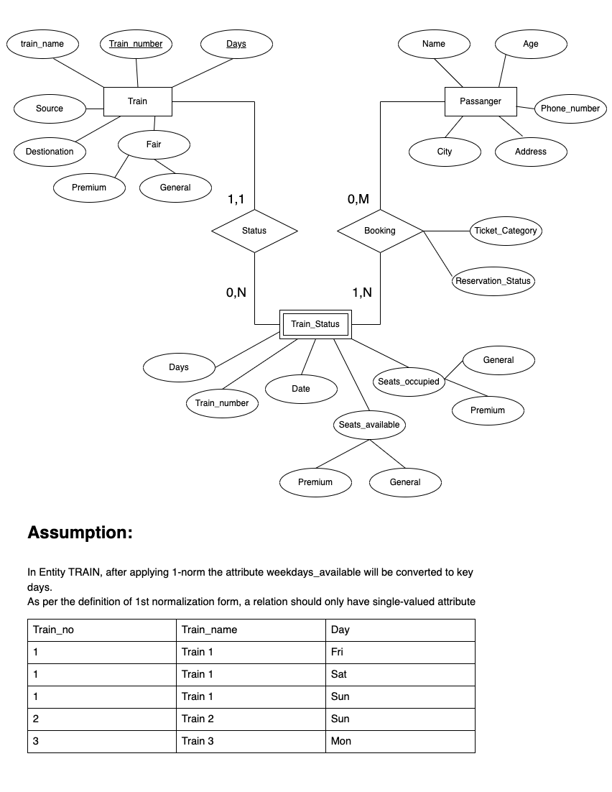

The assumptions and cardinality are mentioned in the above figure.

PART 2: GUI

Task 1:

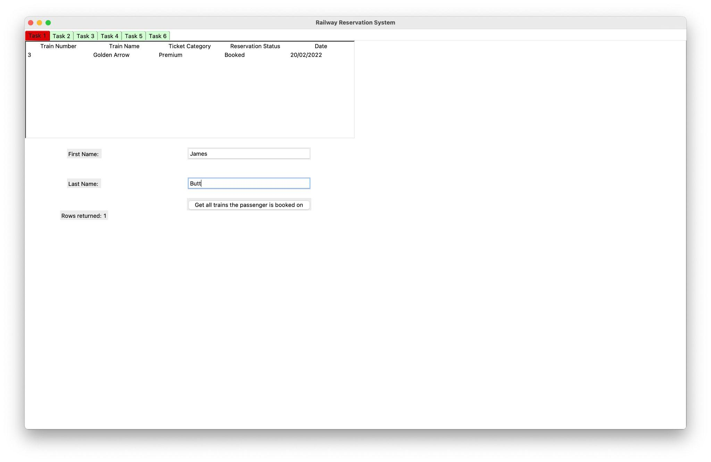When the user provides the first name and first name the query displays all the trains booked.

Task 2:

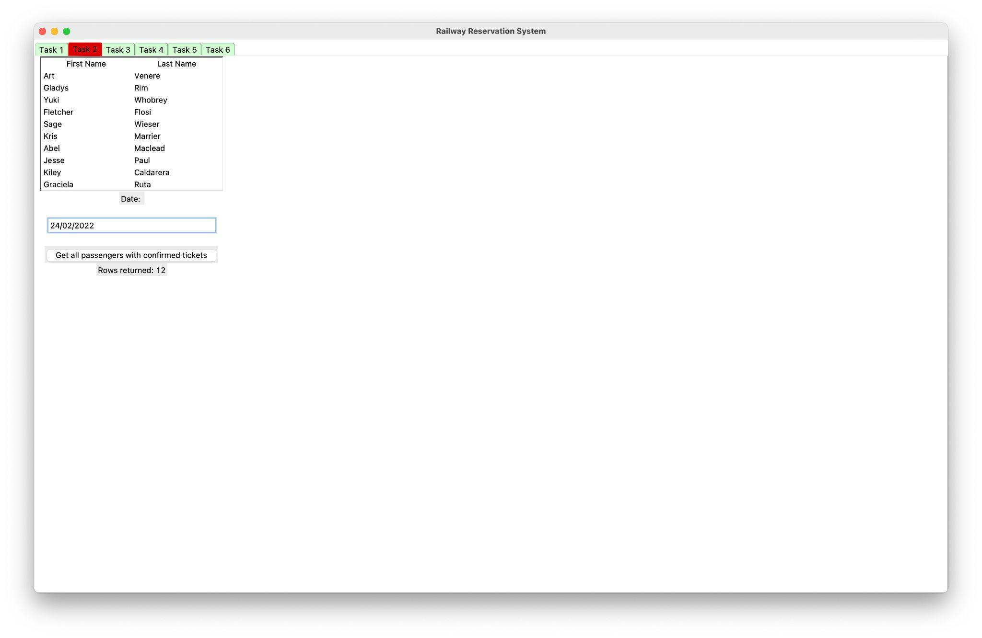When the user inputs the Date all the confirmed tickets are displayed.

Task 3:

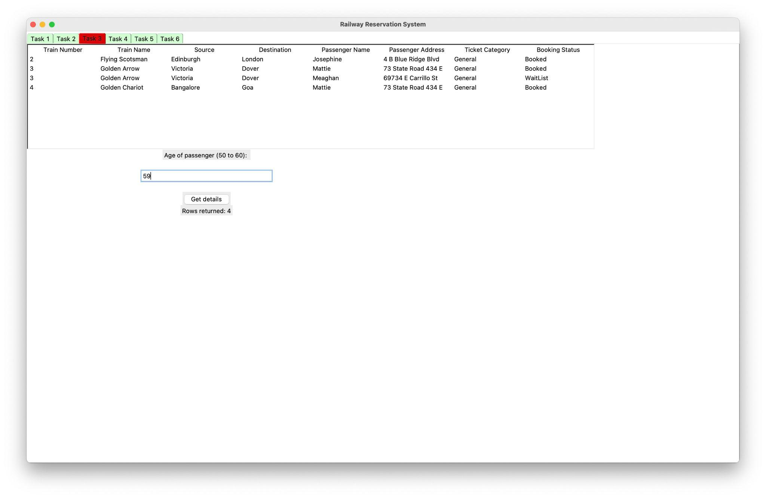Train Number, Train Name, Source, Destination, and Passenger information who are between 50 to 60 are displayed.

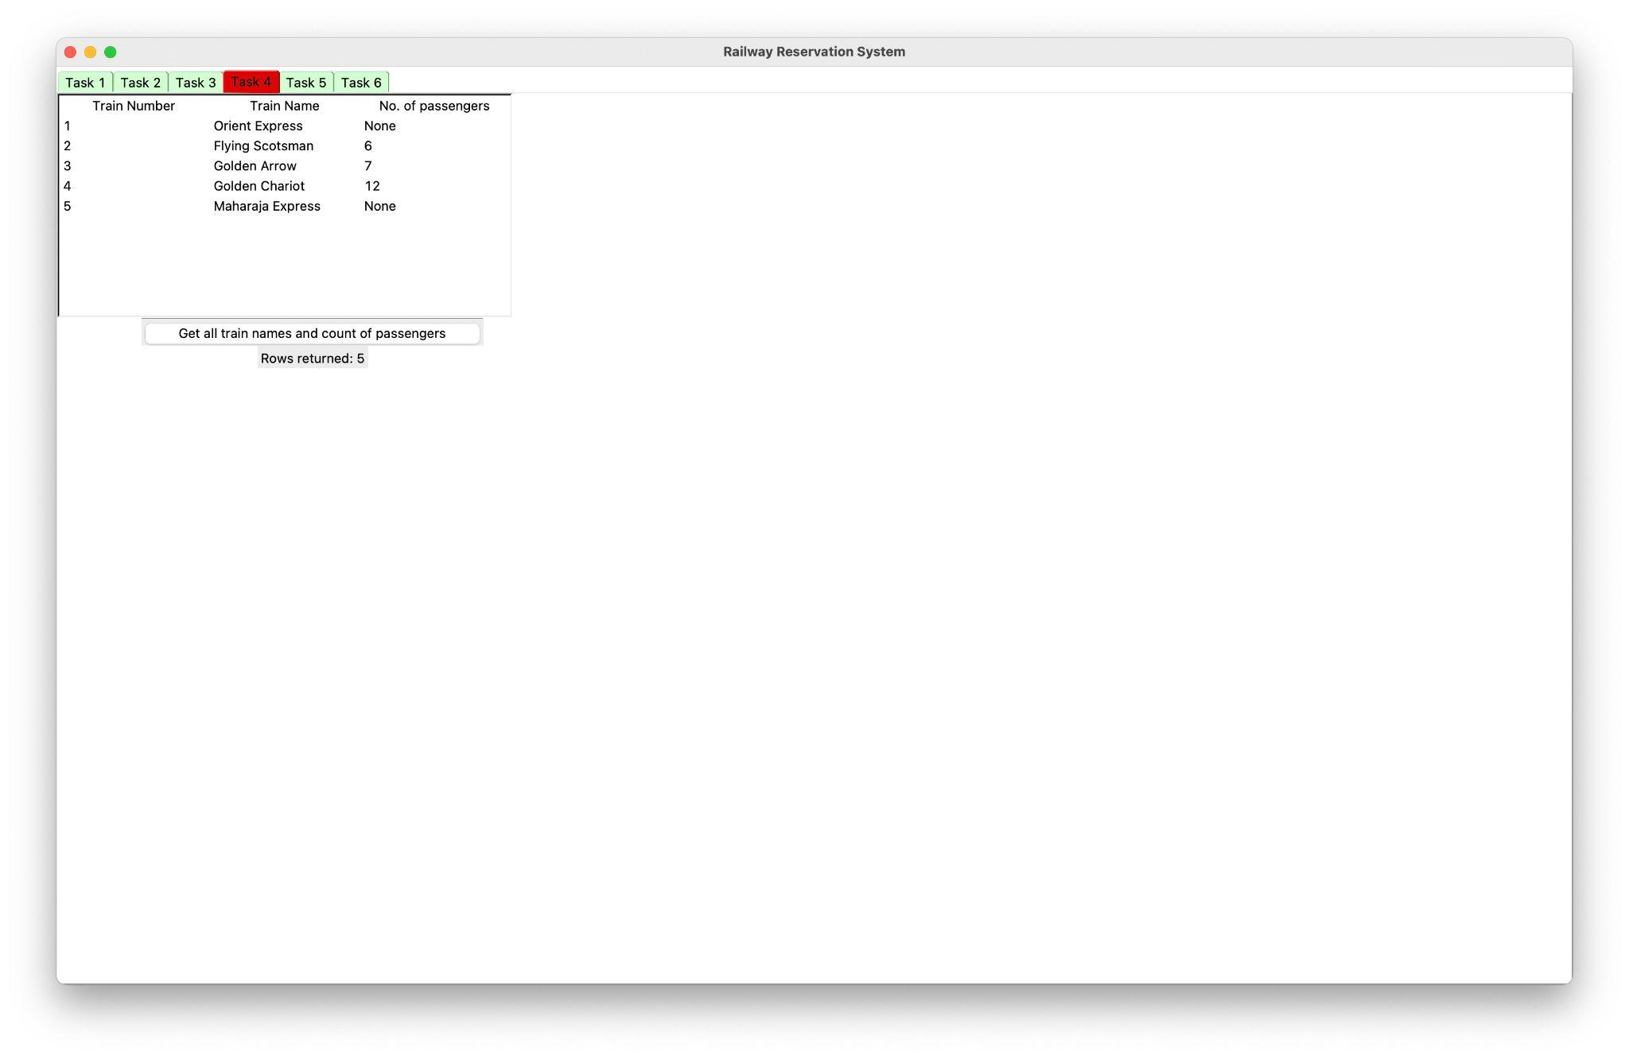Task 4:

On this page, all the train names with passenger count are displayed.

Task 5:

The passengers with Booking status “CONFIRMED” are returned upon entering Train Name.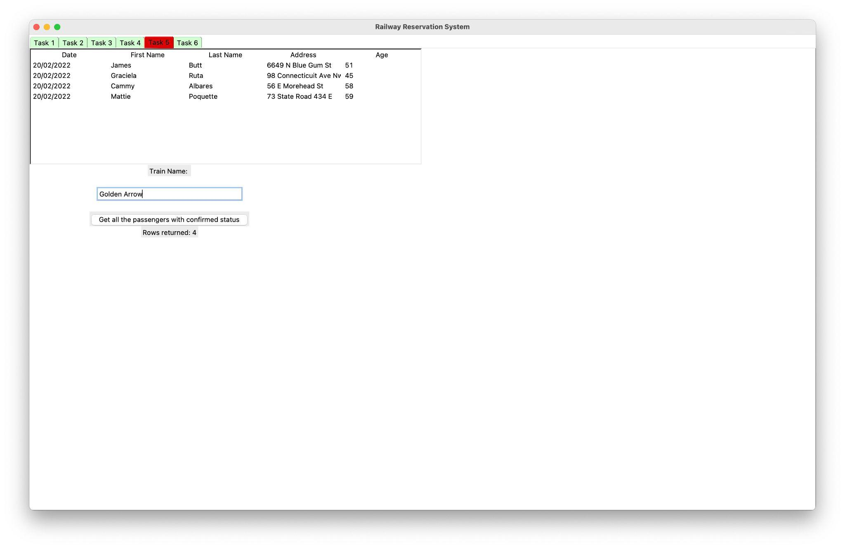

Task 6:

When a user cancels the ticket another passenger who is on the waitlist will be moved up and their Booking status will be changed to confirmed.