Project 0 Report

Yu Liang(Jasmine)

**Question 1.**

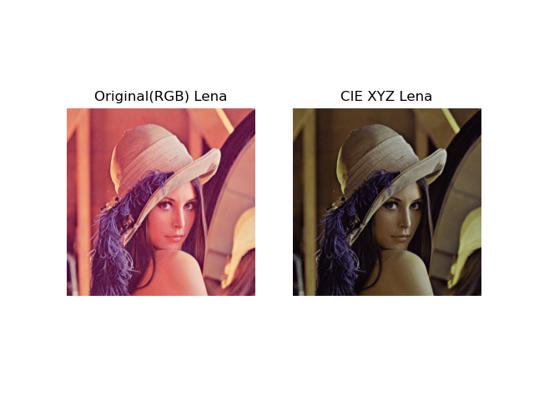Convert Lena.png from RGB to CIE XYZ color space, result showing in Figure(1)

Figure(1) Lena.png Original and Converted

**Question 2.**

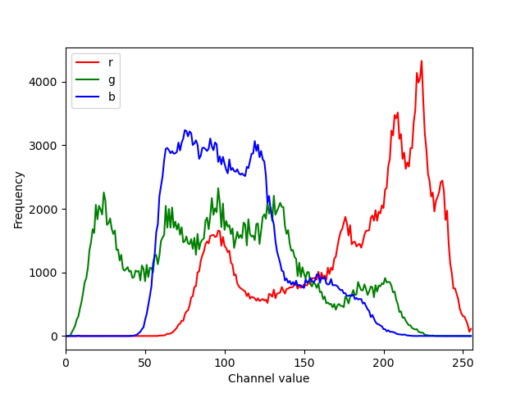Plot the color histogram for original Lena.png, result shown in Figure(2)

Figure(2) Color histogram of RGB Lena.png

**Question 3.**

For this question, I am working with sonnet.png, a gray scale image. Figure 3 is the histogram plot for the original image.

Figure 4 is the result of using my manually determine threshold, 106, to modify the image. Which the result is terrible.

Figure 5 is the result of using adaptive thresholds that was calculated using median formula, median(N*N)+C. The best threshold I got is N = 13 and C = -6. For this problem, I tried the mean and median formula and tried to use otsu’s method to determine the ‘best’ threshold. I found that it’s hard to know what the best values(block sizes & constants) to test around are and my results turn out that I need to invert the image with median result to make the image look nice. Before doing the test, I also normalize/contrast stretching the image to make the value smoother. It also takes long time on running the code to find the ‘optimal’ solution.

Figure 6 is the histogram after having the best adaptive threshold on the image.

1. 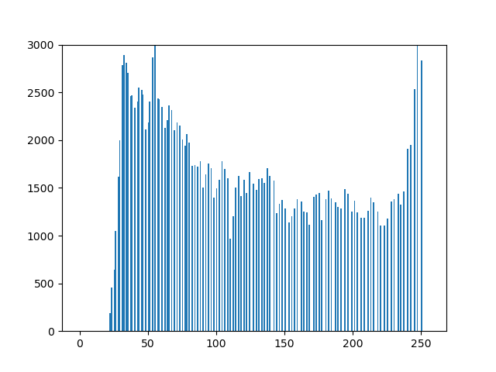Plot histogram of original gray scale image. Result shown in Figure(3)

Figure(3) Histogram of original Sonnet.png

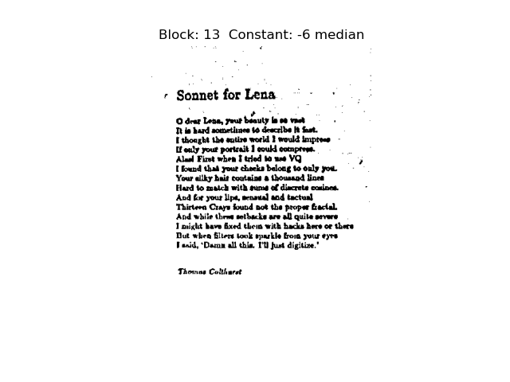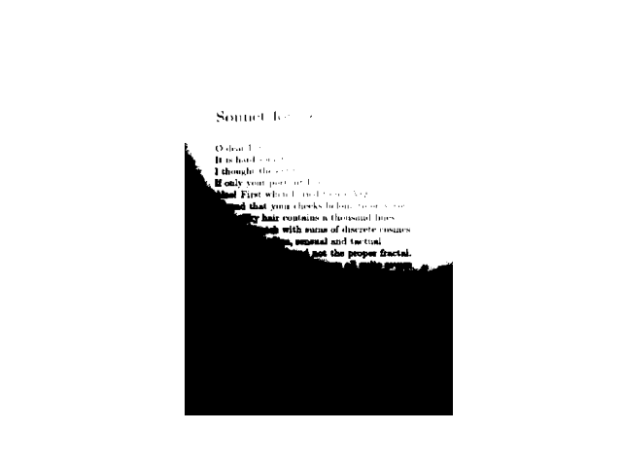Figure(4) Sonnet.png output with threshold 106

Figure(5)Sonnet.png output with adaptive threshold calculated with median

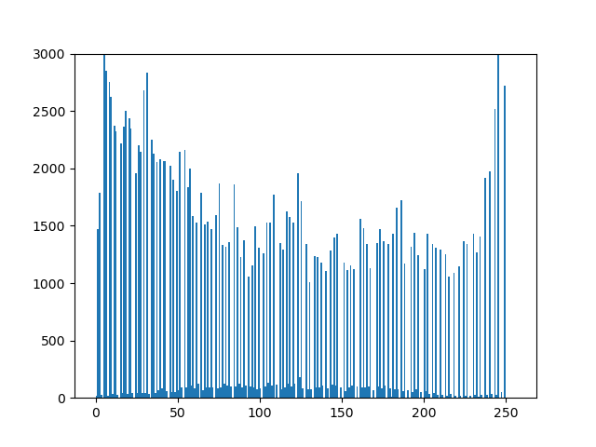Figure(6) The histogram of the image with best threshold

**Question 4.**

For this question I am using sift to get the features of the images and make a bag of words model for them.

I choose one representive image from each category and do a feature detect on each of them using SIFT. Figure 7-10 are the visualization of each.

Then to create a bag of words model, I use all the training image given and detect their features using SIFT. I then use KMean clustering algorithm to train them into different clusters of features. I set the cluster size to 10* the category of images, 4 in this case.

Then for part c, I use the 4 representive image and test out how each features shown on them. The bag of words histogram is showing on firgure 11-14. From Figure 12 you can see that feature 29 has the most outstanding amount, which kinda make sense since soccer ball is just a round ball without much features. Acoordion and dollar bills, shown on figure 10 & 14, have varieties of features. For this problem, I found that it is hard to determine what is the best amount of clusters to train on. I guess it may be better if we gave the same amount of features for each category(I choose 10), but what will be the best amount to set is a question and if we have a formula for that.

**FIGURES ON THE NEXT PAGES**

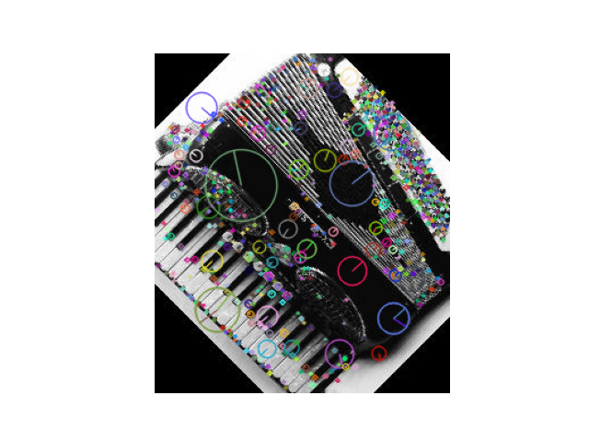(b)

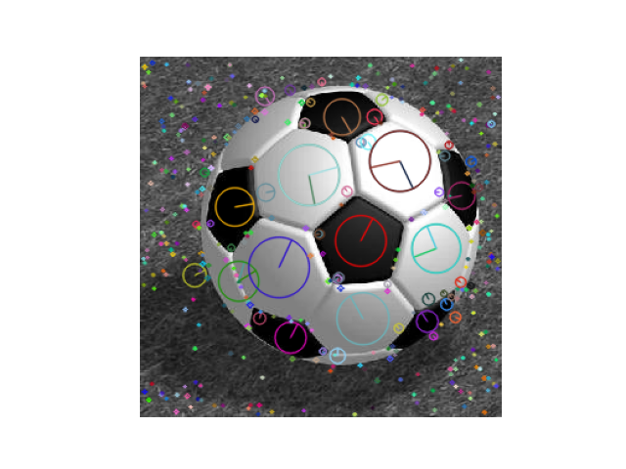Figure(7) Features visualization for accordion.jpg

Figure(8) Features visualization for soccer_ball.jpg

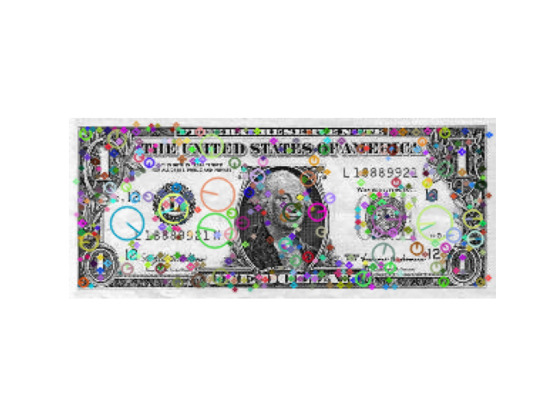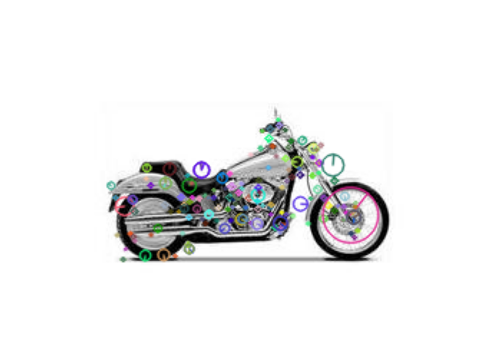Figure(9) Features visualization for motorbike.jpg

Figure(10) Features visualization for dollar_bill.jpg

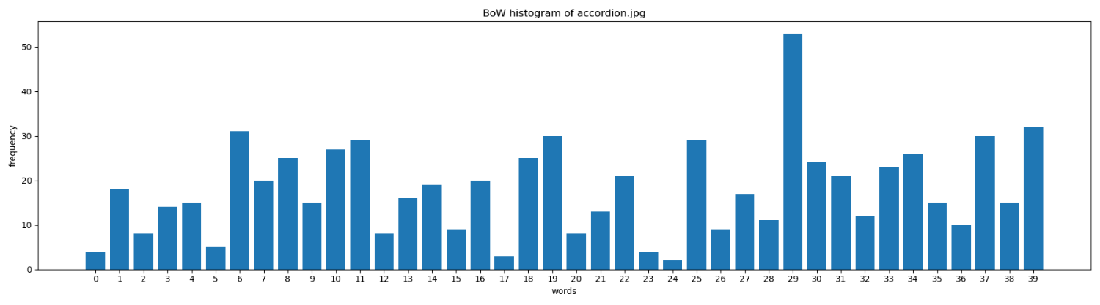 (c)

Figure(11) The bag of words model histogram for accordion.jpg

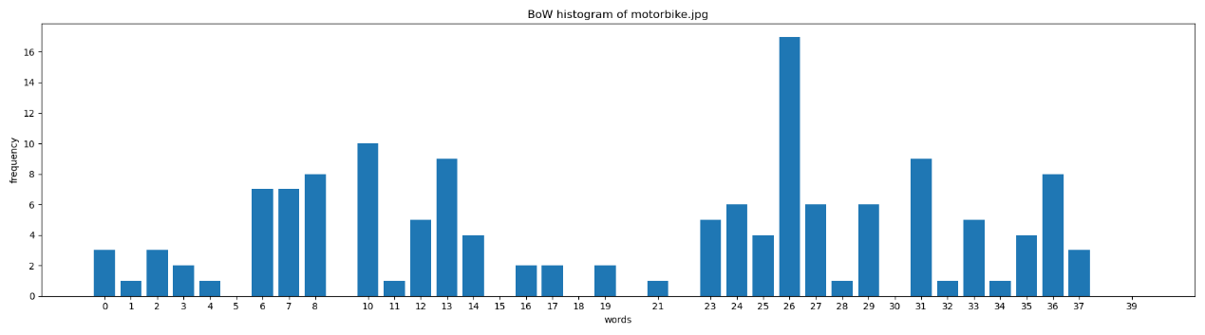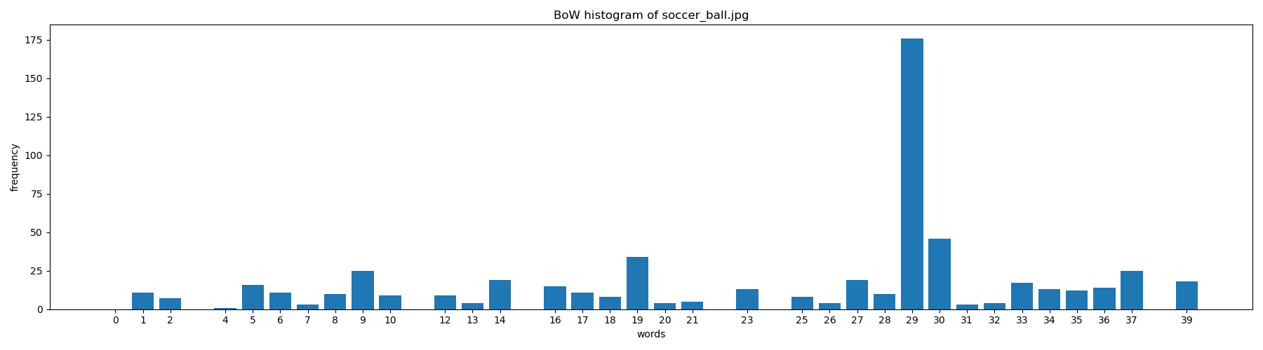Figure(12) The bag of words model histogram for soccer_ball.jpg

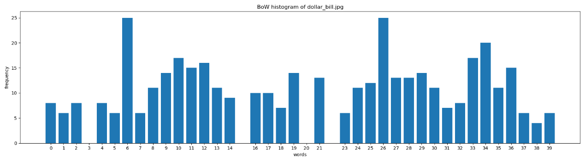Figure(13) The bag of words model histogram for motorbike.jpg

Figure(14) The bag of words model histogram for dollar_bill.jpg