E — Results for slides (main_v2)
Run main_v2 · 100 HotpotQA eval questions (distractor, validation) · gpt-4o-mini, temperature 0 · shared draft · M4 top-5, M5 top-5 per claim, query = question + draft/claim · 0 failed runs · paired bootstrap 95% CI (5,000 resamples).

1. RQ1 — Overall results
Method | EM [95% CI] | F1 | ΔEM vs M1 [95% CI] | Answers changed | Wrong→Right / Right→Wrong
M1 Draft only | 0.63 [0.53, 0.73] | 0.72 | — | — | —
M2 Self-reflection | 0.51 [0.41, 0.61] | 0.64 | −0.12 [−0.19, −0.05] | 30 | 2 / 14
M3 Critic + revision | 0.55 [0.45, 0.65] | 0.65 | −0.08 [−0.17, 0.00] | 33 | 5 / 13
M4 Draft-level verification | 0.61 [0.51, 0.71] | 0.70 | −0.02 [−0.05, 0.00] | 5 | 0 / 2
M5 Claim-level verification | 0.63 [0.53, 0.73] | 0.72 | 0.00 | 0 | 0 / 0

- No method improved on the initial draft.
- Self-reflection and critique (M2/M3) change many answers but mostly for the worse (14 vs 2 and 13 vs 5 harmful vs helpful edits). Only M2’s drop is statistically significant; M3’s CI touches 0.
- Evidence-grounded verification is conservative: M4 flagged 10 drafts and changed 5 answers (2 worse, none better); M5 flagged 25 of 378 claims but changed no answers.

2. Verifier labels and retrieval (for RQ2)
Method | Targets | SUPPORTED | UNSUPPORTED | CONTRADICTED | Gold SF recall
M4 (draft-level) | 100 drafts | 90 | 4 | 6 | 0.74
M5 (claim-level) | 378 claims | 353 | 22 | 3 | 0.80

3. RQ3 — Cost vs reliability
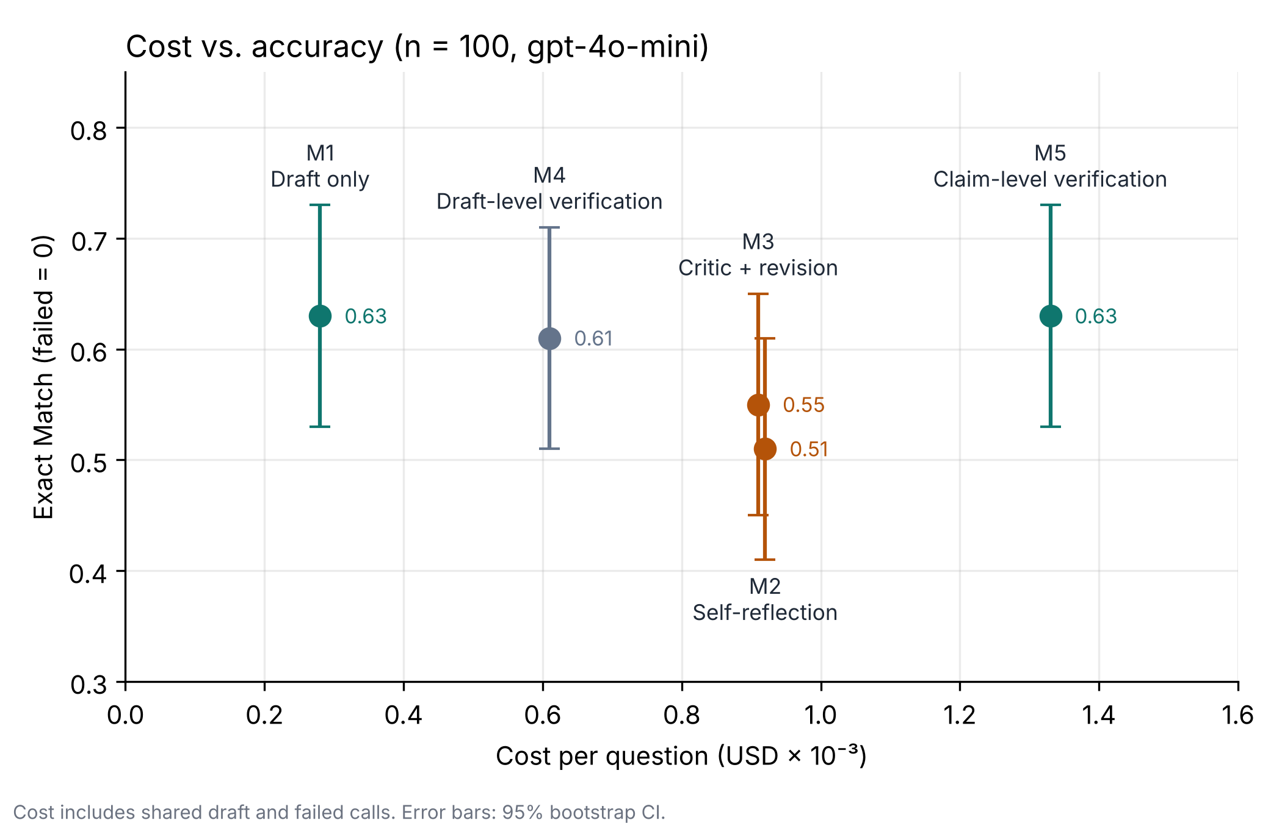
Method | Cost / question (USD) | × M1 | Extra latency / question | EM
M1 Draft only | 0.00028 | 1.0× | — | 0.63
M4 Draft-level verification | 0.00061 | 2.2× | 2.7 s | 0.61
M3 Critic + revision | 0.00091 | 3.2× | 3.7 s | 0.55
M2 Self-reflection | 0.00092 | 3.3× | 3.3 s | 0.51
M5 Claim-level verification | 0.00133 | 4.8× | 10.2 s | 0.63

- M1 is the cheapest and joint-most accurate method; extra spend did not buy accuracy.
- M5 matches M1 at 4.8× the cost and about 10 s extra latency per question; M4 costs about 2× for a slight drop.
- Whole run (100 questions × 5 methods): about $0.29. Cost includes the shared draft and failed calls.

4. Conclusions
- A single well-formatted draft was the strongest and cheapest baseline.
- Unconstrained self-reflection and critique tend to overwrite correct answers.
- Evidence-grounded verification is safe but rarely acts: it seldom flags errors and almost never changes answers, so its value lies in auditability rather than accuracy gains.

5. Limitations
- n = 100 with a single model (gpt-4o-mini); CIs are about ±0.10 EM.
- The same 100 questions were used in an earlier pilot; output-format fixes were informed by that pilot and validated on a separate 50-question dev set.
- Verifier labels are not yet human-validated; a 10-item pilot audit suggests the verifier sometimes judges whether a claim answers the whole question rather than whether the claim itself is supported.
- EM is sensitive to surface form (e.g. "3,677" vs "3,677 seats").

