# 第一张大图从后台请求的数据格式：

1.总体用户年龄分布

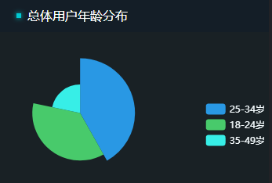

'items':[  
{"name":"25-34岁","value":"500","icon":"pie"},  
{"name":"18-24岁","value":"435","icon":"pie"},  
{"name":"35-49岁","value":"260","icon":"pie"}  
]

1. 总体收入分析

2.1

yxl_ul:{"nation_income":{  
"text":"全国总业务收入",  
"span":"1000"  
},  
"nation_increase":{  
"text":"环比增长",  
"span":"5"  
},  
"users_amount":{  
"text":"用户数量",  
"span":"5000"  
},  
"users_increase":{  
"text":"环比增长",  
"span":"5"  
},  
"average_cost":{  
"text":"人均消费",  
"span":"2000"  
},  
"average_increase":{  
"text":"环比增长",  
"span":"-5"  
}  
}

2.2

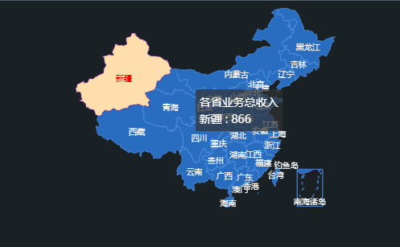

middle_map:{  
"datas":[  
{"name":''南海诸岛","value":''0"},  
{"name":''北京","value":''10''},  
{"name":''天津","value":''10''},  
{"name":''上海","value":''30''},  
{"name":''重庆","value":''10''},  
{"name":''河北","value":''20''},  
{"name":''河南","value":''30''},  
{"name":''云南","value":''20''},  
{"name":''辽宁","value":''30''},  
{"name":''黑龙江","value":''20''},  
{"name":''湖南","value":''40''},  
{"name":''安徽","value":''40''},  
{"name":''山东","value":''140''},  
{"name":''新疆","value":''40''},  
{"name":''江苏","value":''40''},  
{"name":''浙江","value":''40''},  
{"name":''江西","value":''40''},  
{"name":''湖北","value":''40''},  
{"name":''广西","value":''40''},  
{"name":''甘肃","value":''40''},  
{"name":''山西","value":''40''},  
{"name":''内蒙古","value":''40''},  
{"name":''陕西","value":''40''},  
{"name":''吉林","value":''40''},  
{"name":''福建","value":''40''},  
{"name":''贵州","value":''40''},  
{"name":''广东","value":''40''},  
{"name":''青海","value":''46''},  
{"name":''西藏","value":''80''},  
{"name":''四川","value":''80''},  
{"name":''宁夏","value":''70''},  
{"name":''湖南","value":''30''},  
{"name":''台湾","value":''40''},  
{"name":''香港","value":''34''},  
{"name":''澳门","value":''34''}  
]  
}

1. 总体用户性别比例

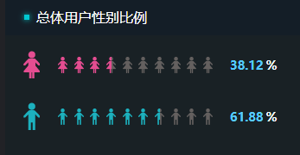

person-msg:{  
'nv_span':'38.12',  
'nan_span':'61.88'  
}

1. 全国各省收入占比

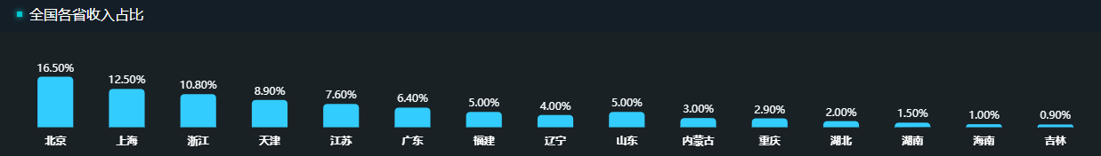

'foot_bar':[  
{'北京':'16.50'},  
{'上海':'12.50'},  
{'浙江':'10.80'},  
{'天津':'8.90'},  
{'江苏':'7.60'},  
{'广东':'6.40'},  
{'福建':'5.00'},  
{'辽宁':'4.00'},  
{'山东':'5.00'},  
{'内蒙古':'3.00'},  
{'重庆':'2.90'},  
{'湖北':'2.00'},  
{'湖南':'1.50'},  
{'海南':'1.00'},  
{'吉林':'0.90'}  
]

1. 业务总体收入与增长率

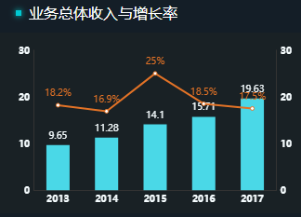

barandpie:{  
"datas":[  
{"xValue":"2013","yValue":"9.65","zValue":"18.20"},  
{"xValue":"2014","yValue":"11.28","zValue":"16.90"},  
{"xValue":"2015","yValue":"14.10","zValue":"25.00"},  
{"xValue":"2016","yValue":"15.71","zValue":"18.50"},  
{"xValue":"2017","yValue":"19.63","zValue":"17.50"}  
]  
}

1. 业务总体收入分类及占比

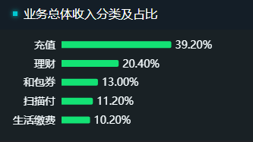

right_bar: [  
{"name":"生活缴费"',"value":"10.20"},  
{"name":"扫码付","value":"11.20"},  
{"name":"和包券","value":"13.00"},  
{"name":"理财","value":"20.40"},  
{"name":"充值","value":"39.20"}  
]

# 第二张大图从后台请求的数据格式：

1.总体用户年龄占比

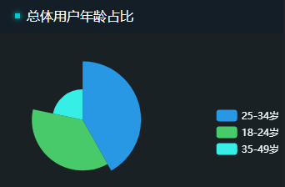

mypie:{'items':[  
{"name":"25-34岁","value":"500","icon":"pie"},  
{"name":"18-24岁","value":"435","icon":"pie"},  
{"name":"35-49岁","value":"260","icon":"pie"}  
]}

1. 总体用户性别比例

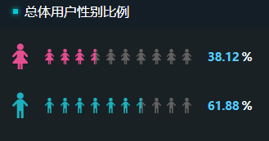

person-msg:{  
'nv_span':'38.12',  
'nan_span':'61.88'}

3全国用户分析

3.1



content-title-ul:{

"nation-users":{  
"text":"全国注册用户数",  
"span":"5000"  
},  
"nation-users-increase":{  
"text":"环比增长",  
"span":"5"  
},  
"user-slient":{  
"text":"沉默用户",  
"span":"1000"  
},  
"user-normal":{  
"text":"一般用户",  
"span":"500"  
},  
"users-active":{  
"text":"活跃用户",  
"span":"3500"  
}  
}

3.2

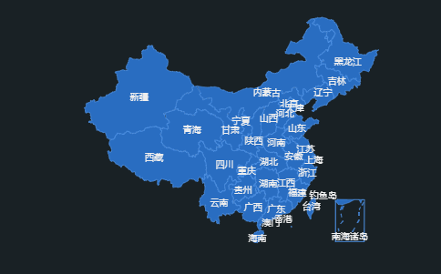

middle_map:{  
"datas":[  
{"name":''南海诸岛","value":''0"},  
{"name":''北京","value":''10''},  
{"name":''天津","value":''10''},  
{"name":''上海","value":''30''},  
{"name":''重庆","value":''10''},  
{"name":''河北","value":''20''},  
{"name":''河南","value":''30''},  
{"name":''云南","value":''20''},  
{"name":''辽宁","value":''30''},  
{"name":''黑龙江","value":''20''},  
{"name":''湖南","value":''40''},  
{"name":''安徽","value":''40''},  
{"name":''山东","value":''140''},  
{"name":''新疆","value":''40''},  
{"name":''江苏","value":''40''},  
{"name":''浙江","value":''40''},  
{"name":''江西","value":''40''},  
{"name":''湖北","value":''40''},  
{"name":''广西","value":''40''},  
{"name":''甘肃","value":''40''},  
{"name":''山西","value":''40''},  
{"name":''内蒙古","value":''40''},  
{"name":''陕西","value":''40''},  
{"name":''吉林","value":''40''},  
{"name":''福建","value":''40''},  
{"name":''贵州","value":''40''},  
{"name":''广东","value":''40''},  
{"name":''青海","value":''46''},  
{"name":''西藏","value":''80''},  
{"name":''四川","value":''80''},  
{"name":''宁夏","value":''70''},  
{"name":''海南","value":''30''},  
{"name":''台湾","value":''40''},  
{"name":''香港","value":''34''},  
{"name":''澳门","value":''34''},  
]  
}

4.用户活跃时段top10

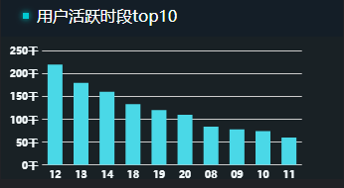

right_bar:[  
{"name":"12","value":"220"},  
{"name":"13",value":"180"},  
{"name":"14","value":"160"},  
{"name":"18","value":"133"},  
{"name":"19","value":"120"},  
{"name":"20","value":"110"},  
{"name":"08","value":"84"},  
{"name":"09","value":"78"},  
{"name":"10","value":"74"},  
{"name":"11","value":"60"}  
]

1. 全国各省用户数top5

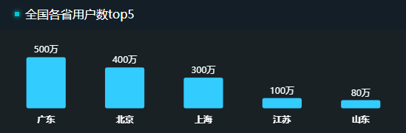

bottom_main:[  
{"name":"广东","value":"500"},  
{"name":"北京","value":"400"},  
{"name":"上海","value":"300"},  
{"name":"江苏","value":"100"},  
{"name":"山东","value":"80"}  
  
]

1. 注册总人数增长率

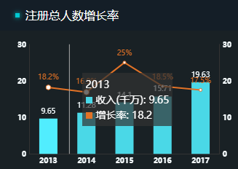

barandpie:{  
"data":[  
{"xValue":"2013","yValue":"9.65","zValue":"18.20"},  
{"xValue":"2014","yValue":"11.28","zValue":"16.90"},  
{"xValue":"2015","yValue":"14.10","zValue":"25.00"},  
{"xValue":"2016","yValue":"15.71","zValue":"18.50"},  
{"xValue":"2017","yValue":"19.63","zValue":"17.50"}  
]  
}

1. 各类用户占比



datas:{  
"names":[  
{"name":"活跃用户"},  
{"name":"沉默用户"},  
{"name":"一般用户"}  
],  
"items":[  
{"value":"29", "name":"25-35岁"},  
{"value":"14", "name":"25岁以下"},  
{"value":"20", "name":"35-45岁"},  
{"value":"14", "name":"46岁以上"}  
]  
}

1. 人均消费金额top5

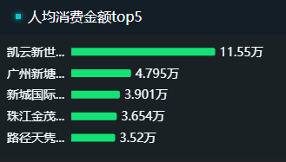

bottom_bar: [  
{"name":"路径天隽"',"value":"3.520"},  
{"name":"珠海金茂","value":"3.654"},  
{"name":"新城国际","value":"3.901"},  
{"name":"广州新塘","value":"4.795"},  
{"name":"凯云新世","value":"11.550"}  
]

# 第三张大图从后台请求的数据格式：

1. 全国用户分类分析

1.1 

wrapper_left_ul:{  
"nation_users_counts":{  
"text":"全国注册用户数",  
"span":"5000"  
},  
"nation_increase":{  
"text":"环比增长",  
"span":"5"  
},  
"users_silent":{  
"text":"沉默用户",  
"span":"1000"  
},  
"users_normal":{  
"text":"一般用户",  
"span":"500"  
},  
"users_active":{  
"text":"活跃用户",  
"span":"3500"  
}  
  
}

1.2

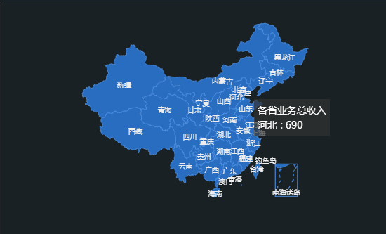

middle_map:{  
"datas":[  
{"name":''南海诸岛","value":''0"},  
{"name":''北京","value":''10''},  
{"name":''天津","value":''10''},  
{"name":''上海","value":''30''},  
{"name":''重庆","value":''10''},  
{"name":''河北","value":''20''},  
{"name":''河南","value":''30''},  
{"name":''云南","value":''20''},  
{"name":''辽宁","value":''30''},  
{"name":''黑龙江","value":''20''},  
{"name":''湖南","value":''40''},  
{"name":''安徽","value":''40''},  
{"name":''山东","value":''140''},  
{"name":''新疆","value":''40''},  
{"name":''江苏","value":''40''},  
{"name":''浙江","value":''40''},  
{"name":''江西","value":''40''},  
{"name":''湖北","value":''40''},  
{"name":''广西","value":''40''},  
{"name":''甘肃","value":''40''},  
{"name":''山西","value":''40''},  
{"name":''内蒙古","value":''40''},  
{"name":''陕西","value":''40''},  
{"name":''吉林","value":''40''},  
{"name":''福建","value":''40''},  
{"name":''贵州","value":''40''},  
{"name":''广东","value":''40''},  
{"name":''青海","value":''46''},  
{"name":''西藏","value":''80''},  
{"name":''四川","value":''80''},  
{"name":''宁夏","value":''70''},  
{"name":''海南","value":''30''},  
{"name":''台湾","value":''40''},  
{"name":''香港","value":''34''},  
{"name":''澳门","value":''34''}  
]  
}

1. 全国各省用户统计对比

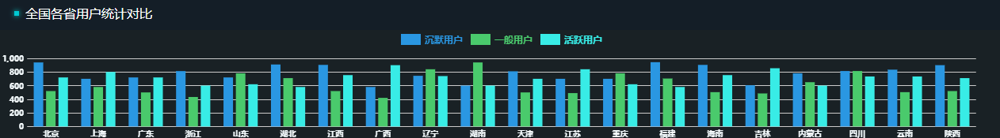

bottom_bar:{  
"datas":[  
{"name":"北京","slientuser":"940","normaluser":"520","activeuser":"720"},  
{"name":"上海","slientuser":"700","normaluser":"580","activeuser":"800"},  
{"name":"广东","slientuser":"720","normaluser":"500","activeuser":"720"},  
{"name":"浙江","slientuser":"813","normaluser":"433","activeuser":"600"},  
{"name":"山东","slientuser":"720","normaluser":"780","activeuser":"620"},  
{"name":"湖北","slientuser":"910","normaluser":"710","activeuser":"580"},  
{"name":"江西","slientuser":"904","normaluser":"520","activeuser":"754"},  
{"name":"广西","slientuser":"580","normaluser":"420","activeuser":"900"},  
{"name":"辽宁","slientuser":"744","normaluser":"840","activeuser":"740"},  
{"name":"湖南","slientuser":"600","normaluser":"940","activeuser":"600"},  
{"name":"天津","slientuser":"810","normaluser":"500","activeuser":"700"},  
{"name":"江苏","slientuser":"700","normaluser":"490","activeuser":"840"},  
{"name":"重庆","slientuser":"700","normaluser":"780","activeuser":"620"},  
{"name":"福建","slientuser":"944","normaluser":"704","activeuser":"580"},  
{"name":"海南","slientuser":"904","normaluser":"504","activeuser":"754"},  
{"name":"吉林","slientuser":"605","normaluser":"485","activeuser":"855"},  
{"name":"内蒙古","slientuser":"780","normaluser":"650","activeuser":"600"},  
{"name":"四川","slientuser":"814","normaluser":"814","activeuser":"734"},  
{"name":"云南","slientuser":"834","normaluser":"504","activeuser":"734"},  
{"name":"陕西","slientuser":"900","normaluser":"520","activeuser":"710"}  
  
]  
  
}

1. 全国年度用户统计及趋势

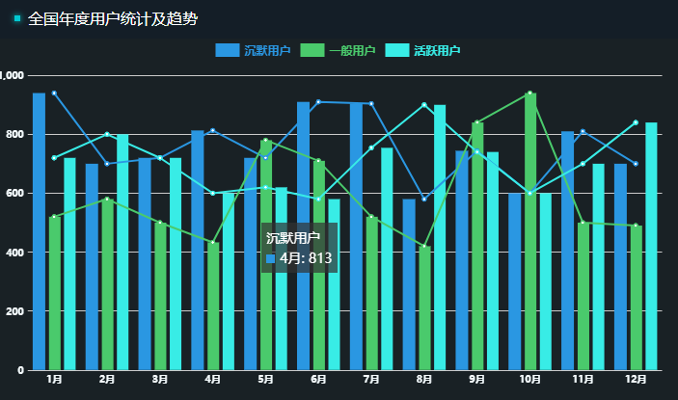

right_bar:{  
  
"datas":[  
{"name":"1月","slientuser":"940","normaluser":"520","activeuser":"720"},  
{"name":"2月","slientuser":"700","normaluser":"580","activeuser":"800"},  
{"name":"3月","slientuser":"720","normaluser":"500","activeuser":"720"},  
{"name":"4月","slientuser":"813","normaluser":"433","activeuser":"600"},  
{"name":"5月","slientuser":"720","normaluser":"780","activeuser":"620"},  
{"name":"6月","slientuser":"910","normaluser":"710","activeuser":"580"},  
{"name":"7月","slientuser":"904","normaluser":"520","activeuser":"754"},  
{"name":"8月","slientuser":"580","normaluser":"420","activeuser":"900"},  
{"name":"9月","slientuser":"744","normaluser":"840","activeuser":"740"},  
{"name":"10月","slientuser":"600","normaluser":"940","activeuser":"600"},  
{"name":"11月","slientuser":"810","normaluser":"500","activeuser":"700"},  
{"name":"12月","slientuser":"700","normaluser":"490","activeuser":"840"}  
]  
}