**CS115-DZ06**

**Zadatak 1.**

1. 1,0,1,1,0,0,1,1,1,0,0,0,1,**1,1,1**
2. 1,2,2,3,4,4,5,6,6,7,8,8,**9,10,10**
3. 1,0,2,0,4,0,8,0,16,0,**32,0,64**
4. 3,6,12,24,,48,96,192,**384,768,1536**

**Zadatak 2.**

1. ∑3 (5k2 + 1) = (5 * 1 + 1) + ( 5 * 4 + 1) + ( 5 * 9 + 1) = 6 + 21 +

K=1

46 = 73

1. ∑8 (2j+1 – 2j) = (21 – 20) + ( 22 - 21) + (23 – 22) + (24 – 23) +

J=0

(25 – 24) + (26 – 25) + (27 – 26) + (28 – 27) + (29 – 28) = 1 + 2 + 4 + 8 + 16 + 32 + 64 + 128 + 256 = 511

1. ∑(1 / j) za S∊{1,3,5,7} = 1/1 + 1/3 + 1/5 + 1/7 =

j∊S

= 176/105

**Zadatak 3.**

1. p(3) za p(x) = x5 – 6x4 + 8x3 + 8x2 + 4x -40

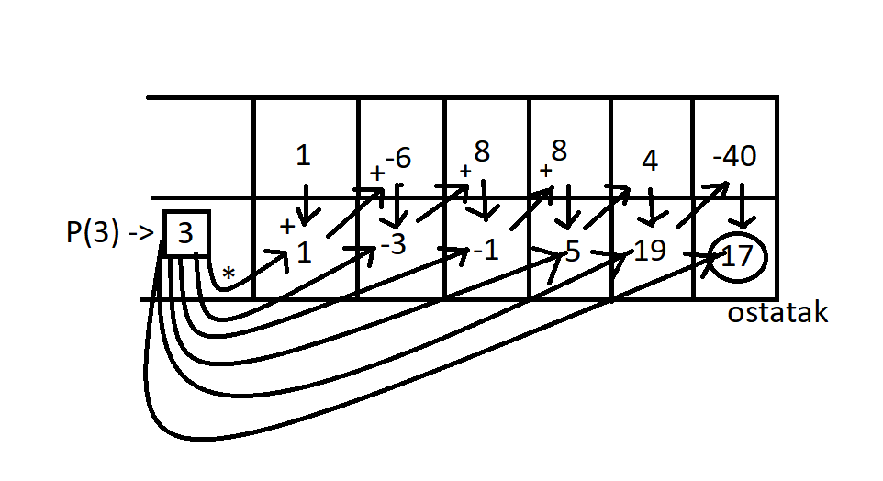

R(x) = 17/ (x -3)

Q(x) = X4 – 3X3- X2 + 5X + 19

P(x) = (x – 3) * ( X4 – 3X3- X2 + 5X + 19) + 17/(x – 3)

1. p(7) za p(x) = x 3 – 6x2 + 11x – 6

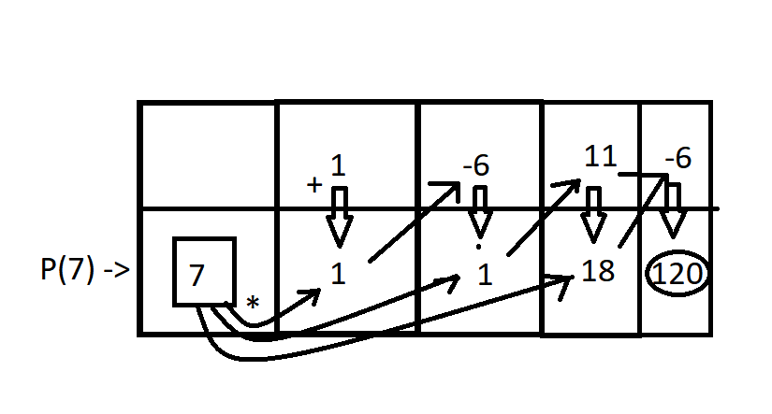

Q(x) = x2 + x + 18

R(x) = 120 / (x – 7)

P(x) = ( x2 + x + 18 ) + 120 / (x – 7)

**Zadatak 4.**

1. NZD(256,21)

256 = 12 * 21 + 4

21 = 5 * 4 + 1

4 = 4 * 1 + 0

NZD(256,21) = 1

1. NZD(837,2015)

2015 = 2 * 837 + 341

837 = 2 * 341 + 155

341 = 2 * 355 + 31

341 = 5 * 31 + 0 NZD(837,2015) = 31

**Zadatak 5.**

f(x) = x2 + x x0 = 1 , x1 = 3

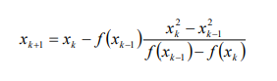

= Xk+1 = Xk - (Xk-12 + Xk-1 ) * Xk2 - Xk-12 / (Xk-12 + Xk-1) – (Xk 2 + Xk) =

Xk+1 = Xk - (Xk-12 + Xk-1 ) * Xk2 - Xk-12 / Xk-12 + Xk-1 – Xk 2 + Xk =

X2 = 3 – (12 + 1) * 32  – 12  / 12  + 1 – 32  - 3

X2 = 3 – 2 * 8 / -10 = 3 + 16/10 = 30/10 + 16/10 = 46/10

X2 = 46/10

X3 = 46/10 – (32 + 3) * (46/10)2 - 32 / 32 + 3 - (46/10)2 - 46/10 =

46/10 – 12 * 2116/100 – 9 / 9 + 3 – 2216 / 100 – 46/10

X3 = 46/10 – 12 * 2116/100 – 900 /100 / 1200/100 – 2116/100 = 460/100 = 46/10 – 12 * 1216/100 / 1376/100 = 46/10 – 12 * 1216/-1376

X3 = 46/10 + 14592/1376 /:32 = 46/10 + 456/43 = 3269/215