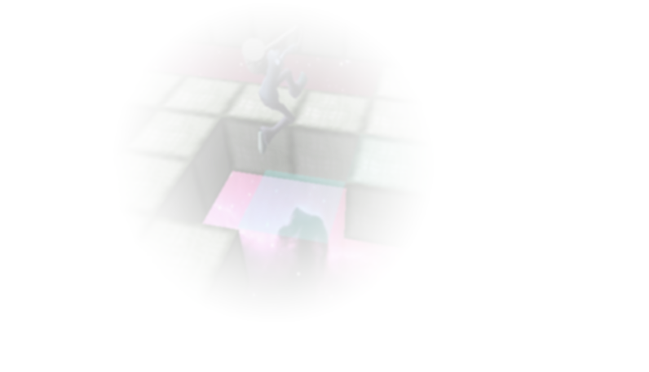
ALEXANDER T. SERIO
Game Programmer (Tools, Networking, General)

14616 NE 44th St, Bellevue, WA 98007
Day/Mobile: (760) 715-7265, email: aserio@digipen.edu

EDUCATION

Currently enrolled fourth year student, DigiPen Institute of Technology
Bachelor of Science in Real-Time Interactive Simulation, expected 2009

EXPERIENCE

Block Breakers: 3D Multiplayer Action (Team of 4)
- Reliable UDP networking using WinSock
- Level editor (C#)
- Animations with Direct3D

Noir: 3D Multiplayer Survival (Team of 4)
- Reliable UDP networking using WinSock
- 2D and 3D sound using FMOD
- In-game console for editing level
- Level and level props created using 3D Studio Max 9

Entou: 2D Side-scrolling Action (Team of 3)
- Level editor created using Win32 API
- Documented 2D physics engine
- Artwork and animations done using Macromedia Fireworks

Other
- Dijkstra and A* pathfinding algorithms
- Image processing techniques, such as motion detection, noise reduction, and object detection
- Software-based graphics pipeline (2D/3D) using GDI+

SKILLS

Languages
- C/C++ (4 years)
- C# (1 year)
- Assembly (GBC, x86)
Software
- Win32 API (3 years)
- Visual Studio .NET (4 years)
- SVN Version Control (4 years)
- Doxygen
- FMOD
- DirectX
- Windows, Linux (Ubuntu)
- Microsoft Office, Finale 2008
- 3D Studio Max, Rhinoceros 3D, Macromedia Fireworks, Paint.NET
Other
- Experienced in tool creation, networking, basic physics, basic AI, graphics, Lua scripts

