Assignment 5 Report

For what little code was involved in this assignment, it can mostly be found in ‘getFeatures.m.’ This file implements a function that returns a feature vector for a given image. Unfortunately, this means all the classes (‘A’, ‘B’, and ‘C’) use the same feature types. Nevertheless, the features are extracted as follows:

- Image is converted to black and white
- Objects are detected and filled
- Each object in the file is of the same type
- Feature vector using area, perimeter, and extent is returned

From that point, I created target (integer IDs for class type), train (first five objects in returned vector), and test (last five objects) vectors. This data was then imported into the neural network. The image below shows the training results for the ‘A’ class:

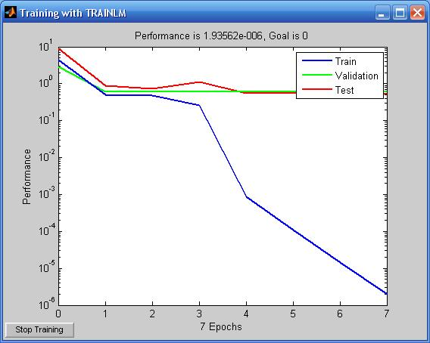

The performance is quite close to the goal. The five test images are rated

[0.99907 0.99999 0.99818 1 0.99971]

with

[1 1 1 1]

being the ideal output (1 is to ‘A’ as 2 is to ‘B’ as 3 is to ‘C’).

The outputs from the ‘B’ and ‘C’ classes were suspiciously too close to their goal, however.

