LAB 6 SE

Name : Yashas Sadananda
SRN : PES2UG24CS610
5th Sem J Section

Github : https://github.com/yxshas565/L6_L7_48_daycare_fees

Screenshot’s

- Branch Coverage

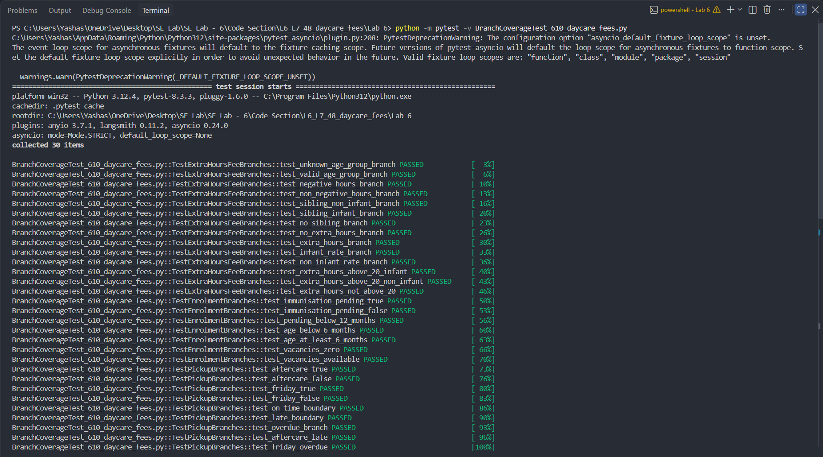

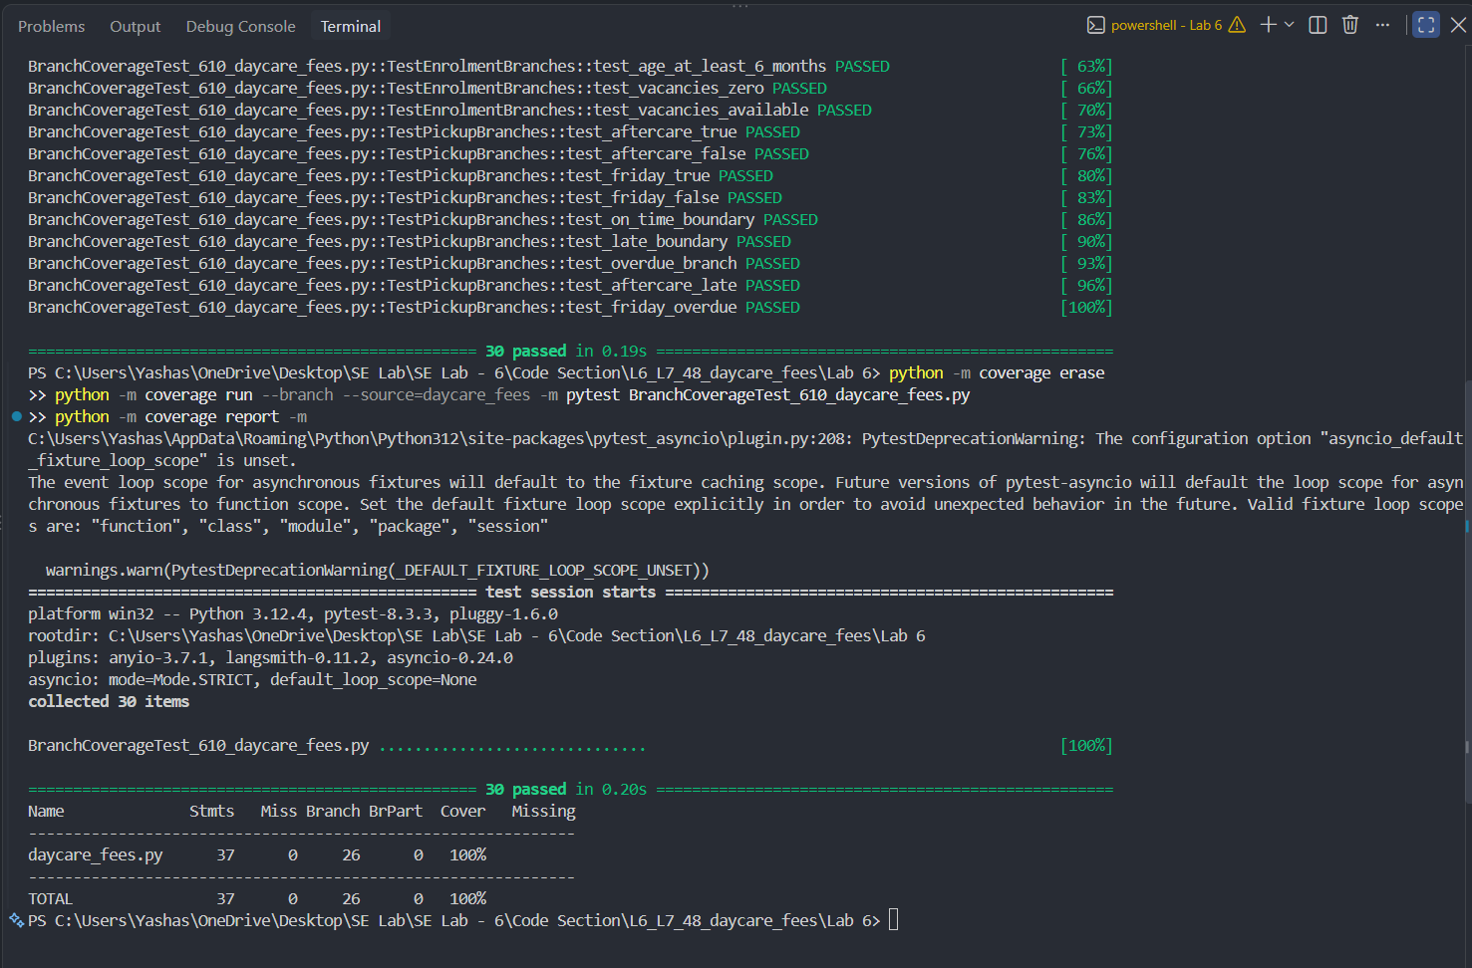

- Code coverage



