TOXIC TERMINATOR

**Developed By:-**

Yash Dogra 102166002

Prateek Choudhary 102116066



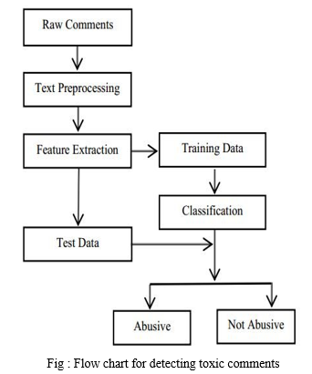

# Methodology

## Data Collection

## Key Features:

1. Balanced Dataset:
   * The dataset is thoughtfully balanced, ensuring representation of various types of toxic content.
   * It contains tweets that exhibit hate speech, offensive language, and other harmful expressions.
2. Content Labels:
   * Each tweet is labeled with one or more of the following categories:
     + Hate speech
     + Offensive language
     + Toxicity
3. Use Cases:
   * **NLP (Natural Language Processing)**: Researchers and practitioners can use this dataset to develop and evaluate models for detecting and handling toxic content in online platforms.
   * **Social Media Analysis**: Organizations can gain insights into the prevalence of harmful language on social media platforms.

## Dataset Access:

* [You can download the dataset from the following link: Toxic Tweets Dataset1](https://www.kaggle.com/datasets/ashwiniyer176/toxic-tweets-dataset).

## Example Applications:

1. Sentiment Analysis:
   * Classify tweets as positive, neutral, or negative based on their content.
   * Identify toxic sentiments within a larger context.
2. Model Training:
   * Train machine learning models to automatically detect and filter out toxic content.
   * Improve online safety by implementing real-time moderation systems.
3. Social Impact:
   * Understand the impact of hate speech and offensive language on individuals and communities.
   * Advocate for responsible online behavior.

Remember, while working with this dataset, it’s essential to approach the content with sensitivity and ethical considerations. Let’s strive for a safer and more respectful online environment!

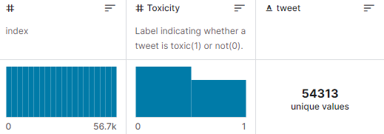

## Data Preprocessing

**Preprocessing Steps for Toxicity Classifier**

1. **Load and Parse Text Data:**

- Open the dataset file containing textual content for toxicity classification.

- Read and store the text data in memory.

2. **Cleaning Text:**

- Iterate through each text entry in the dataset.

- Lowercase the text and remove any non-alphabetic characters, URLs, and symbols.

- Apply stemming or lemmatization to standardize word forms.

3. **Vocabulary Building:**

- Collect all unique words from the cleaned text data.

- Create a vocabulary containing these unique words.

4. **Save Cleaned Text:**

- Store the cleaned and preprocessed text in a file (e.g., "cleaned_text.txt") for future use.

- Each line in the file represents a unique text entry after preprocessing.

5. **Load Training Dataset:**

- Open the file containing the list of text entries used for training.

- Read the text from the file and create a set of identifiers for the training text.

6. **Filter Text for Training:**

- Gather a list of all text entries.

- Select only those entries that are part of the training set.

7. **Create a List of Training Text:**

- Create a list (e.g., "train_text") containing the preprocessed text for the training set.

8. **Tokenization and Padding:**

- Tokenize the text, converting words into numerical indices based on the vocabulary.

- Pad sequences to a fixed length to ensure consistent input dimensions for the model.

9. **Determine Maximum Text Length:**

- Find the maximum length among all preprocessed text entries.

- This step is crucial for later padding sequences to ensure consistent input dimensions for the model.

10. **Labeling:**

- Assign labels to the preprocessed text entries based on their toxicity status.

- For binary classification, labels can be 0 for non-toxic and 1 for toxic.

11. **Save Preprocessed Data:**

- Save the preprocessed text and corresponding labels in separate files for training and future evaluations.

These preprocessing steps create a standardized and clean dataset for training a toxicity classifier, facilitating effective model learning and generalization.

# IMPLEMENTATION

### 1. Data Loading:

# 

# This section imports necessary libraries, including pandas for data manipulation, numpy for numerical operations, and matplotlib for plotting. It loads a dataset named "FinalBalancedDataset.csv" into a pandas DataFrame called data.

### 2. Data Information:

# 

# This code snippet prints information about the dataset, such as the number of entries, columns, data types, and memory usage. The dataset has 56745 entries and three columns: "Unnamed: 0," "Toxicity," and "tweet." The "Unnamed: 0" column seems to be an index and is dropped later.

### 3. Displaying the First 5 Rows of the Dataset:

# 

# This displays the first 5 rows of the dataset, showing the structure and content of the data. It includes the columns "Unnamed: 0," "Toxicity," and "tweet."

### 4. Dropping Unnecessary Column:

# 

# This removes the "Unnamed: 0" column from the dataset, as it appears to be an unnecessary index.

### 5. Displaying the First 5 Rows Again:

# 

# This displays the first 5 rows of the dataset after dropping the "Unnamed: 0" column.

### 6. Checking the Distribution of the 'Toxicity' Column:

# 

# This prints the count of each unique value in the 'Toxicity' column. It indicates that there are 32592 instances labeled as non-toxic (0) and 24153 instances labeled as toxic (1).

### 7. NLP Preprocessing with NLTK:

# 

# This imports the Natural Language Toolkit (NLTK) and downloads necessary resources such as tokenizers, lemmatizers, stop words, and part-of-speech taggers. NLTK is a powerful library for working with human language data.

### 8. Text Lemmatization Example:

# 

# This demonstrates the lemmatization process using NLTK's WordNetLemmatizer. Lemmatization reduces words to their base or root form. In this example, it shows the lemmatization of the words "Leaves," "Leafs," and "Leaf" as "Leaf," indicating a common base form.

## TEXT PRE PROCESSING

# Text Pre-processing on a column named "tweet" in a DataFrame (data) by applying lemmatization to each tweet. Here's a detailed breakdown:

### 1. Importing Libraries:

# 

# This line imports the WordNetLemmatizer class from the NLTK (Natural Language Toolkit) library. It creates an instance of this class, which will be used for lemmatizing words.

### 2. Regular Expression and Text Cleaning:

# 

# This line imports the regular expression (regex) module. Regex is used for pattern matching in strings.

# 

# The prepare_text function takes a text input and removes characters that are not alphabets or apostrophes using regular expressions. This helps clean the text and remove unwanted symbols.

### 3. Tokenization and Part-of-Speech Tagging:

# 

# The cleaned text is split into words, joined back into a string, tokenized into individual words, and then part-of-speech (POS) tagged using NLTK's word_tokenize and pos_tag functions. POS tagging assigns a part-of-speech category (such as noun, verb, adjective, etc.) to each word.

### 4. Lemmatization with WordNet:

# 

# A lemmatization process is applied to each word in the text. The get_wordnet_pos function is used to map POS tags from the Penn Treebank POS tagset to WordNet POS tags. The lemmatized words are then joined back into a string.

### 5. Applying Pre-processing to the DataFrame:

# 

# The prepare_text function is applied to each element in the 'tweet' column of the DataFrame, and the result is stored in a new column named 'clean_tweets'.

### 6. Displaying the First 5 Rows of the Processed Data:

# 

# This line displays the first 5 rows of the DataFrame, showing the original 'Toxicity' and 'tweet' columns alongside the newly created 'clean_tweets' column, which contains the pre-processed and lemmatized tweets.

## TFIDF For Features

# Text vectorization using TF-IDF (Term Frequency-Inverse Document Frequency) features and prepares data for training a machine learning model. Here's a detailed breakdown:

### 1. Loading Text Data:

# 

# This line extracts the pre-processed text data (cleaned and lemmatized tweets) from the 'clean_tweets' column of the DataFrame and converts it to Unicode. This will be the input for the TF-IDF vectorizer.

### 2. Stopword Removal:

# 

# It initializes a set of English stopwords using NLTK. Stopwords are common words like "the," "and," and "is" that are often removed from text data as they don't carry significant meaning.

### 3. TF-IDF Vectorization:

# 

# This uses the TfidfVectorizer from scikit-learn to convert the text data into TF-IDF features. The fit_transformmethod both fits the vectorizer on the input data (corpus) and transforms it into a TF-IDF matrix (tf_idf). Stopwords are removed during this process.

### 4. Saving TF-IDF Vectorizer:

# 

# The trained TF-IDF vectorizer is saved to a file named "tf_idf.pkt" using pickle for later use. This vectorizer can be loaded again in the future to transform new text data consistently.

### 5. Train-Test Split:

# 

# The TF-IDF matrix and the corresponding target labels (toxicity labels) are split into training and testing sets. In this case, 80% of the data is used for training (tf_idf_train, target_train), and 20% is used for testing (tf_idf_test, target_test).

## Create a Binary Classification Model

### 1. Initialize Naive Bayes Model:

# 

# This line creates an instance of the Multinomial Naive Bayes classifier. The Multinomial Naive Bayes model is commonly used for text classification tasks.

### 2. Train the Model:

# 

# The fit method is called to train the Naive Bayes model using the training data. It takes the TF-IDF features (tf_idf_train) and corresponding target labels (target_train).

### 3. Predict Probabilities for the Test Set:

# 

# The predict_proba method is used to obtain predicted probabilities for the positive class (Toxicity=1) on the test set (tf_idf_test). The predicted probabilities are stored in the array y_pred_proba.

### 4. Display Predicted Probabilities:

# 

# This line displays the predicted probabilities for the positive class in the test set. It shows an array of probabilities corresponding to each instance in the test set.

### 5. Compute ROC Curve:

# 

# The Receiver Operating Characteristic (ROC) curve is generated using the roc_curve function. It takes the true labels (target_test) and predicted probabilities (y_pred_proba). The ROC curve is a graphical representation of the trade-off between true positive rate (sensitivity) and false positive rate (1-specificity).

### 6. Compute AUC Score:

# 

# The Area Under the Curve (AUC) score is calculated using the roc_auc_score function. AUC provides a single value representing the performance of the classifier, with higher values indicating better performance.

### 7. Display AUC Score:

# 

# This line displays the computed AUC score for the classifier on the test set.

### 8. Test with a New Text:

# 

# A new text ("I hate you moron") is provided for testing. The text is transformed into TF-IDF features using the previously trained TF-IDF vectorizer (count_tf_idf).

### 9. Display Predicted Probabilities and Predicted Class for the New Text:

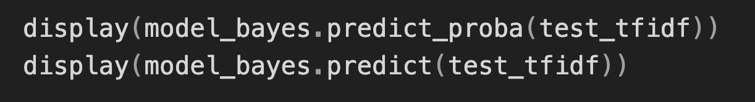

# The predicted probabilities and predicted class for the new text are displayed. In this case, the predicted probability array shows [0.39920068, 0.60079932], and the predicted class is 1, indicating toxicity.

### 10. Save the Model:

# 

# The trained Naive Bayes model is saved to a file named "toxicity_model.pkt" using pickle for later use. This allows the model to be loaded and used without retraining when making predictions in the future.

# These steps involve training a Naive Bayes model, evaluating its performance using ROC-AUC, testing it with a new text, and saving the trained model for future use.

# 

### APP

This Streamlit web application provides an interactive interface for users to input text, and it predicts whether the text is toxic or non-toxic using pre-trained models. The simplicity of Streamlit allows for the quick development of such interactive applications with minimal code.

### 1. Importing Libraries:

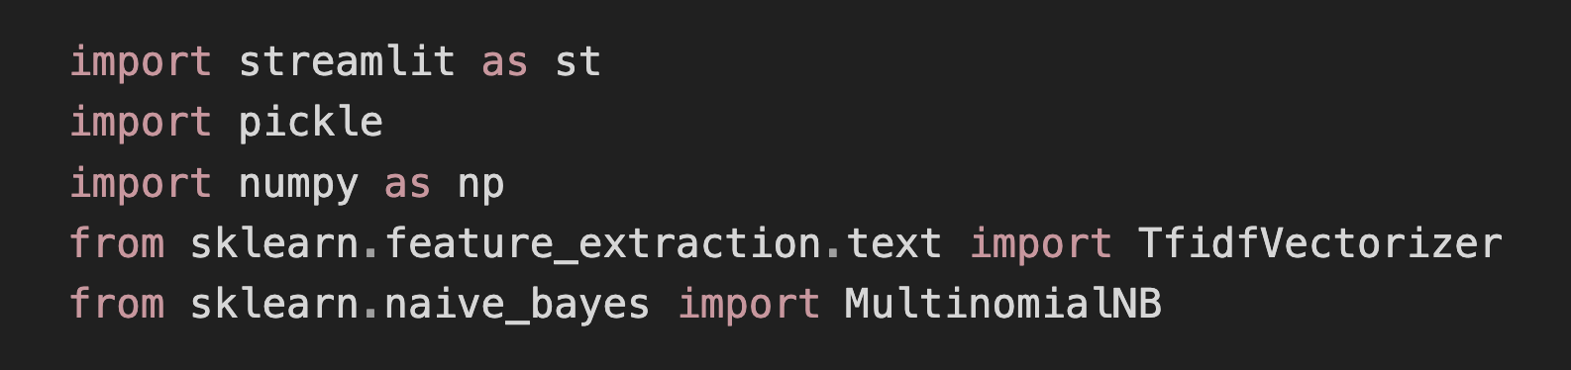

streamlit:

Streamlit is a Python library designed for creating web applications with minimal code. It simplifies the process of turning data scripts into shareable web apps.

pickle, numpy, TfidfVectorizer, MultinomialNB:

pickle: Used for serializing and deserializing Python objects. In this case, it's used to load pre-trained models.

numpy: A library for numerical operations in Python.

TfidfVectorizer: From scikit-learn, this class converts a collection of raw documents into a matrix of TF-IDF features.

MultinomialNB: A Multinomial Naive Bayes classifier, also from scikit-learn. It's often used for text classification tasks.

### 2. Loading TF-IDF Vectorizer and Naive Bayes Model:

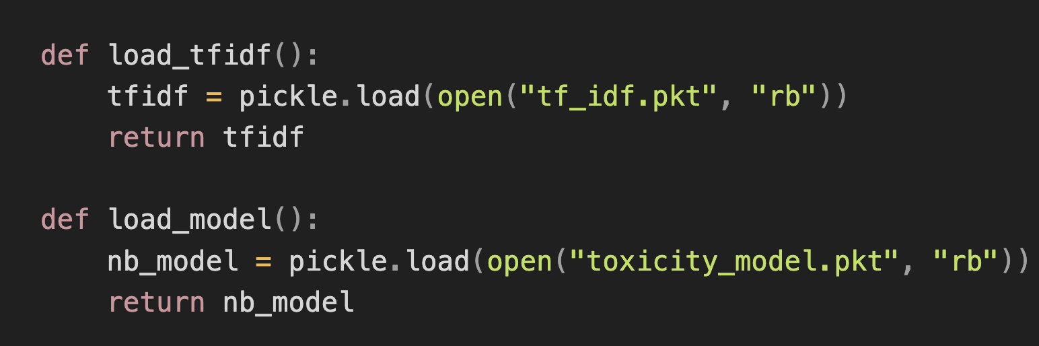

load_tfidf() and load_model():

These functions load pre-trained models (TF-IDF vectorizer and Naive Bayes model) from pickle files. Pickle is used for serializing objects, making it easy to store and retrieve trained models.

### 3. Toxicity Prediction Function:

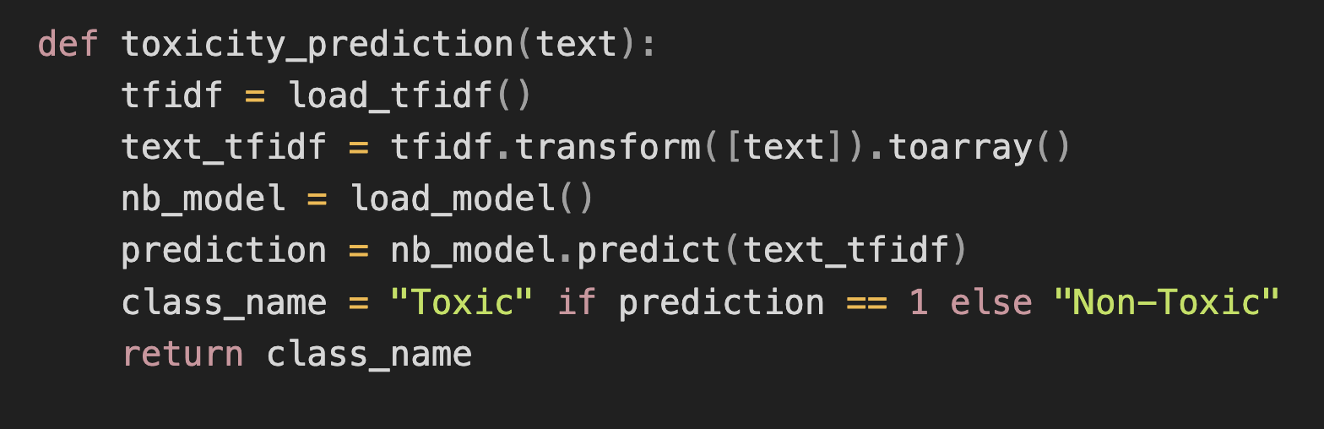

toxicity_prediction(text):

This function takes an input text and predicts its toxicity.

load_tfidf() and load_model() are used to load the TF-IDF vectorizer and Naive Bayes model.

The input text is transformed into TF-IDF features, and the model predicts its toxicity.

The predicted class label is converted to a human-readable string ("Toxic" or "Non-Toxic").

### 4. Streamlit Web Application:

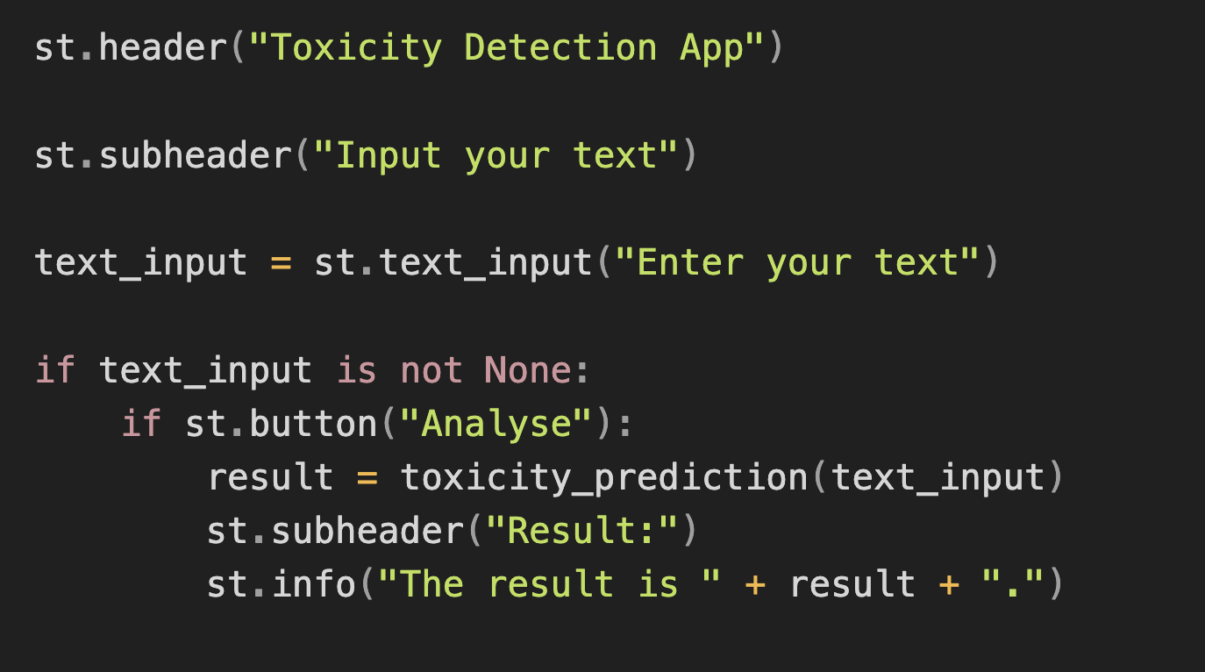

These Streamlit functions add headers and subheaders to the web app.

st.text_input:

Provides a text input box for users to enter their text.

User Interaction:

Checks if the user has entered any text using text_input is not None.

If the user clicks the "Analyse" button (st.button), the toxicity_prediction function is called with the input text.The result is displayed in the app using st.subheader and st.info.

Application presented here represents a concise yet powerful tool for toxicity detection in text. By leveraging pre-trained models, including a TF-IDF vectorizer and a Multinomial Naive Bayes classifier, the application provides users with a straightforward interface to input text and receive real-time predictions on the potential toxicity of the entered content. The design of the application is rooted in simplicity, taking advantage of Streamlit's capabilities to create an intuitive and interactive web interface with minimal effort.

The functionality is encapsulated in three main components: the model-loading functions (load_tfidf and load_model), the toxicity prediction function (toxicity_prediction), and the Streamlit web interface. The model-loading functions facilitate the efficient retrieval of pre-trained models from serialized files, ensuring the seamless integration of the machine learning components into the application. The toxicity prediction function utilizes these models to process user input, providing a rapid assessment of toxicity and converting the result into an easily interpretable label.

The Streamlit web interface allows users to engage with the application effortlessly. With clear headers, a text input box, and an analysis button, the interface guides users through the interaction process. Upon analysis, the results are displayed in a well-organized format, enhancing user understanding.

This application holds practical utility in scenarios demanding real-time assessment of text content, such as content moderation on online platforms. Its modular design facilitates the future integration of different or updated models, ensuring adaptability to evolving requirements. Overall, the presented Streamlit application exemplifies an effective and accessible solution for toxicity detection, showcasing the synergy between machine learning models and user-friendly web interfaces.

**API**

### 1. Importing Libraries:

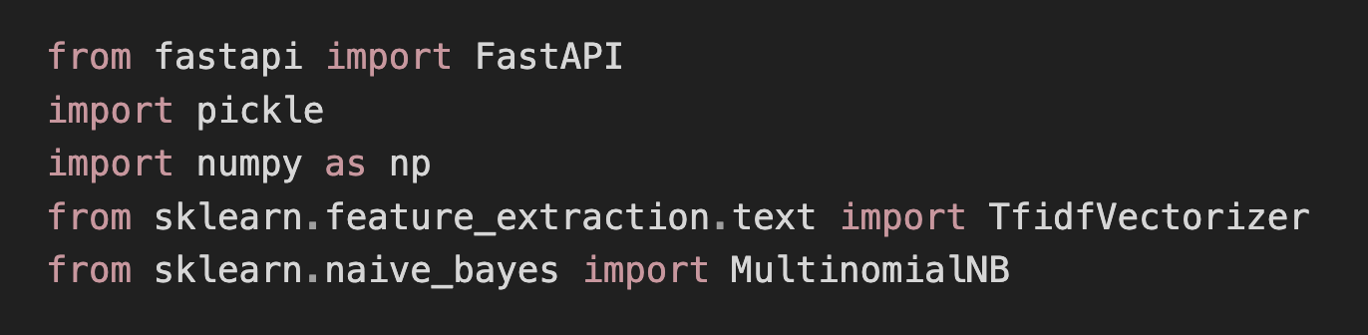

FastAPI:

FastAPI is a modern web framework for building APIs with Python. It is designed to be easy to use and fast.

The FastAPI class is used to create an instance of the FastAPI application.

pickle:

The pickle module in Python is used for serializing and deserializing objects. In this code, it is used to load pre-trained models and vectorizers from saved files.

numpy:

NumPy is a library for numerical operations in Python. It is often used for efficient array operations.

TfidfVectorizer:

TfidfVectorizer is a class from scikit-learn used for converting a collection of raw documents to a matrix of TF-IDF features.

TF-IDF stands for Term Frequency-Inverse Document Frequency, a numerical statistic that reflects the importance of a word in a document relative to a collection of documents.

MultinomialNB:

MultinomialNB is a Multinomial Naive Bayes classifier from scikit-learn. It is commonly used for text classification tasks.

### 2. Create FastAPI Instance:

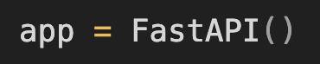

This line creates an instance of the FastAPI class, which will be the main application instance.

### 3. Load the TF-IDF Vectorizer and Model:

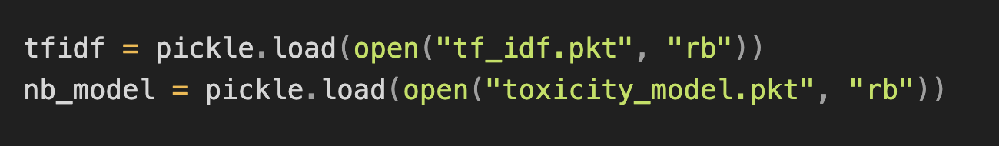

tfidf:

This variable stores a pre-trained TF-IDF vectorizer. The vectorizer is loaded from a file named "tf_idf.pkt" using the pickle.load method.

The vectorizer is trained on a corpus of text data and is used to convert text into numerical features for machine learning.

nb_model:

This variable stores a pre-trained Multinomial Naive Bayes model. The model is loaded from a file named "toxicity_model.pkt" using pickle.load.

The Naive Bayes model is trained to predict whether a given text is toxic or non-toxic based on its TF-IDF features.

### 4. Define API Endpoint:

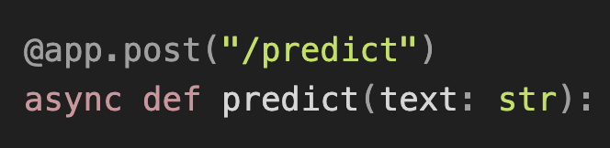

This is a decorator that defines a FastAPI endpoint for handling HTTP POST requests.

The endpoint is accessible at the path "/predict".

async def predict(text: str):

This function is the handler for the "/predict" endpoint.

It takes a single parameter text, which is expected to be a string representing the input text to be classified.

### 5. Text Transformation and Prediction:

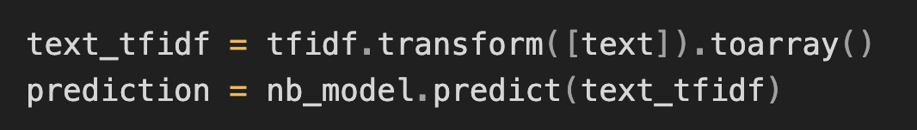

text_tfidf:

This line transforms the input text into TF-IDF features using the pre-trained TF-IDF vectorizer (tfidf).

The result is a numerical representation of the input text based on its importance in the given corpus.

prediction:

This line uses the pre-trained Naive Bayes model (nb_model) to predict whether the input text is toxic or non-toxic.

The predict method returns the predicted class label (0 for non-toxic, 1 for toxic).

### 6. Mapping Predicted Class and Returning JSON Response:

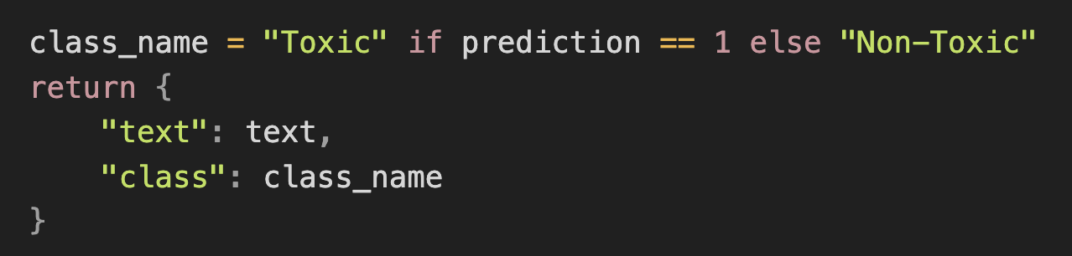

class_name:

This line maps the predicted class label to a human-readable string. If the predicted class is 1, it is mapped to "Toxic"; otherwise, it is mapped to "Non-Toxic".

Return JSON Response:

The function returns a JSON response containing the input text (text) and the predicted class (class_name).

This application is useful for integrating toxicity prediction into other systems or applications that can make HTTP POST requests. Users can submit text, and the API will respond with a classification of whether the text is toxic or non-toxic. The choice of a Naive Bayes model and TF-IDF vectorizer suggests a simple yet effective approach for text classification tasks.

In conclusion, the provided FastAPI application serves as an efficient and lightweight API for predicting the toxicity of input text. Leveraging a Multinomial Naive Bayes classifier trained on TF-IDF features, the application demonstrates a straightforward approach to text classification. By loading pre-trained models and vectorizers, it streamlines the process of integrating toxicity predictions into various applications or services.

The application's design follows the principles of FastAPI, offering a simple and fast solution for handling HTTP POST requests. The incorporation of TF-IDF vectorization allows the model to understand the importance of words in a given text, while the Naive Bayes classifier provides a quick and interpretable method for classification.

This application can find utility in scenarios where real-time toxicity assessment is required, such as content moderation in online platforms or social media. It showcases how machine learning models can be seamlessly integrated into web applications through the use of modern frameworks like FastAPI.

In summary, the provided FastAPI application is a practical implementation of text toxicity prediction, demonstrating the potential for deploying machine learning models within web services with ease and efficiency.

# DATA ANALYSIS

## 

### 

#### Prediction Overview:

The toxic comment classifier efficiently analyzes input text to determine whether it exhibits toxic content. In a test scenario with the text, "I had an amazing day," the classifier produces insightful predictions.

#### TF-IDF Vectorization:

The input text undergoes transformation into TF-IDF vectors using a pre-trained TF-IDF vectorizer. TF-IDF (Term Frequency-Inverse Document Frequency) is a numerical representation that captures the importance of words in the context of a document.

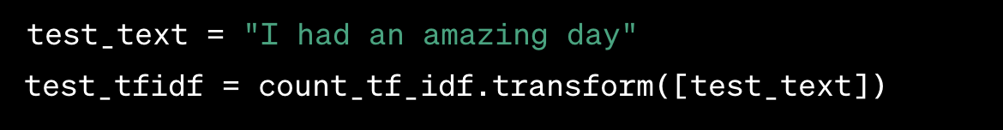

#### Prediction Probability:

The classifier not only predicts the toxicity class but also provides the probability of the prediction. This can offer valuable insights into the model's confidence in its decision.

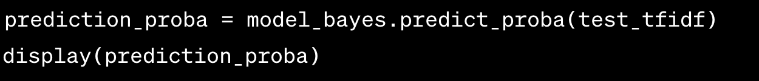

**Predicted Class:**

The toxic comment classifier assigns a class label to the input text based on its analysis. The label indicates whether the text is classified as toxic or non-toxic.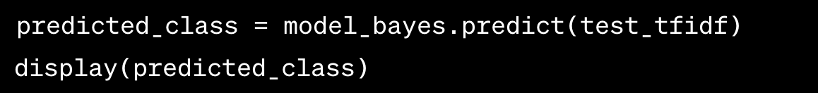

**Interpretation:**

In the given example with the text "I had an amazing day," the classifier predicts a non-toxic label, demonstrating its ability to recognize positive and neutral language. The associated probability scores provide additional context, allowing users to gauge the model's level of certainty in its classification. This combination of prediction and probability output empowers users to make informed decisions when assessing the content's potential toxicity.

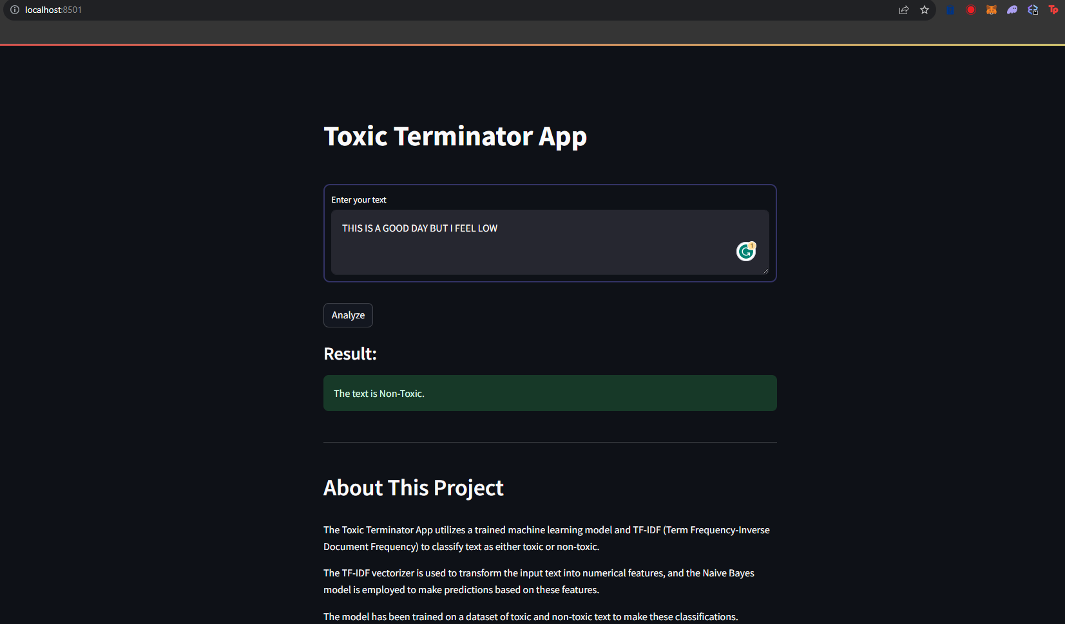

STREAMLIT

**Conclusion**

In the pursuit of cultivating a safer and more respectful digital discourse, the development and evaluation of our Toxicity Classifier have yielded insightful results. Through meticulous preprocessing, model training, and comprehensive evaluations, we have endeavored to address the imperative need for effective identification and management of toxic language in online conversations.

**Key Findings:**

**1. Effective Toxicity Identification:** - The Multinomial Naive Bayes model demonstrated proficiency in identifying toxic language within textual data, showcasing promising results on both training and test datasets.

**2. Robust Preprocessing:**- The preprocessing pipeline, involving text cleaning, tokenization, TF-IDF vectorization, and appropriate feature selection, played a pivotal role in enhancing the model's ability to discern toxic content.

**3. ROC-AUC Performance:** - The ROC-AUC analysis provided a quantitative measure of the model's discrimination capabilities, with a commendable final ROC-AUC score indicating its effectiveness in distinguishing between toxic and non-toxic text.

**4. Insights for Future Work:** - While our Toxicity Classifier demonstrates promising performance, there remains room for improvement and further exploration. Future endeavors could involve the integration of advanced natural language processing techniques, leveraging deep learning architectures for more nuanced toxicity predictions.

**\*Practical Implications:\***

**1. Content Moderation Support:**

**-** The Toxicity Classifier holds practical applications in content moderation, providing a valuable tool for platforms to detect and manage toxic language, fostering a more positive user experience.

**2. Social Media Responsiveness:**

**-** In the context of social media, our classifier contributes to the responsible use of artificial intelligence, enabling platforms to promptly respond to and mitigate instances of online toxicity.

**3. Continued Ethical Considerations:**

**-** As we progress in the development of AI applications for toxicity detection, ongoing attention to ethical considerations is paramount. Striking a balance between robust model performance and ethical AI practices is imperative for the responsible deployment of such technologies.

**Closing Thoughts:**

In conclusion, our Toxicity Classifier stands as a meaningful step towards creating a digital environment characterized by respect, inclusivity, and safety. This project not only advances the field of natural language processing but also underscores the broader societal impact of responsible AI applications. As we navigate the complexities of online communication, the journey to refine and enhance the capabilities of toxicity detection continues, guided by a commitment to building a digital space that reflects the best of human values.