1.打开neo4j 地址

cmd：

D:

打开neo4j 的bin所在目录

cd D:\neo4j-community-3.5.12\bin

neo4j start

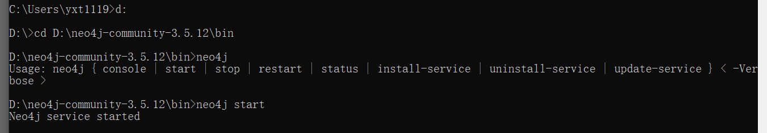

2. 导入数据

导入数据地址

neo4j-admin import --mode=csv --database=graph.db --nodes D:\neo4j-community-3.5.12\bin\importdata\actor.csv --nodes D:\neo4j-community-3.5.12\bin\importdata\director.csv --nodes D:\neo4j-community-3.5.12\bin\importdata\film_name.csv --nodes D:\neo4j-community-3.5.12\bin\importdata\type.csv --relationships D:\neo4j-community-3.5.12\bin\importdata\acted_in.csv --relationships D:\neo4j-community-3.5.12\bin\importdata\belong_to.csv --relationships D:\neo4j-community-3.5.12\bin\importdata\directed.csv --relationships D:**\**neo4j-community-3.5.12\bin\importdata\cooperation.csv

**tips：(1)输入绝对地址**

**(2)每次导入数据前要删除database中的graph.db(D:\neo4j-community-3.5.12\data\databases\graph.db)**

**3. 打开neo4j网站**<http://localhost:7474/browser/>