# Metagenome Annotation Workflow (v1.0.0)

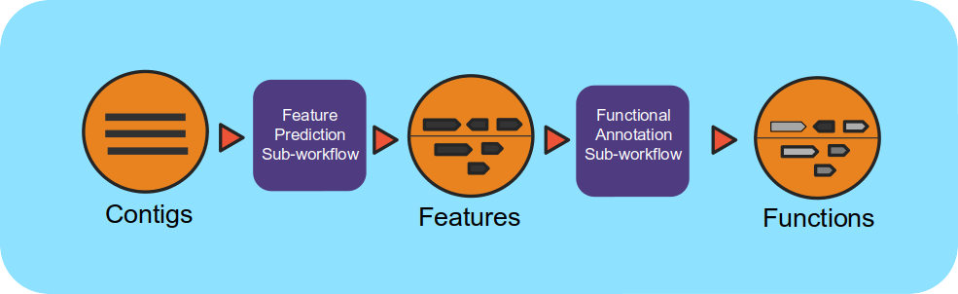

## Overview

This workflow takes assembled metagenomes and generates structural and functional annotations.

## Running the Workflow

Currently, this workflow can be run in [NMDC EDGE](https://nmdc-edge.org/home) or from the command line. (CLI instructions and requirements are found [here.](https://nmdc-workflow-documentation.readthedocs.io/en/latest/chapters/4_MetaGAnnotation_index.html))

## Input

Metagenome Annotation requires assembled contigs in a FASTA file. This input can be the output from the Metagenome Assembly workflow and this is recommended.

* **Acceptable file formats:** .fasta, .fa, .fna, .fasta.gz, .fa.gz, .fna.gz

## Details

The workflow uses a number of open-source tools and databases to generate the structural and functional annotations. The input assembly is first split into 10MB splits to be processed in parallel. Depending on the workflow engine configuration, the split can be processed in parallel. Each split is first structurally annotated, then those results are used for the functional annotation. The structural annotation uses tRNAscan_se, RFAM, CRT, Prodigal and GeneMarkS. These results are merged to create a consensus structural annotation. The resulting GFF is the input for functional annotation which uses multiple protein family databases (SMART, COG, TIGRFAM, SUPERFAMILY, Pfam and Cath-FunFam) along with custom HMM models. The functional predictions are created using Last and HMM. These annotations are also merged into a consensus GFF file. Finally, the respective split annotations are merged together to generate a single structural annotation file and single functional annotation file. In addition, several summary files are generated in TSV format.

## Software Versions

* Conda
* tRNAscan-SE >= 2.0
* Infernal 1.1.2
* CRT-CLI 1.8
* Prodigal 2.6.3
* GeneMarkS-2 >= 1.07
* Last >= 983
* HMMER 3.1b2
* TMHMM 2.0

## Output

The main outputs are the structural annotation file and the functional annotation file. The functional annotation file can be an input for the MAGs Generation workflow.

Primary Output Files Description

|  |  |
| --- | --- |
| Structural Annotation | Consensus structural annotation file from multiple tools (.gff) |
| Functional Annotation | Consensus functional annotation file from multiple tools (.gff) |
| KEGG summary | KEGG gene function tabular summary (.tsv) |
| EC summary | Enzyme Commission tabular summary (.tsv) |
| Gene phylogeny summary | Gene phylogeny tabular summary (.tsv) |

**Running the Metagenome Annotation Workflow in NMDC EDGE**

Select a workflow

1. From the Metagenomics category in the left menu bar, select ‘Run a Single Workflow’.
2. Enter a ***unique***project name with no spaces (underscores are fine).
3. A description is optional, but helpful.
4. Select ‘Metagenome Annotation’ from the dropdown menu under Workflow.

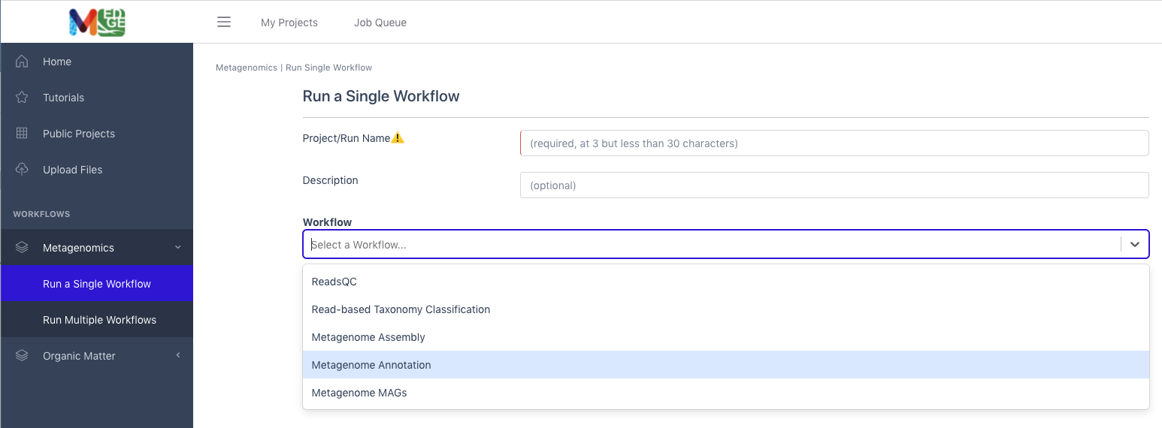

4

1

3

2

Input

This workflow accepts assembled Illumina data in FASTA format as the input; the file can be compressed. (It is highly recommended to input the assembled contigs from the Metagenome Assembly workflow.) **Acceptable file formats:** .fasta, .fa, .fna, .fasta.gz, .fa.gz, .fna.gz.

1. Click the button to the right of the input blank for data to select the data file for the analysis. (If there are separate files, there will be two input blanks.) A box called ‘Select a File’ will open to allow the user to find the desired file(s) from previously run projects, the public data folder, or files uploaded by the user.
2. Then click ‘Submit’.

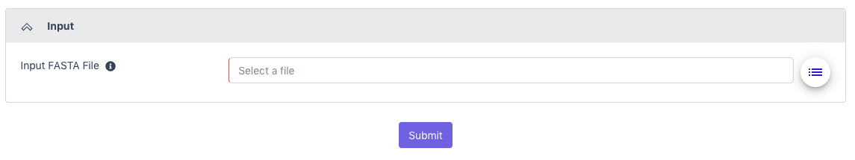

5

6

Output

The General section of the output shows which workflow was run and the run time information.

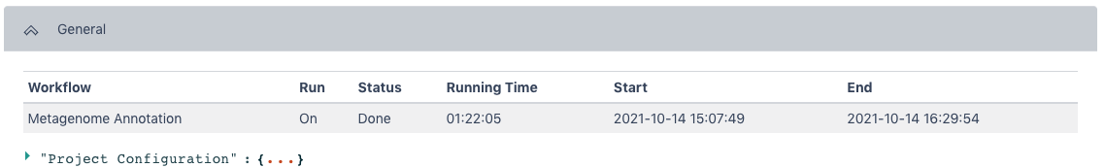

The Metagenome Annotation Result section has statistics for Processed Sequences, Predicted Genes, and General Quality Information from the workflow.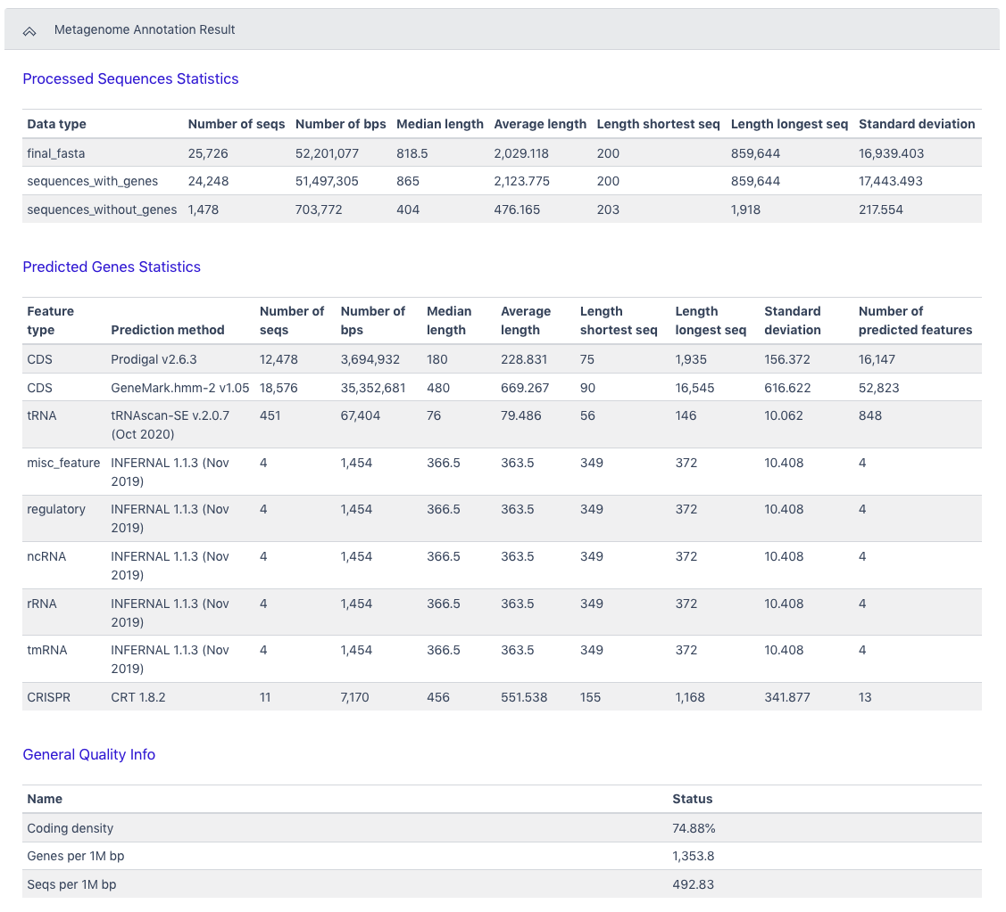

The Browser/Download Output section provides output files available to download. The primary results are the functional annotation and the structural annotation files (.gff). The functional annotation file is required input for the MAGs Generation workflow along with the assembled contigs. 