1. Checkout <https://github.com/yxycman/jenkins-standalone>
2. Step into a root folder and open for edit `*module_caller.tf*` file
3. Insert you SSH public key into `*public_key`* variable

*Optional:*

*Add or change `aws_region`, `instance_type` or any other variable. For list of all available variables reference Readme file*

1. Run `*terraform init && terraform plan*`
2. Review resources to be created and run `*terraform apply*`
3. Review resources to be created and approve execution

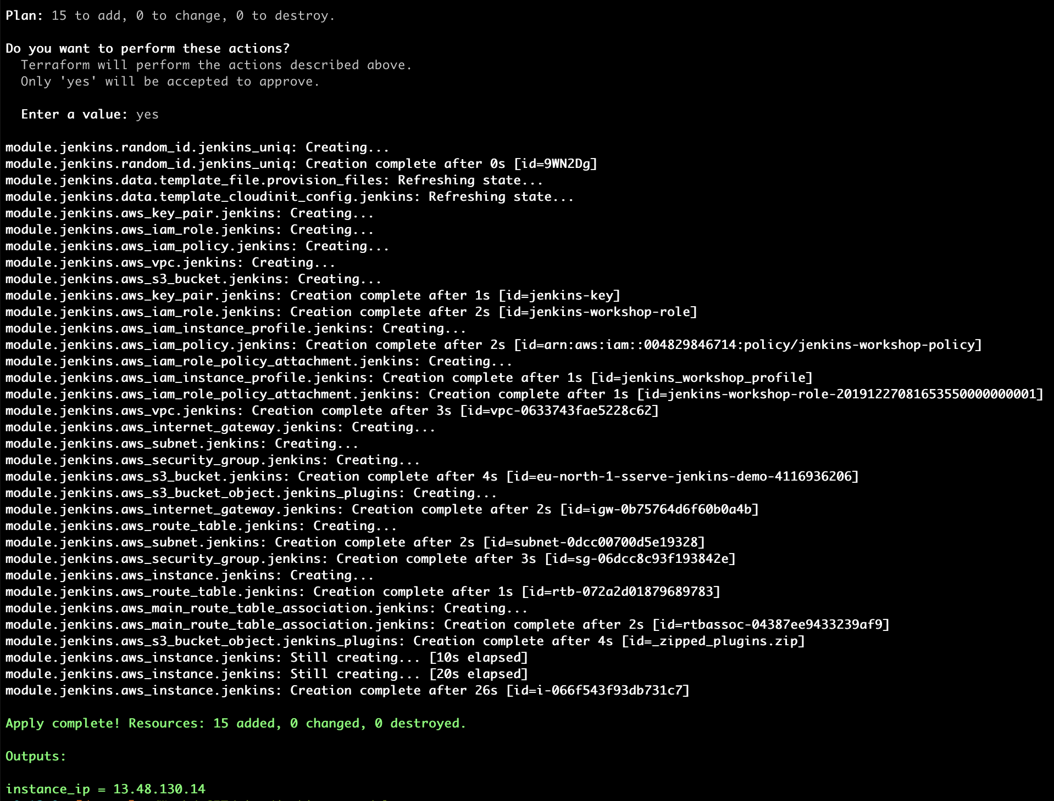

1. Pick IP address for outputs and save it. You will use this IP to connect to you Jenkins node via SSH (port 22) and HTTP (port 8080)
2. Try to login to you Jenkins node via SSH as an `*ec2-user*` with private key related to provided public one
3. Look at the setup progress in the flowing log files:

* /var/log/cloud-init-output.log
* /var/log/jenkins/jenkins.log

*Please note:*

*Jenkins’s mirrors are very unstable and sometimes packets needed for its setup cannot be downloaded.*

*In such case try to rerun init script `/var/lib/cloud/instance/scripts/runcmd` and/or restart Jenkins service*

1. In case of success, you will see Jenkins login page

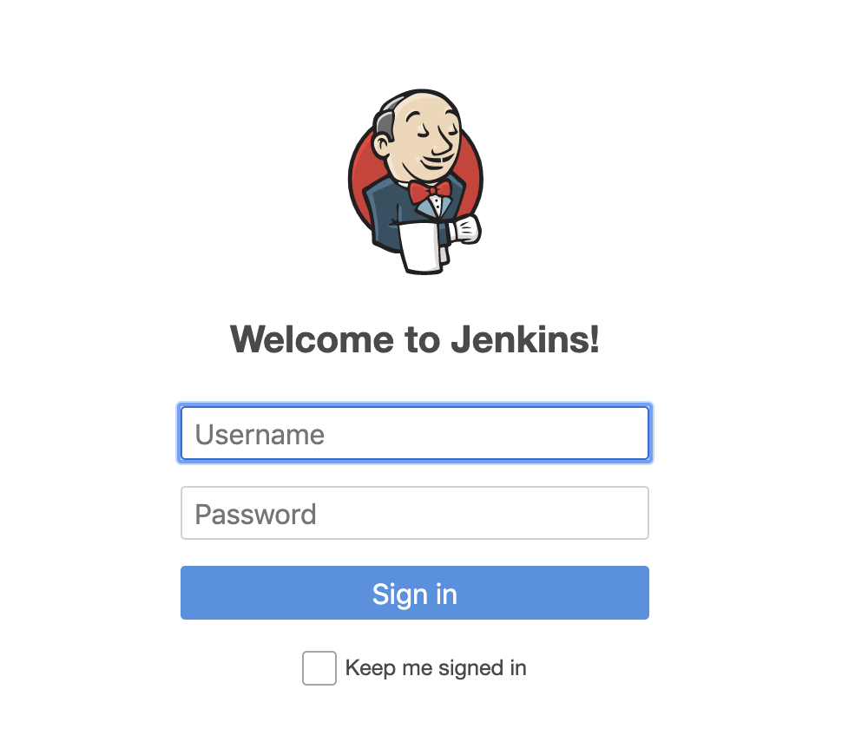

1. Use `*admin / softserve*` to login to an instance
2. Click on a `*terraform-deploy-vpc*` job and press `*Build with parameters*` button
3. Press `*Build*` button
4. Click on a ball of a newly created build on a left of the screen

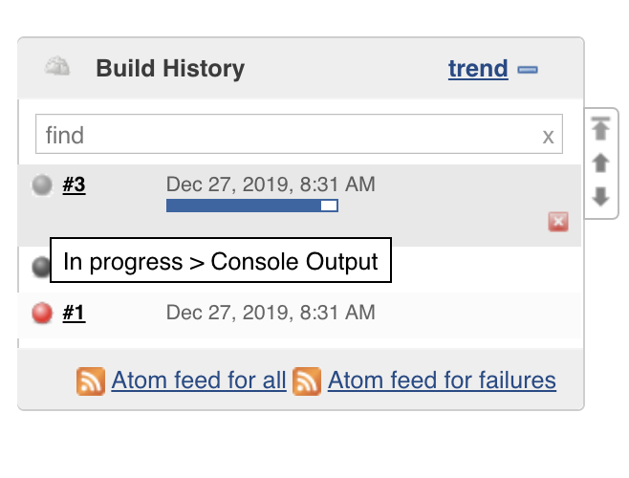

1. You will be going to see the build log with resources to be created with this stack
2. Cause our job expects your input for resources update / creation, your input is requested. Press `*Input requested*` link in the bottom of a page
3. Check `*confirm*` box and press `*Proceed*` button.
4. Your approval will be provided to a module and stack be applied.

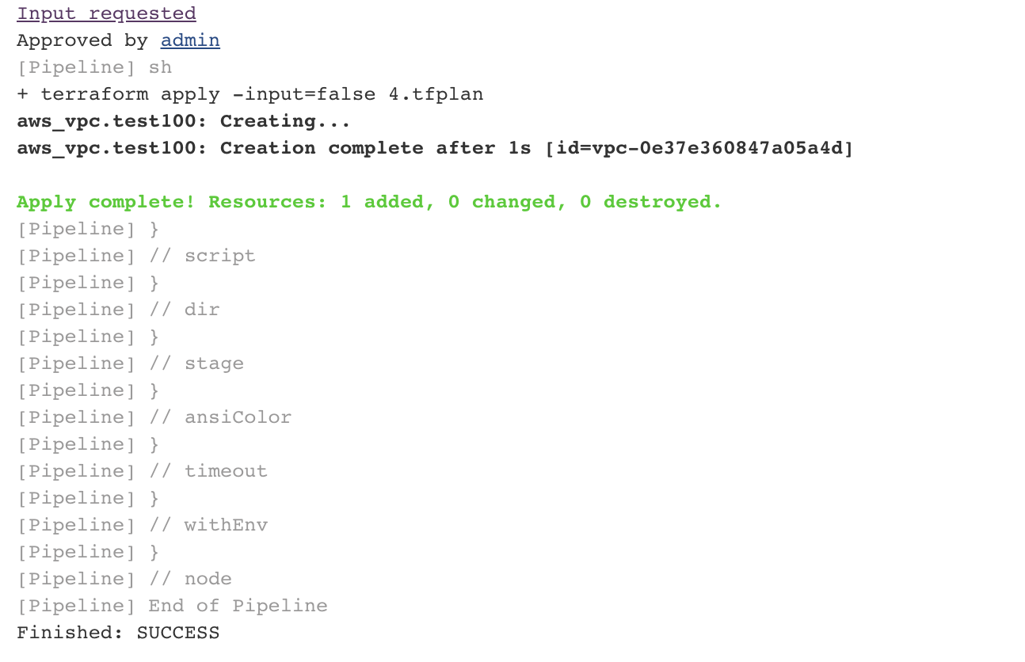

1. Review created VPC and run the same job again
2. No changes are coming from applying same code, so no resources to create. Job will end without your participation.

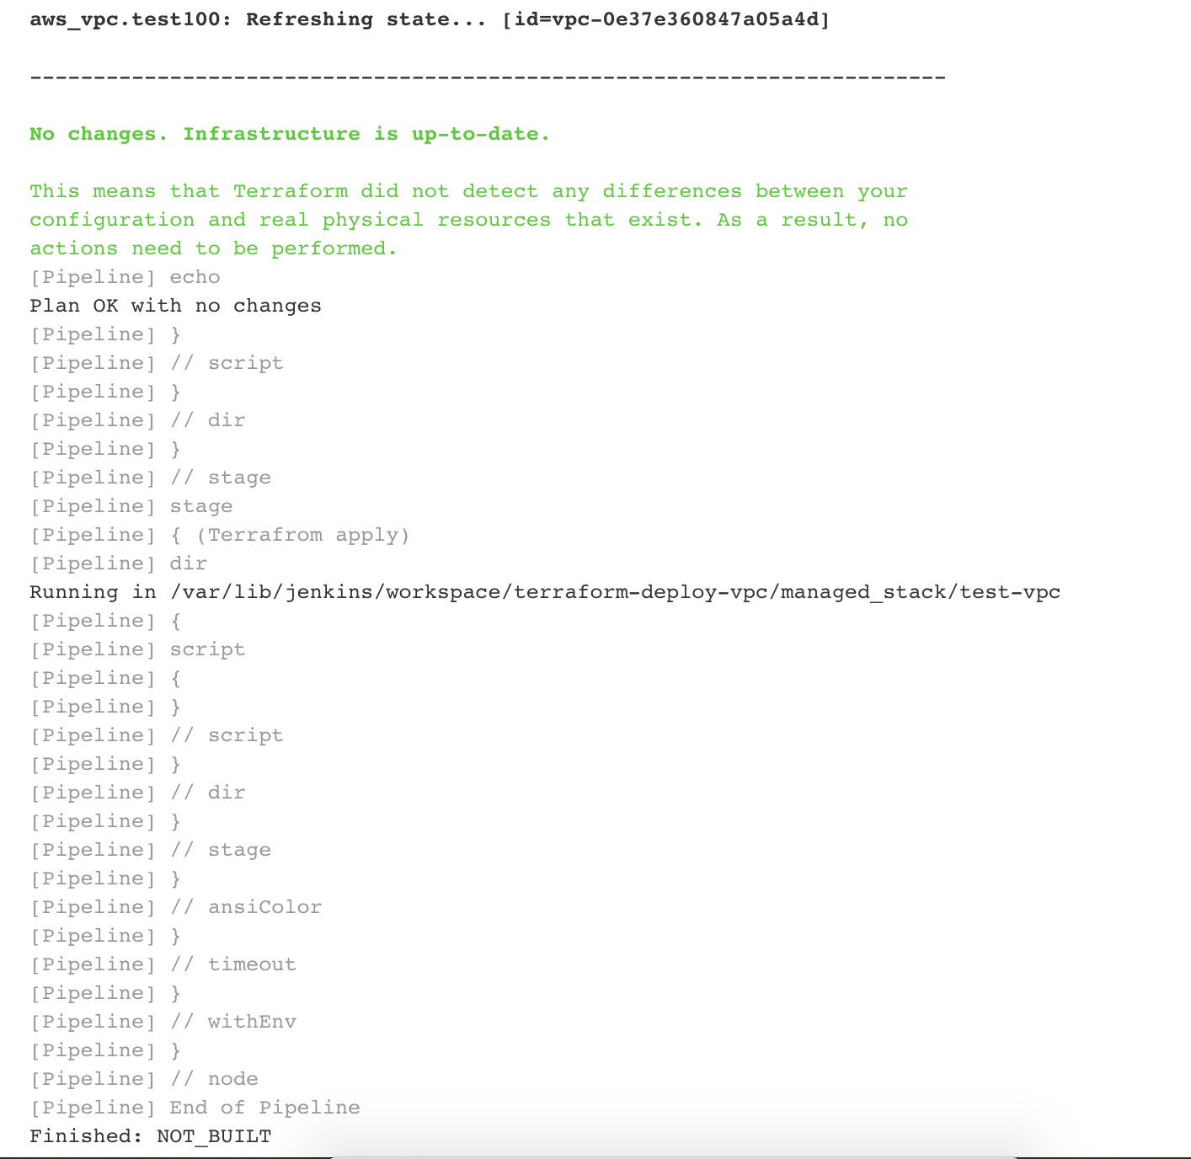

1. To cleanup, please remove created VPC manually and run *`terraform destroy*` from the root folder of this module