How to manually retrieve info from ESXi log bundle

based on tdlog result

1. Reconstruct log files 2

2. General Info 2

2.1 hostname 2

2.2 version 2

2.3 license 3

2.4 software profile 3

2.5 ntp 3

2.6 dns 4

2.7 scratch 4

2.8 boot 4

2.9 virtual machine 4

2.10 vm tools 5

3. Hardware Asset 5

3.1 server model 5

3.2 server compatibility 5

3.3 power policy 6

3.4 cpu 6

3.5 pci device 7

3.6 memory 7

4. Network 8

4.1 vswitch 8

4.2 firewall 8

4.3 vmk address 8

4.4 vmk tags 9

4.5 vswitch ports 9

4.6 vmnic 10

4.7 vmnic stats 11

5. Storage 11

5.1 vmhba 11

5.2 LUN 12

5.3 datastore 12

1. Reconstruct log files

The files in ESXi log bundle are fragmented. For example, the vsish files under Commands folder, they are vsi_traverse_-s--l-0.txt.FRAG-00000

...

vsi_traverse_-s--l-0.txt.FRAG-00309

It need be reconstructed after unzip. How to reconstruct the log files without CSP server?

1. deploy an ESXi 7.0/8.0 in nested or bare metal where we can get the vm-support command
2. upload ESXi log bundle to the ESXi host and unzip with the cmd ‘*tar zxvf <esxi-log.tgz>*’

for example:

# tar zxvf esx-w2-tse-d13.wsl.vmware.com-2024-05-30--09.32-2160407.tgz

1. reconstruct the folder after unzip with the cmd ‘*vm-support -r <folder-after-unzip>*’

for example:

# vm-support -r esx-w2-tse-d13.wsl.vmware.com-2024-05-30--09.32-2160407

NOTE:

1. The below each section to retrieve info contains three parts:
2. sample info in tdlog result file
3. path to get this info from log bundle files
4. corresponding info in ESXi log files
5. The ‘path’ means you have been in the ESXi log folder after unzip.

2. General Info

## 2.1 hostname



Path to retrieve: commands/esxcfg-info_-a.txt

Hostname:

uptime: (*microsecond*)



## 2.2 version

 Path to retrieve: commands/vmware_-vl.txt



## 2.3 license

 Path to retrieve: commands/vmware-vimdump_-o----U-dcui.txt

## 2.4 software profile

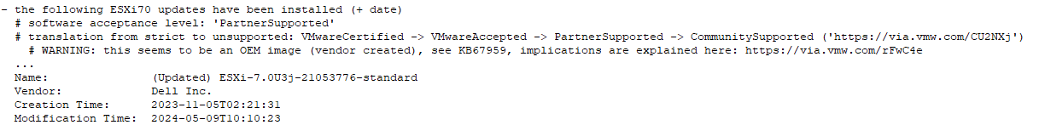 Path to retrieve: commands/localcli_software-profile-get.txt

## 2.5 ntp

 Path to retrieve: commands/vmware-vimdump_-o----U-dcui.txt

## 2.6 dns

Path to retrieve: etc/resolv.conf



## 2.7 scratch

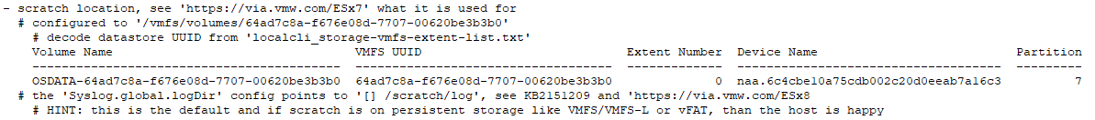

Path to retrieve: commands/vmware-vimdump_-o----U-dcui.txt

## 2.8 boot

Path to retrieve: commands/vmkfstools_-P--v-10-bootbank.txt

## 2.9 virtual machine

Path to retrieve: etc/vmware/hostd/vmInventory.xml

## 2.10 vm tools

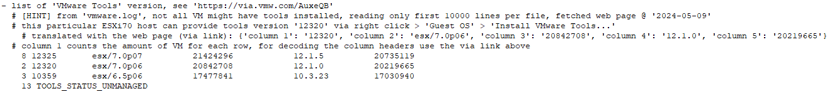

Path to retrieve: vmfs/volumes/<datastore>/<vm-name>/vmware.log



1. Hardware Asset

## 3.1 server model



Path to retrieve: commands/esxcfg-info_-a.txt

## 3.2 server compatibility

Path to retrieve: <https://www.vmware.com/resources/compatibility/search.php>

## 3.3 power policy



Path to retrieve: vsish -c commands/vsi_traverse_-s.txt

Note: vsish is a built-in cmd in ESXi host. Need to run in ESXi host.

## 3.4 cpu

Path to retrieve: vsish -c commands/vsi_traverse_-s.txt

## 3.5 pci device

Path to retrieve: commands/lspci.txt

## 3.6 memory



Path to retrieve: commands/esxcfg-info_-a.txt



1. Network

## 4.1 vswitch

Path to retrieve: commands/esxcfg-vswitch_-l.txt

## 4.2 firewall

Path to retrieve: vsish -c commands/vsi_traverse_-s.txt

vmkModules/esxfw/rulesets/<rule>/ruleset' --> 'enable status'

## 4.3 vmk address

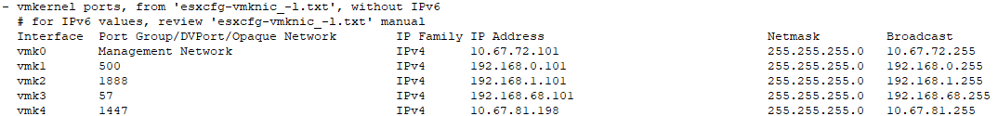

Path to retrieve: commands/esxcfg-vmknic_-l.txt



## 4.4 vmk tags

Path to retrieve: commands/esxcfg-info_-a.txt

## 4.5 vswitch ports

Path to retrieve: commands/dump-cswitch-info.py.txt，vmware-vimdump_-o----U-dcui.txt，net-stats_-l.txt

1. search vm name in dump-cswitch-info.py.txt to get the DVPortID

1. search DVPortID in vmware-vimdump_-o----U-dcui.txt

1. search portgroupkey in net-stats_-l.txt to get portgroup name

## 4.6 vmnic

Path to retrieve: commands/nicinfo.sh.txt，esxcfg-info_-a.txt

1. get pci address from nicinfo.sh.txt

1. search pci address in esxcfg-info_-a.txt to get DID, VID, SDID, SVID

1. search the device compatibility in [VMware HCL](https://www.vmware.com/resources/compatibility/search.php?deviceCategory=io) with the VID, DID, SVID, SDID

## 4.7 vmnic stats

Path to retrieve: vsish -c commands/vsi_traverse_-s.txt

1. Storage

## 5.1 vmhba

Path to retrieve: commands/localcli_storage-core-adapter-list.txt

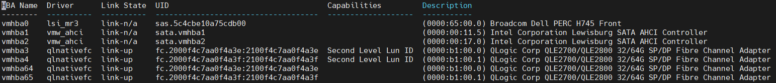

search the HBA name (eg, vmhba3) in commands/esxcfg-info_-a.txt to get VID,DID,SVID,SDID

search the DID, VID, SDID, SVID in [VMware HCL](https://www.vmware.com/resources/compatibility/search.php?deviceCategory=io)

## 5.2 LUN

Path to retrieve: commands/localcli_storage-core-device-stats-get.txt

## 5.3 datastore

Path to retrieve: commands/localcli_storage-vmfs-extent-list.txt

