Group 2
(a)(1)
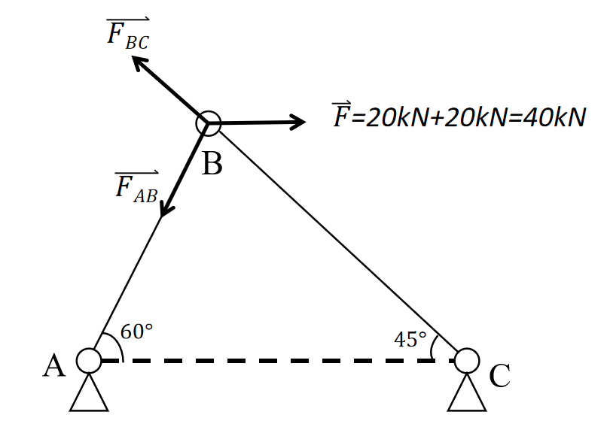

$$\left\{\begin{aligned}F_{BC}\cos{45}+F_{AB}\cos{60}-F=0 \\ F_{BC}\sin{45}-F_{AB}\sin{60}=0\end{aligned}\right.$$
The equilibrium equations become:
$$\left\{\begin{aligned}\frac{\sqrt{2}}{2}F_{BC}=\frac{\sqrt{3}}{2}F_{AB} \\ \frac{\sqrt{2}}{2}F_{BC}+\frac{1}{2}F_{AB}=40\end{aligned}\right.$$
Plugging this into the first equation:
$$\frac{\sqrt{2}}{2}\left(\frac{\sqrt{6}}{2}F_{AB}\right)+\frac{1}{2}F_{AB}=40$$
This simplifies to
$$\frac{\sqrt{3}+1}{2}F_{AB}=40$$
Solving for
$$F_{AB}=\frac{40⋅2}{\sqrt{3}+1}=\frac{80}{\sqrt{3}+1}=40\left(\sqrt{3}-1\right)$$
Thus, the force in member AB is:
$$F_{AB}=40\left(\sqrt{3}-1\right)\text{kN}$$
Similarly, substituting back to find
$$F_{BC}=\frac{\sqrt{6}}{2}F_{AB}$$
$$F_{BC}=\frac{\sqrt{6}}{2}⋅40\left(\sqrt{3}-1\right)=20\sqrt{6}\left(\sqrt{3}-1\right)$$
from
$$F_{AB}=\frac{\sqrt{2}}{\sqrt{3}}F_{BC}$$
Substitute into horizontal equilibrium:
$$\left(\sqrt{2}/2\right)F_{BC}+\frac{1}{2}\left(\frac{\sqrt{2}}{\sqrt{3}}F_{BC}\right)=40$$
Thus
$$F_{BC}=\frac{40⋅2}{\sqrt{2}\left(1+\frac{1}{\sqrt{3}}\right)}=\frac{80}{\sqrt{2}\left(\frac{\sqrt{3}+1}{\sqrt{3}}\right)}=40\frac{\sqrt{6}}{\sqrt{3}+1}$$
Rationalizing the denominator:
$$F_{BC}=40\frac{\sqrt{6}\left(\sqrt{3}-1\right)}{3-1}=20\sqrt{6}\left(\sqrt{3}-1\right)\text{kN}$$
Expanding or evaluating the numeric values of these forces:
$$\sqrt{3}≈and\sqrt{6}≈2.44$$
So:
$$F_{AB}=40\left(1.732-1\right)=40\left(0.732\right)≈29.28\text{kN}$$
$F_{BC}=20\left(2.449\right)\left(0.732\right)=20\left(1.791\right)≈35.82\text{kN}$

These match the symbolic forms obtained:
$$F_{AB}=-40+40\sqrt{3}kN$$
$$F_{BC}=-20\sqrt{6}+60\sqrt{2}kN$$

Axial Stress in Members AB and BC:
$$A_{\text{net}}=\left(W-d\right) t$$
For this bracket, W=4 mm and t=12mm. So
$A_{\text{net}}=\left(45-d\right)×12{\text{mm}}^{2}$.
The axial stress in each member is:
$$σ_{AB}=\frac{F_{AB}}{\left(45-d\right) \left(12\right)}$$
$$σ_{BC}=\frac{F_{BC}}{\left(45-d\right) \left(12\right)}$$
where forces are in Newtons and area in mm² to yield stress in kN/mm² (MPa). In symbolic form, using the expressions derived above for the forces, we have for example:
$$σ_{AB}=\frac{40\left(\sqrt{3}-1\right)\text{ kN}}{\left(45-d\right)⋅12{\text{mm}}^{2}}$$

(a)(2)
Shear Stress in Pins A, B, C:
Each pin has diameter d and is subject to shear due to the forces transmitted through it. The cross-sectional area of a pin (circular cross-section) is $A_{\text{pin}}=\frac{π}{4}d^{2}$. Thus, the average shear stress in pin A due to force $F_{AB}$ is:
$$τ_{A}=\frac{\text{shear force on one plane}}{A_{\text{pin}}}=\frac{F_{AB}/2}{\frac{π}{4}d^{2}}=\frac{2F_{AB}}{πd^{2}}$$
Similarly, pin C carries force $F_{BC}$ in double shear, so:
$$τ_{C}=\frac{2F_{BC}}{πd^{2}}$$
The critical shear stress is $τ_{C}=\frac{2F_{BC}}{πd^{2}}, since F_{BC}>F_{AB}$
(a)(3)
Bearing Stress in the Members:
Assuming the support at A is rigid and stronger, we consider the member’s material bearing stress:
$$σ_{b,A}=\frac{F_{AB}}{d⋅t}$$
$$σ_{b,C}=\frac{F_{BC}}{d⋅t}$$
An effective bearing force of $F_{BC}/2$ on each side of the hole:
$$σ_{b,B,\text{(in BC)}}=\frac{F_{BC}/2}{d⋅t}=\frac{F_{BC}}{2dt}$$
For clarity, we summarize the stress formulas for each type, using
$$A_{\text{net}}=\left(45-d\right)mm^{2}and A_{\text{pin}}=\frac{π}{4}d^{2}$$
Axial stress in member BC:
$$σ_{BC}\left(d\right)=\frac{F_{BC}}{\left(45-d\right) 12}$$
Shear stress in pin C:
$$τ_{C}\left(d\right)=\frac{2 F_{BC}}{π d^{2}}$$
Bearing stress in member BC at pin C:
$$σ_{b,C}\left(d\right)=\frac{F_{BC}}{d⋅12}$$

(b)

d | σAB | σBC | τA | τC | σbsA | σbsB | σbsC
0.0125 | 75.08213 | 91.95646 | 119.3057 | 146.1191 | 195.2135 | 119.5434 | 239.0868
0.01375 | 78.08542 | 95.63472 | 98.59978 | 120.7596 | 177.4669 | 108.6758 | 217.3516
0.015 | 81.33898 | 99.6195 | 82.8512 | 101.4716 | 162.678 | 99.6195 | 199.239
0.01625 | 84.87546 | 103.9508 | 70.59511 | 86.461 | 150.1643 | 91.95646 | 183.9129
0.0175 | 88.73343 | 108.6758 | 60.87027 | 74.55055 | 139.4382 | 85.38814 | 170.7763
0.01875 | 92.95883 | 113.8509 | 53.02477 | 64.94182 | 130.1424 | 79.6956 | 159.3912
0.02 | 97.60677 | 119.5434 | 46.6038 | 57.07777 | 122.0085 | 74.71462 | 149.4292
0.02125 | 102.744 | 125.8352 | 41.28226 | 50.56024 | 114.8315 | 70.31964 | 140.6393
0.0225 | 108.452 | 132.826 | 36.82276 | 45.09848 | 108.452 | 66.413 | 132.826
0.02375 | 114.8315 | 140.6393 | 33.04868 | 40.4762 | 102.744 | 62.91758 | 125.8352
0.025 | 122.0085 | 149.4292 | 29.82643 | 36.52977 | 97.60677 | 59.7717 | 119.5434
0.02625 | 130.1424 | 159.3912 | 27.05345 | 33.13358 | 92.95883 | 56.92543 | 113.8509
0.0275 | 139.4382 | 170.7763 | 24.64994 | 30.18989 | 88.73343 | 54.33791 | 108.6758
0.02875 | 150.1643 | 183.9129 | 22.55307 | 27.62176 | 84.87546 | 51.97539 | 103.9508
0.03 | 162.678 | 199.239 | 20.7128 | 25.3679 | 81.33898 | 49.80975 | 99.6195
0.03125 | 177.4669 | 217.3516 | 19.08892 | 23.37905 | 78.08542 | 47.81736 | 95.63472
0.0325 | 195.2135 | 239.0868 | 17.64878 | 21.61525 | 75.08213 | 45.97823 | 91.95646
0.03375 | 216.9039 | 265.652 | 16.36567 | 20.04377 | 72.30131 | 44.27533 | 88.55066
0.035 | 244.0169 | 298.8585 | 15.21757 | 18.63764 | 69.71912 | 42.69407 | 85.38814
0.03625 | 278.8765 | 341.5526 | 14.18618 | 17.37445 | 67.31502 | 41.22186 | 82.44372
0.0375 | 325.3559 | 398.478 | 13.25619 | 16.23545 | 65.07118 | 39.8478 | 79.6956
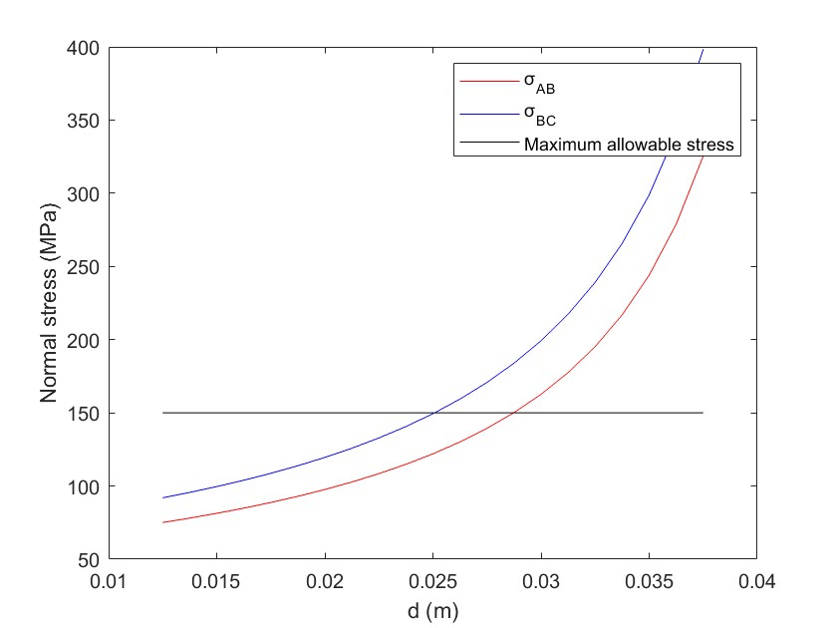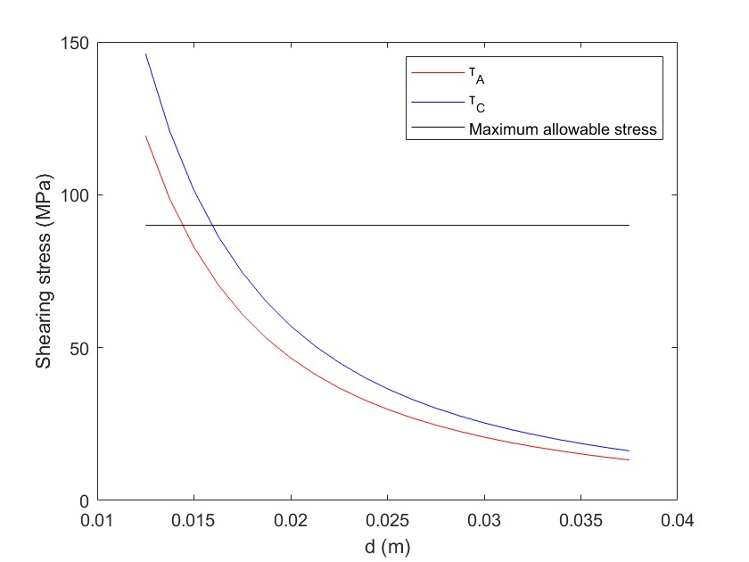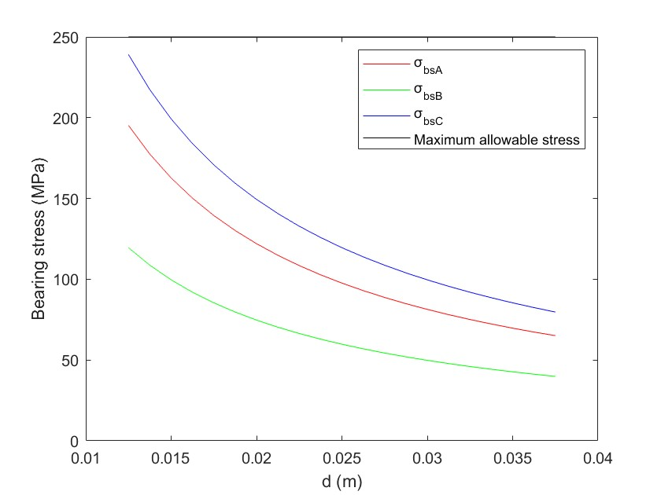
(c)
The steel material in the bracket has allowable stresses of
$$\left\{\begin{aligned}σ_{max}=\frac{F_{BC}}{(45-d)*12mm}<150μPa \\ τ_{max}=\frac{\frac{1}{2}F_{BC}}{\frac{π}{4}d^{2}}<90μPa \\ σ_{bsmax}=\frac{F_{BC}}{dδ}<250μPa\end{aligned}\right.$$
Plugging $F_{BC}=35.863×{10}^{3}$N, we get:
$$\left(45-d\right)⋅12≥\frac{35 863}{150}=239.09{\text{mm}}^{2}$$
Solve for d: $45 - d ≥19.92$mm, so
$$d≤45-19.92=25.08\text{mm}$$
Thus, to keep axial stress ≤150MPa, the pin diameter must not exceed about 25.0mm. If the pin gets too large, the net area$\left(45-d\right)$ becomes too small, raising axial stress above the limit. In other words, there is an upper bound on d from this criterion: $d_{max}≈25.0$mm.
Shear stress constraint: $τ_{C}\left(d\right)≤90$MPa. With $τ_{C}=\frac{2F_{BC}}{πd^{2}}$, the inequality is:
$$\frac{2F_{BC}}{πd^{2}}≤90\text{MPa}$$
Solve for d: $d^{2}≥\frac{2F_{BC}}{90π}$ . Using $F_{BC}=35.863×{10}^{3}$N,
$$d^{2}≥\frac{2\left(35 863\right)}{90π}=253.6{\text{mm}}^{2}$$
So $d≥\sqrt{253.6}$. This gives
$$d≥15.93\text{mm }$$
Pin A, carrying the smaller $F_{AB},wouldgived≥14.4$mm, so pin C is indeed the controlling case for shear.
Bearing stress constraint: $σ_{b,C}\left(d\right)≤250$.$σ_{b,C}=\frac{F_{BC}}{d,12}$, we get:
$$\frac{F_{BC}}{12 d}≤250\text{MPa}$$
Solve for d: $12, d≥\frac{F_{BC}}{250}$ , so
$$d≥\frac{F_{BC}}{250⋅12}$$
Numerically, $d≥\frac{35,863}{3,000}=11.95$ mm.
$$d≥11.95\text{mm }$$
Therefore, the permissible range of pin diameter is approximately
$$\left\{\begin{aligned}d<45-\frac{35863}{150*12}=25.026mm \\ d>\sqrt{\frac{2F_{BC}}{90*π}}=15.927mm \\ d>\frac{F_{BC}}{8.250}=11.95mm\end{aligned}\right.$$
So we get,
$$15.93\text{mm}≤ d ≤25.0\text{mm}$$

d | σAB | σBC | τA | τC | σbsA | σbsB | σbsC
0.01625 | 84.87546 | 103.9508 | 70.59511 | 86.461 | 150.1643 | 91.95646 | 183.9129
0.0175 | 88.73343 | 108.6758 | 60.87027 | 74.55055 | 139.4382 | 85.38814 | 170.7763
0.01875 | 92.95883 | 113.8509 | 53.02477 | 64.94182 | 130.1424 | 79.6956 | 159.3912
0.02 | 97.60677 | 119.5434 | 46.6038 | 57.07777 | 122.0085 | 74.71462 | 149.4292
0.02125 | 102.744 | 125.8352 | 41.28226 | 50.56024 | 114.8315 | 70.31964 | 140.6393
0.0225 | 108.452 | 132.826 | 36.82276 | 45.09848 | 108.452 | 66.413 | 132.826
0.02375 | 114.8315 | 140.6393 | 33.04868 | 40.4762 | 102.744 | 62.91758 | 125.8352
0.025 | 122.0085 | 149.4292 | 29.82643 | 36.52977 | 97.60677 | 59.7717 | 119.5434

(d)

d | σAB | σBC | τA | τC | σbsA | σbsB | σbsC
0.01875 | 88.73343 | 108.6758 | 53.02477 | 64.94182 | 195.2135 | 119.5434 | 239.0868
0.02 | 91.50635 | 112.0719 | 46.6038 | 57.07777 | 183.0127 | 112.0719 | 224.1439
0.02125 | 94.45817 | 115.6872 | 41.28226 | 50.56024 | 172.2472 | 105.4795 | 210.9589
0.0225 | 97.60677 | 119.5434 | 36.82276 | 45.09848 | 162.678 | 99.6195 | 199.239
0.02375 | 100.9725 | 123.6656 | 33.04868 | 40.4762 | 154.116 | 94.37637 | 188.7527
0.025 | 104.5787 | 128.0822 | 29.82643 | 36.52977 | 146.4102 | 89.65755 | 179.3151
0.02625 | 108.452 | 132.826 | 27.05345 | 33.13358 | 139.4382 | 85.38814 | 170.7763
0.0275 | 112.6232 | 137.9347 | 24.64994 | 30.18989 | 133.1001 | 81.50686 | 163.0137
0.02875 | 117.1281 | 143.4521 | 22.55307 | 27.62176 | 127.3132 | 77.96308 | 155.9262
0.03 | 122.0085 | 149.4292 | 20.7128 | 25.3679 | 122.0085 | 74.71462 | 149.4292
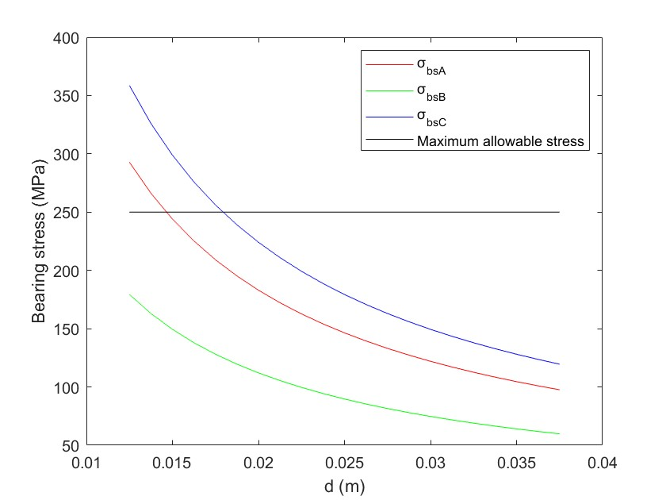

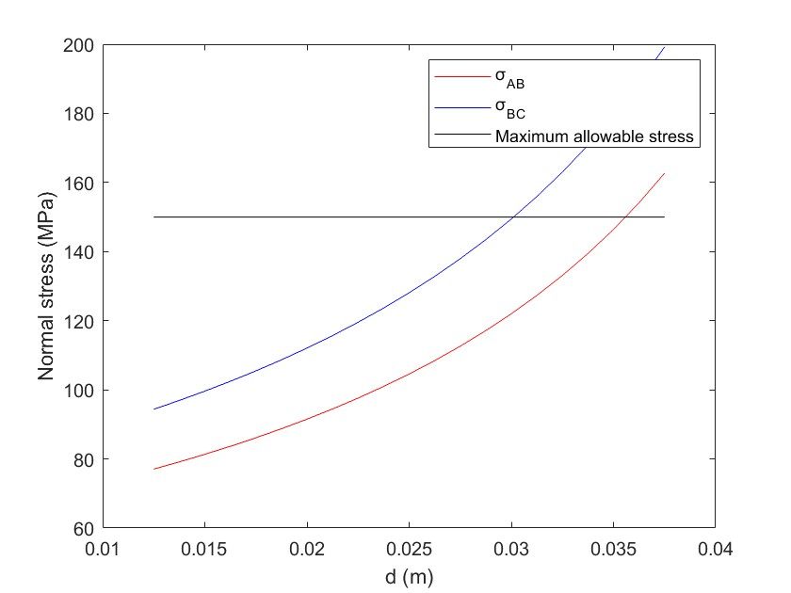

Appendix: Code Listings

MATLAB Code for Stress Calculations and Diameter Selection (original user-provided code, adjusted for clarity):

clear
clc
close all

d=0.001*(12.5:1.25:37.5);
a=0.001*45;
delta=0.001*12;

sAB=zeros(1,length(d));
sBC=zeros(1,length(d));

tA=zeros(1,length(d));
tC=zeros(1,length(d));

sbsA=zeros(1,length(d));
sbsB=zeros(1,length(d));
sbsC=zeros(1,length(d));

for i=1:length(d)
[sAB(i),sBC(i)]=jie1(a,d(i),delta);
[tA(i),tC(i)]=jie2(a,d(i),delta);
[sbsA(i),sbsB(i),sbsC(i)]=jie3(a,d(i),delta);
end

figure
plot(d,sAB,'r')
hold on
plot(d,sBC,'b')
hold on
plot(d,ones(1,length(d))*150,'k')
hold on
xlabel('d (m)')
ylabel('Normal stress (MPa)')
legend('σ_{AB}','σ_{BC}','Maximum allowable stress')

figure
plot(d,tA,'r')
hold on
plot(d,tC,'b')
hold on
plot(d,ones(1,length(d))*90,'k')
hold on
xlabel('d (m)')
ylabel('Shearing stress (MPa)')
legend('τ_A','τ_C','Maximum allowable stress')

figure
plot(d,sbsA,'r')
hold on
plot(d,sbsB,'g')
hold on
plot(d,sbsC,'b')
hold on
plot(d,ones(1,length(d))*250,'k')
hold on
xlabel('d (m)')
ylabel('Bearing stress (MPa)')
legend('σ_{bsA}','σ_{bsB}','σ_{bsC}','Maximum allowable stress')

result=[d; sAB; sBC; tA; tC; sbsA; sbsB; sbsC];

%% q3
d3=zeros(1,length(d));
result3=zeros(8,length(d));
for i=1:length(d3)
if sBC(i)<=150
if tC(i)<=90
if sbsC(i)<=250
result3(:,i)=result(:,i);
d3(i)=d(i);
end
end
end
end
d3;
result3;

%% q4
clear
clc
close all

d=0.001*(12.5:1.25:37.5);
a=0.001*60;
delta=0.001*8;

sAB=zeros(1,length(d));
sBC=zeros(1,length(d));

tA=zeros(1,length(d));
tC=zeros(1,length(d));

sbsA=zeros(1,length(d));
sbsB=zeros(1,length(d));
sbsC=zeros(1,length(d));

for i=1:length(d)
[sAB(i),sBC(i)]=jie1(a,d(i),delta);
[tA(i),tC(i)]=jie2(a,d(i),delta);
[sbsA(i),sbsB(i),sbsC(i)]=jie3(a,d(i),delta);
end

figure
plot(d,sAB,'r')
hold on
plot(d,sBC,'b')
hold on
plot(d,ones(1,length(d))*150,'k')
hold on
xlabel('d (m)')
ylabel('Normal stress (MPa)')
legend('σ_{AB}','σ_{BC}','Maximum allowable stress')

figure
plot(d,tA,'r')
hold on
plot(d,tC,'b')
hold on
plot(d,ones(1,length(d))*90,'k')
hold on
xlabel('d (m)')
ylabel('Shearing stress (MPa)')
legend('τ_A','τ_C','Maximum allowable stress')

figure
plot(d,sbsA,'r')
hold on
plot(d,sbsB,'g')
hold on
plot(d,sbsC,'b')
hold on
plot(d,ones(1,length(d))*250,'k')
hold on
xlabel('d (m)')
ylabel('Bearing stress (MPa)')
legend('σ_{bsA}','σ_{bsB}','σ_{bsC}','Maximum allowable stress')

result=[d; sAB; sBC; tA; tC; sbsA; sbsB; sbsC];

d3=zeros(1,length(d));
result3=zeros(8,length(d));
for i=1:length(d3)
if sBC(i)<=150
if tC(i)<=90
if sbsC(i)<=250
result3(:,i)=result(:,i);
d3(i)=d(i);
end
end
end
end
d3;
result3;

Explanation: The MATLAB script above computes $σ_{AB} , σ_{BC}, τ_{A}, τ_{C}, σ_{bsA}, σ_{bsB}, σ_{bsC}$ for each candidate diameter. It then checks which diameters meet all three allowable stress criteria. The forces $F_{AB}$ and $F_{BC}$ are inserted symbolically (and converted to numeric). The output feasible would contain the list of diameters [16.25, 17.5, …, 25] as derived analytically.

Python Code for Plotting Stress vs Diameter:

import numpy as np
import matplotlib.pyplot as plt

Known forces in N
F_AB = 40*(np.sqrt(3)-1) * 1000 # N
F_BC = (-20*np.sqrt(6) + 60*np.sqrt(2)) * 1000 # N

# Geometry
W = 45.0 # mm
t = 12.0 # mm

# Diameter range (mm)
d_vals = np.arange(12.5, 37.51, 1.25) # 12.5 to 37.5 step 1.25

# Calculate stresses for member/pin C (worst case)
sigma_BC_vals = F_BC / ((W - d_vals) * t) # axial stress in BC (N/mm^2)
tau_C_vals = (0.5 * F_BC) / ((np.pi/4) * d_vals**2) # shear stress in pin C (N/mm^2)
sigma_bC_vals = F_BC / (d_vals * t) # bearing stress in BC at C (N/mm^2)

# Plot the results
plt.figure()
plt.plot(d_vals, sigma_BC_vals, label='Axial stress in BC (MPa)')
plt.plot(d_vals, tau_C_vals, label='Shear stress in pin C (MPa)')
plt.plot(d_vals, sigma_bC_vals, label='Bearing stress in BC (MPa)')
plt.axhline(y=150, color='r', linestyle='--', label='Axial allowable 150 MPa')
plt.axhline(y=90, color='g', linestyle='--', label='Shear allowable 90 MPa')
plt.axhline(y=250, color='b', linestyle='--', label='Bearing allowable 250 MPa')
plt.xlabel('Pin Diameter d (mm)')
plt.ylabel('Stress (MPa)')
plt.title('Stress vs Pin Diameter for critical locations')
plt.legend()
plt.grid(True)
plt.show()

This Python script uses the same formulas to compute stresses for member BC and pin C across the diameter range, and then plots them with matplotlib. The horizontal lines indicate the allowable stress limits. Running this code produced the plot shown in the Results section, which confirms the analytical findings: the safe region where all stress curves are below the limits corresponds to $16~\text{mm} \lesssim d \lesssim 25~\text{mm}$.

