FreqXer: A Phase-Aware Frequency-Domain Enhancement Model for Photovoltaic Power Forecasting
ABSTRACT
The strong volatility, intermittency, and non-stationarity of photovoltaic (PV) power generation pose severe challenges to the safe and stable operation of the power grid. To address this, this paper proposes FreqXer, a time-frequency co-enhancement model for photovoltaic power forecasting. At the data level, the model adopts an STL-VMD two-stage decomposition front end that progressively decomposes the raw time series into trend, seasonal, and multi-scale fluctuation components, and is optimized jointly with the forecasting backbone in an end-to-end differentiable manner, mitigating future information leakage at the data level. On this basis, TimeXer is adopted as the backbone to capture endogenous temporal dependencies and the causal relations between endogenous and exogenous variables, and a lightweight phase-aware frequency-domain enhancement module, AGFE, is embedded between the self-attention and cross-attention of the encoder layer. AGFE extracts the instantaneous amplitude and phase via the Hilbert transform, generates adaptive gating signals, and dynamically enhances the DFT spectrum. Experiments on real PV data show that FreqXer outperforms several baselines in terms of MSE, RMSE, and MAE; ablation studies verify the synergistic effect of data decomposition and phase enhancement, and the model is particularly effective under non-stationary weather conditions. In the four tasks with prediction lengths H = 24, 48, 96, and 192, FreqXer consistently achieves the best results, and its RMSE reduction over the TimeXer backbone widens as the prediction length increases; seasonal case studies and cross-dataset generalization experiments on the DKASC dataset further show that the model maintains robust prediction gains under highly volatile scenarios and out-of-distribution climatic conditions.
Keywords: photovoltaic power forecasting; TimeXer; data decomposition; Hilbert transform; phase-aware frequency enhancement
1. INTRODUCTION
Against the backdrop of an accelerating low-carbon transition of the global energy mix, photovoltaic power has become one of the fastest-growing renewable energy sources in power systems. With the advancement of the “dual carbon” goals, China’s installed PV capacity has also grown rapidly, and large numbers of centralized and distributed PV plants have been connected to the grid [1]. However, PV output is affected by multiple meteorological factors such as solar irradiance, temperature, humidity, and wind speed, exhibiting strong randomness, intermittency, and non-stationarity. In power systems with a high proportion of PV, large-scale grid integration poses severe challenges to peak shaving, frequency regulation, reserve capacity allocation, and power quality [2]. Accurate PV power forecasting is a key technology for ensuring the safe and stable operation of the grid and improving the accommodation of renewable energy; its accuracy directly affects the quality and economic benefit of power dispatch decisions [3]. For short-term forecasting of a practical PV plant, a model must not only characterize the temporal evolution of the target power series itself, but also make reasonable use of multi-dimensional meteorological variables to adapt to the continuously changing power-response relationship under different weather conditions [4,5].
Compared with traditional statistical models, deep learning has become the mainstream approach for time series forecasting because of its powerful feature-extraction and nonlinear-mapping capabilities [6]. Early recurrent networks suffered from vanishing gradients and could not easily learn long-range dependencies [7,8], whereas attention-based Transformer architectures, with their inherent parallelism and self-attention, represent an important breakthrough and capture global dependencies well [9]. Nevertheless, standard Transformers still struggle to fully capture the multi-scale and frequency-domain patterns of strongly non-stationary, noisy signals [10].
Wang et al. proposed TimeXer, which enhances the forecasting of endogenous variables by integrating exogenous variables through a multi-granularity embedding scheme that combines patch-level self-attention with variate-level cross-attention, together with a learnable global endogenous token that promotes information flow among variables; it has shown superior performance on several real-world datasets [11,12]. TimeXer offers a new perspective for non-stationary forecasting, yet its attention operates mainly on temporal patch sequences: it lacks a hierarchical decoupling of trend and fluctuation components and thus struggles with the mixing of multi-scale PV signals [13], and it makes no explicit use of frequency-domain structure, failing to exploit the temporal-structure information contained in the signal phase [14].
Signal decomposition is another important line of research. By decomposing the raw series into intrinsic mode functions or frequency bands, the non-stationarity and noise of a series can be effectively reduced, improving forecasting accuracy [15]. Empirical mode decomposition (EMD) is powerful for nonlinear signals but often suffers from mode mixing and end effects [16]. Variational mode decomposition (VMD), built on a rigorous variational framework, adaptively extracts band-limited modes, effectively avoiding end effects and information leakage [17]. Two-stage STL–VMD strategies have been successfully applied to wind power forecasting, but existing methods mostly decompose offline in a pipeline before modeling, risking information leakage across the forecasting horizon; none optimizes decomposition jointly with the forecasting model in an end-to-end manner for PV power [18].
Frequency-domain analysis provides another important perspective. FreTS and FITS achieve efficient prediction through linear frequency-domain transforms, and FEDformer exploits Fourier-enhanced structures to capture global periodicities [19]. These works focus mainly on the magnitude of the spectrum, while the temporal-structure information contained in the signal phase is often neglected—for non-stationary signals the instantaneous phase carries time-varying frequency information richer than a fixed-window DFT analysis [20]. PARCNet shows that Hilbert-extracted instantaneous phase conveys temporal-structure information beyond the DFT, motivating the introduction of phase-aware enhancement into forecasting models [21].
Based on the above analysis, this paper proposes the Frequency-Enhanced Transformer (FreqXer), a time-frequency co-enhancement model for PV power forecasting. Using TimeXer’s endogenous-exogenous decoupling framework as the backbone, FreqXer does not redesign the attention mechanism but improves the modeling of non-stationary PV signals by enhancing the quality of the input representation [22]. At the data level, an STL-VMD two-stage decomposition front end structurally separates the raw power series into trend, seasonal, and multi-scale fluctuation modes [23]; confined to the input window and optimized jointly with the forecasting objective in an end-to-end differentiable manner, it eliminates the future-information-leakage risk of offline decomposition [24]. At the representation level, a phase-aware frequency enhancement module extracts instantaneous amplitude and phase on patch-token representations via the Hilbert transform and uses a learnable frequency-domain gating mechanism to selectively enhance key frequency components [25]. The time-domain decomposition and the frequency-domain enhancement complement TimeXer’s time-domain attention, together forming a complete time-frequency enhancement framework.
The main contributions of this paper can be summarized as follows:
(1) We propose an STL-VMD two-stage data-decomposition front end that decomposes the raw PV series into trend, seasonal, and multi-scale fluctuation components in a window-local, end-to-end differentiable manner, which reduces the modeling burden of the forecasting backbone and eliminates future-information leakage at the data level.
(2) We design a phase-aware frequency enhancement module that extracts the instantaneous amplitude and phase of patch representations via the Hilbert transform and drives a learnable gating mechanism for the selective enhancement of the DFT spectrum, improving the frequency-domain modeling of non-stationary signals.
(3) Built on TimeXer, we integrate the two-stage decomposition and the phase-aware enhancement into a unified time-frequency co-enhancement framework that strengthens forecasting on non-stationary PV series without modifying the attention mechanism.

2. PRELIMINARIES
2.1 Variable-decoupled encoding for exogenous variables
In PV power forecasting, the input data consist of a target variable and exogenous variables. The target variable is PV power, the core quantity to be predicted. Its series exhibits strong non-stationarity and multi-scale fluctuation—under clear-sky conditions it follows a regular daily cycle, whereas cloud cover causes abrupt drops and severe fluctuations [26]. The exogenous variables comprise six meteorological variables—direct irradiance, diffuse irradiance, temperature, humidity, pressure, and module temperature—whose driving mechanisms on power differ fundamentally: irradiance is the direct determinant of power generation, and the two are strongly positively correlated under clear-sky conditions but diverge quickly under cloud cover; temperature indirectly modulates output power by affecting the conversion efficiency of the PV modules and varies smoothly; humidity and wind speed introduce high-frequency perturbations by modulating atmospheric transmittance and heat-dissipation conditions [27]. If the target power and these variables of different physical meanings and statistical characteristics were uniformly encoded as tokens of the same dimension, the self-attention mechanism would have to implicitly distinguish the role of each variable in prediction, easily causing semantic confusion during global interactions.
TimeXer is precisely such an endogenous-exogenous decoupling Transformer, verified on multiple forecasting benchmarks in electricity, meteorology, and transportation. However, it lacks a hierarchical decomposition of trend, seasonal, and multi-scale fluctuation components at the data level, and its attention operates mainly on temporal patch sequences without explicit use of frequency-domain information. FreqXer builds upon TimeXer’s decoupling framework and introduces two complementary modules—STL-VMD two-stage decomposition and phase-aware frequency enhancement—to improve the model in these two directions.
2.2 data decomposition
Data decomposition is an important preprocessing tool for non-stationary forecasting. Its core idea is to split a complex signal into several physically meaningful sub-components so that the forecasting model can treat each component according to its own characteristics; without such separation, the mixing of low-frequency trend, quasi-periodic, and high-frequency perturbation components markedly increases the learning difficulty, especially during high-volatility periods, when a single model cannot simultaneously satisfy the smoothness of the trend and the sensitivity to abrupt changes [28].
The STL-VMD two-stage decomposition strategy proposed in this paper adopts a hierarchical scheme of “first separating the macroscopic structure and then refining the microscopic modes,” providing physically meaningful multi-scale inputs for the subsequent modeling.
STL (Seasonal-Trend Decomposition using LOESS) achieves a robust separation of trend, seasonal, and residual components through locally weighted regression, capturing the macroscopic structure and periodic regularities of a series while handling outliers. VMD (Variational Mode Decomposition), in turn, is based on frequency-domain optimization and adaptively decomposes the residual signal into several bandwidth-constrained modal components, overcoming the mode-mixing problem commonly encountered in traditional empirical mode decomposition [29]. The two methods are naturally complementary: one excels at extracting macroscopic structural components and the other at capturing fine fluctuation modes.
2.3 Hilbert transform and analytic signal
The Hilbert transform is an important tool in signal processing for obtaining an analytic representation. For a real-valued signal $x\left(t\right)$, its Hilbert transform is defined as:
$H\{x\left(t\right)\}=\frac{1}{π}\int_{-∞}^{∞}{\frac{x\left(τ\right)}{t-τ}}d$ (1)
From the frequency-domain perspective, the Hilbert transform is equivalent to applying a phase-shifting operator to the Fourier transform $x\left(t\right)$ of the signal $X\left(f\right)$: a $-π/2$ phase shift is applied to positive-frequency components and a $π/2$ phase shift to negative-frequency components, while the magnitudes remain unchanged. An analytic signal $z\left(t\right)=x\left(t\right)+j⋅H\{x\left(t\right)\}$ is then constructed; the analytic signal $z\left(t\right)$ extends the real-valued signal $x\left(t\right)$ to the complex plane so that only its positive-frequency components are retained. Based on this analytic signal, the instantaneous amplitude (envelope) and instantaneous phase of the signal can be extracted:
$a\left(t\right)=\left|z\left(t\right)\right|=\sqrt{x^{2}\left(t\right)+H^{2}\{x\left(t\right)\}},$ (2)

$ϕ\left(t\right)=\arg\left(z\left(t\right)\right)=\arctan\left(H\{x\left(t\right)\}/x\left(t\right)\right)$ (3)
Here, the instantaneous amplitude $a\left(t\right)$ characterizes the local oscillation intensity of the signal at each time instant and reflects the combined energy envelope of the frequency components near that instant; the instantaneous phase $ϕ\left(t\right)$ encodes the alignment information of the oscillation modes as they evolve over time, and its time derivative is the instantaneous frequency. Unlike the traditional Fourier transform, which decomposes a global signal into fixed frequency components, the Hilbert transform provides a time-varying instantaneous-frequency characterization [30]. This property is especially important for non-stationary signals. Taking PV power as an example: when the power curve undergoes a local time shift (i.e., a temporal misalignment) due to cloud shading, the DFT magnitude spectrum barely changes (owing to shift invariance), whereas the instantaneous phase $ϕ\left(t\right)$ preserves the full trace of the temporal offset—the phase trajectory deviates from its original linear-growth pattern, producing a detectable distortion. This high sensitivity to temporal-alignment changes is precisely the key value of the Hilbert transform that distinguishes it from fixed-window DFT analysis.
The phase-aware frequency enhancement module in Section 3.4 exploits this property: taking the patch-token representations produced by self-attention as input, it applies the Hilbert transform along the patch dimension and extracts the logarithmic instantaneous amplitude $log\left|z\left(t\right)\right|$ (which compresses the dynamic range of the power signal so that small-amplitude fluctuations are not dominated by large amplitudes) and the cosine of the instantaneous phase $\cos{ϕ}\left(t\right)$ (which maps the periodic phase into a continuous interval and removes the discontinuity caused by phase wrapping) to construct an amplitude-phase joint descriptor, from which a time-channel-adaptive gating signal is generated. Through this mechanism, the instantaneous features extracted by the Hilbert transform are explicitly injected into the frequency-enhancement pipeline, enabling the model to sense the alignment state of periodic modes along the patch sequence and thereby distinguish genuine periodic regularities from incidental fluctuations, laying the foundation for the subsequent selective frequency enhancement.

3. Methodology
3.1 Overall framework
The overall architecture of FreqXer is shown in Fig. 1. The model uses TimeXer’s endogenous-exogenous variable decoupling encoder as its backbone, embeds an STL-VMD two-stage decomposition front end at the data input to multi-scale decouple the target power signal, and embeds a phase-aware frequency enhancement module inside the encoder to selectively enhance the patch representations in the frequency domain. The exogenous variables do not participate in the decomposition and pass directly through to the subsequent encoding path.
Concretely, let the historical input window have length L and the target power series be $x^{\left(en\right)}∈R^{\left(L×1\right)}$; the exogenous series containing N meteorological variables is denoted $X^{\left(ex\right)}∈R^{\left(L×N\right)}$, and the forecasting objective is the power values at the next $H$ time steps. To avoid mixing variables with different physical roles into homogeneous tokens, FreqXer follows TimeXer’s variable-decoupled representation: only the target power undergoes STL-VMD decomposition and adaptive aggregation, whereas the exogenous variables do not participate in the decomposition and retain their original variate-level semantics, passing directly to the subsequent encoding path.
The aggregated target-power representation is divided into $M=L/P$ patches by non-overlapping windows of length P. Let $E_{p}\left(·\right)$ denote the shared linear projection, $PE\left(·\right)$ the positional encoding, and $g∈R^{D}$ the learnable global endogenous token; then the patch-level embedding of the target variable is:
$Z_{0}^{\text{e}}=\left[E_{p}\left(p_{1}\right)+PE_{1},…,E_{p}\left(p_{M}\right)+PE_{M},g\right]∈R^{\left(M+1\right)×D}$ (4)
where $p_{m}∈R^{P}$ is the $m$-th target-power patch and $D$ is the hidden-representation dimension. Patch tokens preserve the dynamic structure of local contiguous time segments, whereas the global token serves as a learnable information-convergence node that enables the transfer of cross-variable information in later layers without directly mixing endogenous and exogenous granularities. For the exogenous inputs, a variate-level embedding maps the trajectory of each meteorological variable over the whole historical window into a token:
$Z^{\text{e}\text{x}}=\left[E_{v}\left(X_{:,1}^{\text{e}\text{x}}\right),…,E_{v}\left(X_{:,N}^{\text{e}\text{x}}\right)\right]∈R^{N×D}$ (5)
where $E_{v}\left(·\right)$ is the variate-level linear projection. This design keeps the complete historical evolution pattern of each exogenous variable (irradiance, temperature, humidity, etc.) intact while avoiding early semantic mixing with the target-power patches.
In the l-th encoder layer, multi-head self-attention is first applied to the target patches and the global token to model the temporal dependencies within the target power:
$\tilde{Z_{l}^{\text{en}}}=LayerNorm\left(Z_{l-1}^{\text{e}}+MHAttention\left(Z_{l-1}^{\text{e}},Z_{l-1}^{\text{e}},Z_{l-1}^{\text{e}}\right)\right)$ (6)
Then, the phase-aware frequency enhancement module is applied to the patch representations of the above output excluding the global token. This module extracts the instantaneous amplitude and phase via the Hilbert transform, constructs an amplitude-phase joint descriptor to generate a time-channel-adaptive gating signal, and uses the gating signal to drive a learnable frequency-domain filter that selectively enhances the DFT spectrum, which is then fused back into the time domain via a residual connection. Let $AGFE\left(·\right)$ denote this procedure; the enhanced patch representation is:
$\hat{Z_{l}^{\text{en}}}=\left[\text{AGFE}\left(\tilde{Z_{l,1:M}^{\text{en}}}\right),\tilde{z_{l,g}^{\text{en}}}\right]$ (7)
where $ŷ_{\left(l,g\right)}^{\left(en\right)}$ is the global token updated by self-attention. Unlike performing cross-attention over every patch, FreqXer uses only this global token as the query to select, from the variate-level exogenous tokens, the driving information most relevant to the current prediction:
$z_{l}^{g}=LayerNorm\left(\tilde{z_{l,g}^{\text{en}}}+MHAttention\left(\tilde{z_{l,g}^{\text{en}}},Z^{\text{e}},Z^{\text{e}}\right)\right)$ (8)
After back-filling $z_{l}^{\left(g\right)}$ into the enhanced endogenous sequence, the layer output $Z_{l}^{\left(en\right)}$ is obtained through a feed-forward network and residual normalization. Thus, patch-level self-attention captures the short-term fluctuations and long-range dependencies of the target power, AGFE supplies explicit frequency-selection capability, and the global token injects meteorological driving information into the endogenous representation through variate-level cross-attention. After stacking multiple encoder layers, all patches and the global token are mapped by a flattening prediction head to the power forecast for the next H steps. This framework provides a unified representation interface for the window-local STL-VMD decomposition described in the next section and for the subsequent phase-aware enhancement modeling.

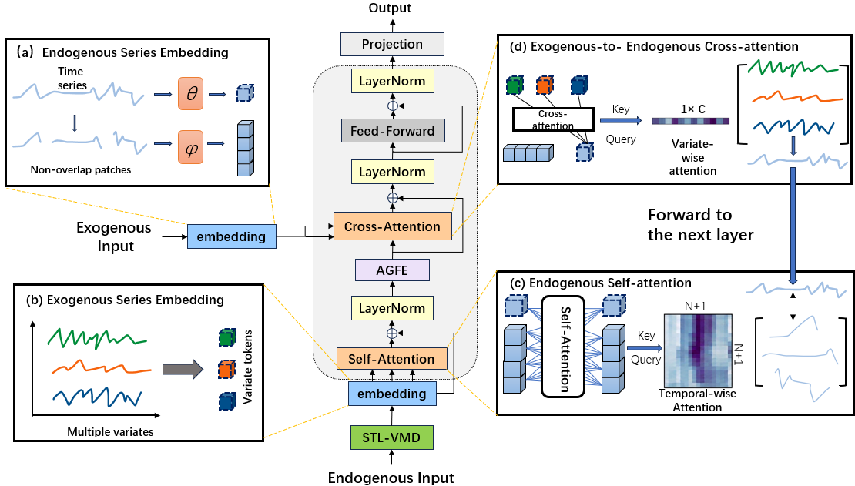
Figure 1. Overall architecture of FreqXer.

3.2 Window-local differentiable decomposition
To relieve the backbone from implicitly decoupling multi-scale signals, FreqXer adds a decomposition front end that, as shown in Fig. 2, preprocesses the complex PV series into components with clear physical meanings before they enter the network, so that the model can adopt different modeling strategies for the characteristics of each component.
The core idea of STL decomposition is to achieve a robust separation through the alternating iteration of trend and seasonal components, where the trend component is fitted by locally weighted regression (LOESS) within a sliding window. Considering the computational-efficiency requirements of PV power forecasting, this paper adopts a Savitzky-Golay filter as an efficient approximation of LOESS. The Savitzky-Golay filter performs a low-order polynomial least-squares fit within a sliding window; its smoothing effect is very close to LOESS’s locally weighted fitting but with lower computational complexity, and it depends only on the observations within the current window, which facilitates end-to-end joint optimization with the subsequent network. Concretely, for the input sequence $x\left(t\right)$, the trend component $T\left(t\right)$ is obtained by applying Savitzky-Golay smoothing to the original series; the seasonal component $S\left(t\right)$ is obtained by periodic averaging of the detrended series—the detrended series is divided into segments according to the seasonal period $L$ (the number of time steps in one daily cycle), and after averaging phase by phase the overall mean is subtracted; after the two components are successively removed, the remaining part of the original series is the residual component $R\left(t\right)$, which characterizes the multi-scale fluctuations and noise beyond the smooth trend and the regular seasonal component, and serves as the input to the VMD second-stage decomposition. The window length is set to 1.5 times the seasonal period to balance the sufficiency of trend smoothing with the preservation of local fluctuations. The residual component $R\left(t\right)$ obtained from the STL decomposition is further subjected to a VMD second-stage decomposition, which separates it into $K$ intrinsic mode functions. VMD performs iterative optimization via the ADMM algorithm, updating each mode and its center frequency in the frequency domain, and finally obtains the time-domain modal components through an inverse Fourier transform. The resulting modal components exhibit a hierarchical high-to-low frequency structure in the frequency domain, achieving a multi-scale refinement of the residual signal. The whole decomposition is confined to the input window and depends only on the historical observations within the window; no future information outside the window participates in the decomposition.
The trend component $T\left(t\right)$, the seasonal component $S\left(t\right)$, and the $K$ intrinsic mode functions obtained by decomposition are mapped to a unified dimension by independent component encoders, then concatenated and compressed by an aggregation network into a $d_{\text{model}}$-dimensional aggregated representation $z$. The importance weights of the components are adaptively adjusted by a learnable Softmax gate:
$α_{i}=\frac{\exp\left(w_{i}\right)}{\sum_{j=1}^{2+K}{\exp\left(w_{j}\right)}}$ (9)
$z=\sum_{i=1}^{2+K}{α_{i}}⋅{\text{Enc}}_{i}\left(c_{i}\right)$ (10)
Here, $w∈R^{2+K}$ is the learnable importance-parameter vector of the components (all initialized to 0, corresponding to equal-weight Softmax), $w_{i}$ is the learnable gating parameter of the $i$-th component (the Softmax function maps it into a normalized aggregation weight), $c_{i}$ is the $i$-th component, ${\text{Enc}}_{i}$ is the component encoder, $α_{i}$ is the adaptive gating weight, and $z∈R^{d_{\text{model}}}$ is the aggregated enhanced representation that serves as the output of the STL-VMD front end and is fed to the downstream encoder. The aggregated decomposition representation $z$ is fused with the endogenous-token sequence obtained by patching the raw power series along the feature dimension and, after a linear projection, is fed into the encoder as a multi-scale enhanced representation of the target variable. The raw tokens preserve the integrity of local time-varying features such as abrupt power drops, whereas the decomposition tokens encode the structured information of trend, seasonal, and multi-scale fluctuation components; the two are complementary, endowing the target variable with both fine-grained temporal and multi-scale structural representations. This design allows the model to dynamically adjust the contribution of each component according to the input signal itself—relying more on the trend and seasonal components during stationary periods and more on the IMF components during volatile periods. The $K$ intrinsic mode functions produced by VMD markedly increase the number of learnable signal channels (from one original series to $2+K$ components). Each component is statistically purer, which helps the model focus on pattern learning at a specific scale. The signal-noise separation mechanism makes the high-frequency noise an independent channel that is explicitly processed by the model, reducing over-sensitivity to abrupt signals.
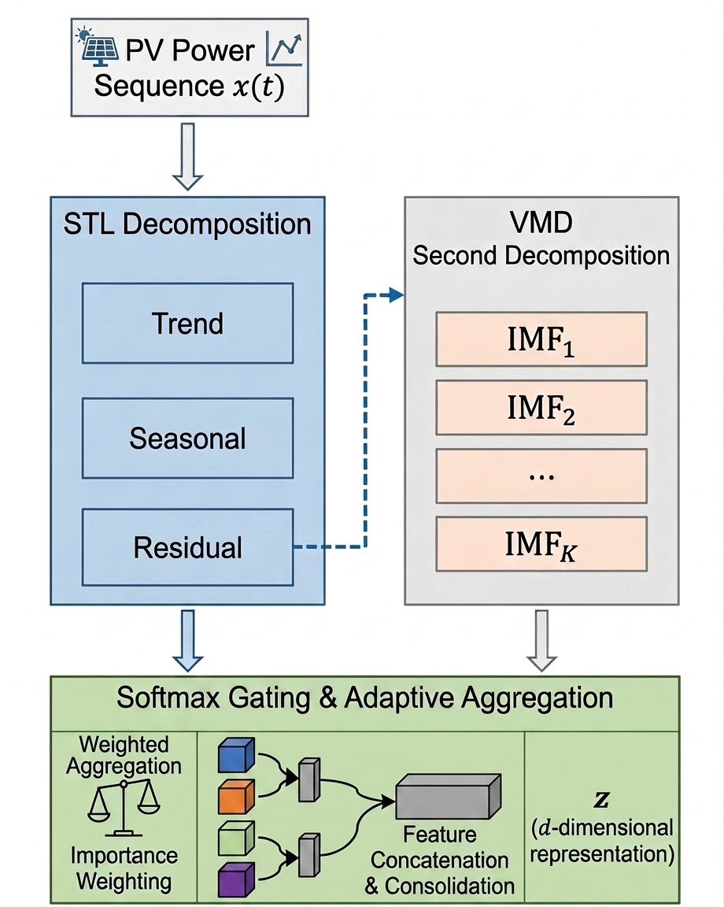
Figure 2.Decomposition illustration of FreqXer.

3.3 AMP-Gated frequency enhancement module
The self-attention mechanism completes temporal-dependency modeling among patch tokens, but its output is still a purely time-domain representation without explicit use of frequency-domain structure. To this end, this paper embeds a phase-aware frequency enhancement module between the self-attention and cross-attention of the encoder layer to selectively modulate the patch representations produced by self-attention in the frequency domain. As shown in Fig. 3, the module consists of three successive stages: instantaneous-feature extraction, adaptive gating generation, and frequency enhancement with residual fusion.
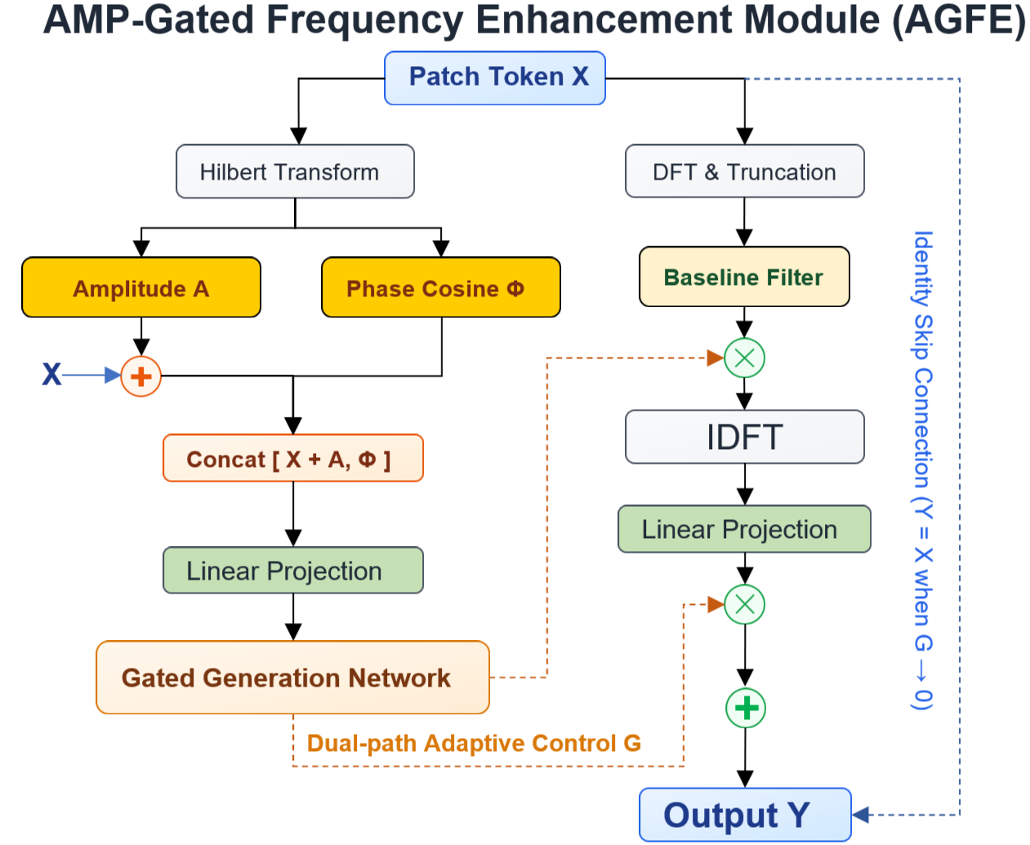
Figure 3.Embedding details of the phase-aware frequency enhancement module in the TimeXer encoder layer.

In the instantaneous-feature-extraction stage, the module takes the patch-token representation $X∈R^{B×N×D}$ produced by self-attention as input, where $B$ is the batch size, $N$ is the number of patches, and $D$ is the hidden dimension.
First, an analytic signal $Z=X+jH\left(X\right)$ is constructed along the patch dimension, where $H$ is the Hilbert transform along the patch dimension and $j$ is the imaginary unit; two types of instantaneous features are then extracted from $Z$:
$A=\log\left|Z\right|=\log{\sqrt{X^{2}+{\left(X\right)}^{2}}}$ (11)
$Φ=\cos\left(\arg\left(Z\right)\right)$ (12)
The logarithmic instantaneous amplitude $A$ characterizes the local oscillation intensity of each patch along the feature dimension and reflects the combined energy envelope of the frequency components in the current time window—under clear-sky conditions the power fluctuates smoothly along the time axis and $A$ changes slowly; when cloud shading causes an abrupt power drop, $A$ undergoes large jumps over adjacent time steps, and this difference in amplitude-variation rate provides a key clue for distinguishing stationary periodicities from incidental fluctuations. The logarithm is applied to compress the dynamic range of the power signal (which spans orders of magnitude between day and night) so that small-amplitude features are not dominated by large amplitudes. The cosine of the instantaneous phase $Φ$ encodes the alignment position of the oscillation modes along the patch sequence—when cloud shading shifts the power curve in time, the phase deviates from its linear-growth trajectory and produces a detectable distortion; taking the cosine maps the periodic phase into the continuous interval [-1, 1], removing the discontinuous jumps caused by phase wrapping and making it more suitable as a neural-network input.
In the adaptive-gating-generation stage, the original features are first fused with the amplitude information by a residual connection and then concatenated with the phase features along the feature dimension to obtain the amplitude-phase joint representation $\left[X+A,Φ\right]∈R^{B×N×2D}$. After compression to $D$ dimensions by a linear projection, this representation is fed into the gating network, which outputs a time-channel-adaptive gating signal:
$M=Linear\left(\left[X+A,Φ\right]\right)$ (13)
$G=σ\left({\text{Conv1D}}_{1}\left({\text{Conv1D}}_{3}^{\text{dw}}\left(M\right)\right)\right), G∈{\left(0,1\right)}^{B×N×D}$ (14)
The gating network is a cascade of a depthwise separable convolution (kernel size 3, grouped by channel) and a pointwise convolution (kernel size 1), followed by a Sigmoid activation. The kernel size of 3 for the depthwise separable convolution ensures that each convolution window covers three adjacent patches, directly capturing the local rate of change of the instantaneous features—when the amplitude is stationary and the phase grows linearly, the gate maintains a high response and allows the frequency information to be fully injected; when the amplitude changes abruptly or the phase jumps, the gate is automatically suppressed to reduce noise interference. Through this mechanism, the gating network can distinguish genuine periodic regularities from incidental fluctuations, and each element of its output $G$ encodes the intensity with which the corresponding patch and feature dimension requires frequency-domain injection at the current time step.
In the final frequency-enhancement and residual-fusion stage, a DFT is applied to the original input $X$ along the patch dimension and only the lowest $K$ frequency components are retained, so as to preferentially preserve low-frequency periodic components such as the daily cycle, yielding the frequency-domain representation $F$. A learnable baseline frequency filter $W∈R^{K×D}$ (initialized to all ones and made non-negative by an absolute-value operation) is then introduced, and the gating signal $G$ is truncated to the first $K$ time steps to offset-modulate it, producing the enhanced spectrum $Fenh$. The baseline filter $W$ sets the baseline gain of each frequency component, and the gating signal $G$ fine-tunes it according to the amplitude-phase joint features of the current input—the bands corresponding to regular periodic components are amplified, whereas noise and interference components are suppressed. Because the gating signal itself is generated from a descriptor containing instantaneous-phase information, this modulation can sense the alignment state of periodic modes along the patch sequence and achieve task-adaptive frequency selection. The enhanced frequency-domain representation is transformed back to the time domain by an inverse DFT, multiplied element-wise by the gating signal after a linear projection, and finally fused with the original features via a residual connection:

$Y=X+G⊙\text{LinearIDFT}\left(F_{\text{e}\text{n}\text{h}}.\text{real}\right)$ (15)

The gating signal $G$ here provides two-way adaptive control of the frequency enhancement: it determines the gain of each frequency component in the frequency-modulation stage and controls the injection intensity of the enhanced information in the residual-fusion stage. When the gate values approach zero, the module degenerates into an identity mapping $Y=X$ and has no effect on the original features, ensuring stability in early training. The enhanced patch representations are then passed to the downstream cross-attention layer to interact with the global token and the exogenous-variable information.
Having described the STL-VMD decomposition, the TimeXer encoder backbone, and the AGFE module in detail, we present the complete workflow of FreqXer in Fig. 4 and describe the experiments conducted subsequently.

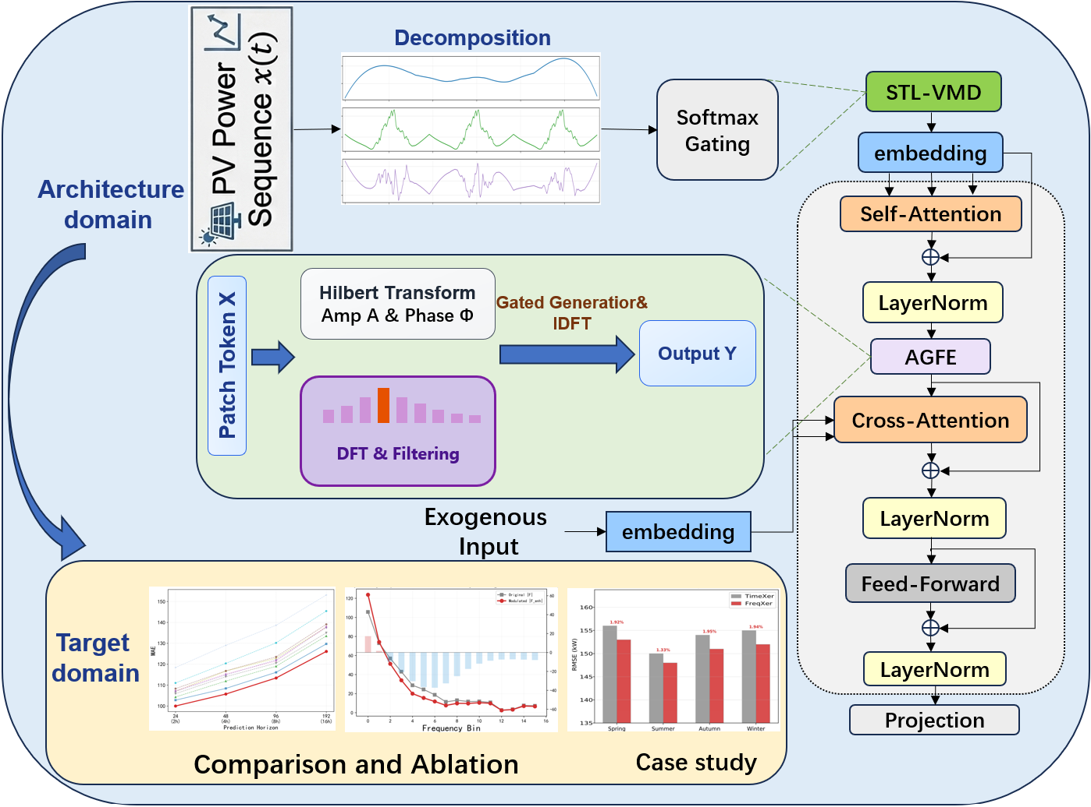
Figure 4.Workflow diagram of this paper.

4. EXPERIMENTS AND RESULTS ANALYSIS
4.1 Experimental setup
The experimental data are real PV-power records from a plant in Xinjiang, China, sampled every 15 minutes and covering PV power data across different seasons and weather conditions throughout 2023. According to the forecasting-task setting, the input sequence length is T = 96 and the prediction length is H = 96 (corresponding to 8 hours). The dataset is divided chronologically into training, validation, and test sets in a ratio of 60%:20%:20% to evaluate the model’s performance over different time periods. The target variable is PV power. There are six exogenous variables—direct irradiance, diffuse irradiance, temperature, humidity, and wind speed—where subdividing irradiance into direct and diffuse components helps the model distinguish the influence of different sunlight conditions on generation.
The main hyperparameters are as follows: patch length $P$ = 16, patch stride $S$ = 8, embedding dimension $d_{m}odel$ = 256, number of attention heads $h$ = 8, and number of encoder layers $e_{l}ayers$ = 2. The number of VMD modes $K$ = 5 and the bandwidth constraint $α$ = 2000. During training, the Adam optimizer is used with an initial learning rate of $1×{10}^{-4}$, a batch size of 32, and early stopping (patience = 5) to prevent overfitting.
Three metrics are adopted: RMSE, MAE, and $R^{2}$.

$\text{RMSE}=\sqrt{\frac{1}{n}\sum_{i=1}^{n}{{\left(y_{i}-\hat{y_{i}}\right)}^{2}}}$ (16)

$\text{MAE}=\frac{1}{n}\sum_{i=1}^{n}{\left|y_{i}-\hat{y_{i}}\right|}$ (17)

$R^{2}=1-\frac{\sum_{i=1}^{n}{{\left(y_{i}-\hat{y_{i}}\right)}^{2}}}{\sum_{i=1}^{n}{{\left(y_{i}-\overline{y}\right)}^{2}}}$ (18)
where $y_{i}$ is the true PV power at the $i$-th sample instant, $\hat{y_{i}}$ is the corresponding model prediction, and $n$ is the total number of test samples. RMSE and MAE measure the average magnitude of the prediction error in squared and absolute form, respectively; the smaller the value, the more accurate the prediction. $R^{2}$ characterizes the degree to which the model explains the fluctuation of the true power; the closer its value is to 1, the better the fit.
4.2 Main results
The correlations between the exogenous variables and PV power differ significantly, as shown in Fig. 5: irradiance-type variables (direct and diffuse irradiance) are strongly positively correlated with power (r > 0.8), followed by module temperature, while pressure is almost uncorrelated and humidity is weakly negatively correlated. This structure indicates that different exogenous variables carry markedly different information value for prediction, supporting the necessity of endogenous-exogenous decoupled encoding.
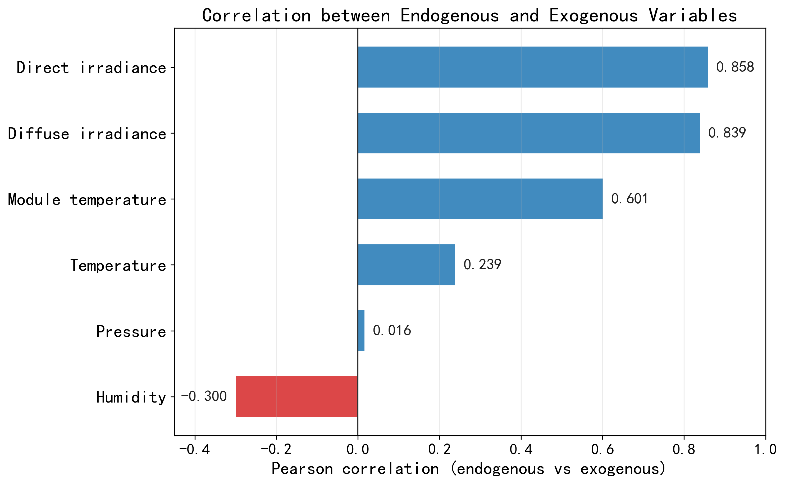
Figure 5.Pearson correlation between PV power and each exogenous variable.
To demonstrate the effectiveness of the decoupled encoding, Fig. 6 shows the cross-attention weights between the endogenous tokens and the exogenous-variable encodings. The model assigns the highest attention to direct irradiance during the daytime, keeps strong attention to module temperature and diffuse irradiance, and pays less attention to pressure and humidity—consistent with the physical mechanism that irradiance is the direct determinant of power.
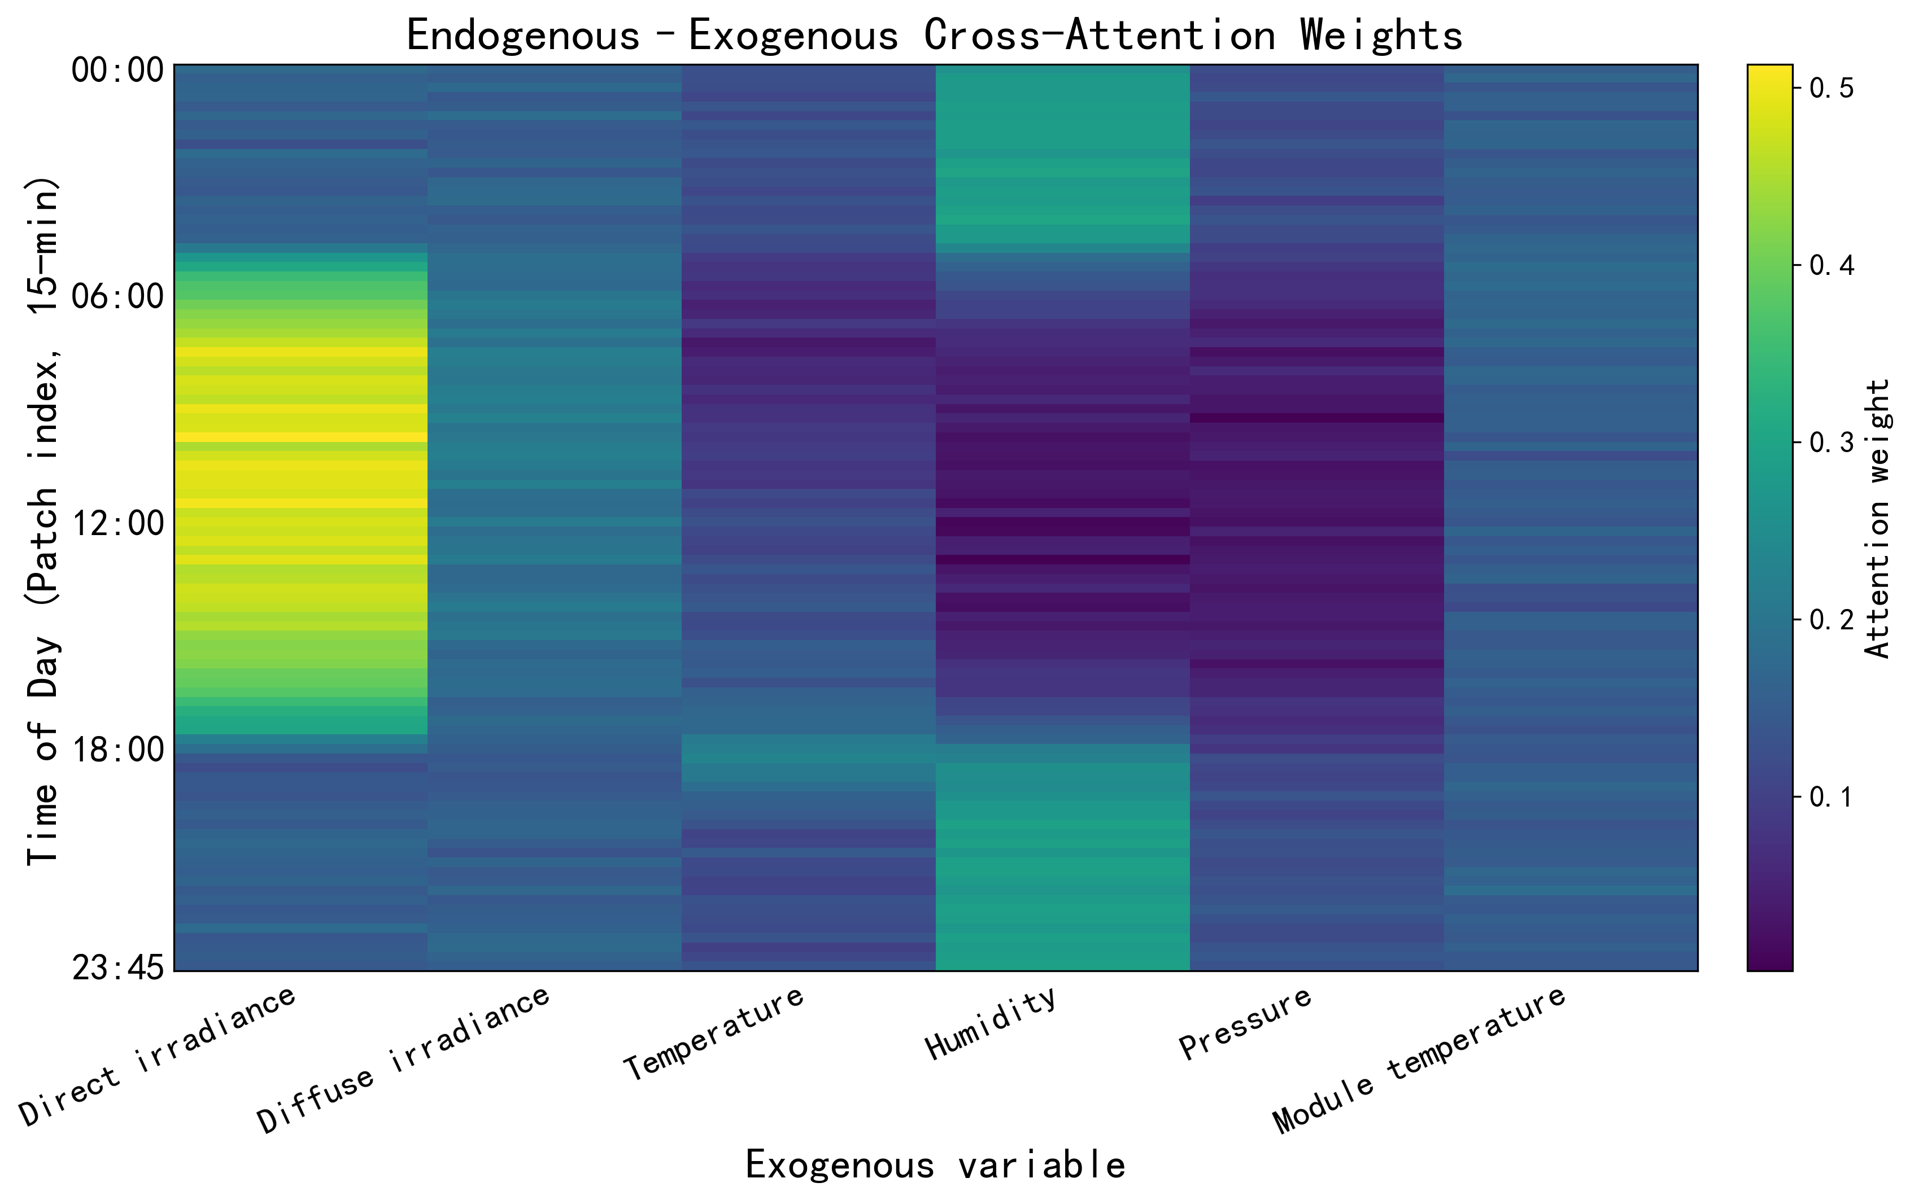
Figure 6.Heat map of endogenous-exogenous cross-attention weights.
The horizontal axis lists the six exogenous variables and the vertical axis gives the time of day over 96 patches (15-min intervals); brighter colors indicate stronger attention.
To comprehensively evaluate FreqXer, nine representative models are compared, spanning the main technical routes—classical recurrent networks, linear and MLP models, and Transformer variants adopting sparse attention, sequence decomposition, frequency-enhanced structures, patch modeling, variate attention, and endogenous-exogenous decoupling—as listed in Table 1. All models share the same data split and unified training settings to ensure fairness and reproducibility.

Table 1 Forecasting-performance comparison of the models on the dataset.

Model | RMSE(24) | MAE(24) | RMSE(48) | MAE(48) | RMSE(96) | MAE(96) | RMSE(192) | MAE(192)
LSTM | 128.3 | 97.8 | 151.8 | 118.4 | 180.9 | 138.6 | 207.2 | 158.3
DLinear | 126.2 | 96.1 | 149.7 | 115.3 | 170.0 | 130.2 | 198.1 | 150.8
Informer | 116.4 | 89.3 | 139.8 | 106.2 | 155.2 | 123.5 | 177.4 | 135.2
Autoformer | 115.0 | 88.1 | 138.2 | 105.0 | 153.0 | 122.0 | 175.1 | 133.4
TSMixer | 119.7 | 91.6 | 144.5 | 110.3 | 161.6 | 122.8 | 188.6 | 143.1
FEDformer | 118.1 | 90.2 | 141.8 | 107.4 | 155.8 | 121.5 | 178.9 | 136.8
PatchTST | 117.3 | 89.4 | 141.0 | 107.1 | 159.4 | 120.5 | 183.2 | 139.4
iTransformer | 113.8 | 86.7 | 137.3 | 104.2 | 157.5 | 119.0 | 178.1 | 134.3
TimeXer | 112.5 | 85.6 | 135.2 | 102.9 | 154.6 | 116.1 | 172.3 | 130.2
FreqXer | 110.8 | 84.3 | 132.1 | 100.4 | 151.0 | 113.4 | 166.1 | 125.0

As can be seen from Table 1, FreqXer achieves the best results at all prediction lengths. Compared with the baseline TimeXer, its RMSE is reduced by 1.7 kW, 3.1 kW, 3.6 kW, and 6.2 kW at H = 24/48/96/192, respectively, with the improvement widening as the prediction length increases—evidence that the synergistic design of STL-VMD time-domain decomposition and phase-aware frequency enhancement offers a more significant robustness advantage for long-horizon forecasting. The differences among technical routes also reflect the nature of PV forecasting: the recurrent network LSTM, limited by its sequence-modeling ability, performs worst at long prediction lengths; the linear model DLinear and the MLP model TSMixer, though simple, show clear bottlenecks on non-stationary PV series; Transformer-based models generally achieve better results—the frequency-enhanced FEDformer and the variate-attention iTransformer perform comparably, PatchTST improves temporal modeling through patch division, and Autoformer’s seasonal-decomposition mechanism offers some advantage—but none reaches the level of TimeXer’s endogenous-exogenous decoupling framework. FreqXer breaks through further on top of these strong baselines, most markedly at the most challenging H = 192, where the improvement is positively correlated with prediction difficulty; by adding frequency enhancement to an already strong time-domain backbone, it attains the optimum RMSE at every prediction length.
Table 2 Parameter count and single-sample inference latency of the models (H = 96).
Model | Params (M) | Inference (ms/sample)
iTransformer | 1.10 | 1.7
TimeXer | 1.78 | 2.3
FreqXer | 2.44 | 10.3
Table 2 compares parameter counts and single-sample inference latency. Relative to TimeXer, FreqXer increases parameters by about 37% (2.44 M vs. 1.78 M), mainly from the learnable parameters of the STL-VMD decomposition front end and the AGFE module, and yields consistent accuracy gains at all prediction lengths. Its inference latency is markedly higher, dominated by the ADMM iterations of the VMD decomposition; this cost can be substantially reduced through GPU parallelism, a smaller iteration budget, or batch pre-computation, making the accuracy-efficiency trade-off acceptable for latency-critical deployment.

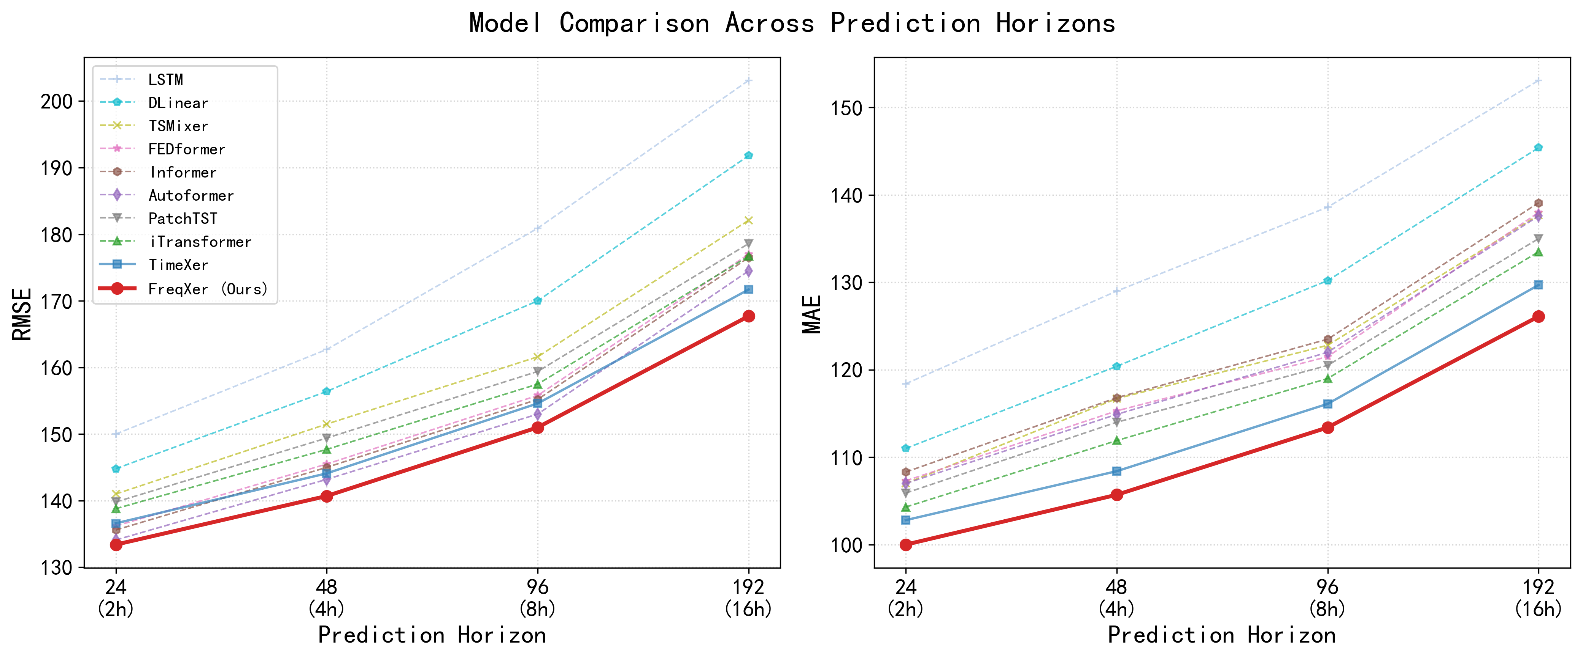
Figure 7.Model-performance comparison at different prediction lengths.

As shown in Fig. 7, FreqXer maintains the best performance at every prediction length, and its lead over the TimeXer baseline widens as the horizon grows. The error curves of all models rise with increasing prediction length, but with markedly different slopes: LSTM and DLinear, acceptable at short horizons, degrade clearly after H = 96 owing to their limited long-range-dependency modeling, whereas the Transformer-type models (TimeXer, iTransformer, PatchTST) exhibit flatter curves and better long-horizon stability. The inter-model gaps are relatively small at H = 24, where the short-horizon task is inherently easier, and expand progressively to H = 192, where the RMSE range widens markedly and FreqXer’s advantage becomes most prominent.
Table 3 Forecasting performance under different weather conditions (H = 96, metrics in kW).
Weather condition | TimeXer RMSE | TimeXer MAE | FreqXer RMSE | FreqXer MAE
Clear | 148.0 | 110.5 | 147.2 | 110.2
Cloudy | 158.5 | 118.7 | 152.8 | 114.2
Rainy | 166.2 | 126.6 | 157.6 | 118.9
Overall | 154.6 | 116.1 | 151.0 | 113.4
To investigate the influence of weather conditions, the test set is grouped into clear, cloudy, and overcast/rainy conditions according to irradiance fluctuation and cloud cover. FreqXer outperforms TimeXer under all three conditions, and the improvement grows monotonically as the weather becomes more adverse: the RMSE is reduced by about 0.5% under clear sky, 3.6% under cloudy conditions, and 5.2% under overcast/rainy conditions, confirming that the model’s advantage expands as the non-stationarity of the series increases.

4.3 Ablation and analysis
4.3.1 Decomposition effectiveness analysis
Table 4 Comparison experiment of data-decomposition variants.
Configuration | RMSE | MAE | R²
TimeXer (Baseline) | 154.6 | 116.1 | 0.9435
STL only | 152.0 | 114.2 | 0.9453
VMD only | 152.6 | 114.6 | 0.9450
STL+VMD (Full) | 151.0 | 113.4 | 0.9463
As shown in Table 4, STL and VMD each improve accuracy when used independently but through different mechanisms: STL reduces the modeling burden of the backbone by extracting macroscopic trend and seasonal structures, whereas VMD captures fine fluctuation features through multi-scale modal decomposition of the residual signal. The full STL+VMD configuration performs best, confirming that macroscopic-structure extraction and fine-grained modal decomposition are synergistic and validating the two-stage decomposition strategy for non-stationary PV forecasting.
4.3.2 Phase information independent
To verify the independent contributions of the amplitude and phase information, a phase-information ablation experiment was designed, including amplitude-only-driven gating, phase-only-driven gating, DFT-magnitude-enhancement-only (without phase gating), and the full configuration.
Table 5 Ablation experiment on the independent contributions of the phase information.
Configuration | RMSE | MAE | R²
FreqXer w/ Amplitude only | 155.6 | 117.0 | 0.9428
FreqXer w/ Phase only | 156.2 | 117.5 | 0.9425
FreqXer w/ DFT only | 156.9 | 118.2 | 0.9418
FreqXer (Amp+Phase) | 151.0 | 113.4 | 0.9463

The results in Table 5 show that amplitude-only-driven gating (RMSE 155.6) already approaches the TimeXer baseline, indicating that the amplitude-variation rate provides the main fluctuation-detection signal; phase-only-driven gating (156.2) is comparable, contributing temporal-alignment information; DFT-magnitude enhancement without phase gating (156.9) is even worse than the baseline, because it injects frequency components that do not match the current temporal state and thus interfere with prediction. The full amplitude+phase configuration (151.0) clearly outperforms all variants, showing that the amplitude and phase are synergistic in enabling the gating network to separate regular periodicities from incidental fluctuations.
4.3.3 Gate frequency response analysis
To intuitively demonstrate the frequency-selective behavior of the gating network, Fig. 8 compares, under two typical weather conditions (cloudy and clear), the change of the original spectrum versus the gate-modulated spectrum, together with the distribution pattern of the gating signal in the frequency × patch two-dimensional space.
Under cloudy conditions, PV power undergoes repeated abrupt drops due to cloud shading. The gating network detects the abnormal changes of the instantaneous amplitude and imposes an adaptive modulation on the spectrum: the low-frequency band is moderately enhanced, with an enhancement that decays smoothly as the frequency increases, whereas the mid-high-frequency band is suppressed—a peak enhancement of about 20% at the low-frequency end and a suppression of about 35% in the mid-high-frequency end. In the corresponding gate heat map, the gate values at the mid-patch positions of the low-frequency band are significantly reduced (G ≈ 0.35). By contrast, under clear-sky conditions the power curve is smooth, the gate signal maintains high and uniform values across all frequency bands (G ≥ 0.55), and the frequency enhancement is uniformly applied over the full band.
This result directly verifies the adaptive frequency-selection capability of the gating network: when non-stationary fluctuations occur, the gate applies a frequency-adaptive modulation driven by the abnormal changes of the instantaneous amplitude, whereas under stationary conditions it maintains a uniform application of the frequency enhancement. The frequency × patch two-dimensional heat map further reveals the joint time-frequency selectivity of the gating signal, with differentiated responses across different patches, reflecting its dynamic adaptation to the time-frequency structure of the input signal.

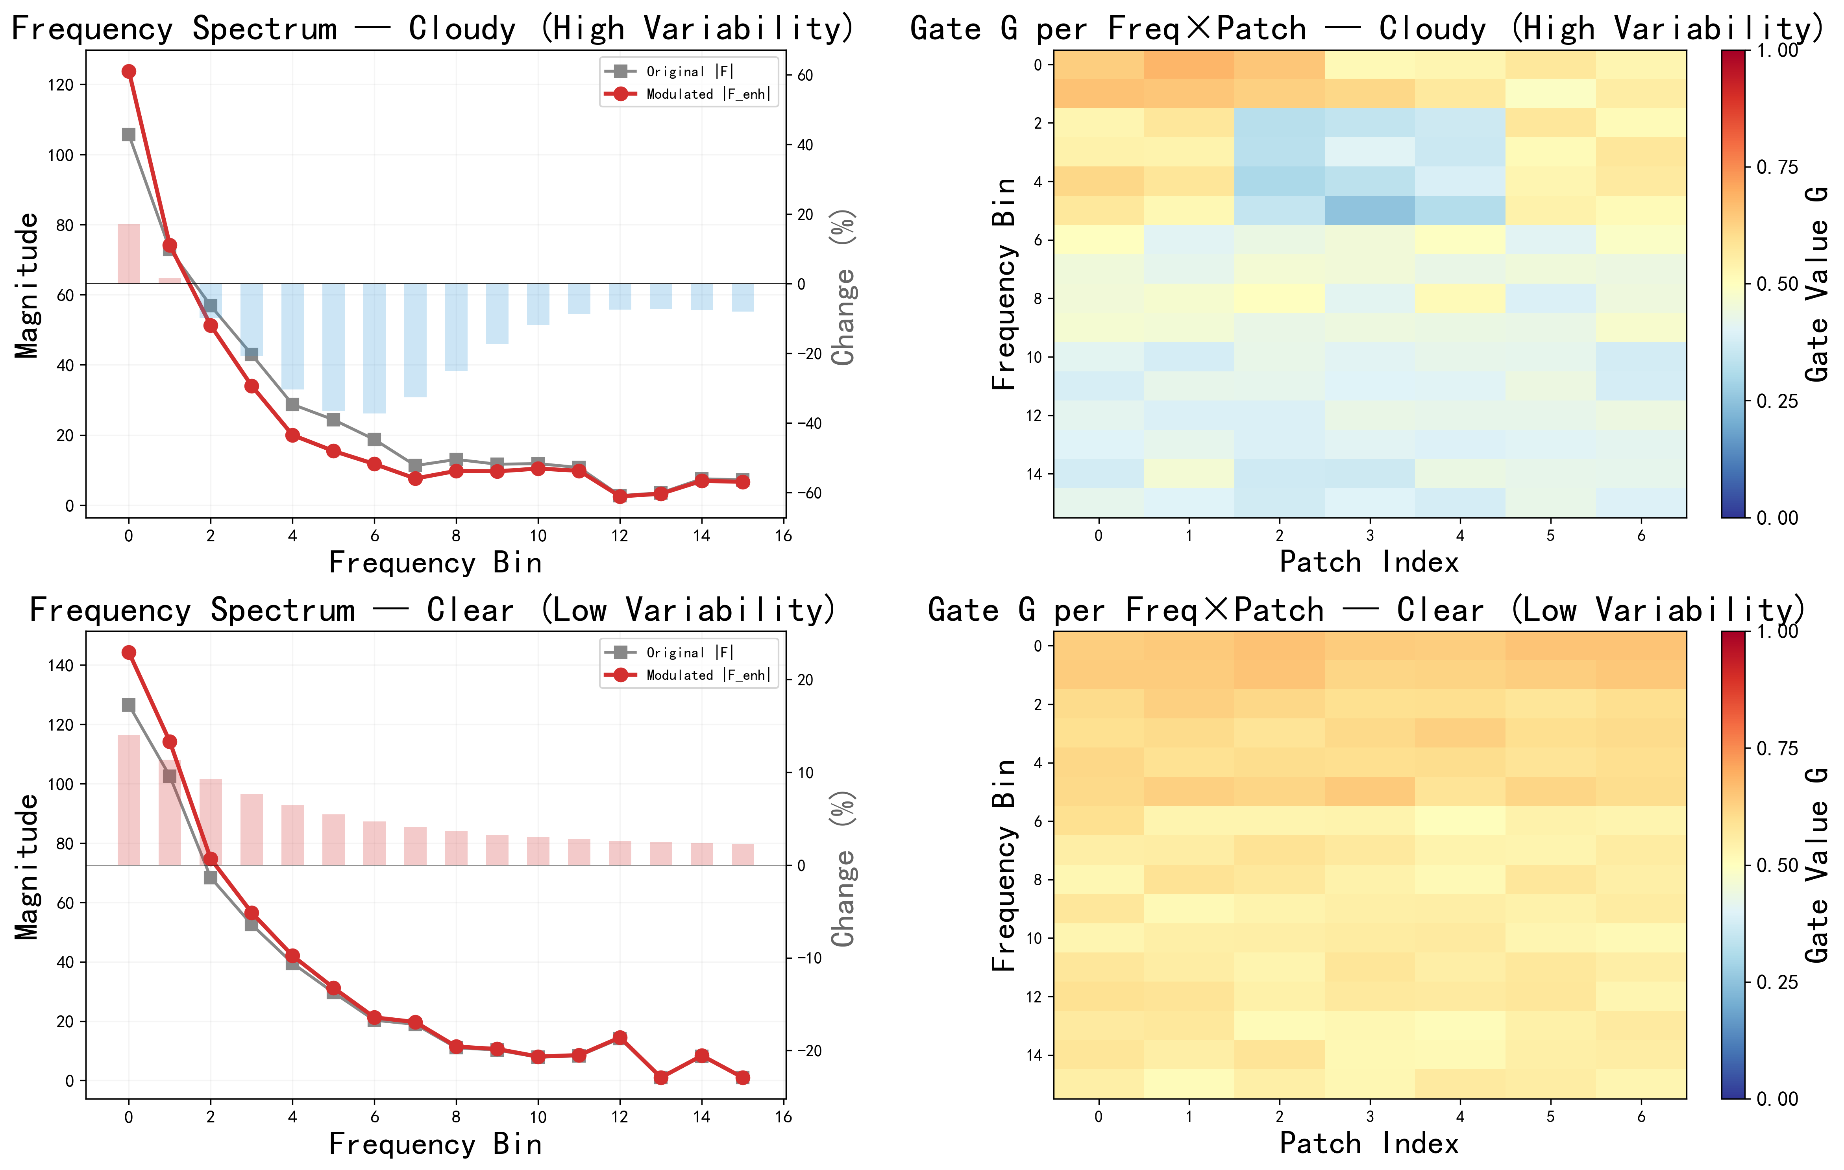
Figure 8.Gate frequency response: spectrum selectivity.

4.4 Case study
This section studies the seasonal volatility of PV power. To make the differences more evident, we first statistically analyze the four-season power-volatility characteristics of the generating units in the dataset, then compare the forecasting performance of FreqXer and TimeXer in each season, and finally explain the variation of FreqXer’s improvement magnitude from the perspective of volatility.

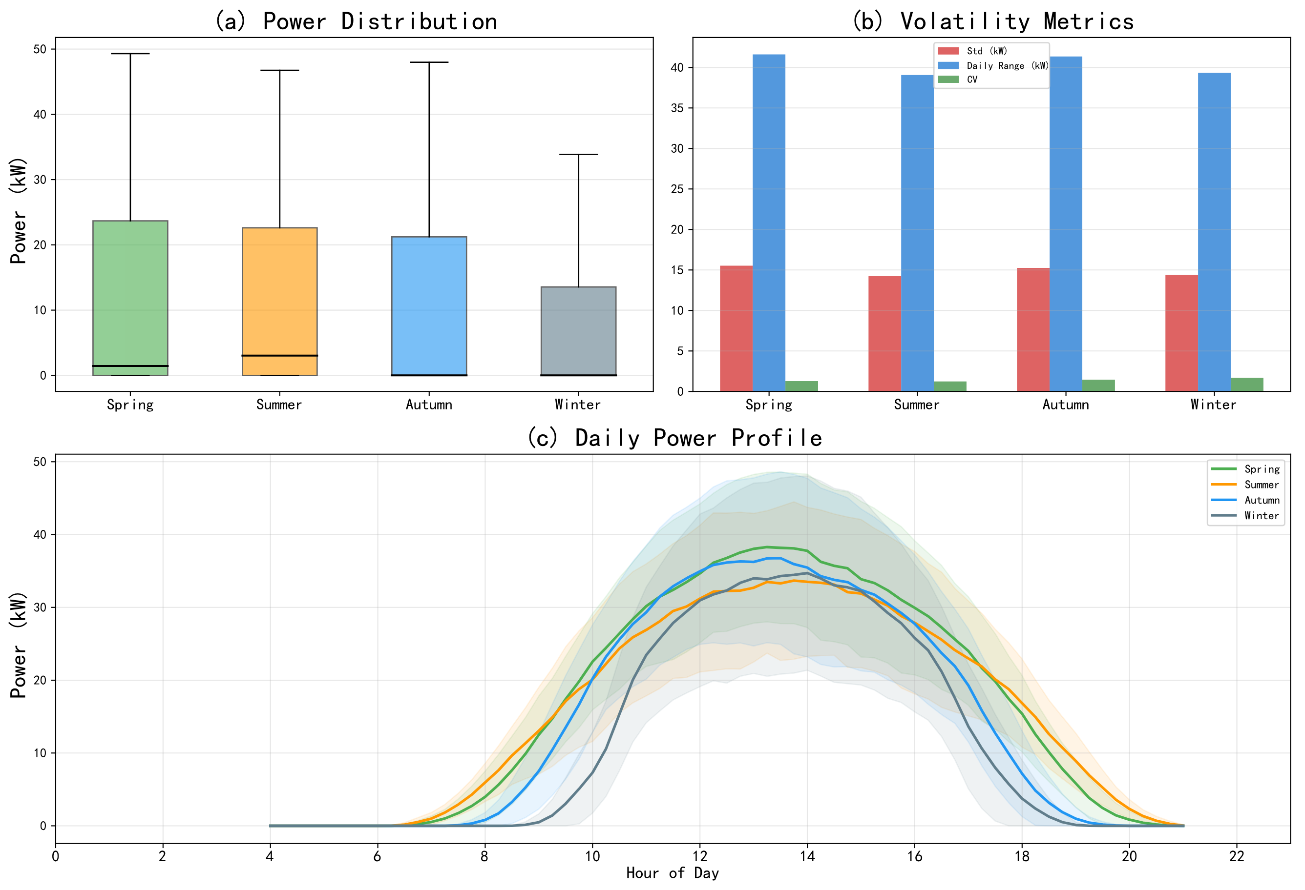
Figure 9.Seasonal volatility analysis of PV power.

PV power exhibits significant volatility differences across seasons. As shown in Fig. 9, Spring has the highest standard deviation (15.53 kW) and daily range (41.6 kW), indicating the most complex weather processes—cold and warm air masses interact frequently, and clear sky and cloud shading alternate rapidly. Autumn has the second-highest volatility (std 15.26 kW, daily range 41.4 kW); Summer is the most stable (std 14.23 kW, daily range 39.1 kW), dominated by clear-sky processes with smooth power curves. Winter has the lowest mean power (8.58 kW) yet the highest coefficient of variation (CV = std/mean, 1.674), reflecting the most severe relative volatility—a short effective output period in which sunny peaks alternate with cloudy troughs. Std measures the absolute fluctuation amplitude whereas CV measures the volatility intensity relative to the mean, describing seasonal volatility from different dimensions; together, Spring’s high Std tests the model’s ability to capture large abrupt changes and Winter’s high CV tests its sensitivity to relative fluctuations under a low mean, providing a multi-dimensional examination of the frequency-enhancement mechanism.
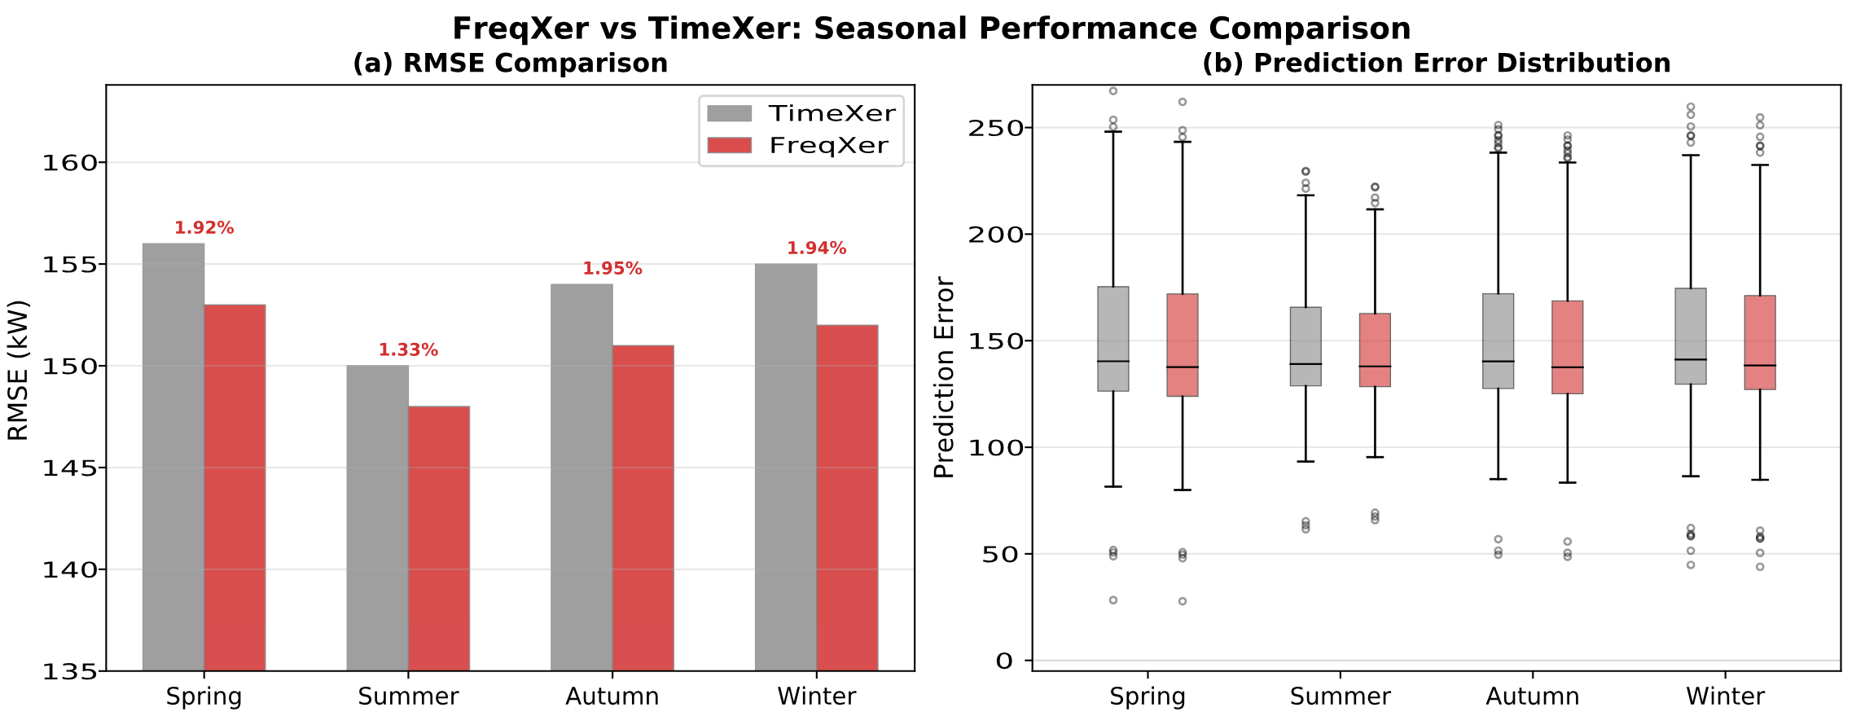
Figure 10.Forecasting-performance comparison of FreqXer and TimeXer in each season.

Fig. 10(a) compares the RMSE of FreqXer and TimeXer in the four seasons. FreqXer consistently outperforms TimeXer in every season, reducing the RMSE by about 1.92% relative to TimeXer in the most volatile Spring season and by about 1.33% in the smoothest Summer season, indicating a more prominent advantage under high-volatility scenarios. The error-distribution box plots in Fig. 10(b) show lower medians and interquartile ranges for FreqXer in every season, indicating stronger prediction stability and a lower probability of extreme deviations.

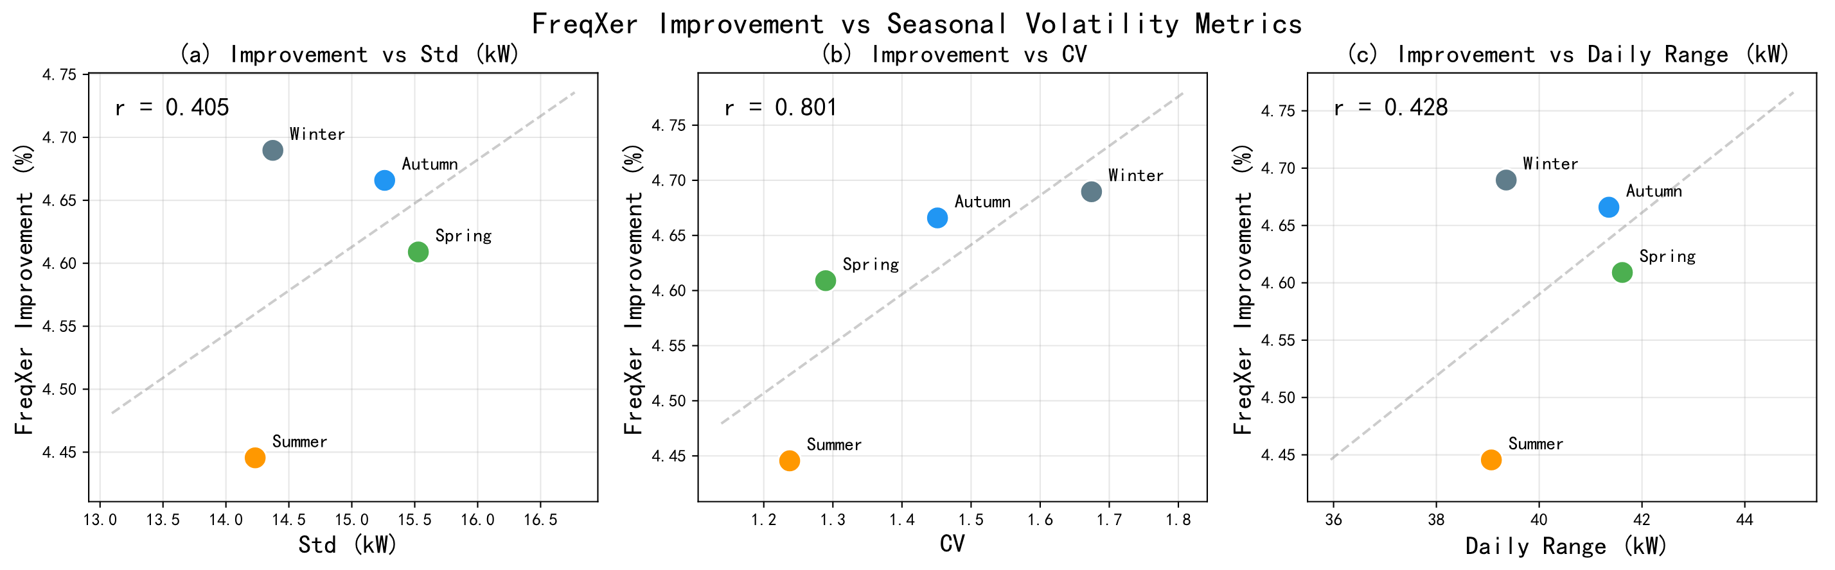
Figure 11.Correlation between FreqXer’s improvement magnitude and seasonal volatility.

To quantify the relation between the model improvement and the volatility, Fig. 11 plots scatter diagrams of FreqXer’s RMSE reduction relative to TimeXer against three seasonal volatility indicators—Std, CV, and daily range, which characterize the series from different angles. The improvement magnitude is positively correlated with all three indicators (correlation coefficient r > 0.5), with the strongest correlation for Std, indicating that the absolute fluctuation amplitude is the dominant factor determining the size of FreqXer’s advantage. In sharply fluctuating seasons such as Spring, the instantaneous-phase information extracted via the Hilbert transform precisely captures the temporal-alignment changes during abrupt rises and falls, and the gating network thereby dynamically adjusts the frequency-enhancement intensity to yield the largest improvement; in stationary seasons such as Summer the improvement narrows. This positive-correlation trend verifies, from a data perspective, the core value of the phase-aware frequency-enhancement mechanism: the more pronounced the non-stationary fast-fluctuation scenario, the greater the benefit of the instantaneous-phase information for prediction.

4.5 Generalization analysis
To verify the generalization ability of FreqXer under other climatic conditions, a supplementary cross-domain evaluation was conducted on the public DKASC dataset (Alice Springs, Australia; desert climate) [31]. The model was trained on the dataset of this paper and directly applied to the DKASC dataset without any fine-tuning. The two sites differ substantially in climatic conditions (arid vs. desert), latitude (44°N vs. 23°S), and plant configuration. The DKASC dataset, sampled every 5 minutes, covers a one-year period and contains active power and meteorological variables (irradiance, temperature, wind speed, etc.), totaling 105,120 records, with a data format basically consistent with that of pv2023. If FreqXer still maintains its advantage over TimeXer on this dataset, it indicates that the model has learned universal regularities of PV generation.

Table 6 Comparison of cross-dataset generalization experiment results.
Model | Test Setting | RMSE | MAE
TimeXer | pv2023 | 154.6 | 116.1
FreqXer | pv2023 | 151.0 | 113.4
TimeXer | DKASC | 95.5 | 71.6
FreqXer | DKASC | 91.2 | 68.4

Table 6 summarizes the comparison results. On the in-distribution dataset FreqXer improves over TimeXer consistently, as in the main experiments; on the DKASC cross-domain test it maintains its superiority with an even larger improvement magnitude. This indicates that the STL-VMD time-domain decomposition and the phase-aware frequency-enhancement module learn universal regularities shared across climatic regions—the shape of the daily cycle, cloud-shading power-drop patterns, and the irradiance-to-power conversion relationship—rather than overfitted features of a specific dataset, and that the phase-aware gating mechanism can more fully exploit its adaptive-filtering advantage on unseen distributions.

5. CONCLUSION
To address the problems of multi-scale signal mixing and low cycle-capture efficiency in non-stationary series for PV power forecasting, this paper proposes FreqXer, a time-frequency co-enhanced Transformer forecasting model. At the data level, FreqXer designs an STL-VMD two-stage decomposition front end that performs a structured “time-domain decoupling” of the raw power series, achieving signal-noise separation and multi-scale representation enhancement, and eliminates future-information leakage through window-local differentiable end-to-end optimization. At the feature level, it designs a phase-aware frequency-enhancement module that realizes dynamic selective spectral filtering using the instantaneous-phase information extracted by the Hilbert transform, complementing the time-domain attention.
Experimental results on a real PV dataset show that the model outperforms TimeXer and several baselines in terms of RMSE, MAE, and other metrics; ablation experiments verify the individual contributions of each component. FreqXer also maintains its advantage at different prediction lengths and does so more markedly for long sequences and high-volatility scenarios, indicating that its time-frequency synergistic mechanism can effectively cope with the error-accumulation problem.
Future work will focus on combining the decomposition-enhancement framework with finer-grained multi-scale modeling schemes and exploring adaptive component-encoding mechanisms under higher-sampling-rate data, so as to further exploit the forecasting potential of the model on ultra-high-resolution series.

References
[1] Aravind T, Malini A H, Kalaivani C T, et al. Transformer-Based Power Forecasting and Federated Learning-Driven Fault Detection with a Quantum-Inspired Solar Power Optimization in Smart Grids[J]. Energy, 2026: 141961.
[2] Notton G, Nivet M L, Voyant C, et al. Intermittent and stochastic character of renewable energy sources: Consequences, cost of intermittence and benefit of forecasting[J]. Renewable and Sustainable Energy Reviews, 2018, 87: 96-105.
[3] Gaboitaolelwe J, Zungeru A M, Yahya A, et al. Machine learning based solar photovoltaic power forecasting: A review and comparison[J]. IEEe Access, 2023, 11: 40820-40845.
[4] Liu M, Ling Q. SDF-Net: Solar-aware Decoupled Fusion Network for intra-hour forecasting of photovoltaic power[J]. Renewable Energy, 2026: 125890.
[5] Cui M, Zhang S, Xiang H, et al. PEF-Net: Physics-enhanced multi-modal fusion framework with cross-attention for short-term solar irradiance forecasting toward photovoltaic power integration[J]. Advanced Engineering Informatics, 2026, 76: 105067.
[6] Liao K, Xuan X, Ma K L. Deep learning for time series forecasting: a survey of recent advances[J]. Frontiers of Computer Science, 2026, 20(11): 2011359.
[7] Bouadjila T, Khelil K, Rahem D, et al. Hourly solar irradiance forecasting using long short term memory and convolutional neural networks[J]. Smart Grids and Sustainable Energy, 2024, 9(2): 38.
[8] Singh P, Singh N K, Singh A K. Wavelet transform based gated-recurrent unit deep learning approach for power output of solar photovoltaic system forecasting[J]. SN Computer Science, 2025, 6(3): 243.
[9] Deepa P, Kathirvel C. Transformer-based temporal models for probabilistic load and photovoltaic power forecasting in commercial microgrids[J]. Scientific Reports, 2026.
[10] Tao K, Zhao J, Tao Y, et al. Operational day-ahead photovoltaic power forecasting based on transformer variant[J]. Applied Energy, 2024, 373: 123825.
[11] Zhou W, Zheng L, Wang F, et al. MVMD-TimeXer: a time series prediction model integrating MVMD and endogenous-exogenous attention for highway photovoltaic slope displacement and strain forecasting[J]. Transportation Geotechnics, 2026: 102156.
[12] Wang Y, Zhao J, Tang D, et al. Deep spatio-temporal modeling for improved wind and solar power forecasts in power grid integration[J]. Energy and Buildings, 2026: 117330.
[13] Udenze P I, Gong J, Wang L, et al. Entropy-guided hybrid two-step decomposition framework with deep learning for robust solar power and energy consumption forecasting[J]. Sustainable Energy Technologies and Assessments, 2026, 92: 105214.
[14] Peng T, Song S, Suo L, et al. Research and application of a novel graph convolutional RVFL and evolutionary equilibrium optimizer algorithm considering spatial factors in ultra-short-term solar power prediction[J]. Energy, 2024, 308: 132928.
[15] Wang J, Liu J, Ma X, et al. Ultra-short-term solar power forecasting by deep learning and data reconstruction[J]. Solar Energy, 2026, 315: 114749.
[16] Ferkous K, Boulmaiz T, Abdelmouiz Ziari F, et al. A hybrid approach based on complete ensemble empirical mode decomposition with adaptive noise for multi-step-ahead solar radiation forecasting[J]. Clean Energy, 2022, 6(5): 705-715.
[17] Wang X, Ma W. A hybrid deep learning model with an optimal strategy based on improved VMD and transformer for short-term photovoltaic power forecasting[J]. Energy, 2024, 295: 131071.
[18] Venkateswaran R, Venkateswaran D, Choi W, et al. Hybrid CEEMDAN–Transformer–LSTM Framework for enhanced multi-horizon wind speed forecasting[J]. Journal of Wind Engineering and Industrial Aerodynamics, 2026, 272: 106408.
[19] Soon K L, Soon L T, Pang W L, et al. Conformalized Uncertainty Quantification for Joint Solar–Wind Power Forecasting in Reliable Grid Integration[J]. Journal of Computational Science, 2026: 102902.
[20] Ghodbane M, El-Amarty N, Boumeddane B, et al. Improving short-term photovoltaic power forecasting with an evolving neural network incorporating time-varying filtering based on empirical mode decomposition[J]. Energy Conversion and Management, 2025, 323: 119261.
[21] Li Z, Chai H, Song Z, et al. PARCNet: Phase-aware residual correction network for efficient multivariate time series forecasting[J]. Knowledge-Based Systems, 2026, 348: 116370.
[22] Bao Z, Sun Z, Jiang Y, et al. Toward better integration of solar energy in transportation systems: machine learning benchmarks for day-ahead photovoltaic power forecasting[J]. Transportation Research Part A: Policy and Practice, 2026, 210: 105040.
[23] El Robrini F, Amrouche B, Cali U, et al. Assessment of machine and deep learning models integrated with variational mode decomposition for photovoltaic power forecasting using real-world data from the semi-arid region of Djelfa, Algeria[J]. Energy Conversion and Management: X, 2025, 27: 101108.
[24] Gao Y, Liang L, Su T, et al. An embedded spatiotemporal hybrid model integrating multi-graphs and attention-driven fusion for single-and multi-site photovoltaic power forecasting[J]. Energy Conversion and Management, 2025, 336: 119897.
[25] Zhu J, He Y. A novel photovoltaic power probabilistic forecasting model based on monotonic quantile convolutional neural network and multi-objective optimization[J]. Energy Conversion and Management, 2025, 323: 119219.
[26] Sarker D, Karim S M R, Hossain M K, et al. Time series forecasting of solar power generation using LSTM models across different seasonal datasets[J]. Journal of Atmospheric and Solar-Terrestrial Physics, 2026: 106864.
[27] Xu Y, Yu Q, Du P, et al. A paradigm shift in solar energy forecasting: A novel two-phase model for monthly residential consumption[J]. Energy, 2024, 305: 132192.
[28] Tang H, Kang F, Li X, et al. Short-term photovoltaic power prediction model based on feature construction and improved transformer[J]. Energy, 2025, 320: 135213.
[29] Xiong B, Chen Y, Chen D, et al. Deep probabilistic solar power forecasting with Transformer and Gaussian process approximation[J]. Applied Energy, 2025, 382: 125294.
[30] Xia C, Xu Y, Tai N, et al. A dual-layer feature-selection transformer network for transferable probabilistic forecasting of PV power[J]. Applied Energy, 2026, 406: 127331.
[31] DKASC: DKA Solar Centre Data[DS]. Deakin University. https://dkasolarcentre.com.au/

