L=4, m=2, alpha=6, weight=6, lr=3e-3

1. Baseline

d_hidden = 32
d_latent = 8

Train token acc: 0.8351, Train seq acc: 0.4167
Test token acc: 0.7083, Test seq acc: 0.1667
Silhouette score (test latent): -0.18095360696315765

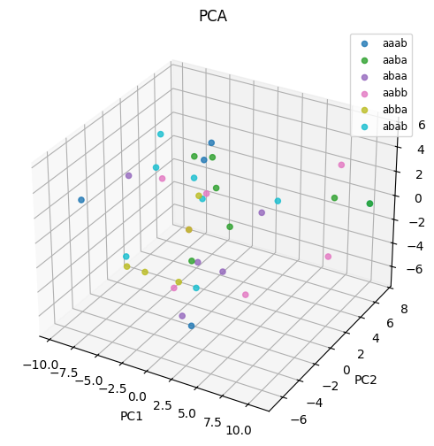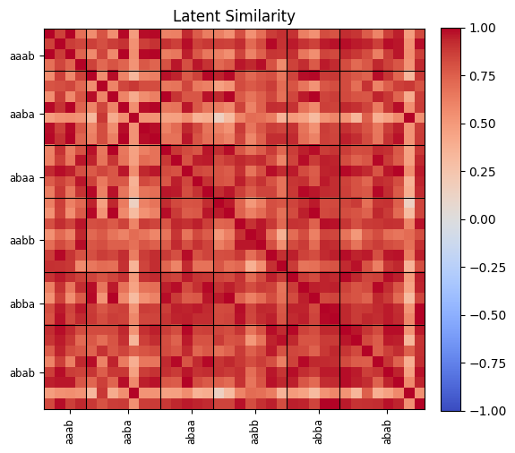

d_hidden = 128
d_latent = 32

Train token acc: 1.0000, Train seq acc: 1.0000
Test token acc: 0.8393, Test seq acc: 0.4524
Silhouette score (test latent): -0.1576

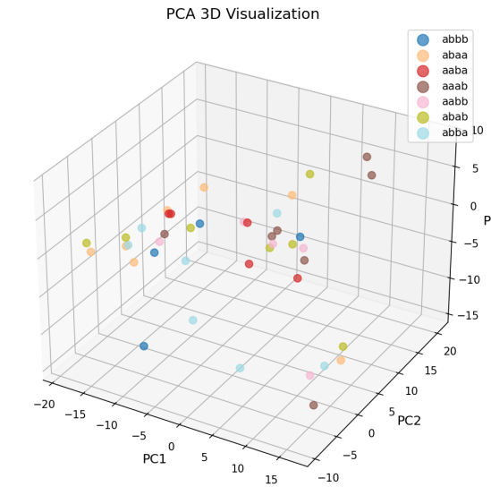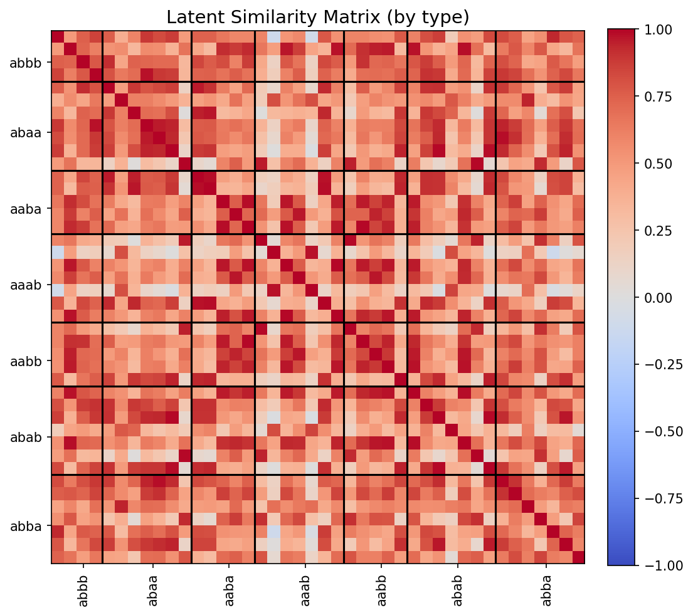
2. Serialize decoder

Train token acc: 1.0000, Train seq acc: 1.0000
Test token acc: 1.0000, Test seq acc: 1.0000
Silhouette score (test latent): -0.1232

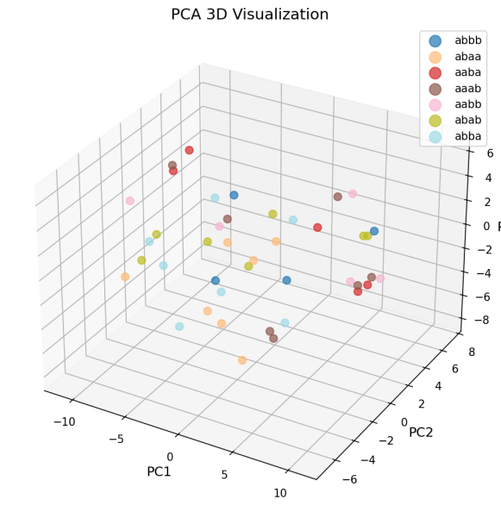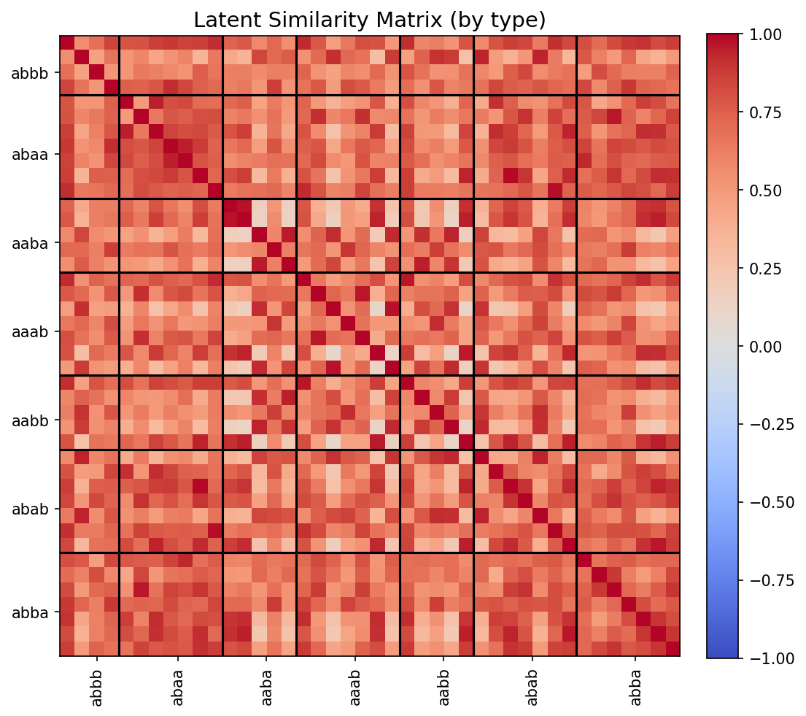

3. Contrastive Loss (lambda = 0.5)

Train token acc: 1.0000, Train seq acc: 1.0000
Test token acc: 0.8750, Test seq acc: 0.6429
Silhouette score (test latent): 0.1289

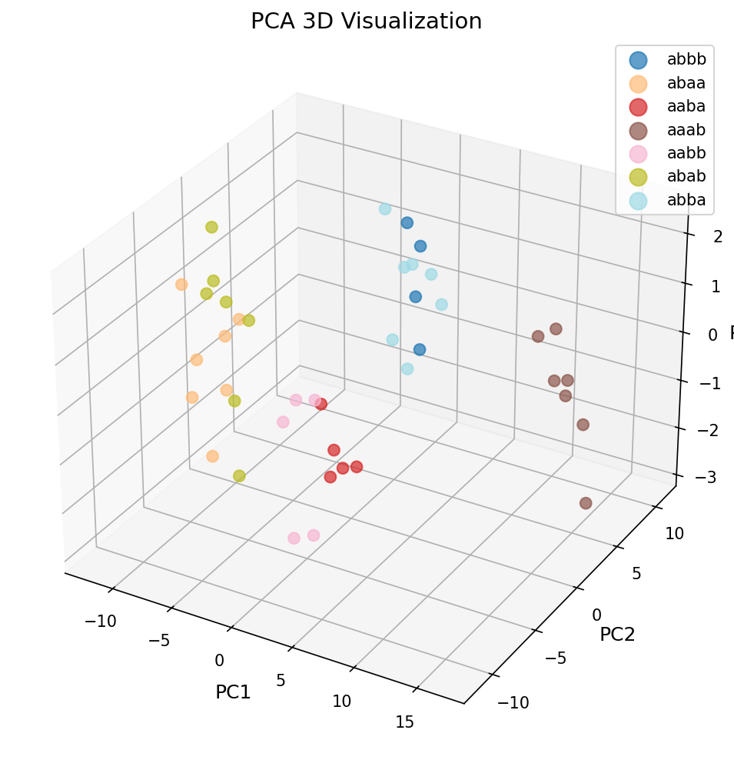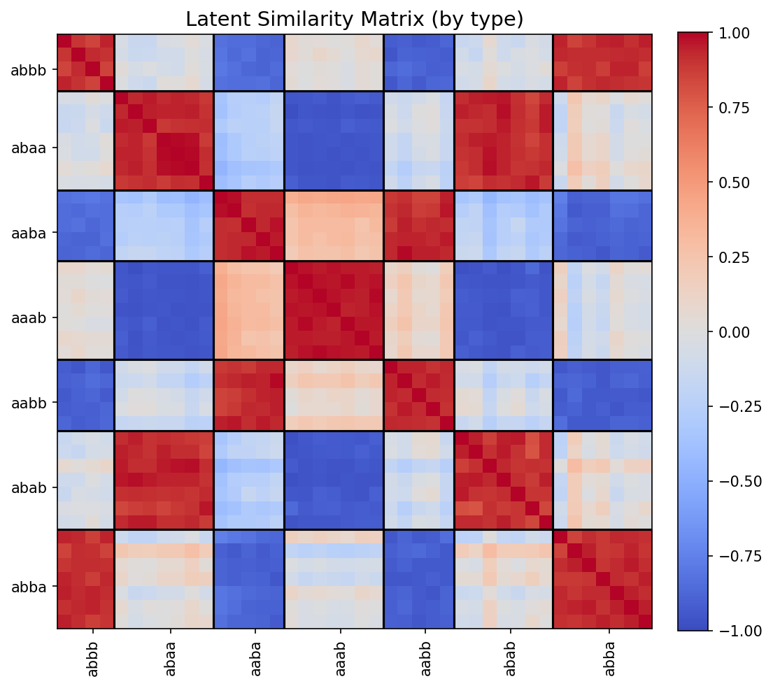

4. Serialize decoder + Contrastive Loss

Train token acc: 1.0000, Train seq acc: 1.0000
Test token acc: 1.0000, Test seq acc: 1.0000
Silhouette score (test latent): 0.7237

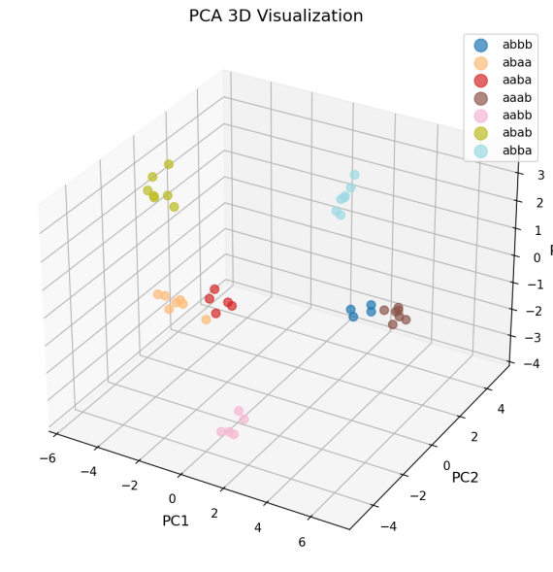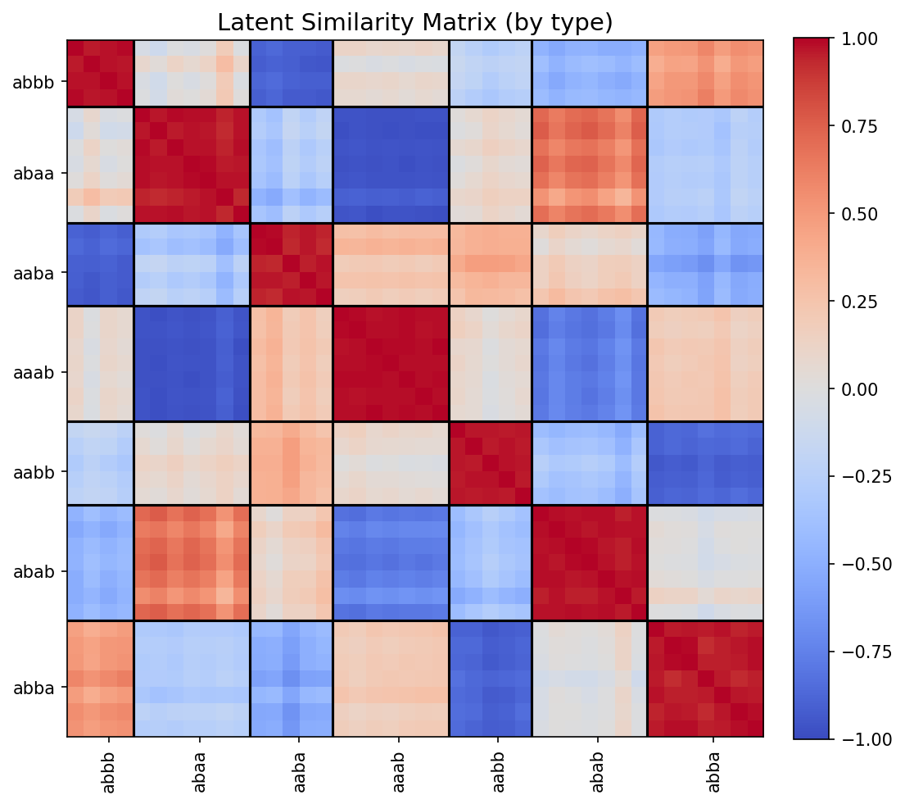

L=5, m=2, alpha=8 (epoch=400, weight=7)

Train token acc: 1.0000, Train seq acc: 1.0000
Test token acc: 1.0000, Test seq acc: 1.0000
Silhouette score (test latent): 0.6882

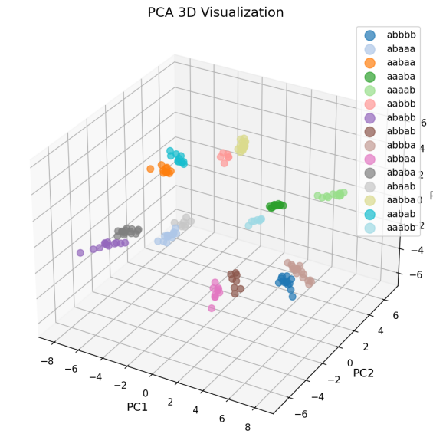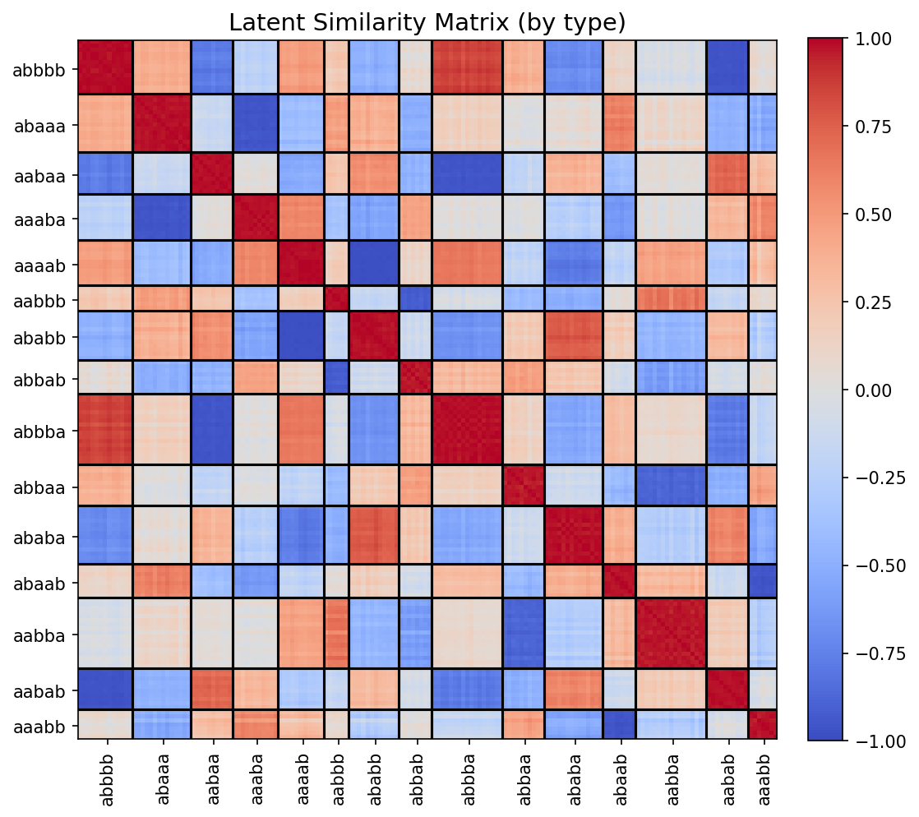

L=5, m=3, alpha=8

Train token acc: 0.9880, Train seq acc: 0.9436
Test token acc: 0.9944, Test seq acc: 0.9720
Silhouette score (test latent): 0.1222

