
GROUP ASSIGNMENT
CT111-3-2-COMT
COMPUTER THEORY
APD2F2506CS(CYB)
HAND OUT DATE:
HAND IN DATE:
GROUP 3
No. | Name | TP Number
1. | Nicholas Beh | TP070075
2. | Fhang Ying Ying | TP076307
3. | Chew Kai Xuan | TP076457
4. | Foo Jia Shuen | TP076360

Workload Matrix
Task | Nicholas Beh (TP070075) | Fhang Ying Ying (TP076307) | Chew Kai Xuan (TP076457) | Foo Jia Shuen (TP076360)
Code Implementation | 25% | 25% | 25% | 25%
Finite Automata | 25% | 25% | 25% | 25%
Functional Definition | 25% | 25% | 25% | 25%
State Transition Table | 25% | 25% | 25% | 25%
Regular Expression | 25% | 25% | 25% | 25%
Complexity | 25% | 25% | 25% | 25%
Computability | 25% | 25% | 25% | 25%

Table of Contents
Workload Matrix 2
1.0 Coding Implementation 3
2.0 Deterministic Finite Automata (DFA) 4
3.0 Functional Definition 6
4.0 Regular Expression 11
Part B 16
5.0 Time Complexity Analysis 16
5.1 Best-Case Complexity O (1) 16
5.2 Worst-Case Complexity 16
6.0 Computability Discussion 17
6.1 Complete 18
6.2 Mechanistic 18
6.3 Deterministic 19
6.4 Decidable 21
6.5 Church-Turing Thesis 22
8.0 Conclusion 23
9.0 References 24

Part A

1.0 Coding Implementation
Chosen Problem: 1 – Parking Kiosk
Coding Implementation | Explanation
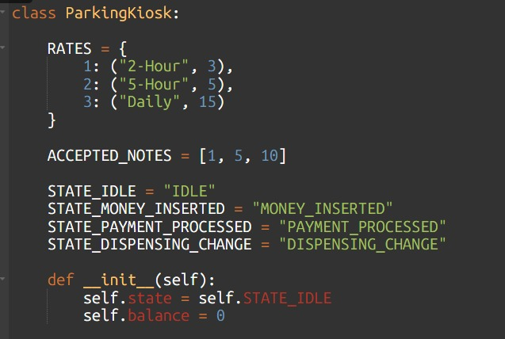 | This program implements the parking kiosk as a state-driven system. The variable ‘self.state’ use to controls how the system progresses through each stage of the transaction
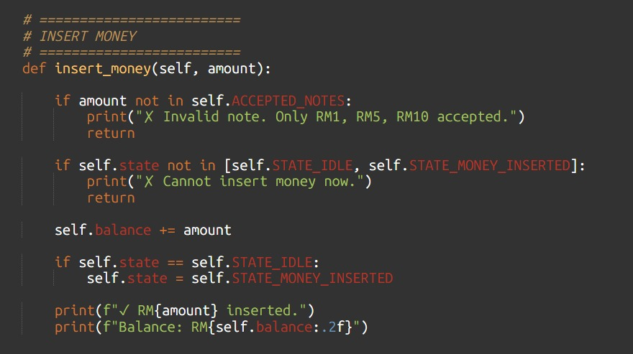 | The system starts from STATE_IDLE condition, where only money insertion is allowed. While user insert a valid note such as RM1, RM5, or RM10 through the insert_money() function, the balance will increase and the state transitions to STATE_MONEY_INSERTED. In this state, additional money can be inserted repeatedly, and the program dynamically enables payment options only when the balance satisfies the required rate like RM3, RM5, or RM15. This helps to ensures payment processing only occurs when sufficient funds are available.
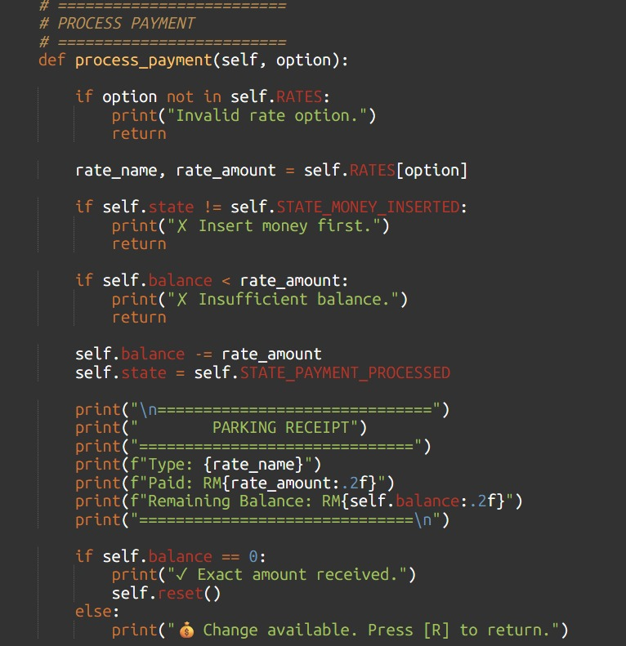 | If user selects a valid payment option, the process_payment() function deducts the amount, prints the receipt, and transitions the system to STATE_PAYMENT_PROCESSED.
From the payment processed stage, the system checks whether any balance remains. If the payment matches the exact rate, the kiosk resets immediately to the idle state. If there is remaining balance, the user may choose the return option that will trigger the return_change() function. After that, it will moves the system into STATE_DISPENSING_CHANGE and dispenses the remaining amount before resetting. Alternatively, at the money-inserted stage, the user may press cancel, which also transitions directly to the change dispensing state. After dispensing change, the reset will function restores the kiosk to the idle state, completing the full transaction cycle and allowing a new session to begin.

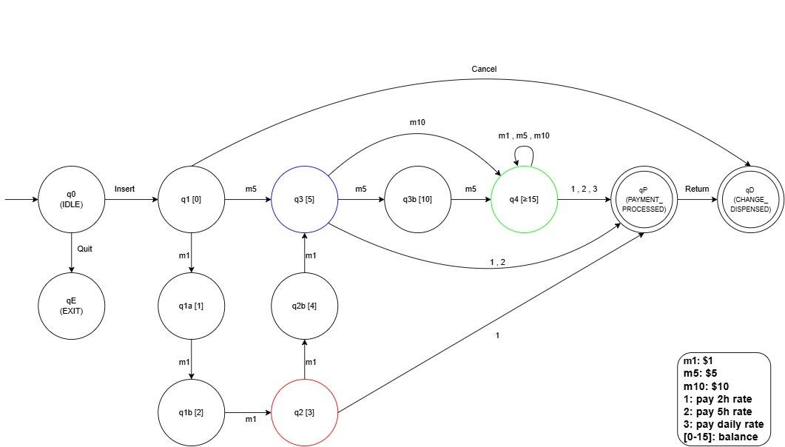
2.0 Deterministic Finite Automata (DFA)
Figure 1: DFA Diagram
Justification of the Finite Automata State Diagram
The Smart Parking Payment Kiosk System is modelled using a Deterministic Finite Automaton (DFA) in order to formally illustrate the sequential logic of the entire parking fee transaction process from fee collection, payment processing, and ultimately to change dispensing. The DFA reads all user interactions that are valid from when system is initialized to transaction completion or exit, ensuring the behavior of the system remains deterministic in every step. Each state in the diagram represents a specific stage in the process of parking fee transaction, where each transition represents a valid user input or system automated event.
Why This Is Deterministic
The automaton is deterministic because:
- For every state and every valid input symbol, there is exactly one defined transition.
- There are no ε-transitions that cause nondeterministic branching.
- All state transitions depend solely on the current state and the current input symbol
- Balance checking does not introduce nondeterminism; it functions as a deterministic guard condition.
Relationship Between Code and Automata
The Python implementation reflects the DFA structure:
- self.state represents the current automaton state.
- The while running loop represents continuous DFA operation.
- The money insertion loop in q1 represents self-loop transitions.
- The change calculation loop represents internal processing within q4.
Final Summary
The designed DFA accurately models the logical stages of the Smart Parking Payment Kiosk:
- Idle
- Money Insertion
- Rate Selection
- Payment Processing
- Change Dispensing
- Exit

3.0 Functional Definition
A DFA diagram is formally defined as a 5-tuple as illustrated below:
Automaton Definition: M = (Q, Σ, δ, S, F)
Element | Definition
Q | All the states consisting in the DFA diagram
Σ | All accepted symbols and characters that are non-empty
δ | The table that displays the mapping of the symbols of current state to the next state
S | The starting state of the diagram
F | The accept or final state(s) of the diagram, where the entire process is completed

A. Language
Σ = {insert, m1, m5, m10, 1, 2, 3, Cancel, Return, Quit}
Input | Description
Insert | User initiates transaction to pay for parking fee
m1 | RM1 bill
m5 | RM5 bill
m10 | RM10 bill
1 | Pay for 2-hour rate, RM3
2 | Pay for 3-hour to 5-hour rate, RM5
3 | Pay for daily rate, RM15
Cancel | Terminates transaction, changes are dispensed
Return | System dispenses remaining balance
Quit | Exit kiosk

B. State Transitions and Detailed Explanation
State | Description
q0 (IDLE) | - Initial state of the machine where it is waiting for user interaction  - User may:  - Select Insert to start the payment process  - Select Quit to exit  - No money is inserted yet, balance remains RM0.
qE (EXIT) | - Represents the termination of the system after user selects Quit  - No transaction is processed; therefore it is not an accepting state  - Session is terminated
q1 (0) | - Transaction begins after user selects Insert  - Balance is RM0 since no money is inserted yet  - System is ready to accept money input  - Accepted inputs include:  - m1 (RM1)  - m5 (RM5)  - m10 (RM10)  - Cancel – Existing balance is dispensed
q1a (1) | - User has inserted RM1  - Balance updated to RM1  - Still insufficient to pay any parking fee rates  - System is waiting for more money inputs
q1b (2) | - User inserted another RM1  - Balance increased to RM2  - Still not sufficient enough for minimum parking fee payment  - System is waiting for more money inputs
q2 (3) | - User inserted another RM1  - Balance is now ≥ RM3, sufficient to pay for 2-hour rate  - “Pay-2-hour-rate" button is activated  - User can:  - Press 1: Proceed to pay for 2-hour rate  - Insert more money
q3 (5) | - User inserted RM5  - Balance is now ≥ RM5, sufficient to pay for 2-hour or 5-hour rates  - “Pay-2-hour-rate" and “Pay-5-hour-rate" buttons are activated  - User can:  - Press 1: Proceed to pay for 2-hour rate  - Press 2: Proceed to pay for 5-hour rate  - Insert more money
q3b (10) | - User has inserted RM10  - Balance is now RM10  - “Pay-2-hour-rate" and “Pay-5-hour-rate" buttons are activated  - User can:  - Insert more money  - Continue to q4 if balance becomes ≥ RM15
q4 (≥ 15) | - User inserted RM15 or more  - Balance is now ≥ RM15  - All 3 payment options are available  - “Pay-2-hour-rate", “Pay-5-hour-rate", and “Pay-daily-rate" buttons are activated  - User can:  - Press 1: Proceed to pay for 2-hour rate  - Press 2: Proceed to pay for 5-hour rate  - Press 3: Proceed to pay for daily rate  - Insert more money
qP (PAYMENT_PROCESSED) | - Payment for rate (1, 2, or 3) has been selected  - Receipt printed for the user  - Transaction successful  - If there are remaining balance (balance > 0), system dispenses remaining change when user selects Return  - This is an accept state
qD (CHANGE_DISPENSED) | - Remaining balance dispensed  - Transaction is also successful  - Final state of the system  - This is an accept state

C. Start State
S = {q₀}

D. Final State
F = {qP, qD}
qP = Payment_processed
qD = Change_dispensed

E. Set of States
Q = {q0, q1, q1a, q1b, q2, q2b, q3, q3b, q4, qP, qD, qE}

F. State Transition Table
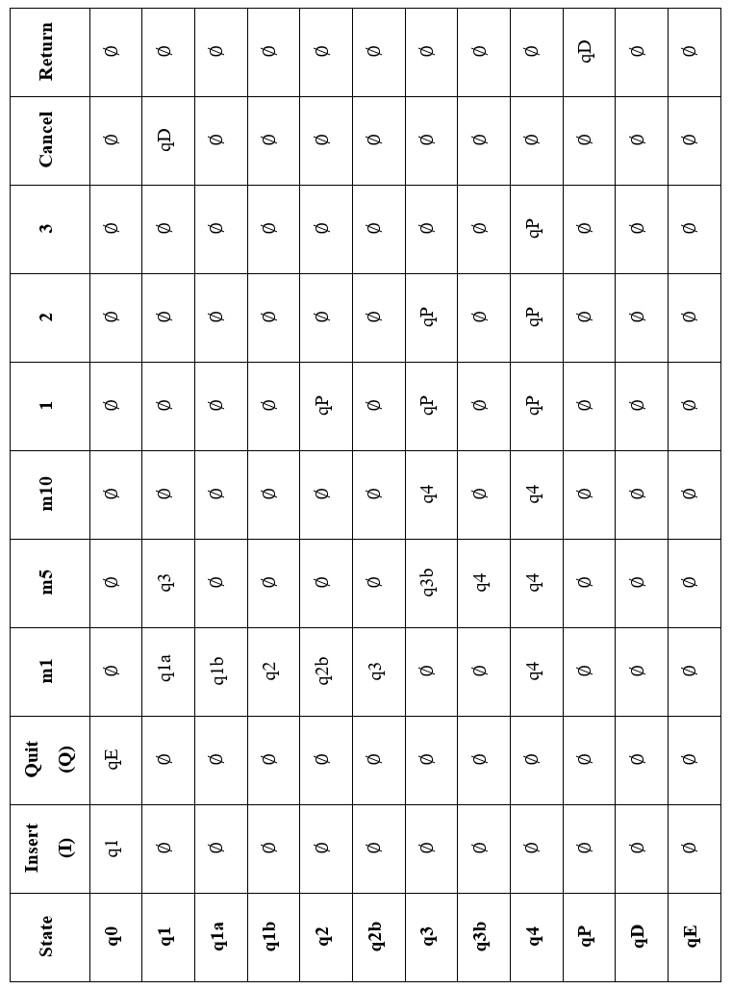

G Transition Function
From q0:  δ(q0, Insert) = q1  δ(q0, Quit) = qE | From q1:  δ(q1, m1) = q1a  δ(q1, m5) = q3  δ(q1, Cancel) = qD | From q1a:  δ(q1a, m1) = q1b
From q1b:  δ(q1b, m1) = q2 | From q2:  δ(q2, m1) = q2  δ(q2, m1) = q2b  δ(q2, 1) = qP | From q2b:  δ(q2b, m1) = q3
From q3:  δ(q3, m5) = q3b  δ(q3, m10) = q4  δ(q3, 1) = qP  δ(q3, 2) = qP | From q3b:  δ(q3b, m5) = q4 | From q4:  δ(q4, m1) = q4  δ(q4, m5) = q4  δ(q4, m10) = q4  δ(q4, 1) = qP  δ(q4, 2) = qP  δ(q4, 3) = qP
From qP:  δ(qP, Return) = qD | From qD:  - | From qE:  -

4.0 Regular Expression
The Regular Expression is derived from the DFA using GNFA Conversion. It is a method used in computing theory in order to convert a finite automaton into a regular expression through the progressive elimination of states.
Step 0: Insert new start and accept states with ε-transition
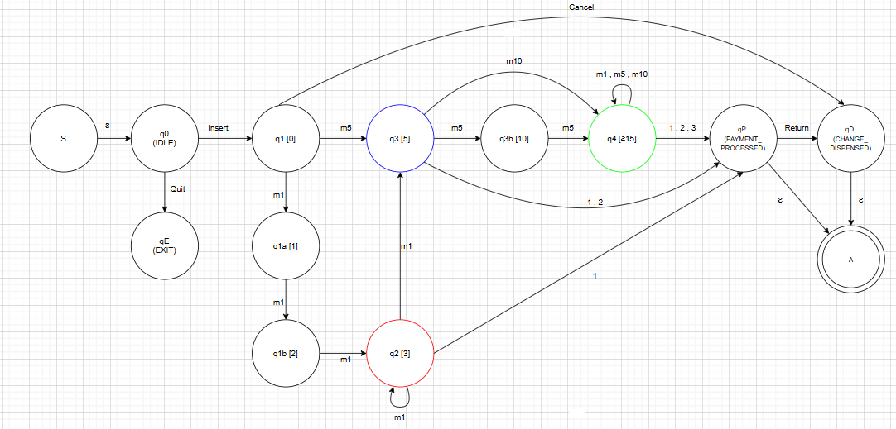
- A new start state and accept state are introduced, labelling as S and A
- An ε-transition is used to connect the new start state to the original start state, q0
- This ensures the structure is able to satisfy the GNFA requirements:
  - Only one start state
  - Only one accept state
- The automaton is prepared for state elimination

Step 1: Eliminate rate 1 (balance ≥ 3)
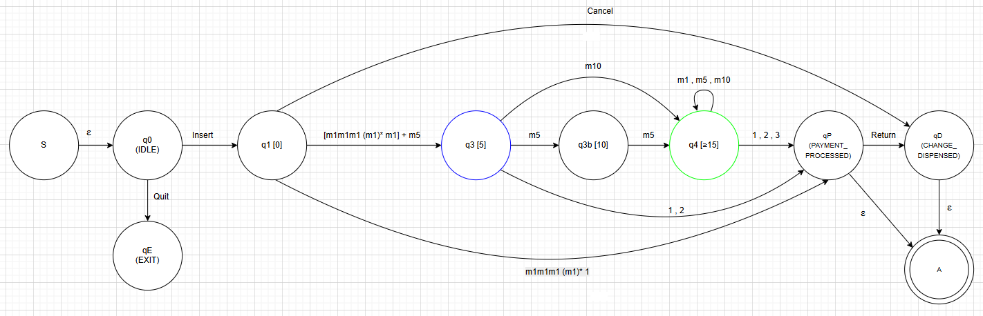
- The initial step is to eliminate the transaction for 2-hour rate, r1
- The intermediate states eliminated include:
  - q1
  - q1a
  - q1b
  - q2
- The intermediate states are merged into one single transition, defining the regular expressions:
  - m1m1m1 (m1)* 1
  - [m1m1m1 (m1)* m1] + m5
- Justification: These two expressions are not combined into a single expression yet at this stage as they correspond to distinct destination states. Therefore, merging them prematurely would require the elimination of the other states, skipping necessary elimination steps.

Step 2: Eliminate rate 2 (balance ≥ 5)
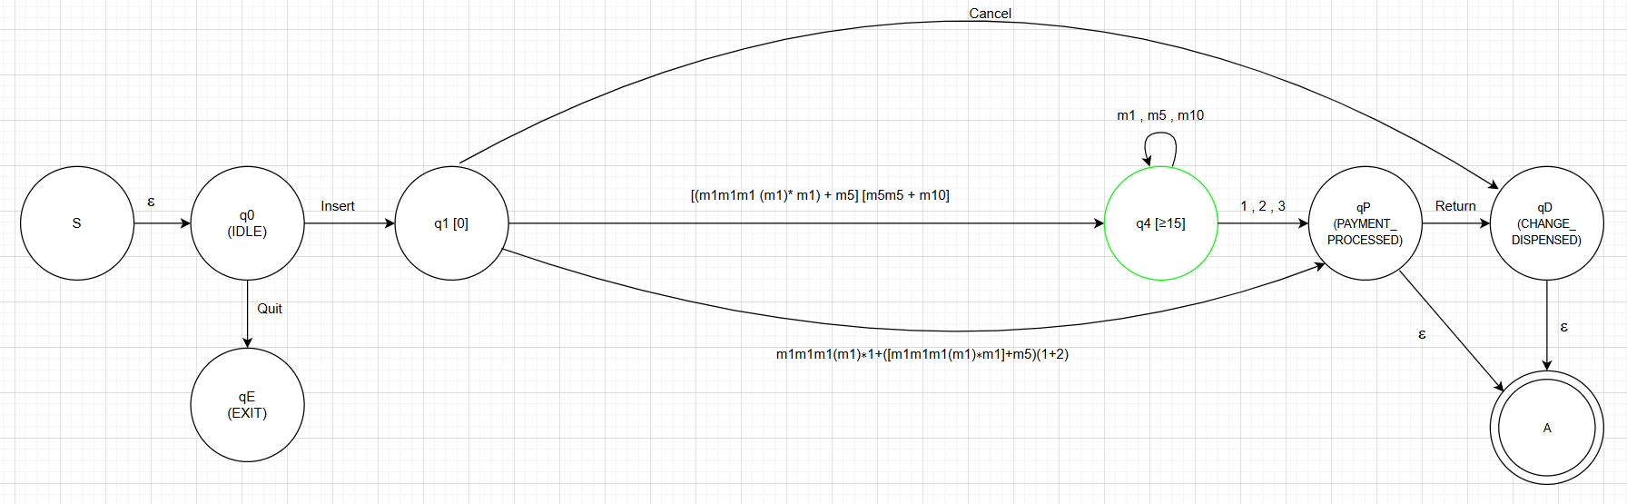
- Following next is to eliminate the transaction for 5-hour rate, 2
- The intermediate states eliminated include:
  - q3
  - q3b
- The intermediate states are merged and combined with the earlier defined regular expressions, defining two regular expressions:
  - [(m1m1m1 (m1)* m1) + m5] [m5m5 + m10]
  - m1m1m1 (m1)* 1 + ([m1m1m1(m1)∗m1]+m5)(1+2)

Step 3: Eliminate r3 (balance ≥ 15)
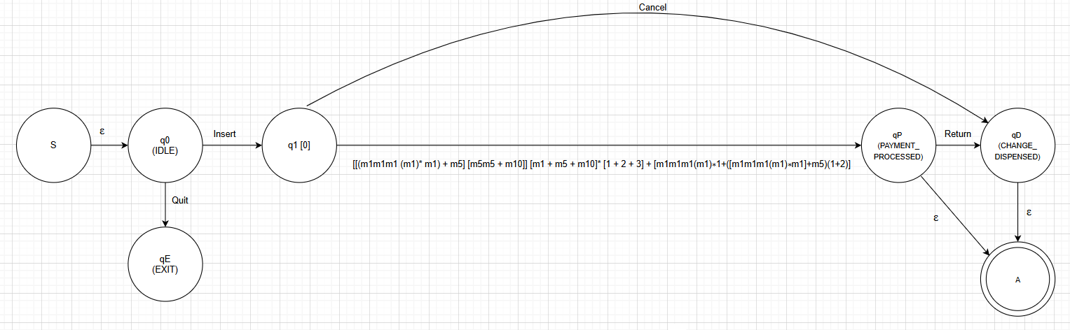
- The next step is to eliminate the transaction for the daily-rate, 3
- The intermediate states eliminated include:
  - q4
- The separated regular expressions in the previous steps are now combinable as they lead to the same destination
- New regular expressions:
[[(m1m1m1 (m1)* m1) + m5] [m5m5 + m10]] [m1 + m5 + m10]* [1 + 2 + 3] + [m1m1m1(m1)∗1+([m1m1m1(m1)∗m1]+m5)(1+2)]

Step 4: Eliminate q1
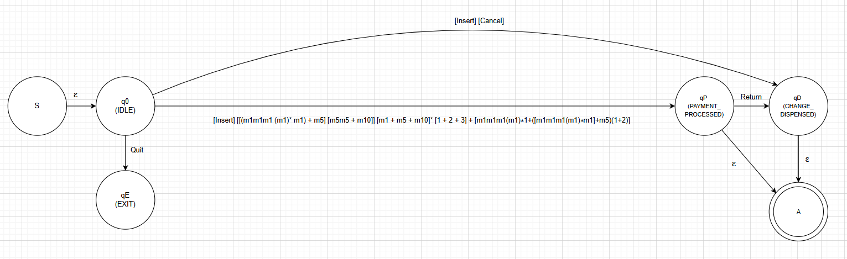
- The preceding step is to eliminate q1, where the money insertion process begins
- The intermediate state eliminated here is:
  - q1
- The newly defined regular expression include:
  - Insert [[(m1m1m1 (m1)* m1) + m5] [m5m5 + m10]] [m1 + m5 + m10]* [1 + 2 + 3] + [m1m1m1(m1)∗1+([m1m1m1(m1)∗m1]+m5)(1+2)]
  - [Insert] [Cancel]

Step 5: Eliminate initial accept states and start state
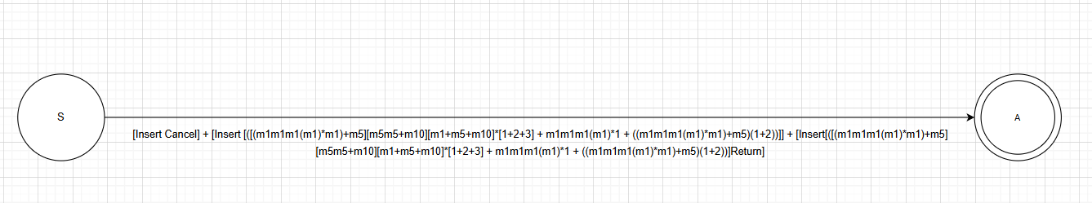
- The last step is to eliminate the initial accept states and start state
- The states eliminated include:
  - q0
  - qE
  - qP
  - qD
- The final regular expression defined is:
[Insert Cancel] +
[Insert [([(m1m1m1(m1)*m1)+m5][m5m5+m10][m1+m5+m10]*[1+2+3] + m1m1m1(m1)*1 + ((m1m1m1(m1)*m1)+m5)(1+2))]] + [Insert[([(m1m1m1(m1)*m1)+m5][m5m5+m10][m1+m5+m10]*[1+2+3] + m1m1m1(m1)*1 + ((m1m1m1(m1)*m1)+m5)(1+2))]Return]
Regular Expression | Description
[Insert Cancel] | Cancel transaction, change dispensed
[Insert [([(m1m1m1(m1)*m1)+m5][m5m5+m10][m1+m5+m10]*[1+2+3] + m1m1m1(m1)*1 + ((m1m1m1(m1)*m1)+m5)(1+2))]] | Transaction process for where balance = 0 after payment, no change dispense required
[Insert[([(m1m1m1(m1)*m1)+m5][m5m5+m10][m1+m5+m10]*[1+2+3] + m1m1m1(m1)*1 + ((m1m1m1(m1)*m1)+m5)(1+2))]Return] | Transaction process for where balance > 0 after payment, change dispense required

Part B

5.0 Time Complexity Analysis
The time complexity analysis targets the efficiency of an algorithm of the input size and the number of fundamental operations performed. For smart parking payment kiosk system, the input size is not like the traditional data structure, but rather the number of user interactions and amount of the user insert their money. It focuses on the computational step executed by python to response the user actions.

5.1 Best-Case Complexity O (1)
Scenario: Users enter the exact amount and completes payment without any required change.
Example: Users enter RM5 and select a 5-Hour rate.
Operations Analysis:
Operation | Complexity | Explanation
Insert_money (RM5) | O (1) | Sigle validation and state transition
Process Payment (RM5) | O (1) | Dictionary checking, state change
Reset () | O (1) | Clear current balance, return to IDLE
The dispense_change() function is not called in this case since the remaining amount is zero. No matter how big the input is, the number of processes carried out stays the same.
Best-Case Time Complexity = O(1).

5.2 Worst-Case Complexity
Scenario: Users enter multiple money, cancel transaction and required maximum change.
Example: Users insert RM10, RM5, RM1, RM1 and RM1 then press cancel.
The dispense_change() function calculates notes required to return the balance using loop:
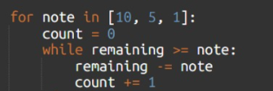
The algorithm repeatedly subtracts note values until the remaining balance becomes zero.
Operations Analysis:
Operation | Complexity | Explanation
5 x Insert_money () | 5 x O (1) | Each insertion is constant time
Cancel () | O (1) | State transition to change
Dispense_change () | O (n) | Where n= number of notes to dispense
Returning RM18 = RM10 x 1, RM5 x 1, RM1 x 3
Classification O (n): Linear where n is number of number of notes dispensed during the change calculation
The number of iterations depends on the number of notes required to dispense the change. If the change of amount increases, the number of iterations will also increase.
Worst-Case Time Complexity = O(n)
Summary:
Case | Complexity
Best Case | O(1)
Worst Case | O(n)
This shows that the Smart Parking Payment Kiosk system performs efficiently for normal transactions, but the execution time increases linearly when calculating change.

6.0 Computability Discussion
Computability helps to determines whether the Smart Parking Payment Kiosk system can be solved by a computational model such as an algorithm, automaton, or Turing machine.
The Smart Parking Payment Kiosk system is computable because it follows to a finite set of rules and deterministic state transitions that always produce a result.

6.1 Complete
The DFA of the Smart Parking Payment Kiosk system is complete since each potential user input has a defined transition or error handler, ensuring that no undefined behavior takes place.
Example from main() function:
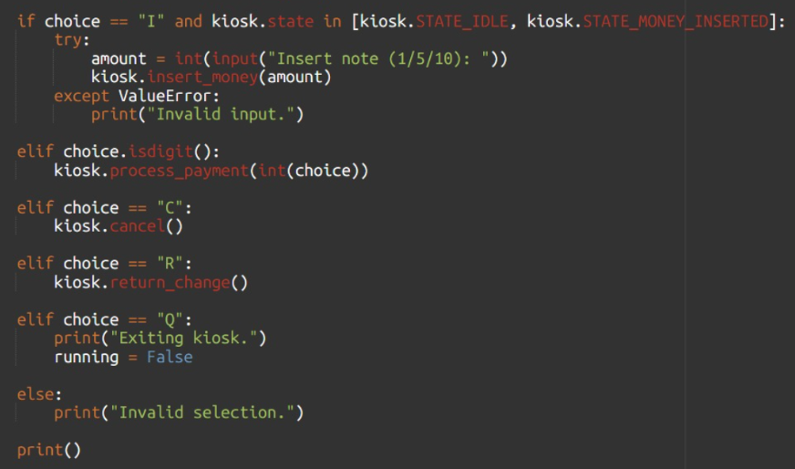
The system handles all possible inputs through exhaustive conditional checking
Completeness:
State | Valid Inputs | Invalid input Handling
STATE_IDLE | Insert (I), Quit (Q) | "Cannot insert money now" if other actions attempted
STATE_MONEY_INSERTED | Insert (I), 1, 2, 3, Cancel (C), Quit (Q) | "Insert money first" if payment attempted without funds
STATE_PAYMENT_PROCESSED | Return (R), Quit (Q) | "No change available" if return attempted without balance

6.2 Mechanistic
The kiosk employs a mechanical design because its operation are defined by precise, step-by-step rules with unambiguity. Every operation follows exact arithmetic and logical conditions.
Code example:
Precise State Transition Rules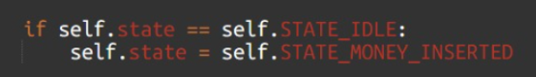 | The state transition only occurs when the exact condition is met. There is no ambiguity - if the state is IDLE, it becomes MONEY_INSERTED. No other outcome is possible.
Exact Arithmetic Calculations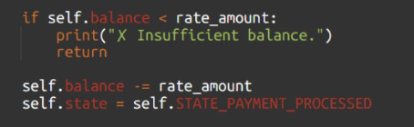 | The balance check uses exact arithmetic comparison (<). The deduction is precise subtraction, and state assignment is immediate and unambiguous. There is no approximation or rounding.
Mechanistic Change Calculation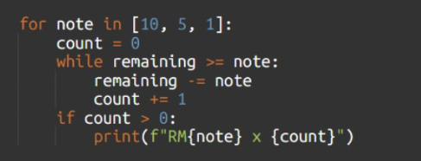 | The loop processes denominations in fixed order (10, 5, 1). The while loop strictly decreases remaining balance until it falls below the note value. The count is exact, and output is deterministic based purely on arithmetic.
No Ambiguity in Decision Making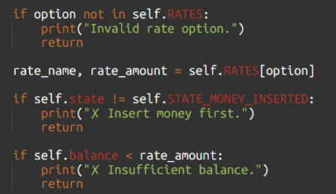 | Each condition is checked in sequence with explicit true or false outcomes. There are no fuzzy logic or probabilistic decisions. Every path leads to a defined result.
Every decision follows if-then-else logic with explicit conditions, making the system fully mechanistic and algorithmic.

6.3 Deterministic
The kiosk is a DFA where the same input in the same state always produces the same result. There is no randomness, no ambiguous transitions, and no ε-transitions. Therefore, it is deterministic.
Justification:
Example | Explanation
Single Transition Per (State, Input):  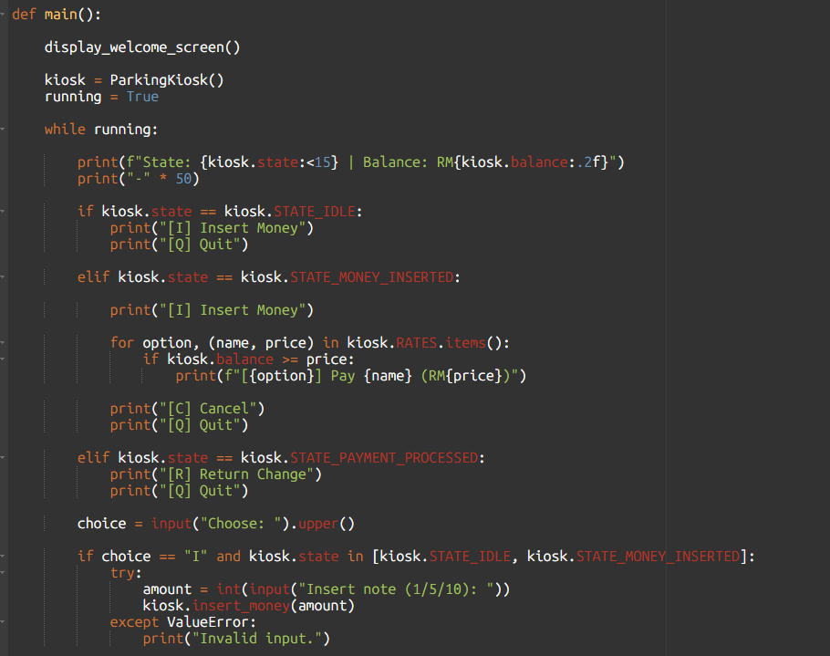 | In STATE_IDLE, input "I" always triggers insert_money(). Input "Q" always sets running = False. The condition kiosk.state in [kiosk.STATE_IDLE, kiosk.STATE_MONEY_INSERTED] ensures only the valid transitions can occur, each input maps need to be in exactly one action.
No ε-Transitions (No Automatic State Changes):  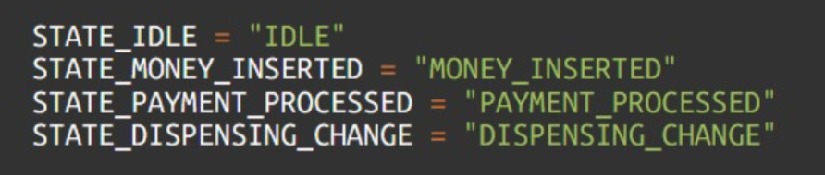 | All transitions require explicit user input. State only changes when user performs action:  Insert money → MONEY_INSERTED  Select rate → PAYMENT_PROCESSED  Press Cancel/Return → DISPENSING_CHANGE  Reset → IDLE  Every state change is triggered by a specific method call, which is invoked by explicit user input in the main loop. There are no automatic transitions based on time, random events, or background processes.
Same Input → Same Result:  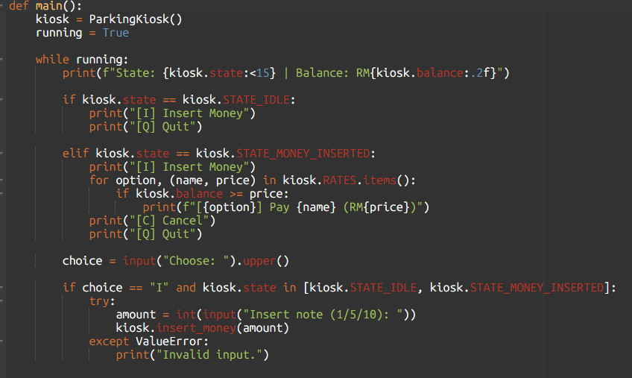 | When main() starts, it creates kiosk = ParkingKiosk() which initializes state = "IDLE" and balance = 0 via __init__. If user inputs "I" and enters amount 5, insert_money(5) executes. Because when self.state == self.STATE_IDLE is true, the state will changes to "MONEY_INSERTED" and balance will becomes 5. This sequence will always produce the same result, which is no randomness or alternative path.

Verification of DFA Properties
Property | Code Implementation
δ: Q × Σ → Q | if self.state == X and input == Y: self.state = Z (single assignment)
No multiple paths | If-elif-else structure ensures only one branch executes
No ε-transitions | Every state change requires explicit user input in main() loop

Transition Function Examples:
- δ(IDLE, Insert) = MONEY_INSERTED through insert_money()
- δ(MONEY_INSERTED, Cancel) = DISPENSING_CHANGE (via cancel())
- δ(PAYMENT_PROCESSED, Return) = DISPENSING_CHANGE through return_change()
- δ(DISPENSING_CHANGE, ε) = IDLE an internal process via reset() without user-triggered

6.4 Decidable
The kiosk problem is decidable because there exists the Python implementation algorithm that always halts with a correct yes or no answer for any valid input. We can construct a Turing Machine that can simulate the kiosk and always be in a halt.
Justification:
Decision Problems and Algorithms:
Decision Problem | Algorithm in Code | Halting Behavior
Is note valid? | if amount not in self.ACCEPTED_NOTES | Halts immediately with rejection
Is balance sufficient? | if self.balance < rate_amount | Halts after arithmetic comparison
Should change be dispensed? | if self.balance == 0 vs else | Halts with binary decision
Is transaction complete? | State reachability via transition table | Halts (finite state path)
Halting Proof:
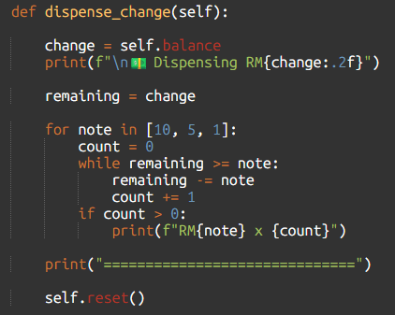
The outer for loop runs exactly 3 times (fixed denominations). The inner while loop strictly decreases remaining by at least 1 each iteration and stops when remaining < note. Since remaining is finite and decreases monotonically, the loop must terminate. Maximum iterations = initial balance value.
Turing Machine Simulation of Kiosk:
The kiosk can be simulated by a Turing Machine where:
- TM Tape = Sequence of user inputs. For example, "Insert, m5, 2, Return".
- TM States = {IDLE, MONEY_INSERTED, PAYMENT_PROCESSED, DISPENSING_CHANGE}
- TM Transition Function = Same as kiosk DFA transitions

6.5 Church-Turing Thesis
The Church-Turing Thesis states that all models of computation are equivalent to a standard Turing machine. The Smart Parking Kiosk, implemented as a DFA, satisfies this thesis because it can be simulated by a TM and is no more powerful than a standard TM.
Justification:
Finite States and Memory  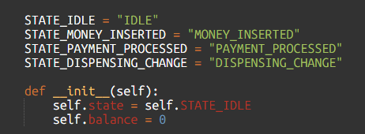 | The kiosk has 4 finite states and one integer variable. This maps to a TM with finite states and finite memory.
Transition Function  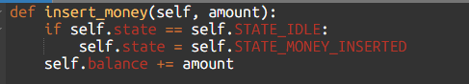  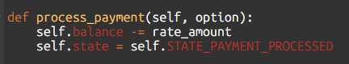 | These methods represent the TM transition function δ(state, symbol). Each (state, input) pair maps to exactly one next state and memory update.
TM Simulation  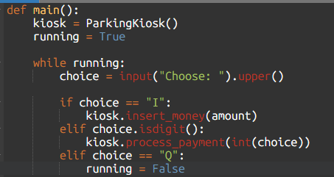 | The main() loop simulates a TM. The choice reads tape symbols one at a time, kiosk.state represents TM state, and the if-elif structure implements the transition function. The TM halts when running = False
Verification:
- The kiosk has been verified through code execution:
- Test case:["Insert","m5","2"]→Halts in PAYMENT_PROCESSED with balance = 0
- Test case: ["Insert", "m10", "Cancel"] → Halts in DISPENSING_CHANGE with balance returned
- Test case: ["Insert", "m1", "Quit"] → Halts in EXIT (via running = False)
- All test cases halt, confirming the Church-Turing Thesis that the DFA is computationally equivalent to a TM.

8.0 Conclusion
This assignment applies the concepts from the automate theory and computability to the Smart Parking Payment Kiosk System. In Part A, a DFA is design to represent the step-by-step process of the system. This including the formal definition of DFA and a corresponding regular expression to describe the Smart Parking Payment Kiosk System.
In Part B, a complex analysis has been conducted. It shows the best-case time complexity (O (1)) and the worst-case time complexity (O(n.)) This computability also confirmed that the system is deterministic and decidable, which mean that it can always produce a clear and predictable result.
In conclusion, this assignment demonstrated how theoretical computer science concepts can be applied to a model and how can it analyse a real-world system effectively.

9.0 References
Sisense. (2025, July 22). What is Deterministic Finite Automata? (DFA) | Definition.
https://www.sisense.com/glossary/deterministic-finite-automata/

GeeksforGeeks. (2025a, July 12). Church’s Thesis for Turing Machine. GeeksforGeeks. https://www.geeksforgeeks.org/theory-of-computation/churchs-thesis-for-turing-machine/

