# Before Login Page Layout

|  |  |  |  |  |  |
| --- | --- | --- | --- | --- | --- |
|  |  |  |  |  |  |
| Endpoint | / | | | | |
| Description | Page Layout | | | | |
| Login Needed | No | | | | |

Real Time

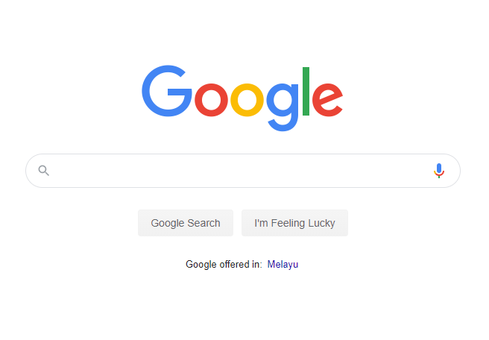

Show <https://www.google.com/> screen

Warning Pop up Close button

Linked to login page

X

WARNING

Time: 3:11 PM

Login

## Home

|  |  |  |  |  |  |
| --- | --- | --- | --- | --- | --- |
|  |  |  |  |  |  |
| Endpoint | /Dashboard | | | | |
| Description | Dashboard Page  1st time loading will show with a “Warning” pop up which can close by click (X) icon at the top right corner of the pop up.  Once close the warning pop up, user can choose to Login or search using the google screen. | | | | |
| Login Needed | No | | | | |



X

WARNING

Time: 3:11 PM

Login

## Login

|  |  |  |  |  |  |
| --- | --- | --- | --- | --- | --- |
|  |  |  |  |  |  |
| Endpoint | /Login | | | | |
| Description | Sign In Page  Show error message if username/password is empty  Once Login can view [Left Menu] and some secured pages.  All validation pass, only allow click on **Sign In** button. | | | | |
| Login Needed | No | | | | |



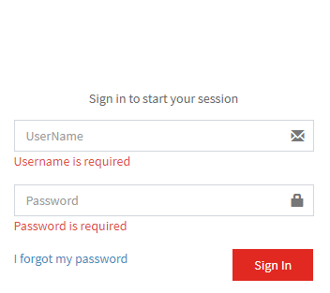

Login

Log-In

## Forget Password

|  |  |  |  |  |  |
| --- | --- | --- | --- | --- | --- |
|  |  |  |  |  |  |
| Endpoint | /ForgetPwsd | | | | |
| Description | Forget Password Page  Once Key in username and click reset password, send email with temporary password.  Show error message if username is empty.  All validation pass, only allow click on **Reset Password** button. | | | | |
| Login Needed | No | | | | |

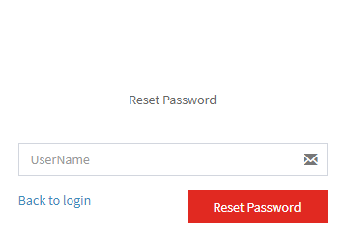

Time: 3:11 PM

Login

Forget Password

# After Login Page Layout

|  |  |  |  |  |  |
| --- | --- | --- | --- | --- | --- |
|  |  |  |  |  |  |
| Endpoint | / | | | | |
| Description | Page Layout  If user try to access these page during not login, show unauthorized page | | | | |
| Login Needed | Yes | | | | |

Welcome to Login User

Real Time

Hello Shawn

Time: 3:11 PM

Logout

Logout and go to Home screen

Profile

Change Password

Products

Left Menu

## My Profile

|  |  |  |  |  |  |
| --- | --- | --- | --- | --- | --- |
|  |  |  |  |  |  |
| Endpoint | /MyProfile | | | | |
| Description | Page Layout  Just display profile information’s.  Profile data get from API to display on screen. | | | | |
| Login Needed | Yes | | | | |

Hello Shawn

Time: 3:11 PM

Logout

Bread Crumb

My Profile

User Name : Shawn

Email : [shwan@yahoo.com](mailto:shwan@yahoo.com)

Profile

Change Password

Products

## Change Password

|  |  |  |  |  |  |
| --- | --- | --- | --- | --- | --- |
|  |  |  |  |  |  |
| Endpoint | /ChangePwsd | | | | |
| Description | Change Password Page  Allow login user to change the login password  Show error message if Current/New/Confirm New password is empty  Show error message if New and Confirm New password is not same  All validation pass, only allow click on **Submit** button. | | | | |
| Login Needed | Yes | | | | |

Hello Shawn

Time: 3:11 PM

Logout

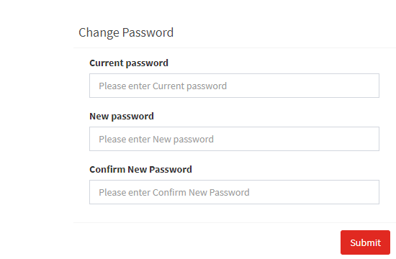

Profile/Change Password

Profile

Change Password

Products

## Products

|  |  |  |  |  |  |
| --- | --- | --- | --- | --- | --- |
|  |  |  |  |  |  |
| Endpoint | /Product | | | | |
| Description | Product Page  Allow login user to view available Product   |  | | --- | | MODEL | | Product Details contains | | * id: number; * Name: string; * Description: string; * ImagePath: string; | | Product Variance contains | | * Info: string * Price: number | | | | | |
| Login Needed | Yes | | | | |

Hello Shawn

Time: 3:11 PM

Logout

Product

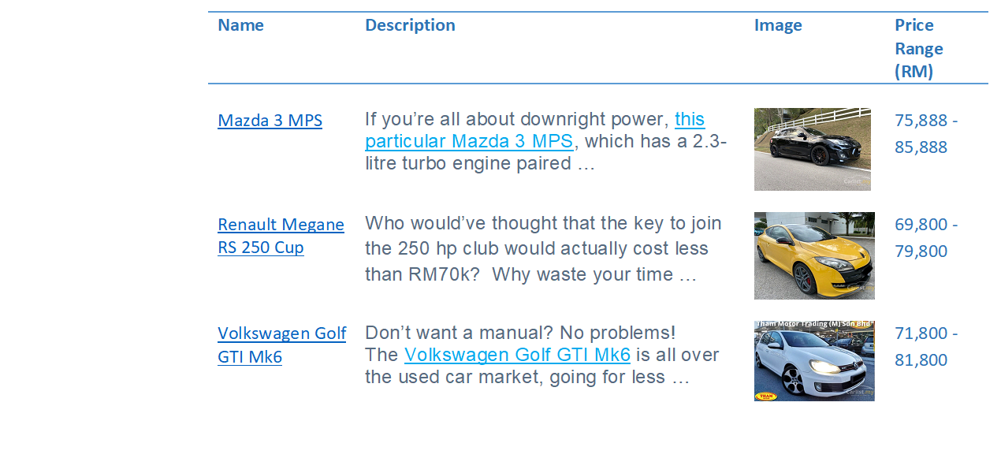

Description: Max Show 3 Line with … at the end

Profile

Change Password

Products

### Products Details

|  |  |  |  |  |  |
| --- | --- | --- | --- | --- | --- |
|  |  |  |  |  |  |
| Endpoint | /Product/[id] | | | | |
| Description | Product Detail Page  Allow login user to view Selected Product Details | | | | |
| Login Needed | Yes | | | | |

Hello Shawn

Time: 3:11 PM

Logout

Product\Renault Megane RS 250 Cup

Profile

Change Password

Products

Renault Megane RS 250 Cup

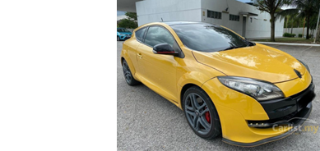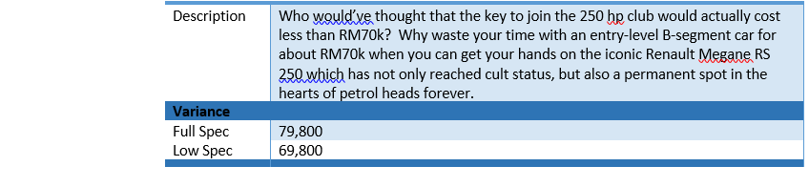

Back

### Invalid Products Details

|  |  |  |  |  |  |
| --- | --- | --- | --- | --- | --- |
|  |  |  |  |  |  |
| Endpoint | /Product/[id] | | | | |
| Description | Product Detail Page | | | | |
| Login Needed | Yes | | | | |

Hello Shawn

Time: 3:11 PM

Logout

Product

Profile

Change Password

Products

Invalid Product ID

Back

# Unauthorized

|  |  |  |  |  |  |
| --- | --- | --- | --- | --- | --- |
|  |  |  |  |  |  |
| Endpoint | /Unauthorized | | | | |
| Description | Unauthorized Page  When user try to access to pages which need Login, they will be directed to this page | | | | |
| Login Needed | No | | | | |

Unauthorized

Time: 3:11 PM

Login

Unauthorized