Lab 8 Activity 1
The Flask container returned Hello, World! with HTTP 200 on port 5000.
1. docker ps -a
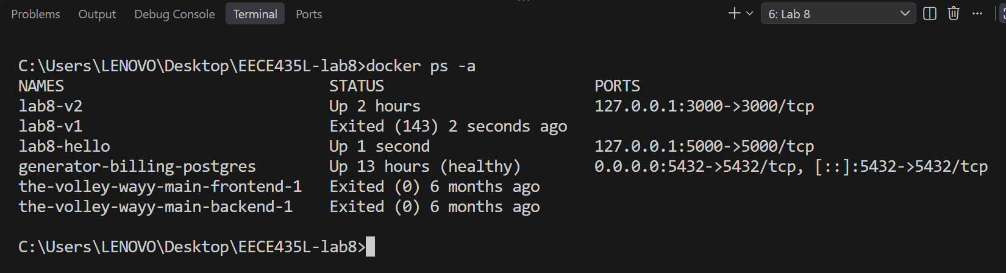
Lists running and stopped containers. The output shows lab8-hello running on port 5000.
2. docker stop lab8-hello
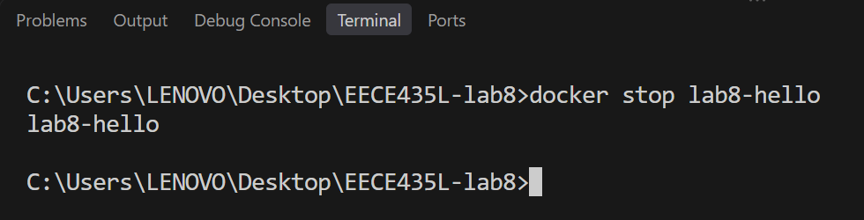
Stops the lab8-hello container and prints its name when it stops.
3. docker logs --tail 10 lab8-hello
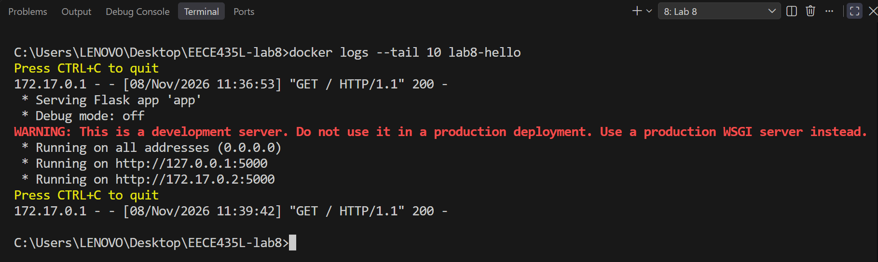
Shows the last ten log lines, including Flask startup and the successful HTTP request.

