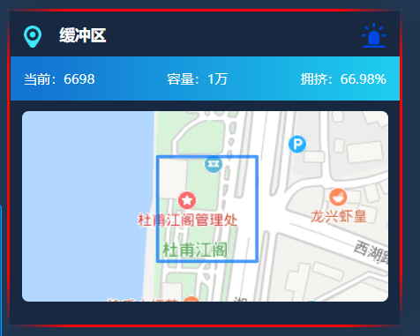

边框渐变

border: 3px solid;

border-image: linear-gradient(38deg,rgba(0,197,255,0.10) 0%, #f00 8%, #f00 42%, rgba(0,197,255,0.10)50%, #f00 58%, #f00 92%, rgba(0,197,255,0.10) 100%) 1 1;