Проектное предложение

Курсовой проект магистранта (первый год обучения)
ОП «Системная и программная инженерия» (СПИ)
Департамент программной инженерии / ФКН
Студент: Яхя Янал
Номер – М231МСПИ4029

Название проекта: Система для поддержки
студенческой деятельности в общежитиях
(System for Supporting Student Activities in
Dormitories)
Руководитель : Х.М. Салех, к.т.н., доцент ДПИ ФКН НИУ ВШЭ

Дата представления предложения: 03.01.2024 г.
Москва, 2024

Abstract

A Russian student dormitory still runs on paper. The rules of residence posted in every building make the security officer write each visitor into a journal by hand — who came, to whom, to which room, and the times of arrival and departure — while a resident of the same building passes the turnstile with an electronic card. A guest is let in between 8:00 and 23:00, and only while the resident who invited them is there [3]. Announcements, lost property and maintenance have no register at all, and no system in a review of 6 joins all four areas in a form fit for a Russian dormitory.

This project treats that daily administration as one system. A web prototype was designed and built: four modules — guest requests, announcements, lost-and-found, maintenance requests — for six roles, on synthetic data. The catalogue holds 43 requirements, 28 of them inside the MVP scope. All 21 Must-priority requirements of that scope are implemented and covered by passing tests, against a threshold of 19. A survey of 26 residents put maintenance first and guests second, which the analysis had not predicted.

Key words: dormitory administration; guest journal; visitor registration; requirements
engineering.

Table of Contents

Abstract ………………………………….……………………………………. page 2

Introduction ………………………………….………………………………… page 4

Project Statement …………….……………………………………………… page 5

Methodology (Approaches / Methods) ……………..………………………… page 6

Expected Results and Discussion ……………………………………. page 7

Work Plan …………………….…………………………………….……. page 8

Implications of the Research (Project’s Work) ……………………. page 9

List of References ……………………. page 10

Introduction

At the end of 2025, 861.1 thousand students in Russia needed a place in a university dormitory and 82.6% got one, against 86.7% in 2015 [1]. The state answers with construction, 473.3 billion roubles to 2030 for new campuses [2], while the running of the buildings stays on paper: electronic document management reaches students in 34.7% of Russian universities, last among nine classes of software [1].

The rules of residence — the document posted on the wall of every dormitory — make the security officer enter six items into a journal for every visitor: who came, to which room, to whom, the document shown, and the times of arrival and departure. A guest may stay from 8:00 until 23:00, and the resident who invited them has to be present [3]. Eleven more universities were read the same way, and the shape does not change: a resident starts the request, a staff member approves it, security checks a document and writes the times [4]. What changes are the numbers — the closing hour runs from 22:00 to 23:00, and the notice a resident has to give runs from none to fourteen days.

Residents already cross the threshold electronically. Kazan Federal University describes the
contactless card and the turnstile right before the visitor journal, and the HSE rules give every resident an electronic pass [3, 4]. The guest entering the same door still gets a paper card and a handwritten line.

Six systems were assessed against seven features, from published descriptions:

System | Residents and rooms | Guest request, approval, entry log | Announcements and maintenance | Lost-and-found | Fit for Russian dormitories
1C:University PROF [5] | + | - | - | - | +
TANDEM.University [6] | + | - | - | - | +
Naumen, Apeks-VUZ, Galaktika, Modeus, VSUES [7] | partly | - | - | - | +
Sigur; PERCo with VisitorControl [8] | - | + | - | - | +
StarRez Front Desk; ResLife Portal Visitor Logs [9] | + | + | + | - | -
Eight other foreign platforms [9] | + | - | + | - | -

No row is complete. Lost-and-found is missing from all sixteen systems and all twelve sets of house rules, and no product joins a guest request, an approval route, a housing stock and announcements the way a Russian dormitory runs them. Six years of living in dormitories produced the author's first list of problems, taken as hypotheses.

Project Statement

The problem is the absence of an integrated information system for the day-to-day administration of a Russian student dormitory — guest visits approved and registered within the hours the building allows, announcements, maintenance requests, lost-and-found — with the roles of resident, duty officer, warden, building manager, security officer and administrator kept apart.

Aim. To design, implement and validate on synthetic data a prototype web system covering four modules — guest requests with approval by the duty officer and verification at the security post, announcements, lost-and-found, maintenance requests — for six roles, realising by the defence not less than 90 % of the Must-priority functional requirements of the MVP scope, that is 19 of 21, measured in the traceability table «requirement → implementation → test».

RQ1. Which elements of the guest procedure are invariant across universities, and which are local parameters for configuration?

RQ2. Which of the six journal attributes must the data model hold, and which can stay outside?

RQ3. Which problems do residents report as primary, and does their ranking match the one the document analysis suggested?

RQ4. What architecture lets one developer without access to university IT build a prototype an access control system can later connect to?

Objectives, each with a named deliverable: (1) analyse the house rules of HSE
university; (2) review 5 or more systems; (3) analyse stakeholders and elicit requirements; (4) compile a catalogue of thirty or more functional and ten or more non-functional
requirements with sources and acceptance criteria; (5) design to IEEE Std 1016; (6) justify the stack; (7) implement four modules with role-based access control; (8) test and evaluate. The first two come first because they deal with what the project cannot change; in January 2024 the order was the opposite, the main defect then.

Constraints. One academic period, one developer: only Must and part of Should, in a monolith without peer review. Zero budget, no access to university IT: open-source only, and an extension point in place of integration with the access control system, turnstiles, 1C or SSO. No real personal data, no real users, few respondents: synthetic data, a prototype, no staff interviews. Differing house rules, no production load: the access
hours live in configuration, performance is estimated.

Methodology (Approaches / Methods)

- Market review — 6 systems against seven features from published descriptions; the rating is the author's, so a missing feature may be undocumented rather than absent.
- Elicitation — a thirteen-question survey, 26 answers, 3–4 September 2026, the expected result written down beforehand; the staff interview guide was prepared but unused.
- Requirements engineering — 43 functional and 14 non-functional requirements, 28 inside the MVP, each traced back to the house rules or to a stated need, with a MoSCoW priority and a Given/When/Then criterion (IEEE Std 830 and 1233 in ISO/IEC/IEEE 29148).
- Design and stack — C4 views, an ER model of sixteen entities and a REST extract to IEEE Std 1016; Laravel 13, PostgreSQL 17, Redis and a React SPA, chosen over Django, Spring Boot and Express for object-level permissions.
- Implementation and testing — five vertical slices, lost-and-found last because it holds no Must requirement; one test per acceptance criterion, and five independent acceptance passes.

Expected Results and Discussion

The January 2024 version described expected results; the work has since been done. On a stand of two dormitories and 72 accounts a resident files a guest request, the duty officer decides it, and the security officer verifies the visitor and logs the times against that building's window, a configuration value.

What the prototype does, area by area:

- Accounts, roles and the housing stock — the administrator keeps the register of dormitories, buildings, rooms and beds and appoints the building manager, who appoints the rest of the staff and issues resident accounts; a residency ties a resident to one bed for a period, and the bed frees itself when the residency ends; the resident card carries the current bed, the history and the open requests; a floor plan shows what is where; logins, status changes and card views leave a line in the audit log, and decisions reach people as notifications.
- Guest requests — a resident files a request; the duty officer approves or refuses it with a reason; the security officer finds the visitor at the post and records entry and exit; the system watches the departure deadline against the hours of that building; the visitor register keeps the line, and no one edits it afterwards.
- Announcements — the building manager or the administrator publishes to a whole dormitory or to one building, and residents read a feed sorted by date with a filter by category.
- Lost-and-found — the security officer or the building manager registers a find with a photo; residents see the list for their own building, not who handed the thing in; a resident claims it by describing it, and the building manager marks it back.
- Maintenance requests — a resident reports a fault with a photo and a place; the building manager sorts the queue and assigns the work; the request walks its statuses to done, and the resident either confirms the repair or reopens it.

Of the forty-three requirements in the catalogue, twenty-eight went into the MVP, and twenty-one of those were obligatory. Fourteen non-functional requirements stand beside them: performance, scalability, availability, security, usability, maintainability, deployment and data integrity.

What the iteration does not have:

- events and the inventory handover with a signed statement — never started, and residents put both of them last of the six areas in the survey below;
- four conveniences that block nobody: moving a resident to another bed, pinning an announcement, the storage clock on a find, and barring an offender from filing guest requests;
- three that were inside and left during the work: acknowledgement of reading, which needs a disciplinary process the prototype does not have; the foreign-guest flag, which has nothing to sit on once the guest's document is not stored; and the consent screen, which has nobody to ask on generated records.

Work Plan

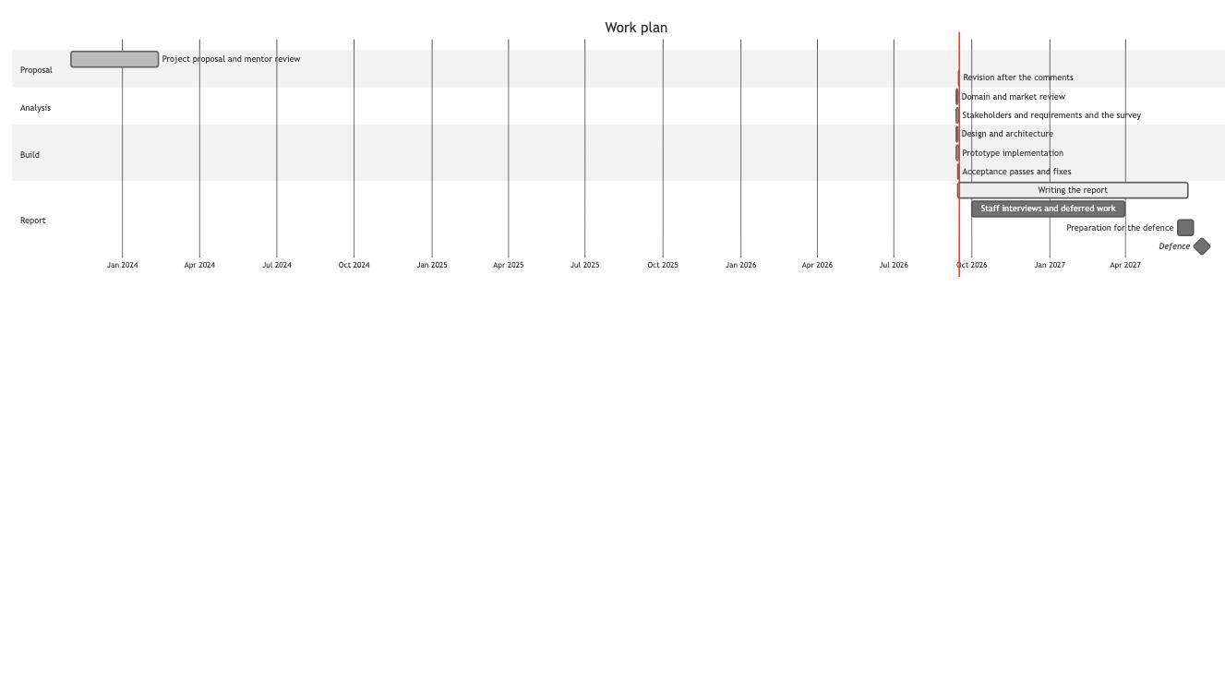

Implications of the Project’s Work

Five of the six items the officer writes by hand move into a register readable by date, by building and by resident, and the sixth stays with him at the desk; what differs between universities — the hours, the notice period — sits in configuration, so the build is not tied to HSE. The niche is unoccupied: Russian dormitories keep the visitor record on paper, while abroad the same function is sold as a separate module. The work claims no deployed system: a frozen prototype on generated data, one rater, a self-selected sample.

List of References

- Education in Figures: 2026. Moscow: HSE ISSEK, 2026. Table 6.8, p. 118; Sec. 7.6, p. 128. URL: https://www.hse.ru/mirror/pubs/share/1196008207.pdf (accessed 13.09.2026).
- HSE University. Rules of Residence in the Student Dormitory. URL: https://www.hse.ru/docs/1189956784.html (accessed 13.09.2026).
- Kazan Federal University. Rules of the Student Campus. URL: https://kpfu.ru/portal/docs/F1088806516/pravila.studgorodka.pdf (accessed 13.09.2026).
- Moscow Institute of Physics and Technology. Rules of Residence in the Dormitory. URL: https://old.mipt.ru/students/life/lodging/pravila/ (accessed 13.09.2026).
- Ural Federal University. Accommodation: Guide for First-Year Students. URL: https://privet.urfu.ru/accommodation (accessed 15.09.2026).
- RANEPA. Rules of Residence in the Student Dormitory. URL: https://www.ranepa.ru/upload/doc/obshejitiya/2025/Pravila_st_dorm.pdf (accessed 13.09.2026).
- ITMO University. Instruction on Issuing an Electronic Pass for Guests. URL: https://student.itmo.ru/files/2603 (accessed 15.09.2026).
- 1C:University PROF. Campus management subsystem. URL: https://solutions.1c.ru/catalog/university-prof/features (accessed 13.09.2026).
- 1C. Deployment at Lomonosov Moscow State University, September 2022. URL: https://solutions.1c.ru/projects/1277397/ (accessed 13.09.2026).
- TANDEM.University. Core modules. URL: https://tandemservice.ru/products/tandem-university/moduli/osnovnye-moduli (accessed 13.09.2026).
- Naumen University. Structure of modules. URL: https://www.naumen.ru/products/university/tour/structure_modules/ (accessed 13.09.2026).
- Vladivostok State University. The “Dormitory” information system. URL: https://www.vvsu.ru/e-campus/it-projects/201015/ (accessed 13.09.2026).
- Sigur. Visitor management. URL: https://sigur.com/features/visitor_management/ (accessed 13.09.2026).
- StarRez. Front Desk module. URL: https://www.starrez.com/features/front-desk (accessed 15.09.2026).
- ResLife Portal. Visitor Logs. URL: https://www.reslifeportal.com/features/visitors/ (accessed 15.09.2026).

