**Monitor Stock Price System**

**Description:**

The system has functionalities:

1. Implement REST API to GET, POST, DELETE data from database.

2. Add Stocks into Database by input the stock’s symbol.

3. Delete Stocks from Database by input the stock’s symbol.

4. Display the Stocks in Database and their current price, company’s full name, change, percentage change.

5. Display the history data in last one year including Date, Open, High, Low, Close, Volume, Adj Close.

6. Use Chart.js to implement a responsive line chart to display the stock’s price trend in last one year.

**How to Implement:**

The system is **JavaEE** based project. It implements **Spring MVC** framework to generate **REST API**s, and integrated with **Hibernate** to achieve the data persistence.

The system is designed by **Data Access Object Pattern** (DAO Pattern) and use **HibernateTemplate** to help in accessing the database. The back end can be divided into Controller layer, Service layer and Dao layer.

In the front end, the system use **AngularJS** to implement data binding to display stock price and other data into the list. The system also implements **Ajax** call by **AngularJS** **$http** service. The dashboard utilized **HTML5** **Canvas** and developed a responsive line chart with help of **Chart.js.** Use bootstrap to implement front end layout and responsive design.

**How to Run the System:**

1. Build Database and Table

create database stockdb;

create table stock (

Sid int(10) not null auto_increment,

Name varchar(255),

Symbol varchar(20) not null,

primary key (Sid),

unique key (Symbol)

);

Database is like

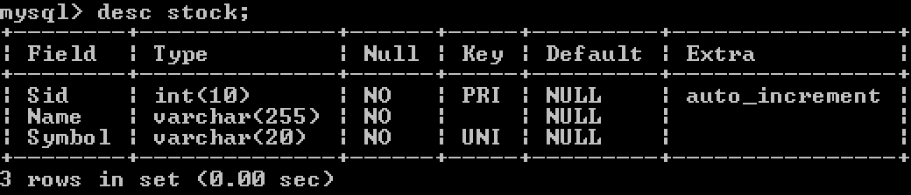

2. Configure spring-servlet.xml in /src/main/webapp/WEB-INF/

modify the following bean block.

<bean name=*"dataSource"* class=*"org.springframework.jdbc.datasource.DriverManagerDataSource"*>

<property name=*"driverClassName"* value=*"com.mysql.jdbc.Driver"* />

<property name=*"url"* value=*"jdbc:mysql://localhost:3306/stockdb"* />

<property name=*"username"* value=*"root"* />

<property name=*"password"* value=*"123456"* />

</bean>

Set your MySQL username and password.

Change “username” to your own username, mine is “root”

Change “password” to your own password, mine is “123456”

3. Add project solution into the Tomcat server and Run the Tomcat server.

4. Open the browser with url /solution/main.html

5. You can run the test in src/test/java/com/example/test

**System REST API:**

1. Save a company

Method: POST

URL: /api/stock/{symbolName}

2. Delete a company

Method: DELETE

URL: /api/stock/delete/{symbolName}

3. Get Specific Stock Current price information

Method: GET

URL: /api/stock/{symbolName}

4. Get Specific Stock Historical Information in Last one year

Method: GET

URL: /api/stock/history/{symbolName}

5. Get the whole List of Stock in DB

Method: GET

URL: /api/stock

**Environment:**

Java 1.7, Maven 3.3.9, Spring 3.1, Hibernate 3, MySQL 5.7.13, Tomcat 7.0, Eclipse Mars, Yahoo Finance API

**Demo:**

1. Main Page

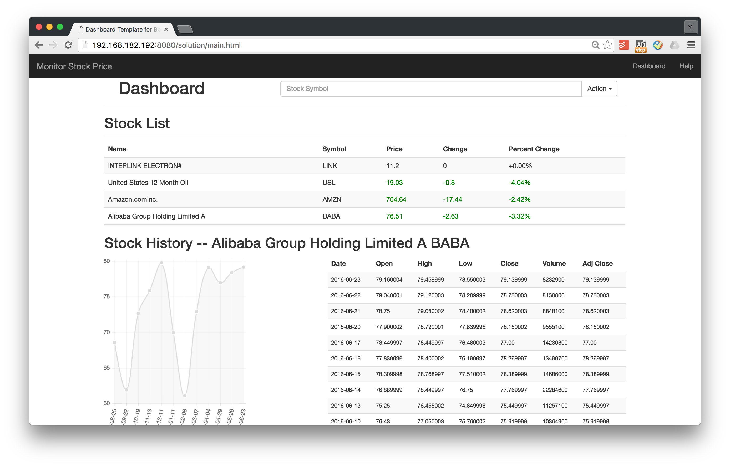

2. Add / Delete Stock

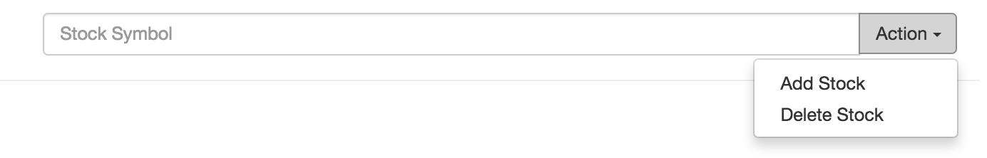

3. Stock List with Real-time Data

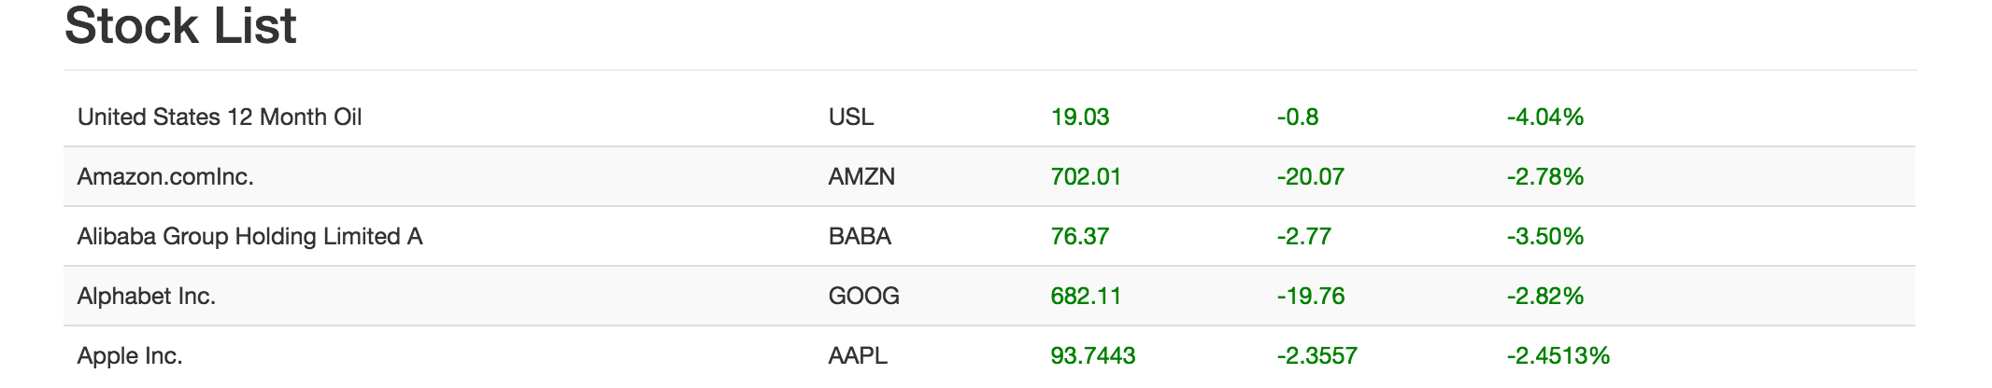

4. Click the row of stock user is interested in and to see its history data.

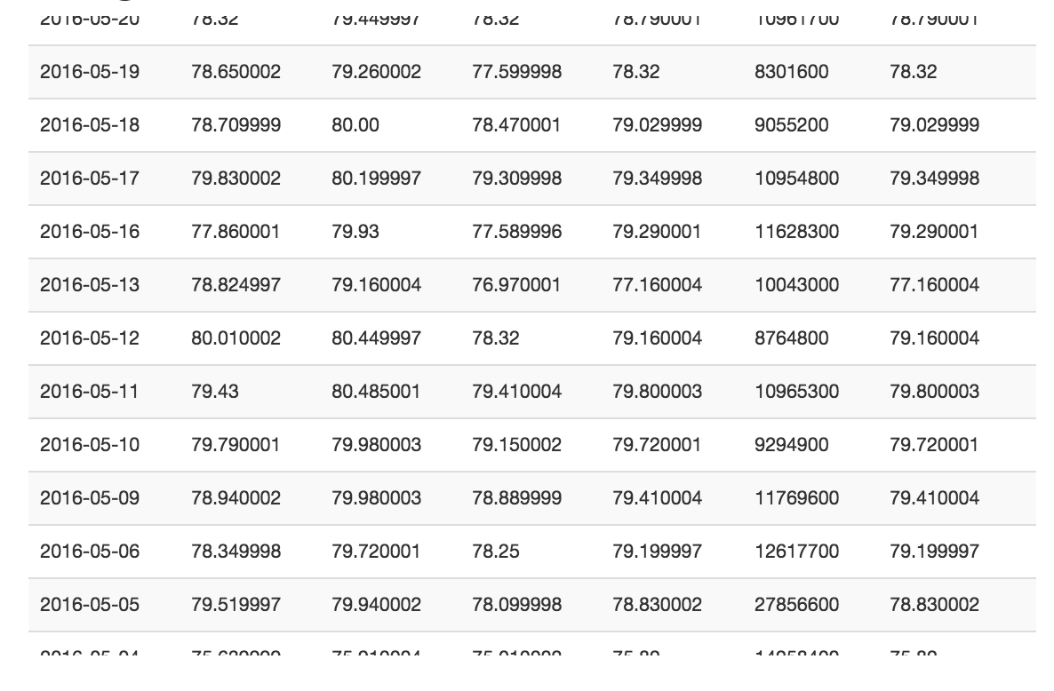

5. See the chart line of this stock price in last one year.

