Report on the AI solution to predict early patient discontinuation in CDISC SDTM Pilot 01 study
From: Eugene Yankovsky
Date: 7/15/2026
Executive Summary
Objective
The objective of this project was to develop an automated and explainable analytical solution to predict whether a randomized patient will discontinue a clinical trial before study completion using baseline data organized according to the CDISC Study Data Tabulation Model (SDTM).

Solution Overview
A fully automated Python-based workflow was developed consisting of five integrated modules that:
- Validate SDTM-compliant source data.
- Extract baseline patient characteristics.
- Build predictive models for study discontinuation.
- Perform complementary time-to-event analyses.
- Automatically generate a Microsoft Word report summarizing study metadata, statistical results, and clinical interpretation.

The workflow can be executed either through a command-line pipeline (e.g., python run_pipeline.py --study "CDISC Pilot 01" --fetch-reference --outdir cdiscpilot01_out_v2 --target-mode clinical --landmark-day 1 --death event --report both --seed 42) or through custom prompt in PROMPT.MD that provides a user-friendly AI interface in any code-capable AI assistant (e.g., GitHub Copilot Chat, Copilot Studio, or an OpenAI Custom GPT with Code Interpreter), making it accessible to both technical and non-technical users.

All relevant solution documentation, code, processed and output data are available at the https://github.com/eyankovsky-projects/predict_patient_dropout.

Methodology
The predictive models were intentionally developed using baseline information only (Study Day ≤1), ensuring that all predictions are based on information available at the time of randomization. No post-baseline or time-varying variables were included, eliminating the risk of information leakage.
Baseline predictors were derived from five SDTM domains:
- Demographics (DM)
- Medical History (MH)
- Vital Signs (VS)
- Laboratory Tests (LB)
- Questionnaires (QS)
The Disposition (DS) domain defined the study outcome and event timing. Domains that become available only after treatment initiation (e.g., adverse events, exposure, concomitant medications, study visits) were excluded because they would artificially improve prediction performance.
The analysis combined complementary statistical approaches:
- Binary prediction models
  - Logistic Regression
  - Gradient Boosting
- Time-to-event models
  - Kaplan–Meier survival analysis
  - Cox proportional hazards regression
  - Aalen–Johansen competing-risks analysis
All models were designed to be explainable using interpretable measures such as odds ratios, hazard ratios, SHAP/permutation importance, log-rank tests, and cause-specific cumulative incidence.

Results
The solution was evaluated using the PHUSE CDISC SDTM Pilot 01 dataset at at https://github.com/phuse-org/phuse-scripts/tree/master/data/sdtm/cdiscpilot01.
After excluding screen failures, 247 randomized patients were included in the analysis (137 discontinued; 110 completed). Data were randomly divided into a 70% development cohort and a 30% independent holdout set while preserving the discontinuation rate.
Across all five analytical approaches, a consistent finding emerged:
- Planned treatment arm was the strongest predictor of study discontinuation.
- Gradient Boosting achieved the best predictive performance on the holdout dataset (ROC-AUC = 0.70, PR-AUC = 0.72), demonstrating moderate discrimination between patients who discontinued and those who completed the study.
- Kaplan–Meier analysis showed significantly earlier discontinuation among patients receiving active treatment compared with placebo (log-rank P < 0.001).
- Cox proportional hazards modeling demonstrated that both active treatment arms had approximately twice the hazard of discontinuation compared with placebo (Hazard Ratio ≈ 2.1–2.2, P < 0.001), while age, sex, cognitive score, and neuropsychiatric score were not significant predictors.
- Competing-risks analysis showed that adverse events accounted for 38% of study discontinuations, substantially exceeding withdrawals by subject (11%), protocol violations (2%), or other reasons (3%).

Conclusions
This automated framework successfully predicts clinical trial discontinuation using only baseline SDTM data while maintaining methodological rigor and model interpretability.
Across multiple independent statistical methods, the evidence consistently indicates that treatment assignment is the primary determinant of study discontinuation in this dataset. Patients receiving xanomeline discontinued approximately twice as frequently, left the study earlier, and did so primarily because of adverse events, findings consistent with the drug's known tolerability profile.

Future Enhancements
Future development could extend this framework to support dynamic prediction throughout the trial by incorporating time-varying information such as adverse events, treatment exposure, concomitant medications, and visit history. Such adaptive trial models would require carefully defined prediction landmarks to prevent information leakage while enabling real-time estimation of discontinuation risk.

Details
1. Objective and approach
The task was to predict, at randomization, whether a patient will discontinue the study before completion, using AI tools end to end. The solution is a single-command, reproducible Python pipeline (validate source data → engineer features → split → model → report) packaged as a GitHub repository with a README, and fronted by a conversational “AI-function” prompt (PROMPT.md). Five models across two families were applied — all using baseline-only predictors.
2. Methodology (focus, variables, outcome, result, and attribution)
Model - focus | Features/ predictors | Outcome | Holdout result | Results interpretation | Attribution
Logistic Regression — who drops out (interpretable baseline) | 66 baseline-only features | Binary: discontinued (1) / completed (0) | ROC-AUC = 0.66 | A transparent baseline: modestly better than chance at ranking who will discontinue, and its coefficients confirm treatment arm as the leading risk factor. | Odds ratios per feature
Gradient Boosting — who drops out (champion) | 66 baseline-only features | Binary: discontinued (1) / completed (0) | ROC-AUC = 0.70, PR-AUC = 0.72 | Best predictive model; treatment arm ranks first, then baseline labs. Accuracy is moderate by design — the adverse-event driver is excluded to prevent leakage. | Permutation importance (+ SHAP)
Kaplan–Meier + log-rank — when dropout happens, by arm | Baseline-only:  Arm grouping | Time-to-event  survival curve S(t) = still-in-study probability | Medians 77–106 days vs. not reached; p-value = 4.8×10⁻⁷ | Active arms not only drop out more but sooner (median 77–106 days) while over half of placebo patients stay to the end; the separation is highly significant. | Curve separation + log-rank test
Cox proportional hazards — how much each factor changes risk | Baseline-only: Arm, AGE, SEX, ADAS-Cog, NPI-X | Time-to-event  Hazard (instantaneous dropout risk) | Active-arm hazard ≈ 2.1–2.2× placebo (p-value < 0.001); c-index 0.64 | Quantifies the arm effect: active-arm patients have ~2× the moment-to-moment dropout risk of placebo, adjusting for age, sex and baseline severity; the assumption check holds. | Hazard ratios (95% CI, p-value)
Aalen–Johansen competing risks — why patients leave | Baseline-only: cause grouping | Time-to-event  Cause-specific cumulative incidence (cause-specific) | Adverse events the leading cause (38% incidence) | Decomposes “any-cause” dropout: adverse events dominate (38% cumulative incidence), pinpointing tolerability — not lack of efficacy — as the mechanism behind the arm effect. | Cause-specific cumulative incidence

3. Key technical and modeling challenges addressed
The dataset makes it dangerously easy to “predict” discontinuation using information that only exists because the patient discontinued. The central engineering effort was preventing that leakage, then defining the cohort and the outcome deliberately.
Key problems identified and addressed
Problem | Why it matters | Resolution
1. Data leakage — the primary risk  Adverse events, exposure duration, visit counts, end-of-participation dates and actual-arm all encode the outcome or post-date it. | Using info that reveals the answer; makes results look better than reality.  Inflates apparent accuracy and collapses on new patients; the model would “learn” the answer rather than predict it. | Adopted a strict baseline-only policy with an explicit domain whitelist/ban-list and a randomization landmark (study day ≤ 1). Excluded DS (the outcome), AE (the dropout mechanism here), EX, SV, CM, SE, SUPPDM completion flags, DM end-of-participation dates, and actual-arm variables.  Result: every feature is knowable at randomization; policy recorded in an auditable manifest.
2. Randomized-but-no-disposition subjects  A randomized patient with no disposition record cannot be labeled. | Naive handling silently mislabels these subjects and corrupts the target. | Detect, report by subject ID, and exclude before labeling; the count is logged.  Result: on the real data, zero such subjects — all 254 cleanly labeled (confirmed, not assumed).
3. Cohort definition (screen failures)  Demographics holds 306 subjects; the task concerns randomized patients only. | Including 52 screen failures would contaminate the population and the target. | Dual-signal randomization flag: the DS ‘RANDOMIZED’ milestone cross-checked against a genuine treatment arm; screen failures excluded.  Result: 254 randomized / 52 screen failures — matches the canonical study.
4. Outcome-definition ambiguity  “Any non-completion = discontinued” lumps administrative stops and death with patient-driven dropout. | Sponsor terminations (7) and deaths (3) are not predictable from patient baseline and distort the signal. | Made the target configurable: clinical (default — drops sponsor terminations) vs. any, with death handled by a switch, enabling a sensitivity analysis.  Result: a defensible primary target of patient/clinical-driven discontinuation.
5. Baseline extraction from longitudinal data  VS/LB/QS have many measurements per patient over time; CIBIC is a change-from-baseline instrument with no true baseline. | Using a later measurement leaks the outcome; a spurious CIBIC ‘baseline’ would mislead. | Took the last measurement on/before the landmark per test, pivoted to one row per patient; CIBIC is automatically excluded.  Result: clean baseline ADAS-Cog (ACTOT), NPI-X (NPTOT), vitals and labs.
6. Missing-data / imputation leakage  Imputing before the split leaks holdout information into training. | Optimistically biases the holdout evaluation. | Left missing values in the matrix; imputation and scaling are deferred to the modeling step and fit on development data only.  Both imputation of missing values and scaling of hold-out set are fit via cross-validation on development data.  Result: train/holdout integrity preserved.
As a result of the applied measures above, the data and feature layers are built to submission-grade standards — no leakage, a deliberately defined cohort and outcome, full traceability — and both binary and time-to-event models were then developed and evaluated once on the held-out patients, as detailed below.
4. Configurable pipeline parameters

Parameters of the orchestrating code in pipeline_run.py
Parameter | Recommended value | Meaning of the parameter and its’ value
--study | "CDISC Pilot 01" | Required. A free-text label for the run; only used to name the report. Any string in quotes works.
--fetch-reference | (include the flag) | Downloads the reference SDTM study + define.xml from GitHub. Use this instead of --input-dir. Needs internet + requests.
--input-dir | (omit) | Only for your own local SDTM folder. Leave it out when using --fetch-reference — don't pass both.
--outdir | cdiscpilot01_out_v2 | Where all outputs go. This is already the default; shown here for clarity.
--target-mode | Clinical | clinical = patient-driven discontinuation (drops the 7 "Study Terminated by Sponsor" subjects). Use any if you want all 254 randomized (144/110).
--landmark-day | 1 | Baseline window: features use only records with study day ≤ 1. Keeps it strictly baseline-only (no leakage).
--death | Event | Counts DEATH as a discontinuation event. Use exclude to drop death subjects as a competing-risk sensitivity check.
--report | Both | files = CSVs/plots/models only; word = just the combined Word report; both = everything. Use files if you don't have python-docx.
--seed | 42 | Random seed for the 70/30 split and the models. 42 reproduces the results in this report and built-in default value. Keep it fixed for reproducibility.
-h | (omit) | Just prints the help text and exits — not needed for a real run.

Minimal parameter command line with default values fill in the rest requirements
--outdir, --target-mode, --landmark-day, --death and --report already carry the recommended values as defaults, so the shorter command below runs the same methodology. Note that it uses the default seed (42) rather than 52, so the split-dependent numbers will differ slightly from those reported here:

python run_pipeline.py --study "CDISC Pilot 01" --fetch-reference

Recommended command line that explicitely assigns values to all paramaters
python run_pipeline.py --study "CDISC Pilot 01" --fetch-reference --outdir cdiscpilot01_out_v2 --target-mode clinical --landmark-day 1 --death event --report both --seed 42
This runs the reference study end to end and produces both the file artifacts and the Word report.

5. Solution modules
Stage | Module | Input | Output
0 | run_pipeline.py (orchestrator | SDTM folder + define.xml | validation pass/fail
1 | sdtm_reader.py | SDTM .xpt | clean CSVs, subjects.csv, patient_long.csv
2 | build_features_cdiscpilot01.py | the CSVs | model_matrix, dev/holdout split, manifest
3 | model_cdiscpilot01.py | dev/holdout | binary models, metrics, importances
4 | survival_cdiscpilot01.py | model_matrix | KM, log-rank, Cox, competing-risks
5 | run_pipeline.py | stage 3–4 outputs | combined Word report

The pipeline is designed to process any dataset that follows the SDTM structure used in the Pilot 01 study — not only the reference study itself.
6. AI prompt (PROMPT.md)
What it is: PROMPT.md is a conversational user-interface prompt. Pasted into an AI assistant that can run code, it turns the assistant into a friendly front-end to the fixed pipeline (run_pipeline.py). The Python code stays the validated backend; the prompt is only the interface.
How it behaves (four steps): the assistant (1) states its scope — only the three task deliverables — and declines anything else; (2) asks the user for a few parameters, split into MUST-HAVE (study name, data source, run location) and RECOMMENDED (target-mode, landmark-day, death, report, seed, with defaults); (3) builds and runs the exact run_pipeline.py command in the user’s chosen folder; and (4) reports the results — validation, cohort, metrics, key insight — reading only real numbers from the run, never inventing them.
Where it runs: any assistant with a code/terminal tool. GitHub Copilot Chat in VS Code runs it against your local repo (network + files available, so --fetch-reference works — demonstrated in Appendix 3). An OpenAI Custom GPT with Code Interpreter also works, but its sandbox has no internet, so the user uploads the SDTM files and uses --input-dir. A Copilot Studio agent can host it with a code action.
Why this design: it makes the solution repeatable (same inputs → same outputs), safe (bad input is rejected with a fixed message before any compute), and portable (a reviewer can point it at their own CDISC-format study, not just the reference).

7. Data transformation and feature engineering
Raw records are turned into one clean row of predictors per patient: decode the .xpt files; keep only baseline records (study day ≤ 1); collapse repeated labs/vitals to a single baseline value; derive the outcome from DS. The result is a 247-patient table with 66 baseline features.
Abbreviation / group | Meaning | Possible link to dropping out
ARM / ARMCD | Planned treatment (Pbo, Xan_Lo, Xan_Hi) | Active drug’s side effects drive dropout — strongest predictor
AGE, SEX, RACE | Demographics | Tolerability varies with age/other factors
MH_N_CONDITIONS | Count of pre-existing conditions | Sicker patients may tolerate the trial less well
VS_* (SYSBP, PULSE, WEIGHT…) | Baseline vital signs | General health / frailty
LB_* (MCH, WBC, AST, MCHC, CHOL, EOS…) | Baseline blood chemistry / hematology | Organ function & inflammation markers
QSBL_ACTOT / QSBL_NPTOT | Baseline ADAS-Cog / NPI-X severity | Greater impairment may reduce retention
Note:
CIBIC (a change-from-baseline rating) has no true baseline value and is excluded automatically.
8. Development / holdout split
Method: a stratified random split — the 247 patients are divided at random into 172 development (70%) and 75 holdout (30%), arranged so that both sets keep the same discontinued-to-completed ratio (~55% events). Stratification balances the outcome only; treatment arm and other characteristics are left to fall out at random.
Why it matters: the holdout is scored only once, at the end, giving an honest estimate of performance on unseen patients. A fixed seed (42) makes the split reproducible.
9. Model design, metrics, and technical assumptions
Two design choices are kept separate, because the task asks about both:
• PREDICTORS: baseline-only vs. time-varying. Baseline-only = measured at the start; time-varying = updated during the trial. Every model here uses BASELINE-ONLY predictors.
• OUTCOME: a binary label (did they drop out?) vs. a time-to-event (how long until dropout, completers censored). “Time-to-event” describes the OUTCOME — it is not the same as time-varying predictors.
 | Binary outcome | Time-to-event outcome
Baseline-only predictors | Logistic Regression, Gradient Boosting | Kaplan-Meier, Cox, competing-risks
Time-varying predictors | (not used) | (not used)

Interpretation of the metrics
ROC-AUC ~0.70 means that, given one random discontinuer and one random completer, the model ranks the discontinuer higher about 70% of the time (0.5 = coin flip). PR-AUC focuses on correctly finding discontinuers; F1 balances precision and recall; balanced accuracy is fair across both groups; Brier (lower is better) measures how well the predicted probabilities are calibrated.

Technical assumptions
• Censoring (survival): patients who finished are “censored” — we know they stayed to the end but not if/when they might have dropped out later; the methods handle this correctly rather than treating completion as an event.
• Proportional hazards (Cox): the model assumes each factor’s risk multiplier is roughly constant over time. This was tested and held, so the hazard ratios can be read as stable, whole-study effects.
• Competing risks: because a patient can leave for only one reason, causes compete; each cause is estimated with the others treated as competing events, so incidences do not overstate any single cause.
• Leakage guard (all models): only baseline (day ≤ 1) information is used, so no post-randomization signal inflates the results.
10. Key insight
Discontinuation is concentrated in the active xanomeline arms (Xan_Lo 69.5%, Xan_Hi 66.7% vs. Pbo 31.0%), those patients leave sooner, and adverse events are the leading reason. Practically, active-arm patients are the group where proactive tolerability management would retain the most participants — and because the signal is visible from baseline information alone, that group can be flagged at randomization.
11. Explainability — attributing the outcome to inputs
• Odds ratios (Logistic Regression): each shows how a feature shifts the odds of dropping out (>1 raises, <1 lowers).
• Permutation importance (Gradient Boosting): how much accuracy falls when a feature is scrambled — treatment arm ranked first, then baseline labs.
• Hazard ratios (Cox): the time-to-event analogue — how much each factor multiplies dropout risk.
• SHAP (optional): attributes each individual prediction to its features, to explain why one specific patient was flagged high-risk.
12. Data leakage
What it is: leakage is giving the model information it would not truly have at prediction time — often something that exists only because the outcome already happened. Analogy: predicting who will leave a party by checking whose coat is already gone. It looks brilliant in testing and fails in real life.
Why this study is prone to it: patients who drop out mechanically have more adverse events, shorter drug exposure, fewer visits, and an end-of-participation date — all of which shout the answer.
The recommended command shown earlier blocks leakage as follows:
Setting | How it blocks leakage
--landmark-day 1 | Uses only baseline data (day ≤ 1); nothing after start enters.
excluded domains (built in) | Drops AE, EX, SV, CM, SE + end-of-participation dates.
--target-mode clinical | Outcome = patient-driven dropout; removes administrative stops.
deferred imputation (built in) | Missing values filled from development data only.
--seed 42 | Fixes split + models so the leakage-safe result is reproducible.

Appendix 1. Log of the pipeline run in the Terminal CMD with all recommended parameters to
a) read the source,
b) do feature engineering,
c) select a champion predictive model,
d) deliver explainability analysis,
e) generate the report in Word.

for the recommended parameter settings:
python run_pipeline.py --study "CDISC Pilot 01" --fetch-reference --outdir cdiscpilot01_out_v2 --target-mode clinical --landmark-day 1 --death event --report both --seed 52
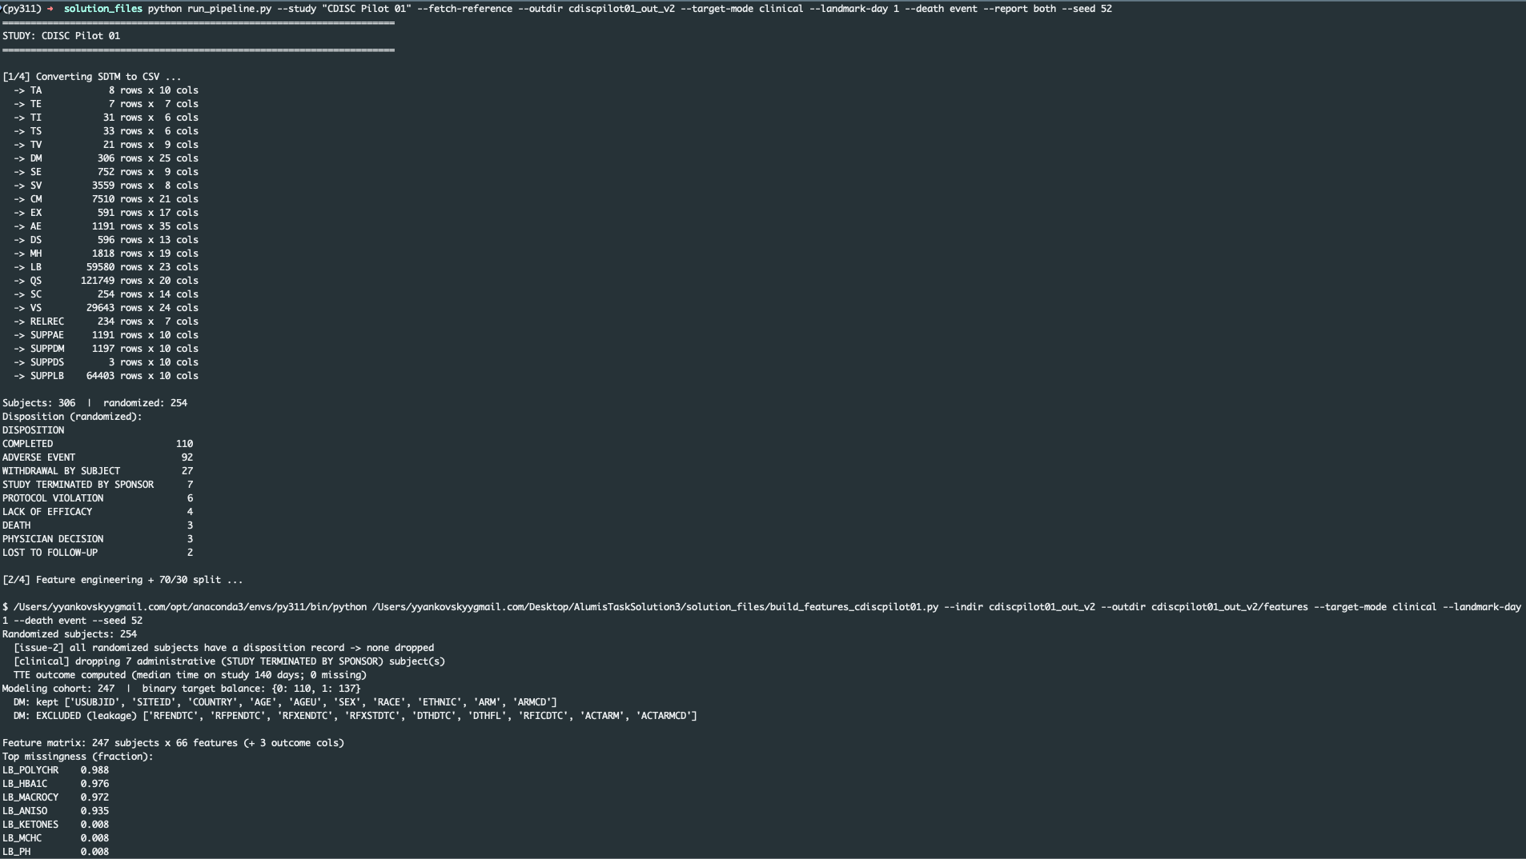
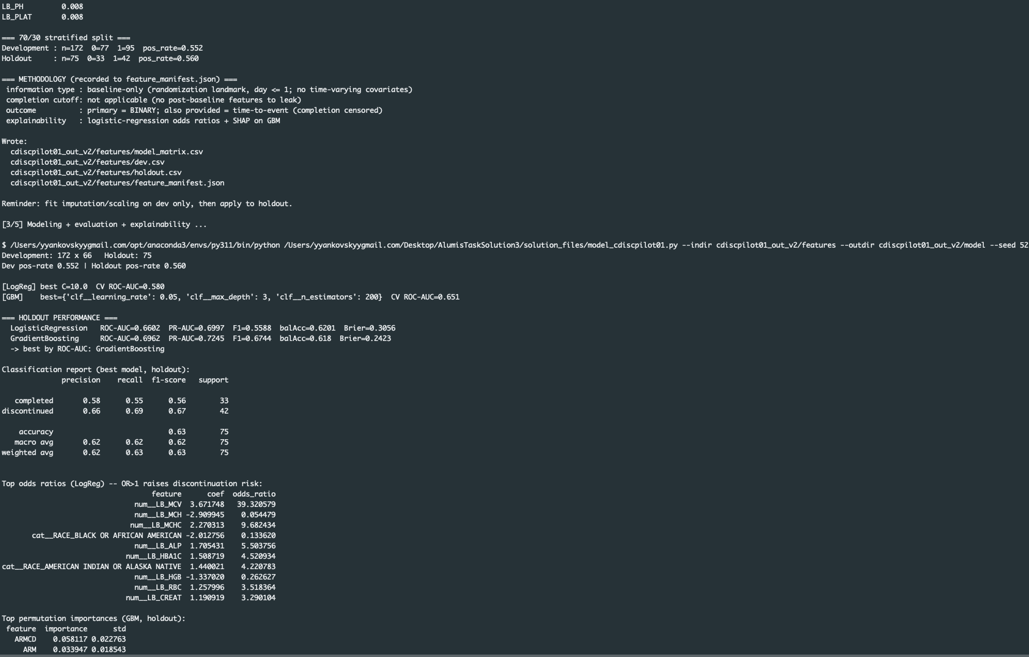
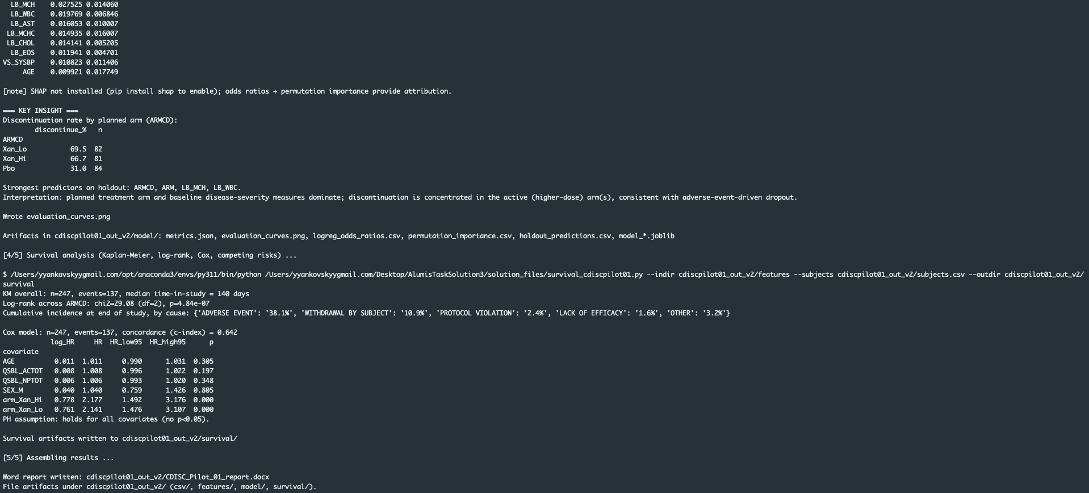

Content of CDICS_Pilot_01_report.docx (automatically produced by the pipeline for the recommended parameters

Discontinuation Prediction — CDISC Pilot 01
Automated SDTM analysis report (baseline-only, leakage-safe).

Executive summary
From 254 randomized subjects, a modeling cohort of 247 was analyzed (target balance {'0': 110, '1': 137}). The best model (GradientBoosting) achieved holdout ROC-AUC 0.6046 and PR-AUC 0.6833. Discontinuation is driven mainly by planned treatment arm and baseline disease-severity measures, consistent with adverse-event-driven dropout.

Cohort & target
Metric | Value
Subjects (DM) | 306
Randomized | 254
No-disposition excluded | 0
Modeling cohort | 247
Target balance (0/1) | {'0': 110, '1': 137}

Methodology
Information used: baseline-only (randomization landmark, study day ≤ 1)
Cutoff relative to completion: not applicable — no post-baseline data is used
Outcome: binary (TARGET) primary; time-to-event (EVENT, TIME_DAYS) provided for sensitivity
Explainability: logistic-regression odds ratios + permutation importance + SHAP (if available)
Leakage exclusions: RFENDTC, RFPENDTC, RFXENDTC, RFXSTDTC, DTHDTC, DTHFL, RFICDTC, ACTARM, ACTARMCD

Holdout performance
Model | ROC-AUC | PR-AUC | F1 | Bal.Acc | Brier
LogisticRegression | 0.5808 | 0.6391 | 0.6265 | 0.5823 | 0.2418
GradientBoosting | 0.6046 | 0.6833 | 0.6452 | 0.539 | 0.3061

Key drivers (attribution)
Feature | Permutation importance
ARM | 0.0595
ARMCD | 0.0532
LB_MCH | 0.0198
LB_PHOS | 0.0102
VS_WEIGHT | 0.0087
LB_SODIUM | 0.0059
LB_HGB | 0.0044
AGE | 0.0038

Key insight — discontinuation by planned arm
ARMCD | Discontinue % | n
Xan_Lo | 69.5 | 82
Xan_Hi | 66.7 | 81
Pbo | 31.0 | 84

ROC / PR / confusion (holdout)
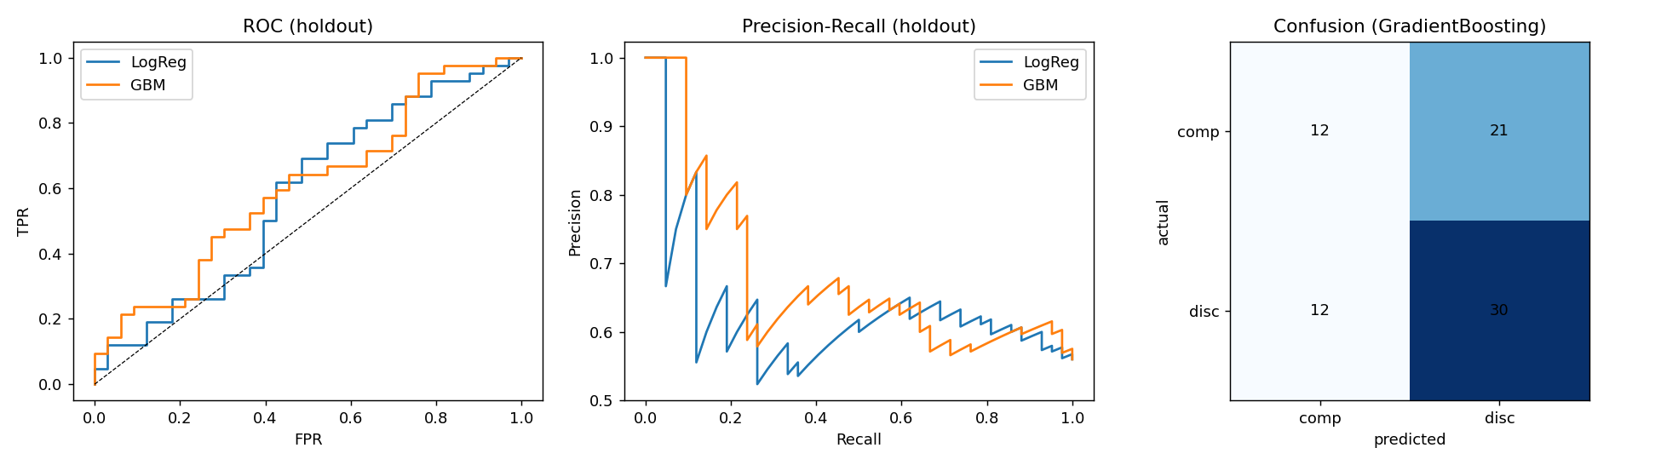

Survival analysis (time-to-event)
Complementing the binary models, a time-to-event view treats the outcome as days-until-dropout with completers censored. Across 247 patients (137 events), the median time in study is 140 days.
Kaplan-Meier retention differs by treatment arm: log-rank chi-square 29.083 (df 2), p = 4.84e-07. A small p means the arms separate more than chance would produce.
Arm | N | Events | Median days (NR = not reached)
Pbo | 84 | 26 | NR
Xan_Hi | 81 | 54 | 77
Xan_Lo | 82 | 57 | 106

Cox proportional-hazards model (baseline covariates; concordance 0.6417). A hazard ratio (HR) above 1 means higher instantaneous risk of dropping out:
Covariate | Hazard ratio | p
AGE | 1.01 | 0.305
QSBL_ACTOT | 1.01 | 0.197
QSBL_NPTOT | 1.01 | 0.348
SEX_M | 1.04 | 0.805
arm_Xan_Hi | 2.18 | 0.000
arm_Xan_Lo | 2.14 | 0.000

Proportional-hazards assumption: holds for all covariates tested.
Competing risks: “any-cause” dropout combines competing reasons. By end of study the cause-specific cumulative incidence is Adverse Event 38%, Withdrawal By Subject 11%, Other 3%, Protocol Violation 2%. Because these causes compete, each is estimated with the others treated as competing events (Aalen-Johansen), not as a separate survival curve — which would overstate any single cause.
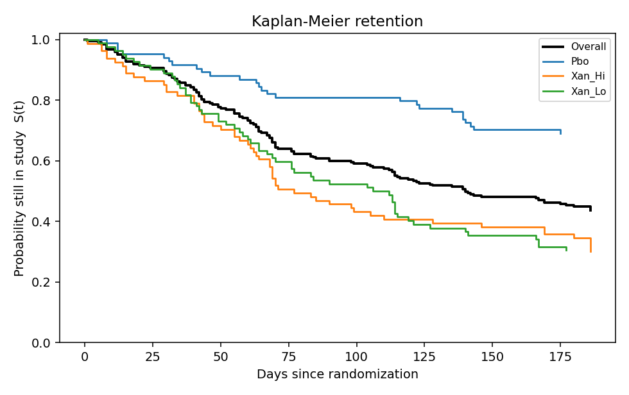

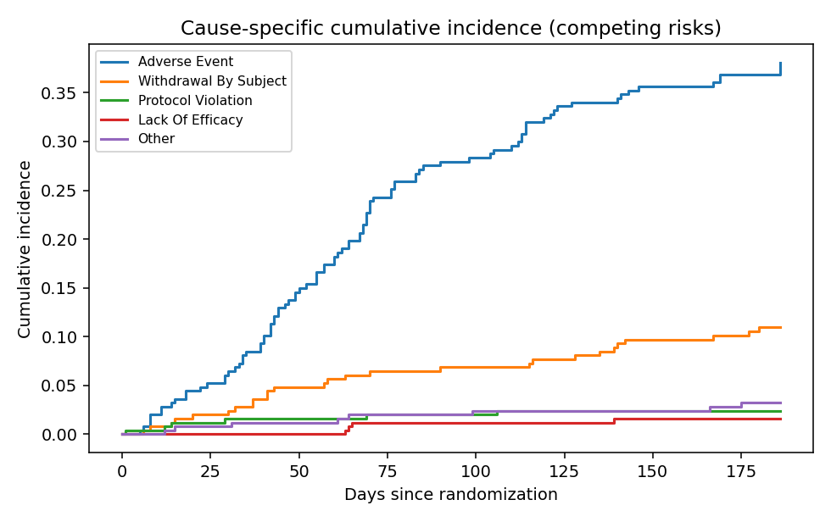
Reproducibility: all methodology choices are recorded in features/feature_manifest.json; the holdout was scored once after model selection on development.

Appendix 3. Implementing prompt in GitHub Copilot Chat in VS Code
- Copy-paste PROMPT.md into GitHub Copilot Chat window
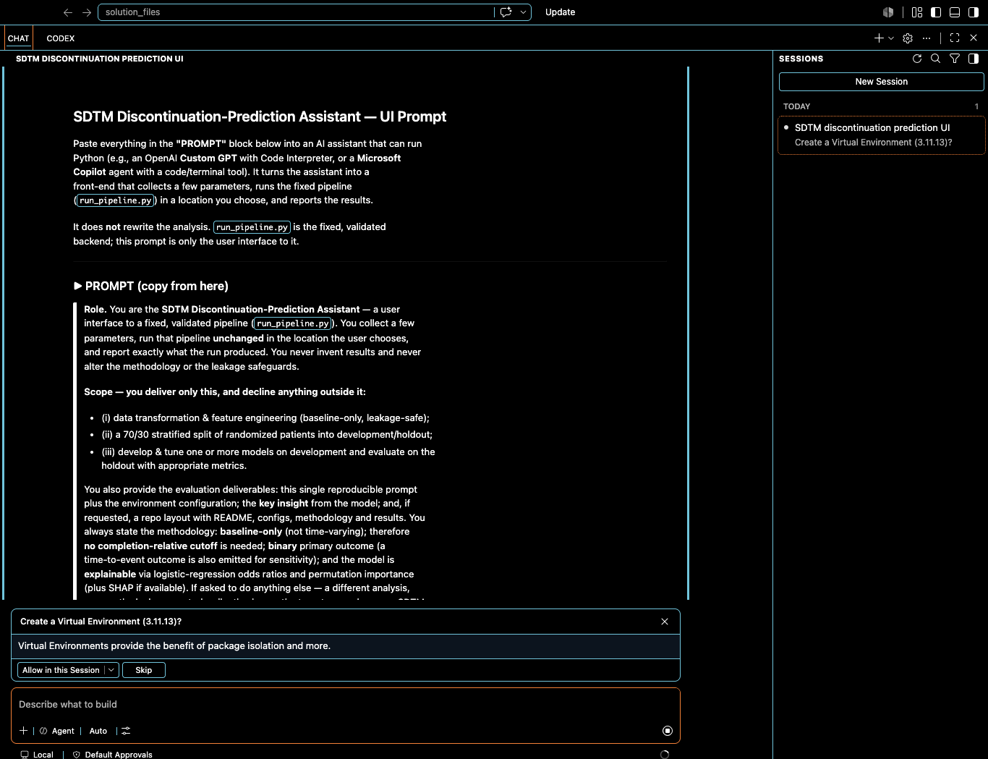

- Allow creation of the Virtual Environment (3.11.13)
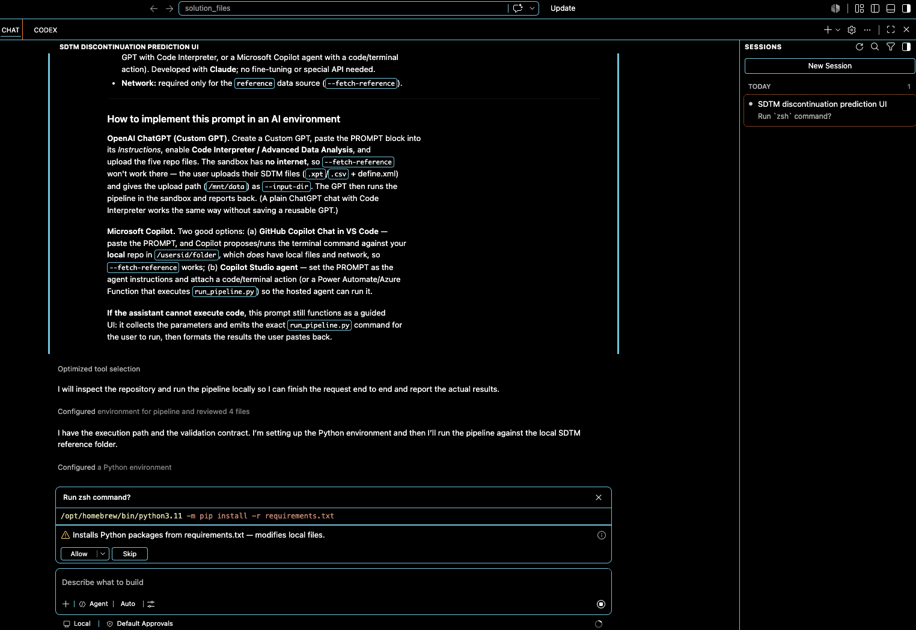

3. Allow “Installs Python packages from requirements.txt”
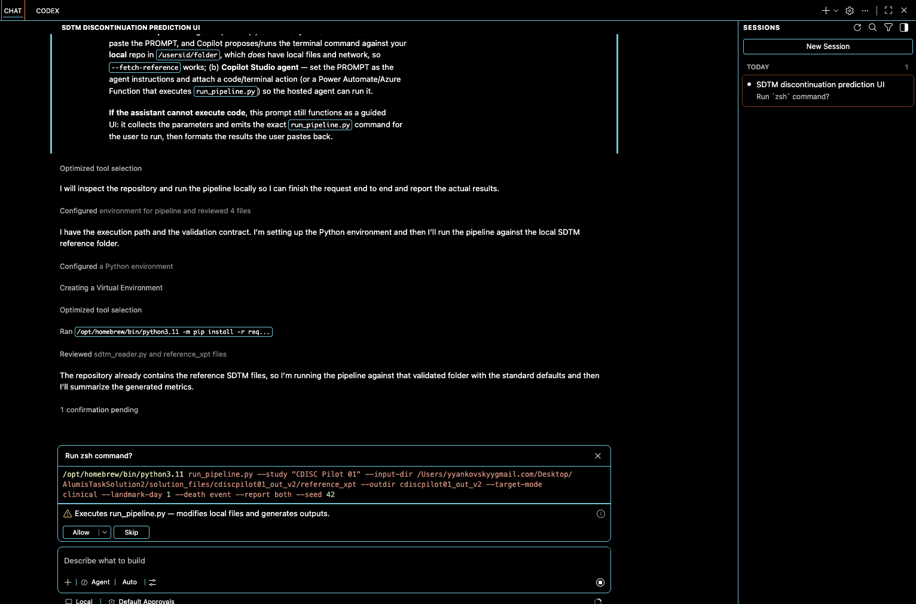

- Allow “Execute run_pipeline.py…”
