Project Summary
Bayesian Analysis of Fatal Accidents in Airline Flights
by Eugene Yankovskyy
This study is devoted to modeling the number of fatal accidents in year t, y_{t}, that is assumed to follow a Poisson distribution with a mean θ_{t} changing with time such as:
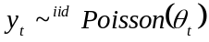
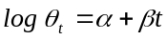 where , t = 1966,….
(a) We offer two options for non-informative prior distribution:
1. An independent and locally uniform improper prior distribution for (α, β) assumes equal probabilities to all values 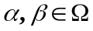 and allows sample data heavily affect the posterior distribution p(α, β|y):
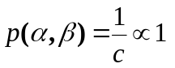
c is a constant in a range (0, +∞) to keep the probability density function positive and proportional to 1 in correspondence to definition of the function at p.90 in Gelman and etc.(2). This distribution is chosen for d)-g) parts.
2. Highly dispersed bivariate normal distribution spreads most probability in the wide range of parameter values and allows sample data driving the posterior p(α, β|y):
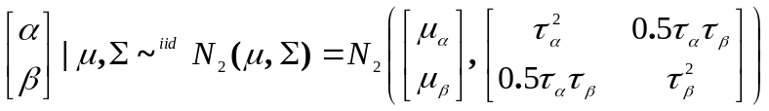
where 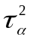and 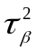are relatively large numbers (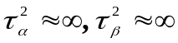). Covariance is chosen to be such that correlation between α and β equals 0.5 implying no any restrictive assumptions on their relations, neither dependence nor independence. Without loss of generality we can assume that 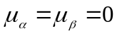.
(b) Thus, our choice for an informative prior is a bivariate normal distribution with the crude estimates parameters obtained in using historical data from 1966 to 1975. Here, we followed El-Sayyad (1973) who showed empirically that 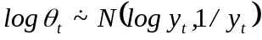 results in approximately bivariate normal posterior distribution 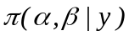. Therefore, having prior and posterior distributions of the same form should be a reasonable choice. Choosing the values of the parameters from the historical data model, we follow Bayesian paradigm directly. In this case, the selected prior distribution takes into account our prior knowledge about parameters of the fatal accidents distribution before observing the new sample data. The estimates and covariance matrix obtained by using the OLS model are provided below, while speculation about the choice of the model is provided in answer to question (e).
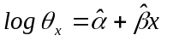  where x= t -1966, t = 1966, …, 1975  Our informative prior distribution is  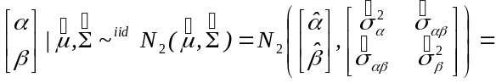  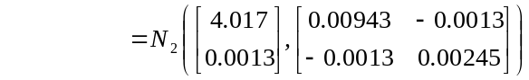  (c) Our exact Bayesian posterior based on non-informative prior is  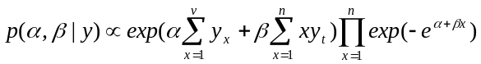  where x = t – 1976, t = 1976, …, 1985  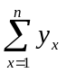 and 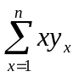are sufficient statistics in this case. | b) Contour plot for the informative prior p(α,β)  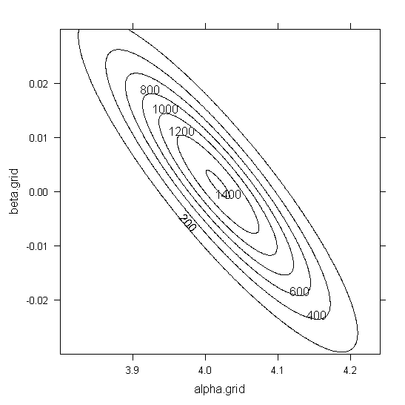
(d) Since the theoretical posterior distribution is hard to handle directly, we used the Bayesian approximation offered by El-Sayyad (1973) to check if the posterior is a proper distribution:
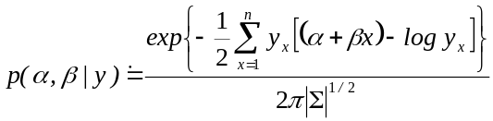where 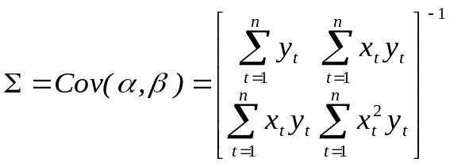
Since the approximate posterior distribution integrates to one, the true posterior is likely a proper distribution.
(e) The crude estimates for α and β are obtained by estimating the log-linear model:
 where x = t -1975, t = 1976,…, 1985
The uncertainties related to the parameters can be expressed by the estimated variance-covariance matrix:
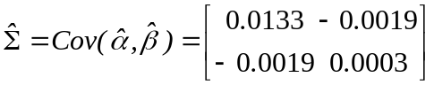
f) Contour plot of the joint posterior p(α, β|y) | f) Scatter plot of 1000 random samples from p(α,β|y)
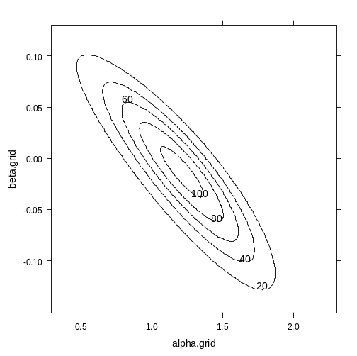 | 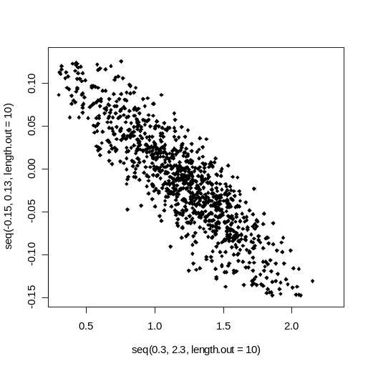
g) The approximate posterior prediction density for the number of fatal accidents in 1986 (in 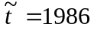) is
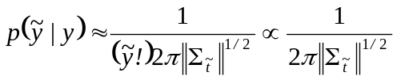, where 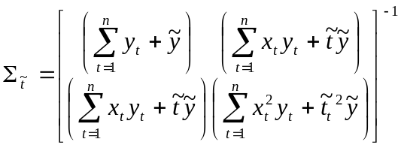
g) Density function of the expected number of fatal accidents in 1986 | 95% posterior predictive interval for the expected number of fatal accident in 1986 is approximately between 13 and 25.  The exact 95% PI is (13.35581; 24.41909)  Conclusion  Since there is evidence that the new sample data does not reconcile with the historical data and likely come from the distribution with different parameters than the informative prior, there is no sense in choosing the informative prior. Possible reasons of difference in data models can be dramatic technical improvements and increase in safety measures in air flight industry. Therefore, the non-informative uniform prior allowing the data “speak for themselves” should result in the posterior distribution that better reflect the dynamic changes in the industry.
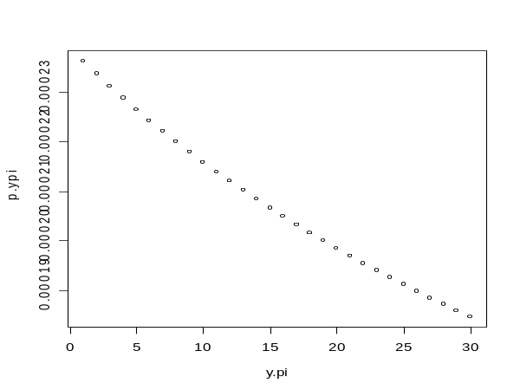
References
1. G.M. El-Sayyad (1973). Bayesian and Classical Analysis of Poisson Regression.
2. Supapakorn, Yankovskyy. Project 1 summary on Bayesian analysis of fatalities in airline flights, February, 2008.

Hull loss data are available at http://aviation-safety.net/statistics/period/stats.php?cat=A1 and were described in detail in Supapakorn and Yankovskyy (3).

