Working Paper

How Does Bribery Affect Economic Efficiency?

By Yevhen Yankovskyy

Introduction

In recent years, especially in the 1990s, a lot of attention of the economists throughout the world has been attracted to corruption and its impact on economic growth. In different countries powerful politicians have had to resign from their posts, and governments have fallen because of accusations of bribery. The growing interest in the corruption issue may be explained by the several reasons. First, as the Cold War has finished, the corrupt regimes in such countries as Indonesia, Nicaragua, Zaire and etc. were deprived from the unconditional support of their more developed countries-protectors. In addition, in the beginning of the political thaw in the early 1990s there was a tendency to ignore the issue of corruption in the centrally planned economies caused by lack of information and by reluctance even to talk about it. Donor countries also tended not to pay a lot of attention to the corruption in the recipient country even if there was a danger of misuse of foreign aid. However, due to next-coming causes the attitude has changed considerably. Second, growing democracy in many countries and strengthening free mass media has created an environment in which discussion of corruption is no longer a taboo. Third, accelerated globalization of the world economy has resulted in more frequent contacts of businessmen from less corrupt countries with the ones from the more corrupt countries. These contacts have increased the international attention to corruption, especially when some companies argued that they were deprived from contracts due to the corrupt acts of the competitors. Fourth, nongovernmental organizations such as Transparency International and international financial institutions such as IMF and Worldbank have been playing a more active role in the anticorruption movement.
There are two controversial theoretical approaches to the effect of bribery on the economic growth. On one hand, there is an opinion that the state system built on the bribery results in more efficient allocation of the licenses and government contracts because the most efficient firms with the lowest marginal cost can afford to pay the highest bribes [Basley (1993)]. As well, the basic model of “speed money” shows that the bribing aimed at getting ahead in the slow-moving queues for public services minimizes the waiting costs involved with the queue, and thereby reduces inefficiency in the public administration [Lui (1985)]. In the conditions of “thin”, undeveloped market similar to the Ukrainian one, corrupted officials may be interested in the future flows of bribes may and promote the development of the new markets and perspective firms [Mauro(1995)].
On the other hand, depriving the government from the revenues required for supplying of the public goods and preventing the entrepreneurs from running business by uncertainty and secrecy, corruption may distort economy even more than taxation [Tanzi (1998)]. Thus, the negative effects of corruption may be as follows. First, having own private interests in any firm and being neutral to the size of bribe, the official may damage the acting competitors to squeeze them out of the market. Second, the bureaucrat generously enumerated by the supplier of low quality good may pose the efficient producer in awkward economic situation. Third, bribery often aimed at restriction of the competition. Fourth, the official interested in further deterioration may permanently cause administrative delays to collect more bribes, instead of accelerating of public services. Fifth, as corruption is associated with costly secrecy, the officials often induce the development of industries with lower-detection activities (i.e., import and export operations) and try to raise the entry barriers for the outsiders. Sixth, higher bribes result in decline of the profitability of productive investments relative to rent-seeking activity. As well, the corruption may be even more harmful than the taxation, because it does not take into account either current economic position of an enterprise or available tax-deductibles [Tanzi (1997)].
To summarize, although the negative effects of bribery seemingly overweigh the positive ones in the economic theory, it is very questionable issue what effect is dominating in particular economy. In this research I attempt to determine the aggregated effect of corruption on the efficiency growth of the Ukrainian firms.
Apart from the general causes stipulating the interest to corrupt activities, there are some particular interests to focus on corruption in Ukraine. First, a lot of facts suggesting about widely spread corrupt practice among the Ukrainian bureaucrats were released recently in the local mass media. Possessing discretion in the regulation of the business activity, corrupt officials often damaged the enterprises and brought considerable delays and waste of time, financial losses, general disappointment in the state, and resultant shutdown of the business. Second, the issue of corruption became more important as there is an opportunity to reduce it considerably by introducing appropriate clauses in the new Tax Code that is to be adopted in the nearest feature. However, the public attention is mainly focused on decrease in the tax rates, whereas the problem of limitation of the bureaucracy discretion over business regulation is almost neglected. Therefore, determining the influence of corruption on the growth of the Ukrainian enterprises will help to provide the right emphasizes for the new legislation.
Having unique and reliable data on bribes paid by the Ukrainian firms, I study whether bribery is really harmful to efficiency of enterprise activity. Therefore, there is a hypothesis to be tested, whether the effect of the bribery on efficiency is really detrimental.

I. Empirical methodology

Model Specifications
To research the issue, I apply three approaches. Two of them apply the different econometric models, while the third one is a visual inspection of the distribution densities of the researched parameters.
The first econometric approach is a Tobit model (1).

γ_{i}* = β₀ + β_{b}BRIBE_{i} + X’_{i}β_{i} + η_{i} (1)

where η~N (0,σ²) and 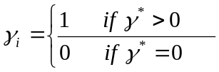
The bribery variable (BRIBE_{i}) is applied either in the form of the monetary units or in the form of dummy, which equals to one if the firm manager reported a sum of given bribe and zero if s/he did not. The vector X’_{i} of explanatory variables consists from the 5 location and 6 industry dummies, age of a firm, time spent on negotiations with officials over regulatory issues, taxes scaled on the sales and paid in 2000, sales and labor in 2000 as a proxy for the size of a firm, labor cost growth, depreciation growth as a proxy for the changes in the used capital, advertising expenses growth, and other expenses. The other expenses equal to cost price net of capital depreciation and labor costs. The growth parameters are the differences between the their magnitudes in 2001 and 2000. The detailed description of the used variables is provided in the Appendix.
The dependent variable (γ_{i}) in the model (1) is a Pure Technical Efficiency Change (PTECH) calculated for the period of 2000-2001 and found by applying Mulmquist approach to productivity analysis. The Pure Technical Efficiency Change measures a change in technical efficiency based on the variable return to scale technology and calculated using the DEAP software in accordance with the following formula (2):
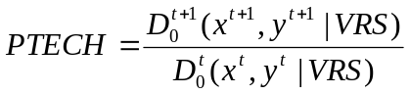 (2)

Where D₀^{t} and D₀^{t+1} are output distance functions relative to a technology that allows for Variable Returns to scale (VRS). The period signs t and t+1 denote 2000 and 2001 correspondingly. The output-oriented distance function for K observations, t periods, M outputs and N inputs is calculated in accordance with the following conditions.
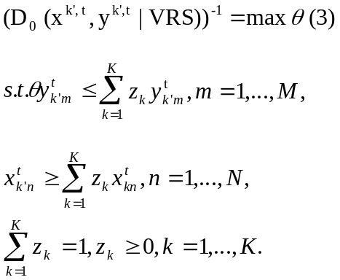

The set of inputs (x^{t}) includes depreciation, labor costs, and other costs, that are obtained by subtracting depreciation and labor costs form the gross cost price. The sales for the same period are accepted as an output (y^{t}).
As the magnitudes of the distance function are in the interval between zero and one, the value of PTECH is positive and can be more than one. A value greater than one will indicate positive technical efficiency growth from period t to period t+1. As all observed explanatory variables correspond to the positive value of dependent variable (PTECH), the given sample is truncated;. Given these conditions, the Tobit model with specialization on truncated sample was applied to study the research question.

The second econometric approach applies OLS model.

γ_{i}¹ = β₀ + β_{b}BRIBE_{i} + X’_{i}β_{i} + η_{i} (4)

where γ_{i}¹ = log[D_{O}^{t+1}(x^{t+1}, y^{t+1}|VRS)] – log [D_{O}^{t}(x^{t}, y^{t}|VRS)]

In the model the growth term (γ_{i}¹) can be either negative or positive. The positive value means increase in technical efficiency, whereas the negative one implies decrease in efficiency.
The given OLS model (4) imposes less restrictive assumptions on the error term distribution. In contrast, a Tobit censored regression model is very vulnerable to the heteroscedastic errors and consequently imposes more rigid restrictions on the distribution of the error term than OLS to give the best linear unbiased estimator. In the regarded particular case, the heteroscedastic errors are even likely because the sample is truncated rather than censored one (to what Tobit is usually applied). As the ratio of two distance functions is strictly positive number, we cannot observe negative magnitudes of dependent variable and corresponding magnitudes of the explanatory variables. Consequently, there are more likely heteroscedastic errors and misspecification of σ in the Tobit (2) that can result in the higher bias and variance of β than the OLS model (4) (page 441, Johnston and DiNardo).

The third approach implies the comparison of the density functions for the distribution of the technical efficiency values [D_{O}^{t}(x^{t}, y^{t}|VRS) and D_{O}^{t+1}(x^{t+1}, y^{t+1}|VRS)] and growth in the efficiency (γ_{i}¹) for the group of bribers and non-bribers. On the first stage the kernel estimator of density function f(x) is found in accordance with the following formula (5).

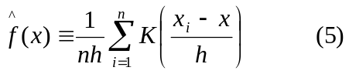
Where K(.) is the Eponechnikov kernel function, x_{i} observed value of the argument, h is a bandwidth of the interval. The optimal value of the bandwidth and the estimation of the function are made in the statistical software STATA.

Possible Estimation Problems
In estimation of the model (1) and model (4) endogeneity and measurement error econometric issues can arise the.
The endogeneity problem may arise due to the fact that both efficiency change and corruption may be jointly determined [Fissman and Svensson (2002)]. First, a rational and profit maximizing bureaucrat would try to extract as high bribe as possible, subject to the constraints that the firm might face, and that he might be caught. In this set up, the bureaucrat is expected to demand higher bribes from the firm producing the good with a favorable demand forecast, because this firm’s expected profit is higher, and, consequently, its ability to pay higher.
Thus, two firms in the same industry may need to pay different amounts of bribes, and the difference may be correlated with unobservable features, i.e. one firm can obtain competitive advantage after invention of the brand new good. To sum up, if the forecast is assumed to influence the firm’s willingness to invest and expand, there is likely a positive relationship between corruption and growth.
Second, the problem of endogeneity can arise if firms specialize in rent seeking as a means of growth. Thus, some firms are eager to succeed in the bureaucrats’ preferences, while the others focus on improving productivity and investing in new capital. Both strategies may lead to growth, and in equilibrium, it is not clear which firm will grow more rapidly. The stated difficulties will tend to mask any direct (possibly negative) effect that corruption can have on growth.
In order to check the presence of endogeneity, I use the Hausman specification test, which is presented in Appendix A1. In case of rejection of the null hypothesis, revealed endogeneity can be mitigated by appliance of the industry-location averages as an instrument for bribes that is a common technique to curb the measurement error [Wald (1940)].
The other significant estimation problem is involved with the impact of the “noisy” micro-level data that is resulted from using the data from a wide range of the enterprises and bribes of different sizes. The heterogeneity of the data and resultant heteroscedasticity in the model may be mitigated by scaling and appliance of the data in log-transformed form. Bribe and taxes paid in 2000 are scaled on the sales for the same period; the other variables (except binary one) are used in the log-linearized form.
II. Data Description

The micro level data used in the paper are originated from two different sources, i.e. the Regulatory Cost Surveys of 2000 and the financial statements of the firms. The data on bribery, date of the registration, location, sector of the economy, labor employed in 2000, time spent by the management on dealing with the regulatory requirements and binary data on hiring the mediator to negotiate with the officials during the registration were obtained from the results of the Regulatory Cost Surveys (RCS) of 2000. RCS were funded by the USAID project “Regulatory reform” and conducted by the project “Brain for Ukraine” during January-June 2001 to study the cost structure and particularities of the Ukrainian business practice. Although the agricultural sector was not taken into account, the distribution of the firms in the sample generally corresponds to the structure of the Ukrainian economy in accordance with the statistics of the State Statistics Committee of Ukraine (express-report No.455 dated Dec. 10, 1999). The survey comprised a total of 700 enterprises in 6 different sectors of the Ukrainian economy and in 10 towns (70 firms per town) representing 5 main geographical locations. The interviewed firms were engaged in the manufacture (29%), trade (23%), intermediary (18%), services (9%), science and innovation (5%), and in the other activities (16%). The majority of the firms in the sample (71.7%) are small enterprises with the number of employees up to 50 persons. The detailed description of the data in the sample and the methodology of the data collection are represented in Appendix A.
The primary concern related with the data is the issue of reliability of the bribery data. The empirical strategy utilized to collect the information on corruption gives the confidence in reliability of the data. First, in Ukraine the majority of the population has a deep distrust in the state bureaucratic establishments regulating the economy or interfering in the business activity in any way. According to the inquiry provided by the Transparency International in April-May 2000, 53%-78% of the Ukrainians believe that corruption is widely spread in the public and government institutions. As far as 56-75% of the population perceived non-government organizations as non-corrupted institutions, the surveys were conducted by the non-government research organization that did not related to any Ukrainian official establishment to avoid any negative prejudice or reluctance from the side of the interviewed managers. Second, the questions on corruption were phrased in such a way to avoid implicating the respondent of wrongdoing. Third, seven multiple questions and four simple questions about corruption in the various fields of business activity were located in the different sections of the questionnaire. Fourth, the interviewers visited each firm at least twice to accommodate the manager’s time schedule. The data collection efforts were also aided by the fact that the issue of corruption has been widely discussed in the Ukrainian society. The public concern on corruption has been flurried by the corrupt scandals involved with the Ukrainian high-top officials and highlighting of corruption practice at the local mass media.
The RCS researchers were able to collect the following bribery data. The top managers of 359 out of 700 enterprises answered the general questions (implying “yes” or “no” answers) involved with grafting the officials in any possible way; and only 246 firm managers declared the sum of paid bribes.
Concerning the second source of the data, the financial statements of only 151 firms out of 359 answered ones were obtained from the database “Phenix” and from the web sites originated from the State Committee of Ukraine on Securities and Derivatives (www.smida.gov.ua and www.corporation.com.ua). The data for another 208 firms were not available because of the following reasons. First, the applied database and the web sites contain the data of near 140,000 enterprises, whereas there were 211.1 thousand of the enterprises at the end of 1999 (express-report No.455 of the State Statistics Committee of Ukraine dated 10 December 1999). Second, the data of the firms were searched by the name of the firms in correspondence with the spelling used by the RCS interviewer because the official registration code was not inquired in the surveys. Therefore, the interviewers might have mistaken in the precise writing of the firms’ name and in this way impeded the search for the financial statements. However, the data of 151 firms on labor employed (2001), sales, capital, cost price, payment bills, profit, taxes, and (all data for 2000 and 2001) were obtained from the financial statements. In the models the data were used mainly in log-transformed form or in the “growth” form that is a difference between the log-transformed data for 2001 and 2000. The descriptive statistics for the key variables are represented in Table A.1 (Appendix).
The research sample is constituted from 359 observations corresponding to the top managers having generally answered the questions on bribery (“yes” or “no”); 246 firms out of the total declared the sum of the paid bribes.

Defining the outliers
In general, the size of a bribe should not exceed the sales in the same period; otherwise expenses on the bribe would be more than the returns from bribery for the same period that can be economically inefficient. Meanwhile, there may be a “long-term” effect of grafting on sales because possible growth may occur not exactly in the period of giving bribe but in the next one. However, the principle of unordinary large size of bribe in comparison with the sales for the same period was chosen as a rule for defining the outliers in the bribery data.
According to Graphs 3.1 and 3.2 (Appendix) the vast majority of bribes scaled on sales concentrates within the interval from 0 to 0.06. However, there are only three observations with the scaled bribes equal to 1160, 125 and 0.68. They may be characterized as “unusual” scaled bribes for the given sample. In the first two cases the briber had too lean sales in 2000, (TUAH 0.10 TUAH 0.001 correspondingly), whereas in the third case the bribe amounts to more than a half of the sales in the same period, TUAH 17.1 and TUAH 25.6 correspondingly. On the basis of the given above economic reasoning the observations with the scaled bribes equal to 1160 and 125 are accepted as outliers.
The outliers for the data on yearly labor cost, capital cost, and gross cost price were determined on the principle of unordinary small size. Thus, all observations with the magnitude less than 0.1 TUAH are accepted as outliers and were not regarded during the calculations of the PTECH. As well, the magnitude of the observations higher than 0.1 was required to provide calculations of PTECH by Malmquist method in DEAP software. Therefore, all calculations and regressions were provided on free of outliers basis.

III. Results
The regression analysis was provided for two specifications of Tobit (1) and OLS (4) models. One of them applied bribery dummy equal to one if a manager recognize the fact of giving bribe and zero if otherwise. The other specification used bribe ratio (bribes in monetary units scaled on sales). The specification model with an instrument for bribes was not provided, as the Hausman (Appendix 1) test does not reject the null hypothesis of non-endogeneity in relation between efficiency growth and bribe.
The results of the regression analyses using bribery dummy in Tobit and OLS specifications (Table 4.1 and Table A.5, Appendix correspondingly) do not reveal statistically significant relations between the efficiency change and the fact of bribing. The highest level of significance for the coefficients was relatively 14% and 13%. However, the models have rather different estimates of the coefficients at the bribe in the monetary units. Although all coefficients at the bribe rate are negative, the Tobit does not found statistically significant negative relationship. The coefficients are significant only at 14% and 15% level. In contrast, more reliable and operating with the larger sample OLS estimator discovered strongly negative relations between bribery and the efficiency growth. The one-percentage increase in the bribe rate corresponds to 0.002%-0.019% decline in the efficiency.
The dispute in significance of the negative effect of the bribery is clearly resolved by comparison of the density functions. Although there is no considerable difference in densities, the group of bribers performed a little bit better in technical efficiency than the group of non-bribers for 2000 and 2001 (Graph A.1 and Graph A.2, Appendix). Thus, the density function of bribers skewed more to the left, to the higher efficiency values than the one of non-bribers. However, regarding the firms separately inside the groups, the density functions for the growth in efficiency revealed obviously opposite result. The Graph A.3 demonstrates that the non-bribers grow more dynamically than the bribers. This outcome unambiguously proves that bribery has strongly negative effect on the efficiency growth.
To take into account the other growth factors, the strongly significant impact on efficiency is involved with location on the East of Ukraine; engagement in different types of activities combined in the category “Other”; age of a firm; taxes paid in 2000 and scaled on the sales; capital depreciation growth; cost price growth; and advertising expenses growth. Thus, the efficiency growth was higher by 12.6-17.8% in the East of Ukraine than in the other regions. This fact may be connected with the better usage of available capacities by the heavy industry enterprises concentrated in the Eastern Ukraine, which use preferable market situation for the industry in 2000 and 2001.
The firms engaged in extracting and infrastructure sector of economy (i.e., mining, production of energy, gas and water, hotel and restaurant businesses, transport, financial activity) also demonstrate higher efficiency growth by 21.2%-22.1% than the enterprises in the other industries.
The cost price growth and advertising expenses growth affect efficiency quite modestly. One-standard-deviation increase in cost price growth corresponds to 0.005%-0.035% growth in efficiency, whereas increase in advertising growth relates to 0.0001%-0.0003% growth in sales efficiency.
The strongly significant and positive relations between the taxes paid in 2000 and efficiency can suggest that the more efficient producers have paid more taxes. Thus, one-standard-deviation increase in taxes corresponds to the efficiency growth by 9.5-27.2%.
Age of an enterprise negatively relates to the efficiency. Thus, one-standard-deviation increase in age corresponds to the decrease in efficiency by 0.003-0.007%. This fact may be explained in two different ways. On the one hand, it can be involved with inefficient usage of resources accumulated for the previous periods. On the other hand, the old enterprises may be less flexible to the market changes and less innovative in the promotion of their goods, as far as the sales efficiency is regarded.

There is a significant negative association between depreciation growth accepted as a proxy of the growth of the exploited fixed assets and efficiency. One-standard-deviation increase in the depreciation growth relates to 0.007% decrease in efficiency. This result suggests that the available capital is not fully exploited, and there are reserves for efficiency improvement.
Furthermore, there are weak relations between efficiency and locations in the West and in the capital of Ukraine, engagement in manufacture, and log of labor in 2000. The efficiency decreases by 9% and by 16% at maximum in case of location in the West and in the capital correspondingly; while engagement in the manufacture relates to the efficiency growth by 7.2%. The decrease in efficiency by 0.005% associated with one-standard deviation in labor employed in 2000 can suggest that efficiency tends to decline in the large enterprise.

Table 4.1. The coefficients at researched variables and the significant coefficients found during the Probit analysis with dependent variable equal to one if a manager gave bribe and zero if s/he did not
Variable | Coefficients in the interval | Marginal effect
Dummy for bribing | 0.043 ÷ 0.082  (0.122 ÷ 0.124) | Insignificant
Bribes scaled  on sales | -1.038 ÷ 0.504  (4.411 ÷ 0.343) | Insignificant
East | 0.315 ÷ 0.445  (0.137 ÷ 0.190) | 0.126 ÷ 0.178
West | -0.226 ÷ 0  (0.136) | -0.090 ÷ 0
Capital | -0.403 ÷ 0  (0.242) | -0.161 ÷ 0
Manufacture | 0.179 ÷ 0  (0.092) | 0.072 ÷ 0
Other | 0.531 ÷ 0.554  (0.332 ÷ 0.188) | 0.212 ÷ 0.221
Log of firm age | -0.184 ÷ -0.130  (0.105 ÷ 0.071) | - 0.007 ÷ - 0.003
Taxes for 2000 scaled on sales | 1.578 ÷1.779  (0.150 ÷ 0.382) | 0.095 ÷ 0.272
Log of labor in 2000 | -0.188 ÷ 0  (0.072) | -0.005 ÷ 0
Labor cost growth | -0.410 ÷ 0  (0.175) | -0.028 ÷ 0
Depreciation growth | -0.396 ÷ -0.441  (0.050 ÷ 0.041) | -0.007 ÷ - 0.007
Cost price growth | 0.147 ÷ 0.438  (0.089 ÷ 0.201) | 0.005 ÷ 0.035
Add expenses growth | 0.037 ÷ 0.043  (0.010 ÷ 0.019) | 0.0001÷ 0.0003
R² | 0.168 ÷ 0.727 | -
Akaike info criterion | 1.397 ÷ 2.368 | -
Observations | 79 ÷ 153 | -
Notes:
The standard deviations are provided in the parenthesis.
Zero in the intervals means that some coefficients in the regression analysis were insignificant at any sensible level.
For the non-binary variables the marginal effect of one standard deviation increase was calculated

IV. Conclusions
Provided regression analysis applying OLS approach and density functions comparison revealed that bribery is really harmful to the efficiency growth. The bribers are less flexible in improvement of efficiency and grow more slowly than non-bribers. Thus, the one-percentage point increase in the bribe rate relates to 0.002%-0.019% decline in the technical efficiency of the Ukrainian enterprises.
Thus, the found evidence of significant negative effect of bribes on efficiency in Ukraine justifies the negative public opinion on corruption and complies with the macro-level and the theoretical researches proving negative effect of bribery on the economic growth. However, there is a broad way in further researches of bribery impact. One of them is to provide the similar research on the base of the larger sample.

References

1. Basley, T., 1993, “Tax and bribery: the role of wage incentives”, The Economic Journal, Vol. 103(416): 119-41.
2. Fare, R. and Grosskopf,S. “Intertemporal production frontiers: with dynamic DEA.”, Kluwer Academic Publishers.
3. Fisman, R., Svensson, J., 2002, “Are corruption and taxation really harmful to growth? Firm level evidence”, IMF working paper: WP/02/129, April 2002.
4. Johnston, J. and DiNardo, J., 2000, “Econometric methods”, Fourth edition, The MacGraw-Hill Companies, Inc.
Lui, F., 1985, “An equilibrium queuing model of an bribery”, The Journal of Political Economy, Vol.93(4): 760-81.
5. Mauro, P., 1995, “Corruption and growth”, The Quarterly Journal of Economics, 110:681-712.
6. Tanzi, V., 1998b, “Corruption around the world: Causes, consequences, scope, and cures”, IMF Staff Papers, 45: 599-94.

Appendix
Data description
LAGE is a log of a number of days from the day of the official registration of a firm till the 31st December 2001.

BRIBE_sc is a reported bribe in UAH scaled on the sales in 2000 (bribe ratio).

TAX_sc_2000 is reported taxes paid in the UAH and scaled on the sales in 2000.

LLABOR_2000 are log of the labor employed in 2000.

DEPRECIATION is fixed assets depreciation in correspondence with the financial statements of a firm. The capital amortization in a particular year is determined as a fixed share of the book value of the fixed assets.

DEPRECIATION_GROWTH is a change in the capital amortization for the period 2000-2001 that is defined as [log(capital depreciation in 2001) – log (capital depreciation in 2000)].

LABOR_COST is a payroll expenses including taxes on the payoffs in correspondence with the financial statements.

LABOR_C_GROWTH is a change in the labor costs defined as [log(labor cost in 2001) – log(labor cost in 2000).

OTHER_C are other material expenses (other costs) that equal to gross cost price reduced on fixed assets depreciation and labor costs.

OTHER_C_GROWTH is a change in the cost prices of the produced goods for the period 2000-2001 that is defined as [log (other costs in 2001) – log (other costs in 2000)].

ADV_EXP_GROWTH is a change in the expenditures on advertising for the period 2000-2001 that is defined as [log (advertising expenses in 2001) – log (advertising expenses in 2000)].

There is a set of five dummies reflecting the location of the firms in the geographical regions. The groups of respondents from the different towns are joined in the larger groups in correspondence with the geographical position of the towns.

EAST equals to 1 if a firm is from the Eastern towns Kharkiv and Donetsk and 0 if otherwise.

WEST equals to 1 if a firm is from Ternopil, Lutsk, L’viv, and Chernivtsi and 0 if otherwise.

CENTRE equals to 1 if a firm is from Khmelnitskiy and 0 if otherwise.

CAPITAL equals to 1 if a firm is from Kiev, and 0 if otherwise.

There is a set of six dummies reflecting the sectors of the Ukrainian economy, which the firms are mainly engaged in. This set is obtained from the answers of the firms on question II of the questionnaire about major type of activity. However, 23 firms declared that they are engaged in some types of activity. In order to be complied with the nature of the dummy variable, the data for these firms were reclassified in correspondence with the dominant type of activity stated in the financial documents, registration codes, or interviewers’ notes.

MANUFACT equals to 1 if a firm is engaged in a production of any goods or construction and 0 if otherwise.

TRADE equals to 1 if a prime activity of a firm is a retail trade or a wholesale of low scale and 0 if otherwise.

SERVICE equals to 1 if a firm provided services for the population or business and 0 if otherwise.

INTERMED equals to 1 if a main activity of a firm is an intermediary or a wholesale and 0 if otherwise.

SCIENCE equals to 1 if a firm is engaged in an innovations or technology development and 0 if otherwise.

OTHER equals to 1 if a firm is engaged in mining; production of energy, gas and water; hotel and restaurant businesses; transport; financial activity; and 0 if otherwise.

Graph A.3.1. Scatter graph of scaled bribes against the sales for the whole sample
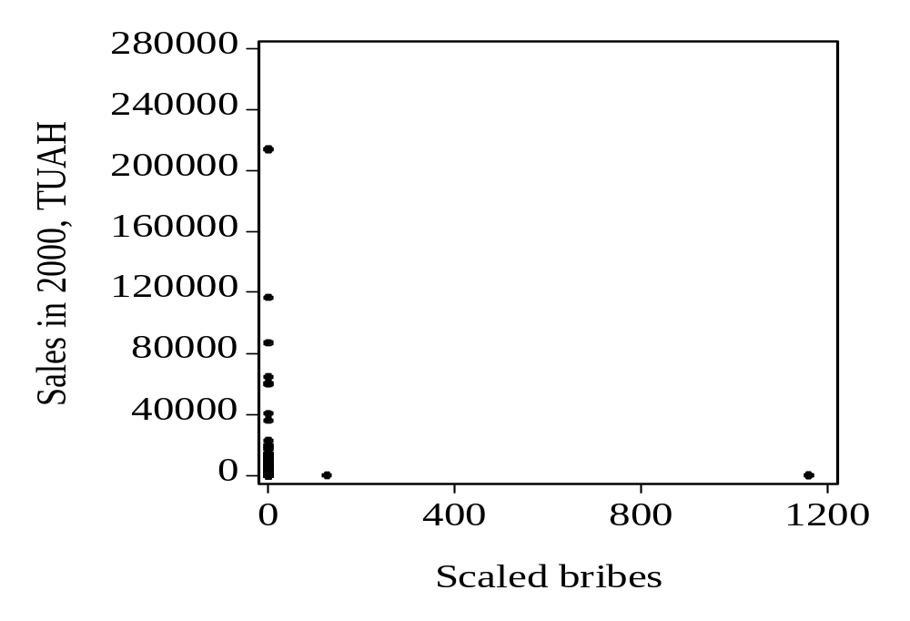
Graph A.3.2. Scatter graph of scaled bribes against the sales for the main group in the sample
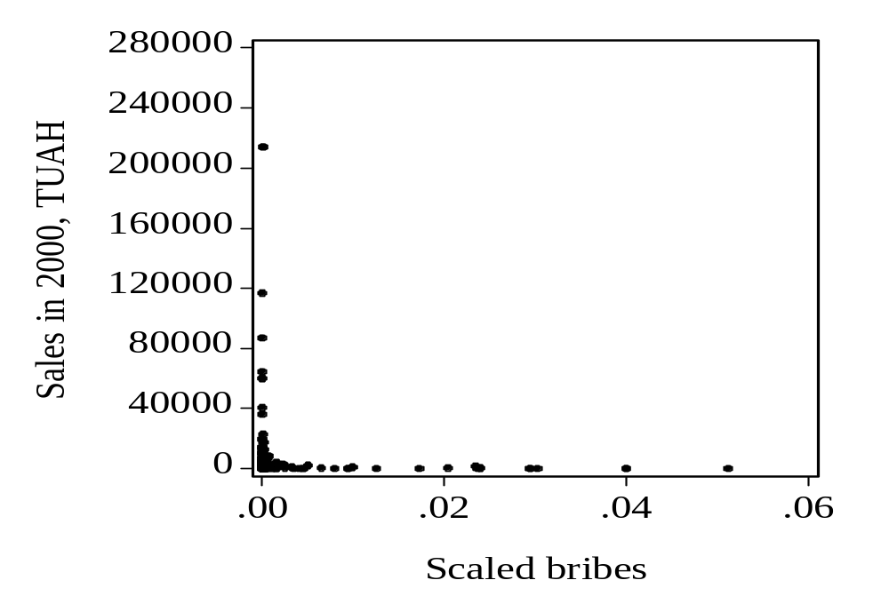

Table A.1. Summery statistics for the key variables from the work group
Variables | Mean | Standard deviation | Observations
SALES_GROWTH | 0.124 | 1.514 | 162
BRIBE_TOT_SC | 10.716 | 106.409 | 120
TAXES_2000_SC | 26.880 | 249.004 | 120
LLABOR_2000 | 2.458 | 1.996 | 359
LAGE | 7.141 | 0.696 | 359
DEPRECIATION_GROWTH | -0.164 | 0.899 | 164
LABOR_C_GROWTH | 0.086 | 0.475 | 164
OTHER_C_GROWTH | 0.003 | 2.655 | 164

Table A.2. Descriptive statistics of the scaled bribes
Statistic | BRIBE_TOT_SC
Mean | 1.059034
Median | 0.000125
Maximum | 125.0000
Minimum | 0.000000
Std. Dev. | 11.45810
Skewness | 10.77025
Kurtosis | 117.0017
Observations | 119

Appendix A1. Hausman test on endogeneity
Eff_change_{i} = α₀ + α₁T_{i} + α₂A_{i} + v_{i} (2a)
B_{i} = β₀ + β₁T_{i} + β₂A_{i} + ω_{i} (2b)
Where Eff_change_{i} is a technical efficiency change; B_{i} is a bribe payment; A_{i} is an log of age of a firm; T_{i} is log of time spent by businessmen on negotiation with the officials about regulatory issues involved with activity
Eff_change_{i} = a + bB_{i} + cA_{i} + hB’_{i}+ u_{i} (3a)
B_{i} = d + eEff_change_{i} + fT_{i} +gEf_change’_{i}+ w_{i} (3b)
where Eff_change’_{i} and B’_{i} are the fitted values from the reduced form (2a) and (2b) correspondingly. The null hypotheses that B’_{i} and u_{i}, Eff_change’_{i} and w_{i} are uncorrelated boils down to test of h and g equal to zero. If the null hypotheses are rejected, then there is endogeneity between bribes and efficiency growth.

TE_GROWTH = 2.181+ 0.027*BRIBE_TOT_SC + -0.181*LAGE – (1)
(0.452) (0.103) (0.062)
- 0.0008*BRIBE_TOT_SC_FIT
(0.002)

BRIBE_TOT_SC = 0.118 + 0.024*TE_GROWTH - 0.024*LTIME - (2)
(0.132) (0.033) (0.027)
- 0.047*TE_GROWTH_FIT
(0.069)

The coefficients at fitted values of bribe rate [BRIBE_SC_FIT in (1)] and efficiency change [TE_GROWTH _FIT in (2)] are insignificant at any sensible levels of significance. The null hypothesis of non-endogenity in relations between total bribes and sales is not rejected.

Table A.3. The results of the Tobit analysis with the dependent variable change in efficiency (TE_GROWTH) regressed on the dummy for giving bribe (D_bribe_tot)

Independent variables | Specification of the models
Independent variables | I | II | III | IV
Constant | 1.427**  (0.634) | 1.470**  (0.707) | 0.431  (0.757) | 0.605  (0.623)
Center | - | -0.002  (0.166) | -0.179  (0.188) | 0.004  (0.179)
East | 0.445***  (0.190) | 0.443***  (0.139) | - | 0.133  (0.153)
West | -0.004  (0.165) | - | -0.226*  (0.136) | -0.056  (0.122)
Capital | 0.093  (0.187) | 0.093  (0.141) | -0.234  (0.155) | -0.103  (0.159)
South | 0.115  (0.183) | 0.125  (0.128) | -0.192  (0.153) | -
Manufact | 0.110  (0.122) | 0.081  (0.289) | 0.503  (0.469) | -0.195  (0.158)
Trade | 0.082  (0.137) | 0.038  (0.294) | 0.530  (0.471) | -0.166  (0.177)
Service | - | -0.042  (0.295) | 0.476  (0.479) | -0.184  (0.170)
Intermed | 0.047  (0.295) | - | 0.329  (0.555) | -0.325  (0.347)
Science | -0.291  (0.587) | -0.311  (0.644) | - | -0.662  (0.486)
Other | 0.554***  (0.188) | 0.531*  (0.332) | 0.675  (0.495) | -
Lage | -0.132*  (0.075) | -0.133*  (0.075) | -0.166**  (0.070) | -0.130*  (0.071)
D_bribe_tot | 0.070  (0.123) | 0.082  (0.124) | 0.043  (0.122) | 0.064  (0.120)
Taxes_2000_sc |  |  | 1.578***  (0.150) | 1.621***  (0.148)
Llabor_2000 | 0.025  (0.048) | 0.009  (0.053) | -0.116**  (0.050) | -0.124***  (0.050)
Lsales_2000 | -0.001  (0.033) | 0.006  (0.035) | 0.178***  (0.036) | 0.187***  (0.035)
Llabor_c_growth |  | -0.060  (0.151) | -0.185  (0.134) | -0.178  (0.132)
Depreciation_growth | -0.399***  (0.050) | -0.396***  (0.050) | -0.432***  (0.042) | -0.441***  (0.041)
Other_c_growth | 0.095  (0.089) | 0.102  (0.095) | 0.147*  (0.089) | 0.168*  (0.089)
Adv_exp_growth |  |  |  | 0.043**  (0.019)
R² | 0.368 | 0.368 | 0.697 | 0.710
Akaike info criterion | 2.189 | 1.871 | 1.508 | 1.494
Observations | 153 | 152 | 112 | 111

In the regressions the Huber/White procedure covariance were applied to obtain robust covariance.
The standard deviations are provided in the parenthesis.
*** (**/*) denote the significance at 1% (5%/10%) confidence level.

Table A.4. The results of the regression analysis with the dependent variable change in efficiency (TE_GROWTH) regressed on bribe scaled on the sales for the same period (Bribe_tot_sc).

Independent variables | Specification of the models
Independent variables | I | II | III | IV | V | VII | VIII
Constant | 2.373***  (0.685) | 1.789***  (0.473) | 2.088**  (0.935) | 2.090**  (0.936) | 2.123*  (1.141) | 0.702  (0.653) | 0.912  (0.781)
Center | -0.534  (0.374) | -0.084  (0.152) | -0.093  (0.157) | -0.094  (0.158) | -0.096  (0.165) | 0.074  (0.191) | -0.012  (0.213)
East | - | 0.487  (0.318) | 0.480  (0.305) | 0.478  (0.302) | 0.485  (0.350) | 0.315**  (0.137) | 0.178  (0.153)
West | -0.478  (0.317) | - | - | - | - | 0.129  (0.101) | 0.009  (0.132)
Capital | -0.403*  (0.242) | 0.060  (0.107) | 0.063  (0.113) | 0.062  (0.111) | 0.064  (0.121) | - | -0.150  (0.136)
South | -0.347  (0.242) | 0.141  (0.126) | 0.145  (0.128) | 0.143  (0.127) | 0.147  (0.146) | 0.102  (0.130) | -
Manufact | 0.133  (0.118) | 0.117*  (0.069) | 0.144  (0.097) | 0.147  (0.101) | 0.147  (0.104) | 0.179**  (0.092) | -0.224  (0.312)
Trade | - | -0.010  (0.114) | 0.002  (0.108) | -0.0002  (0.110) | 0.003  (0.100) | 0.033  (0.123) | -0.367  (0.341)
Service | 0.017  (0.113) | - | - | - | - | 0.128  (0.104) | -0.246  (0.315)
Intermed | 0.089  (0.189) | 0.052  (0.153) | 0.063  (0.148) | 0.061  (0.146) | 0.066  (0.155) | - | -0.370  (0.333)
Other | 0.761  (0.772) | 0.754  (0.707) | 0.852  (0.790) | 0.861  (0.806) | 0.853  (0.747) | 0.375  (0.327) | -
Bribe_tot_sc | 0.478  (0.339) | 0.504  (0.343) | 0.326  (0.233) | 0.323  (0.236) | 0.302  (0.321) | -1.038  (4.411) | -0.852  (4.415)
Tax_2000_sc |  |  |  |  |  | 1.747***  (0.390) | 1.779***  (0.382)
Lage | -0.176**  (0.076) | -0.159**  (0.072) | -0.184*  (0.102) | -0.183*  (0.100) | -0.184*  (0.105) | -0.168**  (0.070) | -0.130**  (0.069)
Llabor_2000 |  |  | -0.027  (0.070) | -0.028  (0.073) | -0.016  (0.051) | -0.173**  (0.071) | -0.188***  (0.072)
Lsales_2000 |  |  |  |  | -0.011  (0.086) | 0.188***  (0.035) | 0.197***  (0.035)
Labor_c_growth |  |  | -0.214  (0.278) | -0.218  (0.284) | -0.200  (0.203) | -0.390**  (0.177) | -0.410***  (0.175)
Depreciation_growth |  |  | 0.146  (0.131) | 0.050  (0.167) | 0.045  (0.152) | 0.018  (0.254) | 0.055  (0.259)
Other_c_growth |  | 0.109  (0.086) |  | 0.141  (0.127) | 0.144  (0.142) | 0.427**  (0.204) | 0.438**  (0.201)
Adv_exp_growth |  |  |  |  |  |  | 0.037***  (0.010)
R² | 0.168 | 0.175 | 0.186 | 0.186 | 0.187 | 0.727 | 0.660
Akaike info criterion | 1.958 | 1.968 | 2.368 | 2.020 | 2.037 | 1.415 | 1.397
Observations | 112 | 112 | 111 | 111 | 111 | 81 | 79

Notes:
In the regressions the Huber/White procedure covariance were applied to obtain robust covariance.
The standard deviations are provided in the parenthesis.
*** (**/*) denote the significance at 1% (5%/10%) confidence level.
The observations with the dummy SCIENCE do not correspond to the observations with the concrete declared sum of bribes. Therefore, the dummy SIENCE is dropped to avoid singular matrix and to make possible the estimation procedure.
In the first and the second specifications the coefficients at scaled bribes are significant at 15% and 14% level of significance correspondingly.

Table A.5. The results of the regression analysis with the dependent variable change in efficiency (TE_GROWTH) regressed on the dummy for giving bribe (D_bribe_tot).

Independent variables | Specification of the models
Independent variables | I | II | III | IV | V | VI | VII
Constant | -0.086  (0.238) | -0.243  (0.187) | -0.073  (0.247) | -0.196  (0.290) | -0.132  (0.720) | -0.358  (1.006) | -0.476  (0.811)
Center | -0.083  (0.210) | -0.059  (0.216) | -0.252  (0.215) | - | -0.033  (0.174) | 0.023  (0.259) | 0.078  (0.258)
East | 0.187  (0.166) | 0.199  (0.179) | - | 0.329*  (0.194) | 0.301**  (0.140) | 0.260  (0.219) | 0.261  (0.217)
West | -0.040  (0.142) | -0.035  (0.159) | -0.235  (0.152) | 0.033  (0.173) | - | 0.037  (0.187) | 0.077  (0.176)
Capital | -0.005  (0.178) | - | -0.201  (0.180) | 0.006  (0.197) | -0.027  (0.146) | - | -0.018  (0.229)
South | - | -0.005  (0.180) | -0.202  (0.168) | 0.020  (0.193) | -0.012  (0.132) | -0.066  (0.223)
Manufact | -0.155  (0.201) | - | 0.097  (0.140) | 0.110  (0.134) | 0.245  (0.306) | 0.073  (0.672) | -0.144  (0.225)
Trade | -0.192  (0.220) | -0.022  (0.140) | 0.059  (0.153) | - | 0.131  (0.310) | -0.003  (0.675) | -0.213  (0.248)
Service | -0.253  (0.214) | -0.081  (0.133) | - | 0.027  (0.140) | 0.161  (0.310) | 0.052  (0.686) | -0.129  (0.238)
Intermed | -0.994***  (0.346) | -0.814***  (0.301) | -0.730**  (0.308) | -0.144  (0.305) | - | -0.238  (0.798) | -0.395  (0.502)
Science | -0.349  (0.676) | -0.176  (0.654) | -0.032  (0.680) | 0.012  (0.609) | 0.128  (0.676) | - | -0.179  (0.702)
Other | - | 0.118  (0.207) | 0.201  (0.222) | 0.164  (0.205) | 0.294  (0.349) | 0.191  (0.705) | -
Lage |  |  |  |  | -0.021  (0.077) | 0.010  (0.098) | 0.043  (0.100)
D_bribe_tot | 0.207  (0.139) | 0.179  (0.141) | 0.182  (0.142) | 0.180  (0.128) | 0.180  (0.129) | 0.189  (0.172) | 0.207  (0.172)
Taxes_2000_sc |  |  |  |  |  | 0.015**  (0.008) | 0.016**  (0.008)
Llabor_2000 |  |  | -0.014  (0.038) | -0.067  (0.055) | -0.067  (0.055) | -0.079  (0.068) | -0.078  (0.068)
Lsales_2000 |  |  |  | 0.015  (0.034) | 0.014  (0.034) | 0.037  (0.043) | 0.036  (0.043)
Llabor_c_growth |  | 0.152  (0.157) | 0.142  (0.160) | 0.131  (0.149) | 0.127  (0.150) | 0.010  (0.182) | 0.024  (0.182)
Depreciation_growth | -0.162***  (0.056) | -0.167***  (0.056) | -0.163***  (0.058) | -0.155***  (0.052) | -0.155***  (0.052) | -0.160***  (0.059) | -0.168***  (0.059)
Other_c_growth | 0.039**  (0.019) | 0.031  (0.021) | 0.030  (0.021) | 0.057**  (0.022) | 0.057**  (0.022) | 0.077**  (0.030) | 0.071**  (0.030)
Adv_exp_growth |  |  |  |  |  |  | 0.044*  (0.027)
White test | Not | Not | Not | Not | Not | Not | Not
R² | 0.148 | 0.154 | 0.155 | 0.199 | 0.200 | 0.274 | 0.294
F-statistic | 2.187 | 2.078 | 1.928 | 2.399 | 2.240 | 2.206 | 2.042
Observations | 163 | 162 | 162 | 160 | 160 | 117 | 116

The coefficient at bribery dummy is significant at 13% level of significance in the 1st specification.

Table A.6. The results of the regression analysis with the dependent variable change in efficiency (TE_GROWTH) regressed on bribe scaled on the sales for the same period (Bribe_tot_sc).

Independent variables | Specification of the models
Independent variables | I | II | III | IV | V | VI
Constant | 0.541  (0.685) | 0.702  (0.707) | 0.818  (0.760) | 1.131  (0.770) | 0.741  (0.880) | 0.203  (1.114)
Center | -0.080  (0.206) | -0.060  (0.219) | 0.075  (0.194) | -0.366*  (0.214) | - | -
East | 0.306**  (0.161) | 0.307*  (0.178) | 0.443***  (0.157) | - | 0.372*  (0.215) | 0.056  (0.296)
West | -0.150  (0.152) | -0.152  (0.168) | - | -0.440***  (0.157) | -0.070  (0.197) | -0.084  (0.250)
Capital | 0.009  (0.172) | - | 0.115  (0.168) | -0.328*  (0.179) | 0.043  (0.220) | -0.160  (0.286)
South | - | 0.0006  (0.172) | 0.158  (0.151) | -0.284*  (0.159) | 0.069  (0.209) | -0.135  (0.276)
Manufact | -0.248  (0.223) | 0.005  (0.141) | - | 0.119  (0.151) | 0.150  (0.305) | 0.147  (0.445)
Trade | -0.281  (0.243) | -0.090  (0.161) | -0.111  (0.149) | - | 0.048  (0.316) | 0.090  (0.460)
Service | -0.207  (0.235) | - | -0.032  (0.141) | 0.082  (0.161) | 0.124  (0.316) | 0.241  (0.460)
Intermed | -0.354  (0.362) | -0.104  (0.314) | -0.153  (0.300) | -0.043  (0.313) | - | -
Other | - | 0.211  (0.234) | 0.169  (0.223) | 0.295  (0.245) | 0.346  (0.377) | 0.338  (0.513)
Bribe_tot_sc | -0.002***  (0.0005) | -0.003***  (0.0005) | -0.013**  (0.006) | -0.013**  (0.006) | -0.013**  (0.006) | -0.019**  (0.009)
Tax_2000_sc |  |  |  |  |  | 0.488  (0.228)
Lage | -0.058  (0.089) | -0.078  (0.090) | -0.100  (0.091) | -0.096  (0.092) | -0.099  (0.094) | -0.030  (0.118)
Llabor_2000 |  | -0.055  (0.041) | -0.100*  (0.056) | -0.103**  (0.057) | -0.090  (0.070) | -0.222**  (0.088)
Lsales_2000 |  |  | 0.017  (0.039) | 0.018  (0.039) | 0.011  (0.045) | 0.094  (0.059)
Labor_c_growth |  |  |  |  | -0.021  (0.193) | -0.387*  (0.234)
Depreciation_growth |  |  |  | 0.076  (0.190) | 0.083  (0.194) | 0.307  (0.385)
Other_c_growth | 0.042**  (0.020) | 0.042**  (0.020) | 0.073***  (0.025) | 0.074***  (0.026) | 0.075**  (0.029) | 0.169***  (0.041)
Adv_exp_growth |  |  |  |  |  | 0.044  (0.030)
R² | 0.273 | 0.286 | 0.165 | 0.167 | 0.163 | 0.351
White test | Not | Not | Not | Not | Not | Not
F-test | 3.665 | 3.542 | 1.589 | 1.475 | 1.314 | 2.615
Observations | 119 | 119 | 118 | 118 | 117 | 82

Notes:
In the sixth and the fifth regressions F-test does not reject the null hypothesis that all coefficients equal to zero from 1% to 10% level of significance. In the third regression the null hypothesis is rejected at 10% level of significance.
The standard deviations are provided in the parenthesis.
*** (**/*) denote the significance at 1% (5%/10%) confidence level.
The observations with the dummy SCIENCE do not correspond to the observations with the concrete declared sum of bribes. Therefore, the dummy SIENCE is dropped to avoid singular matrix and to make possible the estimation procedure.

Graph A.1. The estimated density functions for 2000.

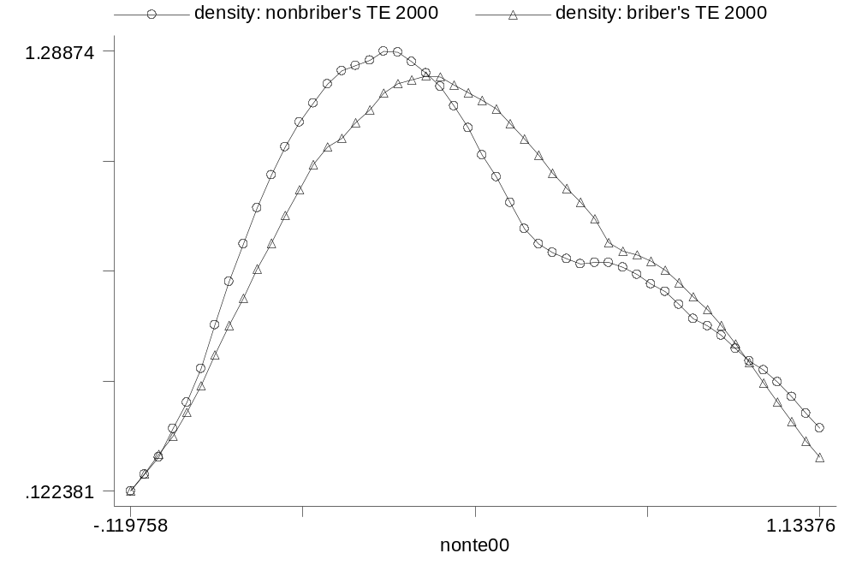

Graprh A.2. The estimated density functions for 2001.

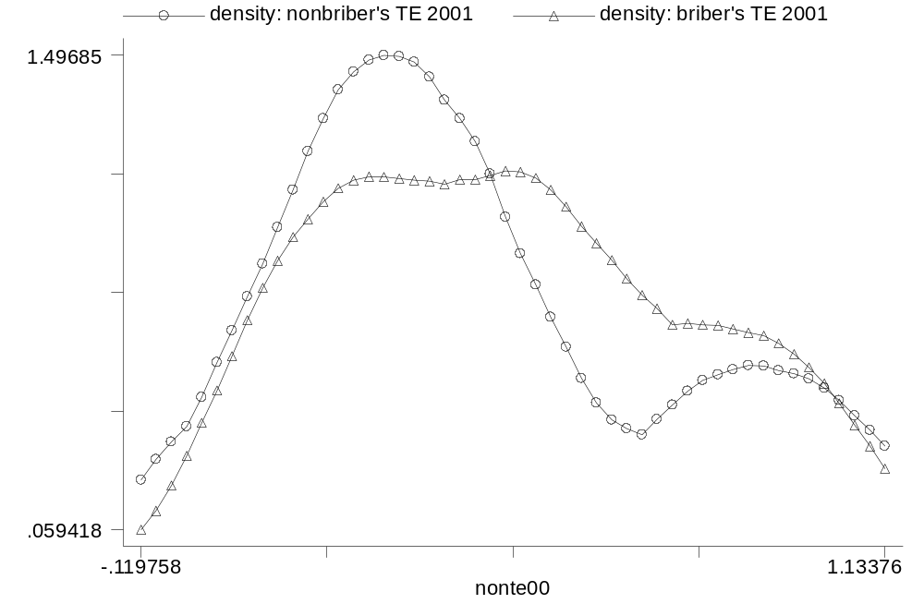

Graph A.3. The estimated density functions for growth in technical efficiency demonstrated by bribers and non-bribers

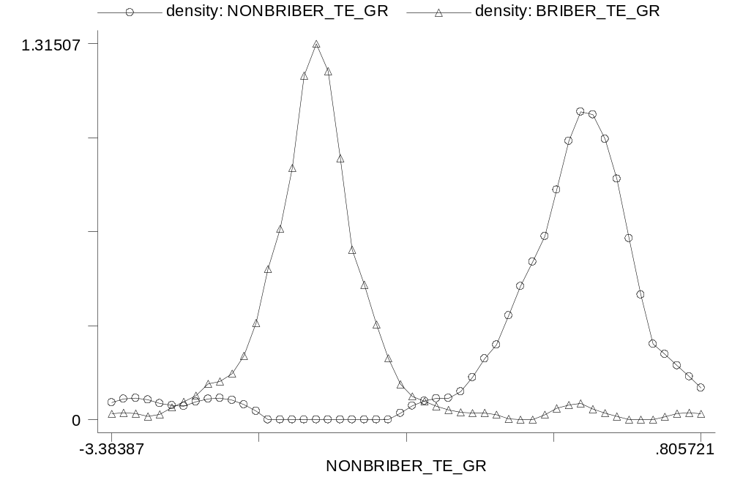

The conditions of weak and strong output disposability can be violated, as in reality the sales can decrease or be at the same level even if there is a increase in one inputs or proportional growth in all inputs.
According to the specification of the D_{O} (3), D_{Oi} should be equal or more than one. However, the DEAP software calculated it in the interval between 0 and 1 implying that the more efficient firm the closer the D_{Oi} to 1. The growth term (γ_{i} ) complies with the given condition to reflect growth in the log form.
The results of the survey “Partnership for a Transparent Society” are available at the web-site www.prozorist.org.ua
TUAH is shorthand from a thousand of the Ukrainian hryvnias.

