Application of the Data Envelopment Analysis (DEA) to decision-making on labor and capital investment in the US hospitals
Eugene Yankovsky, presented at Joint Statistical Meetings 2025
Objective | Minimize inputs while maintaining output levels:  Can the hospital maintain the same level of quantity and quality of the healthcare with less resources used?” | Maximize outputs while keeping inputs constant:  Does the hospital have any efficiency reserves to increase quantity and quality of healthcare without extra investment into the labor and capital?
Methodology | Risk-adjustment of a composite healthcare quality indicator PSI 90i  a) E[PSI 90i] = $β_{0}$ + $β_{1}$* CMIi  0.8827*** + 0.1146* CMI  s.e. 0.113 0.074  b) Risk-adjusted PSI 90i = -1* (PSI 90i – E[PSI 90i])  for i = 1,…, 63 hospital  c) Input-Oriented DEA with Variable-Return to Scale (VRS)  assesses how much each Decision Making Unit (DMU) (hospital) can reduce its inputs (costs/resources) while maintaining the same level of outputs (quantity and quality).  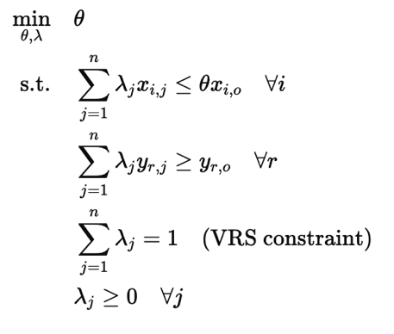  where  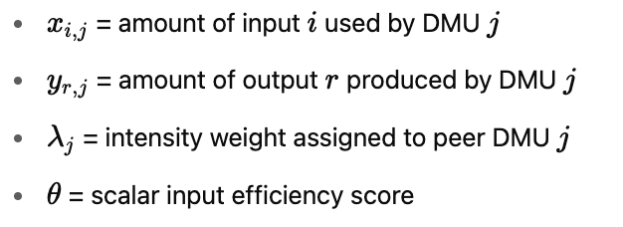  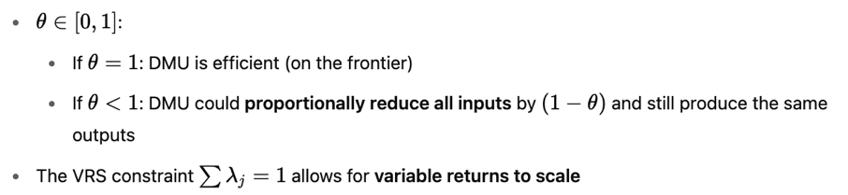 | Risk-adjustment of a composite healthcare quality indicator PSI 90i  a) E[PSI 90i] = $β_{0}$ + $β_{1}$* CMIi  0.8827*** + 0.1146* CMI  s.e. 0.113 0.074  b) Risk-adjusted PSI 90i = -1* (PSI 90i – E[PSI 90i])  for i = 1,…, 63 hospital  c) Output-oriented DEA model with variable returns to scale (VRS)  An output-oriented DEA linear programming model evaluates how much a Decision Making Unit (DMU) can proportionally increase its outputs given the same level of inputs.  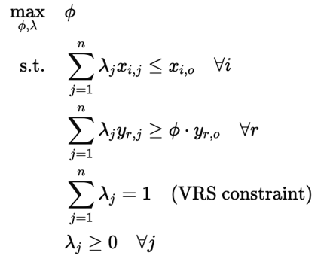  where  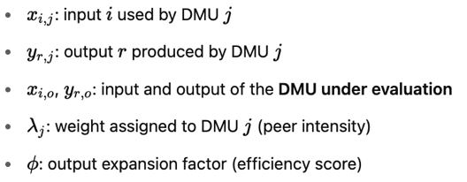  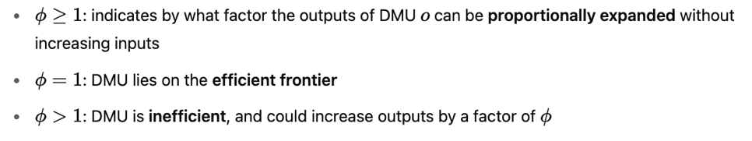
Visualization | Simplified one input – one output visualization of the sample with most efficient hospitals A, C, and D located on variable return to scale (VRS) efficiency frontier 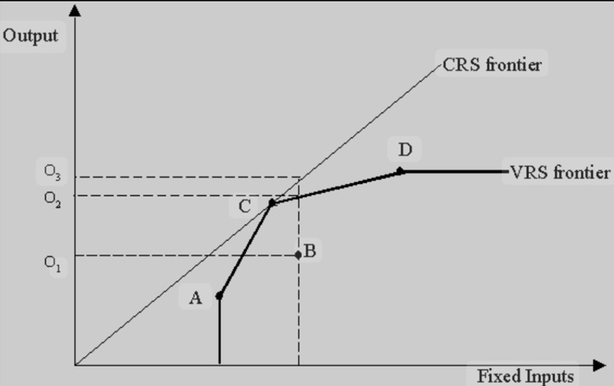 | Simplified one input – one output visualization of the sample with most efficient hospitals A, C, and D located on variable return to scale (VRS) efficiency frontier
Data | Input variables (X)  Output variables (Y)  - Patient accounts receivable as an indicator of quantity of healthcare provided  - Risk adjusted PSI 90, an indicator of quality of healthcare provided | Input variables (X)  Output variables (Y)  - Patient accounts receivable as an indicator of quantity of healthcare provided for  - Risk adjusted PSI 90, an indicator of quality of healthcare provided
  - Depreciation and amortization
  - Salaries and wages
  - Depreciation and amortization
  - Salaries and wages
Results | All hospitals in the sample are ranked by their potential to reduce labor and capital expenses without reduction of quantity and quality of the healthcare that varied in the range between 0.09% to 43.31% (estimated by dea.robust() in rDEA package). | All hospitals in the sample are ranked by their potential to increase their healthcare output without increase in labor and capital investment that varied from 0.03% to 209.5% (estimated by dea.robust() in rDEA package).

