After discussed with advisor James, I found the transfer function I obtained was wrong. The correct transfer function should be Vd2/Vsd which is the list of (2, 1) elements of the Htrans matrix.

And after I changed my codes, the channel impulse response looks fine

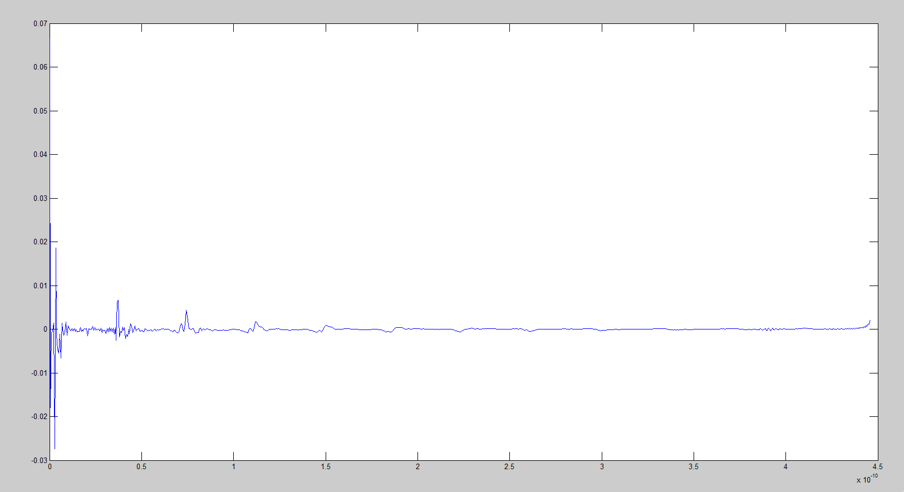

And I found when I run a double time of amiinit_1207a function, the Matlab would crash down.

I’m still working on it. After I run the amiinit function once, I plot the output impulse response shows below.

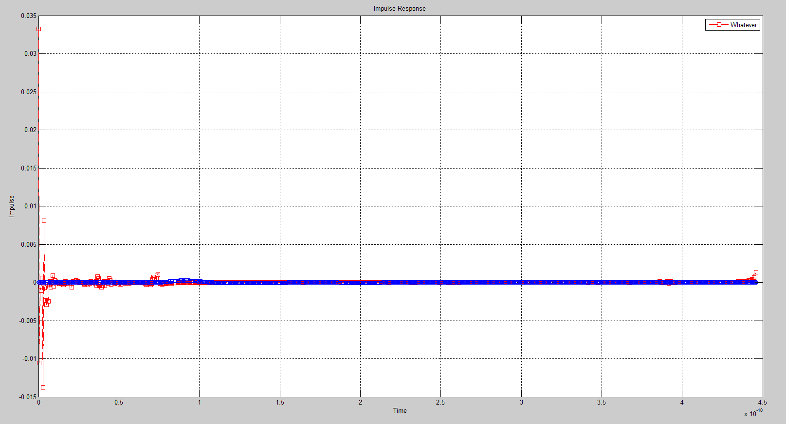

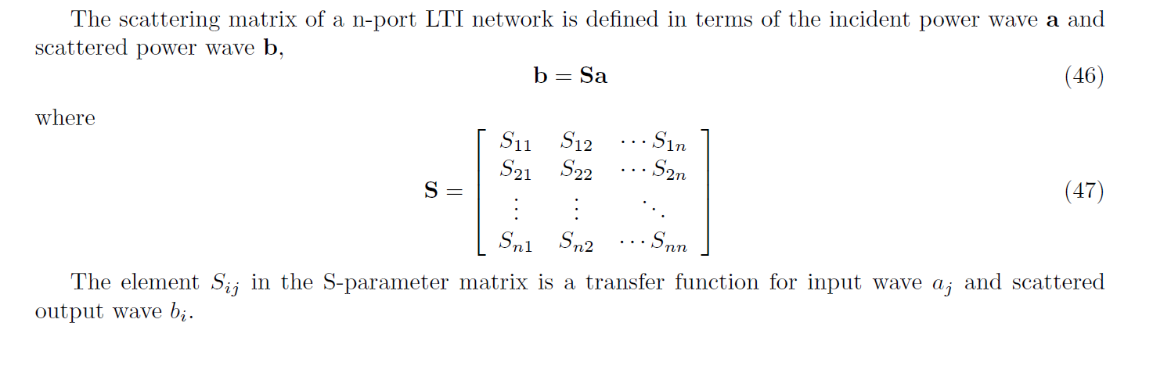This graph looks fine, but I haven’t included DC point in S-parameters. The problem I encountered was that I don’t know how to derive the DC point of s-parameter at a four-port network. I wonder what a four-port network inside looks like. Is it just adding another loop circuit as a two-port network? And like the following says, how to find S13 and S14 those irrelevant ports?

And I think b1 = S11*a1 + S12*a2 + S13*a3 + S14*a4, why Sij is a transfer function for aj and bi?