Weekly Report

03/08/2015

Yuan Yao

This week Meng and I have derived channel impulse response correctly by using the method in the pdf “time-frequency transform of band-limited signals 02 - jzhou_20150303”.

There are several points need to be clarified.

1. We use Hmirror = conj( Htrans1( :, :, nfp:-1:2) ); to observe a periodic and Symmetrical frequency domain function. Then, we do ifft to observe the corresponding time domain response hac_t. We find that hac_t doesn’t have any imaginary part and I don’t know whether it is correct.
2. 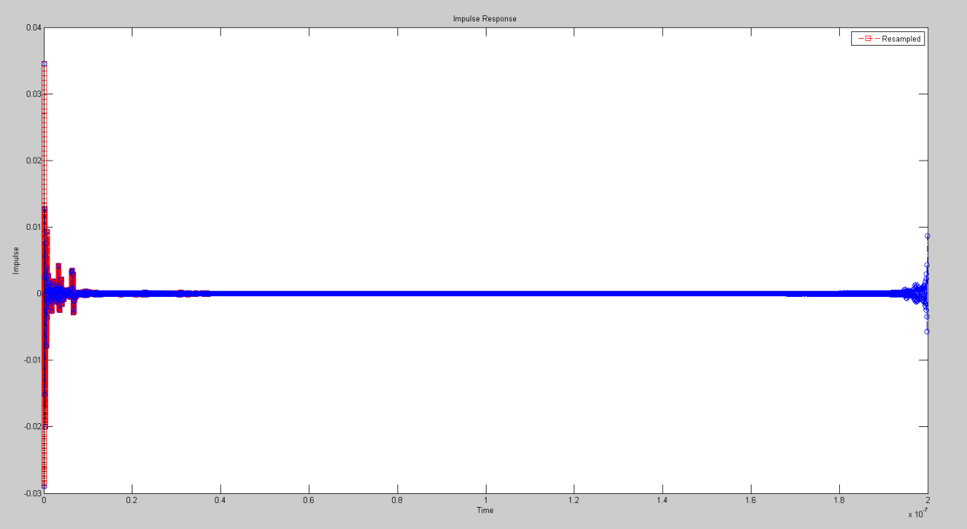To find out the corresponding time list, we calculate Ts through frequency list and stop frequency. Because impulse response has reached almost to 0 at about 800 point and the corresponding time is (3.9930*10^-8)s, about 10^5 sample steps, I use tinterp = 0:sample_step:1e5*sample_step; to get the channel impulse response in order to convolve with input signal x(t) which uses the same sample step. The following shows the channel impulse response (red) and the hac_t( blue).
3. We didn’t derive hac_t according to x(nTs) = 1/Ts * x[n]. If we add this step, the final eye diagram will be something weird and obviously incorrect.

Next week we will find out how to plot eye diagram properly and we may need your help then.

Thanks!