Design and Implementation of Intelligent Monitoring System for Elderly Nursing Based on Internet of Things
Fenfang Liao https:// orcid.org/ 0009-0009-2637-8339MinXi Vocational and Technical College, Longyan, China

ABSTRACT
With the increasing number of the aged globally, ensuring the physical safety and quality of life of the elderly has become an urgent issue in the field of smart medical care and internet of things technology. In this study, a set of intelligent monitoring systems for elderly nursing is built, which integrates multi-modal data acquisition, lightweight time series anomaly detection algorithm, and energy consumption adaptive mechanism. The system can realize high-frequency dynamic updating of state awareness, high-reliability alarm, and fine intervention. The system shows good stability and universality in trial operation, which reduces the risk of data islands and also significantly improves nursing efficiency. In addition, this paper also systematically optimizes communication protocol, data security, and user experience. This study is of great significance to improve the digital level of old-age care services and also provides a new idea for the follow-up multidisciplinary integration research.

KEYWORDS
Design, Elderly Care, Intelligent Monitoring System, Internet of Things

INTRODUCTION
The drastic changes in the population structure have made the “silver-haired economy” the focus of social attention(Zhang, 2024). However, it is difficult for the traditional labor-intensive nursing methods to strike a balance between cost, efficiency, and quality(Krzywdzinski et al., 2024). Although the existing health monitoring products on the market, such as wearable devices and smart mattresses, have brought new possibilities for elderly care, these technologies are facing many limitations in practical application. First of all, many single-point products lack a unified communication protocol and good data format compatibility, which makes it difficult for them to effectively integrate information, thus affecting the ability to comprehensively evaluate the health status of the elderly, and the response speed is restricted in emergency situations(Ray et al., 2020). In addition, with the enhancement of the elderly’s awareness of privacy protection and the improvement of comfort requirements, those solutions with high energy consumption and large amounts of data are not suitable, because these problems are often accompanied by an uncomfortable wearing experience or potential risk of privacy leakage, which limits their large-scale promotion(Ometv et al., 2021).
Furthermore, although the adaptive seamless redundancy scheme proposed by some studies has significantly improved the reliability of Message Queuing Telemetry Transport(MQTT) communication, the actual performance in a complex wireless environment still needs more verification(Awan, 2023). At the same time, in the continuous monitoring of vital signs, how to improve the real-time response speed of the system and reduce the false alarm rate is still an unsolved problem(Salem et al., 2022). Although the smart home medical system can achieve high accuracy in extracting user behavior characteristics, its stability and security in long-term operation is still a topic that needs to be discussed in depth(Mohammed et al., 2020). Especially in the cross-cultural background, considering the differences in living habits and circadian rhythms in different regions, it is a big challenge to ensure the universality and flexibility of the system(Tang et al., 2019).
DOI: 10.4018/IJHISI.383536
Faced with the above challenges, there is an urgent need for a technical route that integrates low power consumption, strong interoperability, and high security to support the development of continuous nursing service. This technology not only needs to reconstruct the multi-modal sensor network on the hardware level but also needs to deploy a lightweight anomaly detection model on the edge side and introduce adaptive algorithms and visual decision-making interfaces to the cloud platform. In this way, while protecting personal privacy, advanced technologies such as federated learning can be used to optimize the model to adapt to the physiological baseline of different individuals, to provide more accurate and reliable health monitoring services. This end-edge-cloud cooperation mechanism can not only shorten the alarm closed-loop time but also maintain the minimum local service when the link is disconnected, giving the system natural fault-tolerant flexibility. Therefore, it is particularly important to explore and develop such a comprehensive technical framework to meet the growing demand for aged care.
This paper aims to solve the problems of lack of in-depth discussion on end-edge-cloud full-link collaboration and insufficient attention to the dynamic balance between energy consumption, accuracy and user experience in existing research by means of system engineering. Specifically, this research focuses on three aspects. First, the multi-modal sensor network is reconstructed at the hardware level to support more efficient data acquisition and processing. Secondly, a lightweight anomaly detection model is deployed on the edge side to ensure real-time analysis ability and reduce energy consumption. Finally, adaptive algorithms and visual decision interfaces are introduced into the cloud platform to improve the accuracy and response speed of data analysis and enhance user experience. The main contribution of this paper is to propose an integrated technical framework, which not only covers the multi-dimensional exploration from protocol stack optimization to model compression to federated learning but also emphasizes the collaborative work among different levels(terminal, edge, and cloud). Through this end-edge-cloud cooperation mechanism, this study successfully realized the second level closed-loop operation of the alarm link, and carried out trial operation in the actual nursing home environment, which verified the effectiveness of the proposed design ideas and implementation paths. In summary, the work of this paper provides an innovative solution to the challenges brought by an aging society, and opens up a new direction for the interdisciplinary integration of the Internet of Things(IoT) and digital health.
The structure of the article is as follows: the second part summarizes the related research. The third and fourth parts explain the system architecture and key algorithms respectively. Then the experimental results and discussion are given. The end summarizes the full text and looks forward to the future direction. This study can provide useful reference for the continuous innovation in the field of smart pension.

LITERATURE REVIEW
In recent years, with the aggravation of global population aging, health monitoring systems, and reliable data communication technology for the elderly have become research hotspots(Wang et al., 2024). This review summarizes several recent research results and discusses how to improve the efficiency and reliability of the health monitoring system for the elderly by using modern technologies such as IoT, smart wearable devices, machine learning algorithms and reinforcement learning.
When discussing the health monitoring system for the elderly, the existing research shows the application potential and limitations of various technologies, which have had an important impact on the design ideas of this study. Zunino et al.(2023) proposed a solution based on the concept of software-defined network architecture, which realized highly reliable MQTT communication through the redundant version of MQTT at data level and the path quality evaluation and dynamic selection mechanism at control level. However, although in theory this method can significantly improve communication reliability, its practical application effect in complex wireless environments remains to be verified. This prompted us to introduce the end-edge-cloud collaboration architecture in our design to ensure the continuity and stability of services even under poor network conditions.
El-Shoafey and Ghanem(2024) introduced an intelligent medical monitoring system(SW-SHMS) for the elderly, which can remotely monitor in real time, find health problems in time and take corresponding measures. The research shows that the proposed neural network model is excellent at disease detection, especially for diabetes and cardiovascular diseases. The diagnostic accuracy is97.64% and 99.67% respectively. The research of Hosseinzadeh et al.(2023) realized the continuous monitoring of vital signs and behavior changes of the elderly by using intelligent pension technology and IoT technology. Although different machine learning algorithms, such as decision tree(J48) and multi-layer perceptron, have been proved to be useful for analyzing collected data and predicting health status. Although their research has realized real-time monitoring, how to improve the real-time response speed of the system and reduce the false alarm rate is still an unsolved problem. Yang et al.(2022) put forward a sustainable medical care system for nursing homes. The system adopts cost-effective fingerprint indoor positioning technology to achieve rapid response service, emphasizes improving the safety and management efficiency of the elderly, and provides Application Programming Interface interfaces to connect various health equipment. Their research improves the real-time response speed of the system. These studies have inspired us to study the direction of real-time response speed, and in addition, we can combine feature fusion and multi-task distillation technology to optimize the accuracy and recall on resource-limited equipment.
Wang(2022) designed and evaluated a smart home medical system based on IoT, 5G wireless technology and smart wearable technology, aiming at providing support for patients with Alzheimer’s disease. The experimental results show that the system not only improves the accuracy of extracting patients’ behavior characteristics but also reduces the accident rate in the nursing process and improves patients’ satisfaction. Although the system improves the accuracy of extracting patients’ behavioral characteristics, its long-term stability and safety still need further discussion. Therefore, in our system architecture, the reconstruction of hardware layer and the fast-reasoning ability of edge side are particularly emphasized to ensure the stability and security of the system.
Isa et al.(2024) demonstrated the possibility of integrating fuzzy rules and IoT technology into the health monitoring system for the elderly and used MAX30100 sensor and ESP32 microprocessor to measure oxygen saturation and heart rate. Although the experiment shows that the measurement accuracy of the system is as high as 98.89%, the accuracy of fuzzy logic judgment is 96%, which means that there may be some limitations in dealing with complex or unclear situations.
Through the analysis of the above cases, we can see that each technology or method has its unique advantages and limitations. It is these limitations that inspire us to rethink the relationship among hardware layer, edge computing and cloud computing from the perspective of system engineering, and finally form the comprehensive technical framework proposed in this paper. This framework not only considers the balance between energy consumption, accuracy and user experience, but also provides a solid foundation for intelligent elderly care in the future.
Volume 20 • Issue 1 • January-December 2025

MATERIAL AND METHODS

Overall Architecture of IoT Nursing Systems
End-Edge Cloud Cooperation Model
The traditional “terminal directly connected to the cloud” model seems simple in the laboratory, but once it landed in the noisy and crowded wireless environment of nursing homes, packet loss, time delay and energy consumption followed. Therefore, according to the idea of “end-edge cloud”collaboration, this paper re-divides the responsibilities of perception, reasoning and storage: wearable and environmental nodes denoise and compress at the end, edge gateway is responsible for rapid reasoning and caching, and cloud platform only retains the functions of model training and policy delivery(Nag et al., 2024; Wang et al., 2020). This three-layer layout shortens the alarm closed loop on the one hand and can still maintain the minimum local service when the link is disconnected on the other hand, thus making the system have natural fault-tolerant flexibility. At the same time, this paper cuts the protocol stack clipping as shown in Figure 1. The bottom layer uses low-power Bluetooth Low Energy(BLE) Mesh to ensure indoor coverage(Ghori et al., 2020). The relay link adaptively switches between Thread and Wi-Fi according to the load(Morales-Caporal et al., 2020). Constrained Application Protocol and MQTT are used in the upper layer to realize parallel transmission of event-driven and streaming data(Khriji et al., 2022).

Figure 1. The Flow Chart of Protocol Stack Editing
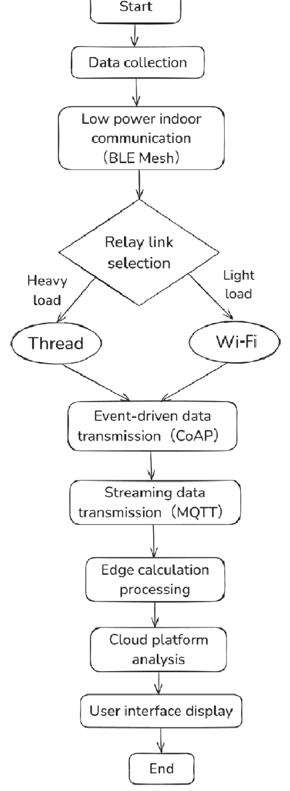
Note.BLE: Bluetooth Low Energy, CoAP: Constrained Application Protocol, MQTT: Message Queuing Telemetry Transport

Hierarchical Layout of System and its Functions
It is worth noting that the edge layer introduces a Graphics Processing Unit(GPU)-accelerated lightweight reasoning engine, which can complete the fall probability calculation in milliseconds and broadcast the results to the clinical decision-making panel through WebSocket(see Figure 2). In order to avoid the data peak in peak hours, we design an adaptive sampling strategy based on Shannon entropy: when the vital signs fluctuate smoothly, the nodes reduce the sampling rate. Once a significant deviation is detected, the system immediately improves the resolution and starts local analysis. This strategy not only suppresses redundant uploads, but also significantly prolongs the battery life. In addition, the client side uses Exclusive OR(XOR) encryption and salt hash to store cache fragments, and the cloud only receives metadata transmitted through encrypted tunnels, thus reducing the risk of privacy leakage from the source(Joshua, 2023). To sum up, the three-tier collaborative architecture considers reliability, real-time performance, and security while maintaining simplicity, which provides a stable operating base for the subsequent algorithm deployment.
Figure 2. System Data Flow
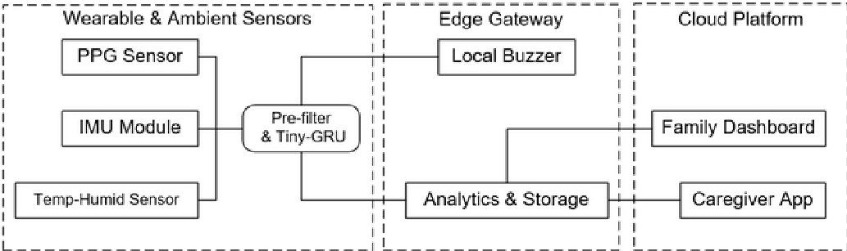
Note. PPG: Photoplethysmography, IMU: Body motion, Tiny-GRU: Tiny Gated Recurrent Unit

Performance Comparison of Existing Methods
The upgrade of the perceived link cannot measure the quality of the system, so we build a three-dimensional evaluation framework of “delay-false alarm-power consumption,” and automatically assign index weights by entropy weight method in an effort to reduce subjective deviation. In this paper, the popular cloud model scheme(Plan A), mobile terminal scheme(Plan B), and lightweight equipment scheme(Plan C) are selected as the control, and they are placed in the same bed and the same network environment for 72 hours of continuous testing. As can be seen from Table 1, Plan A is slightly better in accuracy due to the big model, but the high delay makes the fall alarm later than the medical intervention window. Plan B reduces part of the waiting time through mobile phone forwarding, but significantly increases the static power consumption due to too many reconnections. Although Plan C focuses on low energy consumption, the high false alarm rate leads to the fatigue of nursing staff, which indirectly reduces the service quality.
Table 1. Comparison Scheme Performance
Plan | Average alarm delay(ms) | False alarm rate(%) | Static power consumption of nodes(mW)
Plan A | 450 | 3.2 | 260
Plan B | 230 | 4.1 | 310

Plan | Average alarm delay(ms) | False alarm rate(%) | Static power consumption of nodes(mW)
Plan C | 180 | 11.5 | 120
This paper’s model | 190 | 2.9 | 150
In this paper, the key to achieving a balanced improvement in all indicators is not hardware stacking, but the dual role of edge cloud collaborative reasoning and dynamic threshold calibration. On the one hand, the edge nodes adjust the model sensitivity according to the difference between the rest period at night and the active period during the day, which avoids the state misjudgment from the mechanism. On the other hand, the cloud learns the periodic aggregation parameters by Federation, so that the model can adapt to the physiological baseline of different people under the premise of ensuring privacy(Qi et al., 2024). In addition, we also introduce breakpoint continuation and local cache in the link layer, which means that network jitter no longer directly leads to data gaps. Although the evaluation results are encouraging, there are still some shortcomings: the entropy weight method is sensitive to sample distribution, and the weight may be unbalanced in extreme scenarios. At the same time, the current sample size is not enough to represent people with cognitive impairment or Parkinson’s disease. Due to the time limit and the limitation of sample data acquisition, this study will supplement the sample size in the follow-up study. In the future, it is planned to continuously expand the data pool through cross-agency cooperation and explore the adaptive weight distribution based on multi-arm gambling algorithm to further enhance the robustness of the evaluation system. In addition, we try to combine situational awareness rules with statistical models. Preliminary experiments show that this hybrid scheme may further reduce false positives without sacrificing response speed.

Physiological Signal Data Modeling Hybrid Modeling Strategy
To meet the requirements of resource-limited equipment and high accuracy, this paper proposes a two-layer hybrid modeling strategy of “regular filtering+TinyGRU”. The bottom moving average combined with adaptive threshold can quickly eliminate the normal interval with extremely low probability. In the upper layer, TinyGRU after tensor pruning is used to capture long-range dependence, so as to realize early warning of subtle trends(Pandey& Azcarreta, 2025). In this paper, TinyGRU model reduces the number of parameters by 90% by using tensor pruning technology, and replaces standard convolution with Integer 8-bit quantization and deep separable convolution, which greatly reduces the computational complexity and storage requirements, makes the model run efficiently on resource-limited devices and maintain high accuracy, and shows an effective application example of model compression technology. Compared with the complete GRU, this model retains only one tenth of the parameters but maintains a considerable recall rate in off-line testing. More importantly, after the model is deployed on the edge node, with the support of Integer 8-bit quantization of Open Neural Network Exchange Runtime, the reasoning can still be completed within 20 milliseconds without the help of GPU.
Multi-Mode Training Data Collection and Processing
Multimodal training data are collected from three pension institutions for a long time. See Table 2for the specific sample size, characteristic dimension and sampling frequency. To alleviate the category imbalance, we first use Variational Autoencoder to synthesize the rare critical event sequence, and then introduce the Focal Loss to avoid the model leaning towards the dominant category(Khan et al., 2023). In addition, the system will map the number of false alarms in the last hour to a dynamic penalty term and then correct the output threshold of TinyGRU in real time-this closed loop keeps the model low in sensitivity during the rest period at night, and rapidly increases the alert value during the daytime activity period. Experiments show that this mechanism significantly reduces false positives at night. At the same time, energy consumption monitoring shows that quantitative reasoning saves nearly 30% electricity compared with the floating-point version. Although the two-tier model improves the overall complexity, its reliability and endurance advantages are enough to offset the additional software implementation costs, thus providing positive support for sustainable deployment.
Table 2. Statistics and Multimodal Datasets
Data type | Sampling frequency(Hz) | Characteristic dimension | Effective sample number
Heart rate(PPG) | 50 | 6 | 92 432
Blood pressure(CUFF) | 1 | 4 | 11 580
Body motion(IMU) | 100 | 9 | 144 210
Room temperature | 0.2 | 1 | 28 944
Humidity | 0.2 | 1 | 28 944
Note.PPG: Photoplethysmography, CUFF: Blood pressure cuff, IMU: Body motion

RESULTS

End-Edge-Cloud Collaboration Mechanism and Hardware Implementation
To break through the bottleneck of the traditional single-layer architecture, this paper proposes a coupling scheme of “Wearable Node Micro-Gateway Cloud Service” in the hardware layer. The core idea is to increase the computing power step by step with the data value level: the wristband sensor only keeps the signal pre-filtering and event triggering logic, the raspberry pie-Nordic dual Microcontroller Unit gateway is responsible for the middle-level reasoning and caching, and the cloud carries the model training and global strategy optimization(Chen& Lin, 2022; Olaisen et al.,2023). As shown in Figure 3, all layers are connected through a unified gRPC Remote Procedure Call interface, which avoids the extra delay caused by protocol switching, and reduces the data replication overhead with the aid of zero copy buffer. In view of the energy-sensitive characteristics of this application, we mount unnecessary peripheral power supplies to an independent Power Management Integrated Circuit, and use the three-state scheduling strategy of deep sleep and light sleep to make the node in an extremely low current state 80% of the time every day, which creates a prerequisite for long-term deployment.

Figure 3. Hardware Cooperation Framework
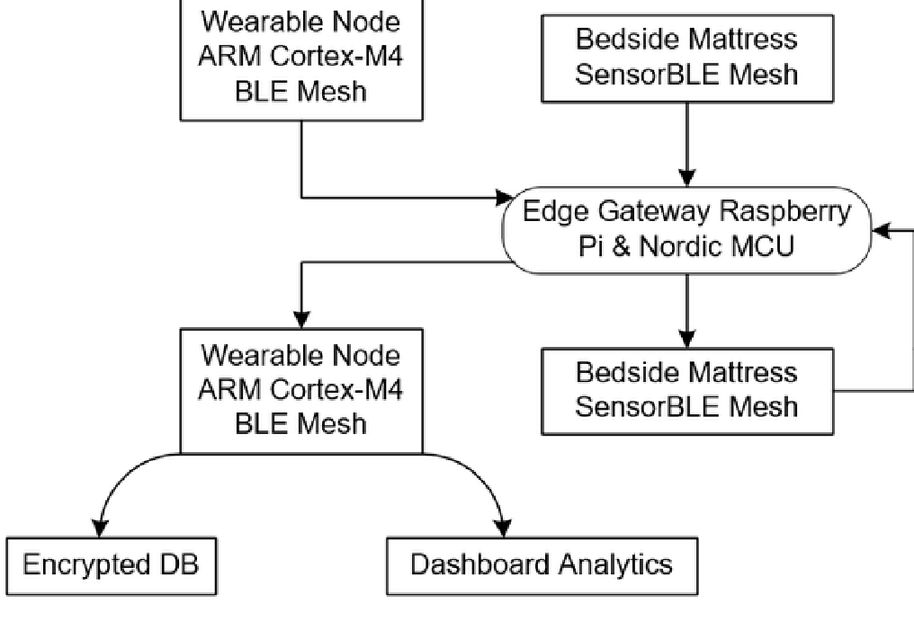
Note. BLE:Bluetooth Low Energy, ARM: ARM Holdings, MCU:Microcontroller Unit
Table 3 summarizes the hardware configurations and processing capabilities of different node types in the system, including wearable nodes, edge gateways and cloud servers. Specifically, it lists the main frequency(MHz), memory size(MB), the number of GPU cores and the maximum number of concurrent models of each node. Wearable nodes have a main frequency of 120 MHz and 256 MB of memory, which is suitable for lightweight tasks. The edge gateway is equipped with a stronger main frequency of 1500 MHz, 4096 MB of memory and 128 GPU cores, which supports up to 8concurrent models and is suitable for intermediate data processing tasks. The cloud server, on the other hand, has a main frequency of 3000 MHz, 65536 MB of memory and 3584 GPU cores, and can handle up to 100 concurrent models, which is specially designed for high-load data analysis and storage. These hardware specifications reflect the design concept of allocating resources according to node roles, aiming at optimizing the performance and efficiency of the health monitoring system.
Table 3. Hardware Capability-Load Matrix
Node category | Main frequency(MHz) | Memory(MB) | GPU core number | Maximum concurrency model
Wearable node | 120 | 256 | 0 | 1
Edge gateway | 1 500 | 4 096 | 128 | 8
Cloud server | 3 000 | 65 536 | 3 584 | 100
Different from the conventional “first-come, first-served service,” we delimit the upper limits of Central Processing Unit, GPU and memory for different model instances according to the hardware capacity load matrix listed in Table 3. Then, combined with Kuberneteslite scheduler, block batch reasoning and streaming alarm are split into heterogeneous cores. The experimental results show that the layout can still maintain the reasoning throughput of 30 FPS during peak hours and stabilize the return delay within 200 milliseconds. At the same time, the gateway will subscribe to the energy consumption threshold issued by the cloud in real time. Once the algorithm upgrade leads to a surge in power consumption, it will trigger a “downshift” strategy: the edge side switches back to the quantization model, the end side reduces the sampling rate, and the cloud side postpones non-critical training tasks. Through this closed loop, we not only realize the dynamic balance between performance and power consumption, but also maintain the continuity of alarm link in many network disconnection drills.

Lightweight Anomaly Detection Algorithm
After the hardware framework is stable, the innovation of the algorithm layer determines the ceiling of the system. The lightweight anomaly detection algorithm proposed in this paper takes“feature fusion+multi-task distillation” as the core. First, edge nodes extract three types of features:heart rate variability, attitude angular velocity and temperature and humidity environment mapping. Then, the multi-task encoder is used to predict the fall probability and suffocation risk at the same time, so as to improve the robustness by using the complementarity between tags. As shown in Figure4, the network main body adopts the serial-parallel mixed structure of 1Dimensional-Convolutional Neural Network and TinyGRU, and the channel attention module is inserted across layers to strengthen the sparse sensitive dimension. To make the model land in MCU, we replace the standard convolution with the deep separable convolution product, and compress the parameter quantity to one twelfth of the original structure through network pruning, which greatly reduces the storage requirement while maintaining the time sequence memory ability.
In the actual reasoning process, the algorithm will dynamically switch the accuracy according to the remaining power of the edge device: when the battery is higher than the threshold, the complete model will be enabled, and only GRU branches will be reserved, and quantitative reasoning will be started in the low power state. Comparative experiments show that the hybrid precision strategy can reduce the average power consumption while maintaining the detection sensitivity. With the help of the periodic aggregation of federal learning, the cloud teacher model not only keeps privacy, but also integrates the network with richer crowd characteristics. Nevertheless, extreme noise may still induce false positives, and we are exploring interpretable methods to visualize the contribution of local features to help nurses quickly verify the cause of alarm.

Figure 4. Multi-Model Receiver Operating Characteristic and Precision-Recall Curves
Prototype vs Baseline Model Performance
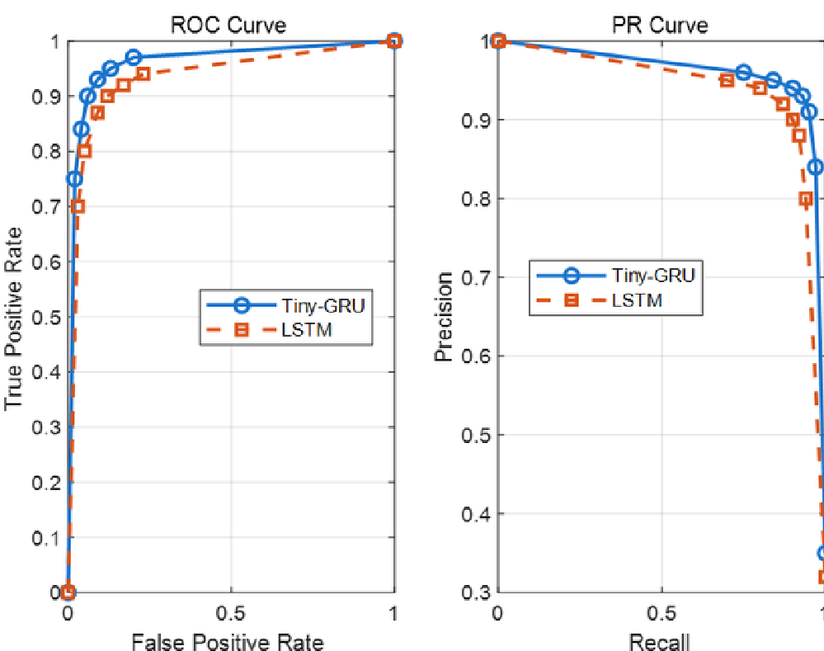
Note. GRU= Gated Recurrent Unit; LSTM= Long Short-Term Memory; ROC= Receiver Operating Characteristic; PR= Precision-Recall.

Experimental Results and Performance Evaluation
To verify the comprehensive performance of the system in the real environment, we cooperated with a large-scale old-age care institution and selected a total of 45 beds in a two-story nursing area for a one-month controlled experiment. During this period, the prototype and the control system jointly monitored and recorded all alarm events and collected node power consumption and network quality indicators. As shown in the columnar comparison of energy consumption shown in Figure5, the end, edge, and cloud devices all show obvious power consumption advantages under various workloads, especially in the long-term rest stage at night when the gateway power consumption is only about half of that of the control scheme. To evaluate the system’s ability to capture rare events, we also conducted three artificial simulation falls and one power failure test without warning. All the scenes were accurately identified and triggered the local acousto-optic alarm. The difference between the event stamp recorded in the cloud and the actual situation on the ground was less than 0.3 seconds, which further confirmed the reliability of the collaborative architecture under extreme conditions.
Figure 5. Comparison of End/Edge/Cloud Power Consumption
Energy Consumption under ldle /Mixed/Peak Loads
1400r
->EcovaE3二coLozod—1200
Base-ldle
1000
Base-Mixed
Base-Peak
Proto-ldle
800 Proto- Mixed
Proto-Peak
600
400
200
0
Wearable Edge Cloud
Table 4 further lists the multi-dimensional indicators such as accuracy, recall rate, average time delay and nursing confirmation time.
Table 4. Comparison Table of Multidimensional Indicators
System | Accuracy(%) | Recall rate(%) | Average delay(ms) | Nursing confirmation time(s)
Plan A | 95.0 | 94.5 | 450 | 18
Plan B | 93.5 | 92.0 | 230 | 17
Plan C | 88.5 | 84.0 | 180 | 25
This paper’ model | 96.4 | 95.8 | 190 | 12
Table 4 shows the performance comparison between the system proposed in this paper and three control schemes(Plan A, B and C) in multiple dimensions, including accuracy, recall rate, average delay, and nursing confirmation time. Specifically, the accuracy and recall rate of this model reached96.4% and 95.8% respectively, which is better than the other three schemes. The average delay is 190milliseconds, which is slightly higher than some control schemes, but still within a reasonable range. It is particularly worth mentioning that the nursing confirmation time is shortened to 12 seconds, which is about one-third less than other schemes, greatly improving the response efficiency.
The data show that the system in this paper breaks through the existing scheme in accuracy and recall and shortens the alarm confirmation time by nearly one third. Because the number of false positives dropped sharply, the score for “annoyance” in the questionnaire of nursing staff decreased by two grades. At the same time, the long-term operation of the system also reveals some room for improvement. First, under the interference of large-scale Wi-Fi, thread fallback logic occasionally causes second-order delay. Secondly, the atypical body movement pattern caused by psychological anxiety is still easy to be misjudged as falling.

DISCUSSIONS
This study systematically verifies the feasibility of end-to-end cloud collaboration in the elderly care scene. The experimental results show that architecture not only compresses the data return link but also realizes the dynamic convergence of energy consumption without sacrificing the recognition sensitivity. At the same time, the lightweight anomaly detection algorithm, driven by multi-modal data, shows a robust time series insight, which is particularly prominent at night. The subjective feedback of nurses on the system “reducing the sense of concentration caused by false positives” highlights the importance of paying equal attention to technological innovation and humanistic care. However, in-depth interviews also revealed several shortcomings that cannot be ignored: First, edge nodes will still experience second-order delay when encountering large-scale Wi-Fi interference, indicating that the existing disaster-tolerant links need to be strengthened. In this paper, it is suggested that Long Range Wide Area Network can be added as a backup link in future research to enhance the network disaster tolerance of the system and ensure that basic services can be maintained even if the network is interrupted.
Secondly, the frequent misjudgment of atypical body movement patterns caused by psychological stress suggests that relying solely on physiological signals cannot completely cover the emotional dimension. Therefore, it is suggested to integrate the emotion recognition model in the follow-up work to understand the behavior intention of the elderly more accurately and reduce the false alarm caused by emotional fluctuation.
Thirdly, the feedback on skin irritation caused by long-term wearing has not yet formed a quantitative index. It is suggested that doctors and nursing staff should conduct joint evaluations to develop more humanized and comfortable wearable equipment materials and technologies to enhance user experience.
Fourthly, using high-end hardware such as GPU-accelerated lightweight reasoning engines may significantly increase the cost of the system, which may be a major burden for old-age care institutions with limited resources or poor economic conditions. In order to reduce the system cost and make it more suitable for old-age care institutions with limited resources or poor economic conditions, we can reduce the dependence on high-performance hardware by optimizing algorithms and model compression, replace expensive special hardware with edge computing devices with high cost performance, and reduce the development cost with the help of open source technology and community support. At the same time, it is suggested to adopt a phased implementation strategy, beginning with basic allocation, and gradually upgrading with the improvement of the capital situation, and seeking cooperation and funding from the government and non-profit organizations.
In addition, although privacy protection measures such as XOR encryption and salt hash have been proposed, there may still be security loopholes in practical applications with increased system complexity and frequent data interaction. To further improve security, we should introduce more advanced encryption technology(homomorphic encryption), implement strict access control, conduct regular security audits, and explore emerging technologies such as blockchain to enhance data traceability and tamper resistance. At the same time, establishing a perfect emergency response mechanism and strengthening the training of users’ safety awareness will also help to build a more credible and robust intelligent pension system, thus comprehensively reducing privacy leakage and other security risks.
Finally, the generalization performance in cross-cultural scenes remains to be verified, and different living habits and circadian rhythms may have an impact on the threshold strategy. In the future, multi-center joint debugging should be carried out around the world to test the universality of the model in different cultural backgrounds and adjust the threshold strategy according to the feedback to ensure the effective application of the technology around the world.
These findings are instructive for future work. Based on the current research, we can explore the future directions of enhancing network flexibility and disaster recovery capability, integrating emotion recognition to achieve personalized health management, improving distributed learning and privacy protection technology, optimizing user experience and humanized design, and improving the sustainable development and environmental adaptability of the system. By integrating LoRaWAN to improve communication reliability, monitoring the emotional state of the elderly by using multimodal data fusion, ensuring data privacy by using technologies such as homomorphic encryption, improving the comfort of wearable devices by using flexible materials, and adjusting system parameters to adapt to different cultural and environmental conditions, the aim is to build a more intelligent and humanized pension ecosystem, which not only makes up for the shortcomings of the existing technology, but also provides a theoretical and practical basis for future innovation. Such a comprehensive exploration will greatly expand the application scope and service depth of intelligent pension technology and promote its development in a more inclusive and flexible direction.

CONCLUSION
Focusing on the continuous monitoring needs of elderly care, this paper proposes and implements an IoT platform that integrates wearable perception, edge intelligence and cloud collaboration. By redefining the responsibilities of the end-side cloud, designing a zero-copy protocol stack and implementing an adaptive energy management strategy, the prototype system realized the second-level closed loop of the alarm link in the trial operation of the real nursing home, and effectively reduced the node power consumption. The TinyGRU model based on feature fusion and multi-task distillation maintains a high recall rate on resource-limited MCU, which verifies the feasibility of lightweight algorithms and hardware collaboration. Chart data and nurses’ feedback prove that this research scheme has achieved a balance between accuracy, real-time performance and man-machine experience, which provides a reliable technical base for intelligent old-age care.
The completion of this work not only provides an engineering example for the domestic aging challenge but also injects new impetus into the interdisciplinary integration of the IoT and digital health. Although the system has shown advantages in energy consumption and false alarm rates, there is still room for improvement in network disaster tolerance, emotion recognition, and long-term wearing comfort. Future research will be carried out in three phases. First, joint multi-agency deployment will be used to test the cross-cultural generalization ability of the model. Second, the introduction of LoRaWAN and edge trusted execution environment will be used to further enhance security and flexibility. Thirdly, multi-modal emotional signals and flexible material technology will be integrated to improve humanistic care. The results of this paper have laid a solid starting point for the large-scale application of smart nursing and outlined the evolution path worth looking forward to for the future of smart medical ecology.

FUNDING STATEMENT
This research received no specific grant from any funding agency in the public, commercial, or not-for-profit sectors. Funding for this research was covered by the author of the article.

COMPETING INTERESTS STATEMENT
The author of this publication declares there are no competing interests.

PROCESS DATES
06, 2025
Received: 04/24/2025, Revision: 05/13/2025, Accepted: 05/21/2025

CORRESPONDING AUTHOR
Correspondence should be addressed to Fenfang Liao; fang29000@ 163.com

ACKNOWLEDGEMENTS
The author would like to show sincere thanks to those techniques who have contributed to this research.

International Journal of Healthcare Information Systems and Informatics
Volume 20 • Issue 1 • January-December 2025

REFERENCES
Awan, R.(2023). Seamless connectivity: Investigating implementation challenges of multibroker MQTT platf orm f or smart environmental monitoring[Master’s Thesis, University of OULU] https:// urn.fi/ URN: NBN: fi: oulu-202306302808
Chen, Y. J.,& Lin, E. C.(2022). Design and implementation of hardware and peripheral system for IoT gateway. In Proceedings of the 2022 8th International Conf erence on Computer Technology Applications(pp. 268–274). DOI: 10.1145/3543712.3543740
Ghori, M. R., Wan, T. C.,& Sodhy, G. C.(2020). Bluetooth low energy mesh networks: Survey of communication and security protocols. Sensors(Basel), 20(12), 3590. DOI: 10.3390/s20123590 PMID: 32630381
Hosseinzadeh, M., Koohpayehzadeh, J., Ghafour, M. Y., Ahmed, A. M., Asghari, P., Souri, A., Pourasghari, H.,& Rezapour, A.(2023). An elderly health monitoring system based on biological and behavioral indicators in internet of things. Journal of Ambient Intelligence and Humanized Computing, 14(5), 5085–5095. DOI:10.1007/s12652-020-02579-7
Isa, I. G. T., Ammarullah, M. I., Efendi, A., Nugroho, Y. S., Nasrullah, H.,& Sari, M. P.(2024). Constructing an elderly health monitoring system using fuzzy rules and Internet of Things. AIP Advances, 14(5), 055317. DOI: 10.1063/5.0195107
Joshua, T.(2023). A secure model for student results verification using salted hash functions.(Doctoral dissertation, Kampala International University).
Khan, M. A., Asad, B., Vaimann, T., Kallaste, A., Pomarnacki, R.,& Hyunh, V. K.(2023). Improved fault classification and localization in power transmission networks using VAE-generated synthetic data and machine learning algorithms. Machines(Basel), 11(10), 963. DOI: 10.3390/machines11100963
Khriji, S., Benbelgacem, Y., Chéour, R., Houssaini, D. E.,& Kanoun, O.(2022). Design and implementation of a cloud-based event-driven architecture for real-time data processing in wireless sensor networks. The Journal of Supercomputing, 78(3), 3374–3401. DOI: 10.1007/s11227-021-03955-6
Krzywdzinski, M., Evers, M.,& Gerber, C.(2024). Control and flexibility: The use of wearable devices in capital-and labor-intensive work processes. Industrial& Labor Relations Review, 77(4), 506–534. DOI:10.1177/00197939241258206
Mohammed, M. N., Desyansah, S. F., Al-Zubaidi, S.,& Yusuf, E.(2020). An internet of things-based smart homes and healthcare monitoring and management system. Journal of Physics: Conf erence Series, 1450(1),012079. DOI: 10.1088/1742-6596/1450/1/012079
Morales-Caporal, R., Reyes-Galaviz, A. S., Casco-Vásquez, J. F.,& Martínez-Hernández, H. P.(2020). Development and implementation of a relay switch based on Wi-Fi technology. In 17th International Conf erence on Electrical Engineering, Computing Science and Automatic Control(pp. 1–6). IEEE. DOI: 10.1109/CCE50788.2020.9299142
Nag, A., Hassan, M. M., Das, A., Sinha, A., Chand, N., Kar, A., Sharma, V.,& Alkhayyat, A.(2024). Exploring the applications and security threats of internet of thing in the cloud computing paradigm: A comprehensive study on the cloud of things. Transactions on Emerging Telecommunications Technologies, 35(4), e4897. DOI:10.1002/ett.4897
Olaisen, M. H., Onsager, L. F. S., Rundereim, N.,& Tønnesen, J. H.(2023). Cellular IoT Asset Tracker(Bachelor’s thesis, NTNU). DOI: 10.1136/bmj.f5880
Pandey, A.,& Azcarreta, J.(2025). Ultra low-compute complex spectral masking for multichannel speech enhancement. ICASSP 2025-2025 IEEE International Conf erence on Acoustics, Speech and Signal Processing,1–5. DOI: 10.1109/ICASSP49660.2025.10890512
Qi, P., Chiaro, D., Guzzo, A., Ianni, M., Fortino, G.,& Piccialli, F.(2024). Model aggregation techniques in federated learning: A comprehensive survey. Future Generation Computer Systems, 150, 272–293. DOI:10.1016/j.future.2023.09.008
Ray, P. P., Dash, D.,& Kumar, N.(2020). Sensors for internet of medical things: State-of-the-art, security and privacy issues, challenges and future directions. Computer Communications, 160, 111–131. DOI: 10.1016/j. comcom.2020.05.029
Salem, M., Elkaseer, A., El-Maddah, I. A., Youssef, K. Y., Scholz, S. G.,& Mohamed, H. K.(2022). Non-invasive data acquisition and IoT solution for human vital signs monitoring: Applications, limitations and future prospects. Sensors(Basel), 22(17), 6625. DOI: 10.3390/s22176625 PMID: 36081081
Tang, V., Choy, K. L., Ho, G. T., Lam, H. Y.,& Tsang, Y. P.(2019). An IoMT-based geriatric care management system for achieving smart health in nursing homes. Industrial Management& Data Systems, 119(8), 1819–1840. DOI: 10.1108/IMDS-01-2019-0024
Wang, F., Zhang, M., Wang, X., Ma, X.,& Liu, J.(2020). Deep learning for edge computing applications: A state-of-the-art survey. IEEE Access: Practical Innovations, Open Solutions, 8, 58322–58336. DOI: 10.1109/ACCESS.2020.2982411
Wang, H., Chen, H.,& Wang, Y.(2024). Analysis of hot topics regarding global smart elderly care research—1997–2021. China CDC Weekly, 6(9), 157–161. DOI: 10.46234/ccdcw2024.032 PMID: 38495592
Wang, Q.(2022). Computer internet of things-based intelligent medical system to be applied in home care of senile dementia patients. Wireless Communications and Mobile Computing, 2022(1), 1374835. DOI:10.1155/2022/1374835
Yang, C., Wang, W., Li, F.,& Yang, D.(2022). A sustainable, interactive elderly healthcare system for nursing homes: An interdisciplinary design. Sustainability(Basel), 14(7), 4204. DOI: 10.3390/su14074204
Zhang, A.(2024). Prospective analysis and innovative path research on silver sports economy in the context of aging society. Journal of Ecohumanism, 3(6), 1391–1411. DOI: 10.62754/joe.v3i6.4120
Zunino, C., Cena, G., Scanzio, S.,& Valenzano, A.(2023). Adaptive seamless redundancy to achieve highly dependable mqtt communication. IEEE Transactions on Industrial Inf ormatics, 20(1), 984–994. DOI: 10.1109/TII.2023.3271708

