CraneLock
CSC3104 Project Proposal | Group 20
A Fault-Tolerant Distributed Coordination System for Automated Yard Cranes

1. Introduction and Motivation
Automated container terminals coordinate cranes, vehicles, and storage operations under strict interference and safety constraints. Singapore provides a relevant motivation: PSA Singapore (n.d.) describes Tuas Port as the world's largest fully automated container terminal and plans an annual capacity of 65 million TEUs when it is completed in the 2040s. Public information confirms extensive automation, but it does not establish the internal failure architecture of PSA's control systems. CraneLock therefore studies a realistic, simulated scenario rather than claiming that a specific operational port has a known vulnerability.
In the scenario, several automated yard cranes share a narrow lane. A central controller normally schedules access. If the controller or its link to a yard block becomes unavailable, stopping all cranes is safe but reduces throughput, while acting on stale permissions can create conflicting access decisions. CraneLock investigates whether local agents can preserve limited safe progress during an outage without replacing the optimizer or the physical safety system. Recovery must also happen quickly enough to avoid unnecessarily disrupting crane operations, making coordination and recovery latency an important requirement of the proposed system.

2. Problem Statement and Research Question
A digital token represents authority to request entry to the shared lane. Only the current token holder may obtain an access grant; other agents wait for the token. Two failures are central. First, a crash while holding the token can block a basic token protocol indefinitely. Second, an isolated but still-running holder can be mistaken for a crashed process. If the remaining agents create a replacement token, both sides may believe they hold valid authority. A higher version number alone is insufficient because the isolated holder may continue issuing old commands.
Research question: Under stated crash and network assumptions, can CraneLock preserve exclusive lane access while reducing recovery latency compared with a basic token protocol, and how do latency, throughput and coordination overhead change as the number of crane agents and lane-access requests increases?
The model assumes that all agents are authenticated and follow the protocol. Agents may stop or become temporarily disconnected, but they do not act maliciously. The set of agents remains fixed during each experiment, and delayed messages are eventually delivered after the network recovers. Replacing a lost token requires a reachable majority of agents. A trusted simulated gate rejects any request it cannot verify. The system may stop making progress when no majority can communicate or when the lane’s occupancy is unknown.

3. State of the Art and Research Gap
Existing crane research primarily optimizes task allocation, routing and completion time while respecting interference. Nossack et al. (2018) formulate conflict-free dispatching and routing for two rail-mounted gantry cranes, while Zhang et al. (2024) jointly optimize automated guided vehicles and double yard cranes. These studies establish operational constraints, but their main objective is efficient scheduling rather than distributed recovery after loss of an upstream coordinator.
Distributed mutual-exclusion research supplies a second foundation. Raymond's (1989) tree-based algorithm routes a unique token efficiently, but loss or isolation of the holder requires additional recovery logic. Production coordination systems such as ZooKeeper provide ordered, replicated state for locks and membership (Hunt et al., 2010). Chubby uses leases and sequencers to reject stale lock holders (Burrows, 2006), while Raft uses majority agreement to maintain one committed history (Ongaro & Ousterhout, 2014). Kubernetes Leases apply related time-bound coordination concepts to node heartbeats and leader elections (Kubernetes, n.d.).
The gap lies at their intersection: existing crane studies optimize normal operations, while distributed locks recover software coordination state. Neither evaluates a crane-specific fallback that must distinguish valid digital permission from confirmed physical lane clearance. CraneLock will experimentally evaluate token handoff, quorum recovery, fencing and occupancy checks; a broader review will precede any world-first claim.

4. Proposed Original Contribution
CraneLock’s contribution does not lie in introducing a new mutual-exclusion primitive. Instead, it adapts and integrates established distributed-coordination mechanisms into a fault-recovery protocol for shared crane lanes. The protocol combines four mechanisms: a majority of agents approve recovery using a new epoch; the gate rejects permissions from old token holders; the system confirms that the lane is physically clear before allowing recovery; and agents switch safely between central and local coordination. The evaluation will determine whether these mechanisms jointly preserve exclusive access and reduce recovery delay, while measuring how long the system cannot issue new permissions when a quorum or physical clearance cannot be established. The project’s originality therefore lies in its crane-specific protocol design and systematic experimental evaluation, rather than in any individual mechanism.

5. Proposed System and Cloud-Native Implementation
The prototype will initially simulate three to five crane agents competing for one shared lane for functional validation and detailed failure-recovery experiments. Scalability experiments will then increase the number of simulated crane agents and the rate of lane-access requests, subject to available computing resources. Larger-scale experiments may use lightweight logical crane agents rather than a separate Kubernetes container for every simulated crane. This will allow us to evaluate how latency, throughput and coordination overhead change as the workload and number of participants increase.
In normal mode, the controller schedules access, and the gate validates each permission. During a simulated controller outage, agents enter local mode using an agreed control epoch. The current token holder may request a time-bound lane grant. If the holder stops responding, agents exchange recovery proposals and a strict majority must sign a certificate for epoch e + 1. An epoch number alone cannot silence an isolated old holder, so the gate stores the highest accepted epoch and authorized holder, then rejects older epochs, unauthorized holders and expired grants. A minority therefore cannot create permission that the gate accepts.
Token recovery does not imply that the lane is empty. If the previous holder's last confirmed state indicates possible occupancy, the gate marks the lane unknown occupied and refuses a replacement entry until a position update or simulated operator clearance is received. When the controller returns, it first reconciles the active epoch, token holder, queue, and lane state before agents leave local mode.
Every component will be packaged in Docker. Kubernetes will deploy stable crane identities with persistent vote state, controller and gate services, service discovery, experiment configuration and readiness and liveness probes. Prometheus-compatible metrics and structured event logs will support repeatable evaluation. Kubernetes restarts containers; CraneLock remains responsible for restoring correct protocol state.
The failure injector will independently simulate controller failure, crane-agent failure, token-holder failure, communication loss, gate unavailability and loss of lane-occupancy updates so that the effect of individual safety-relevant component failures can be evaluated.

6. Evaluation Plan
Three systems will be compared under identical workloads: a central lock service, a basic token protocol without holder-failure recovery, and CraneLock. Experiments will cover normal contention, controller outage, token-holder crash before entry, crash or disconnection during occupancy, delayed and reordered messages, agent restart, gate unavailability and network partitions. Each experiment will be repeated with deterministic seeds and retained event traces.
Experiments will also vary the number of simulated crane agents, request arrival rate and communication delay to evaluate scalability under increasing contention. Detailed failure experiments will begin with three to five containerised cranes, while larger numbers of logical crane agents and higher request rates will be used for performance and scalability testing.
Primary measures are conflicting accepted entries, end-to-end access latency, failure-detection time, recovery latency, request waiting time, completed lane uses per minute, fairness, time stopped for safety, messages per successful entry and availability under each failure condition. Mean and percentile latency will be recorded to identify whether occasional long coordination delays occur under load. The safety target is zero conflicting accepted entries within the stated model.
Automated checks in the simulator will detect duplicate valid tokens, conflicting grants and acceptance of stale epochs. Results will show both where CraneLock improves recovery and where quorum or physical-clearance requirements deliberately sacrifice availability to preserve safety.

7. Feasibility and Expected Outcome
The scope is limited to simulated cranes, fixed membership and one shared lane. The six-member team will divide work across the protocol, simulator, Kubernetes deployment, testing and evaluation. Development will proceed from the simulator and two baselines to recovery, fencing, deployment, failure injection, latency and scalability experiments. The project excludes real cranes, terminal-wide scheduling, machine learning and industrial safety certification. The expected outcome is a reproducible cloud-native prototype demonstrating CraneLock’s safety, recovery latency, scalability and availability trade-offs.

CraneLock — Group 20 Workload Plan
Roles

Member 1 — Crane agent: normal operation
- Token handoff, request queue, heartbeats and failure detection
- Switching between central and local mode
- Persistent vote/token state; a restarted agent reconciles the current epoch before rejoining
- Owns the shared gRPC/proto definitions everyone builds against
- Writing: System Design (agent and token flow), Implementation (concurrency inside the agent)

Member 2 — Recovery and quorum
- Recovery proposals and the strict-majority certificate for epoch e+1, including signing (HMAC or Ed25519 from a library, no hand-rolled crypto)
- Partition behaviour, so only a majority side can recover
- Writing: the safety argument for why a minority or an old holder can never get an accepted grant — the core of the originality claim

Member 3 — Trusted Access Gate (Max)
- Certificate verification; storing the highest accepted epoch and holder
- Fencing stale epochs, unauthorised holders and expired time-bound grants
- The unknown/occupied lane state and fail-closed behaviour
- Writing: Design and Implementation sections on the gate, fencing and occupancy

Member 4 — Simulator and evaluation
- Shared lane/yard simulator and workload generator
- Automated safety checker for duplicate valid tokens, conflicting grants and accepted stale epochs
- Lightweight logical agents for scalability runs
- Experiment runner with deterministic seeds, CSV export and all graphs
- Writing: the whole Evaluation section

Member 5 — Controller and baselines
- Central controller simulator
- Centralised-lock baseline and basic-token baseline (reuses Member 1's token code with recovery switched off)
- Controller-return reconciliation of epoch, holder, queue and lane state
- Writing: Abstract, Introduction, Related Work, references, and editing the final video

Member 6 — Platform and failure injection
- Dockerfiles, StatefulSet with persistent volumes, Services, ConfigMaps, probes, Helm chart or Kustomize
- Prometheus and Grafana setup; structured event-log format
- Failure injector: controller crash, agent crash, partition, delay/reorder, gate unavailability, lost occupancy updates
- Integration lead who keeps main deployable
- Writing: deployment part of Implementation, plus the full GROUPNN_INSTRUCTIONS.pdf

Load balance
Member | Engineering (pts) | Writing/deliverables (pts) | Total (pts) | Buddy
1 Agent | 8 | 2 | 10 | Member 5 helps
2 Recovery | 8 | 2 | 10 | Member 4 helps
3 Gate (Max) | 7 | 3 | 10 | Member 6 helps
4 Sim + eval | 6 | 4 | 10 | Supports Member 2
5 Controller + baselines | 5 | 5 | 10 | Supports Member 1
6 Platform + chaos | 7 | 3 | 10 | Supports Member 3

References
Burrows, M. (2006). The Chubby lock service for loosely-coupled distributed systems. In Proceedings of the 7th USENIX Symposium on Operating Systems Design and Implementation (pp. 335–350). USENIX Association. https://research.google.com/archive/chubby-osdi06.pdf
Hunt, P., Konar, M., Junqueira, F. P., & Reed, B. (2010). ZooKeeper: Wait-free coordination for Internet-scale systems. In Proceedings of the 2010 USENIX Annual Technical Conference. USENIX Association. https://www.usenix.org/legacy/event/atc10/tech/full_papers/Hunt.pdf
Kubernetes. (n.d.). Leases. Retrieved September 20, 2026, from https://kubernetes.io/docs/concepts/architecture/leases/
Nossack, J., Briskorn, D., & Pesch, E. (2018). Container dispatching and conflict-free yard crane routing in an automated container terminal. Transportation Science, 52(5), 1059–1076. https://doi.org/10.1287/trsc.2017.0811
Ongaro, D., & Ousterhout, J. (2014). In search of an understandable consensus algorithm. In Proceedings of the 2014 USENIX Annual Technical Conference (pp. 305–319). USENIX Association. https://www.usenix.org/conference/atc14/technical-sessions/presentation/ongaro
PSA Singapore. (n.d.). Port—Tuas Port. Retrieved September 20, 2026, from https://www.singaporepsa.com/our-business/port/
Raymond, K. (1989). A tree-based algorithm for distributed mutual exclusion. ACM Transactions on Computer Systems, 7(1), 61–77. https://doi.org/10.1145/58564.59295
Zhang, X., Li, H., & Sheu, J.-B. (2024). Integrated scheduling optimization of AGV and double yard cranes in automated container terminals. Transportation Research Part B: Methodological, 179, Article 102871. https://doi.org/10.1016/j.trb.2023.102871

Appendix A: System Architecture and Recovery Protocol

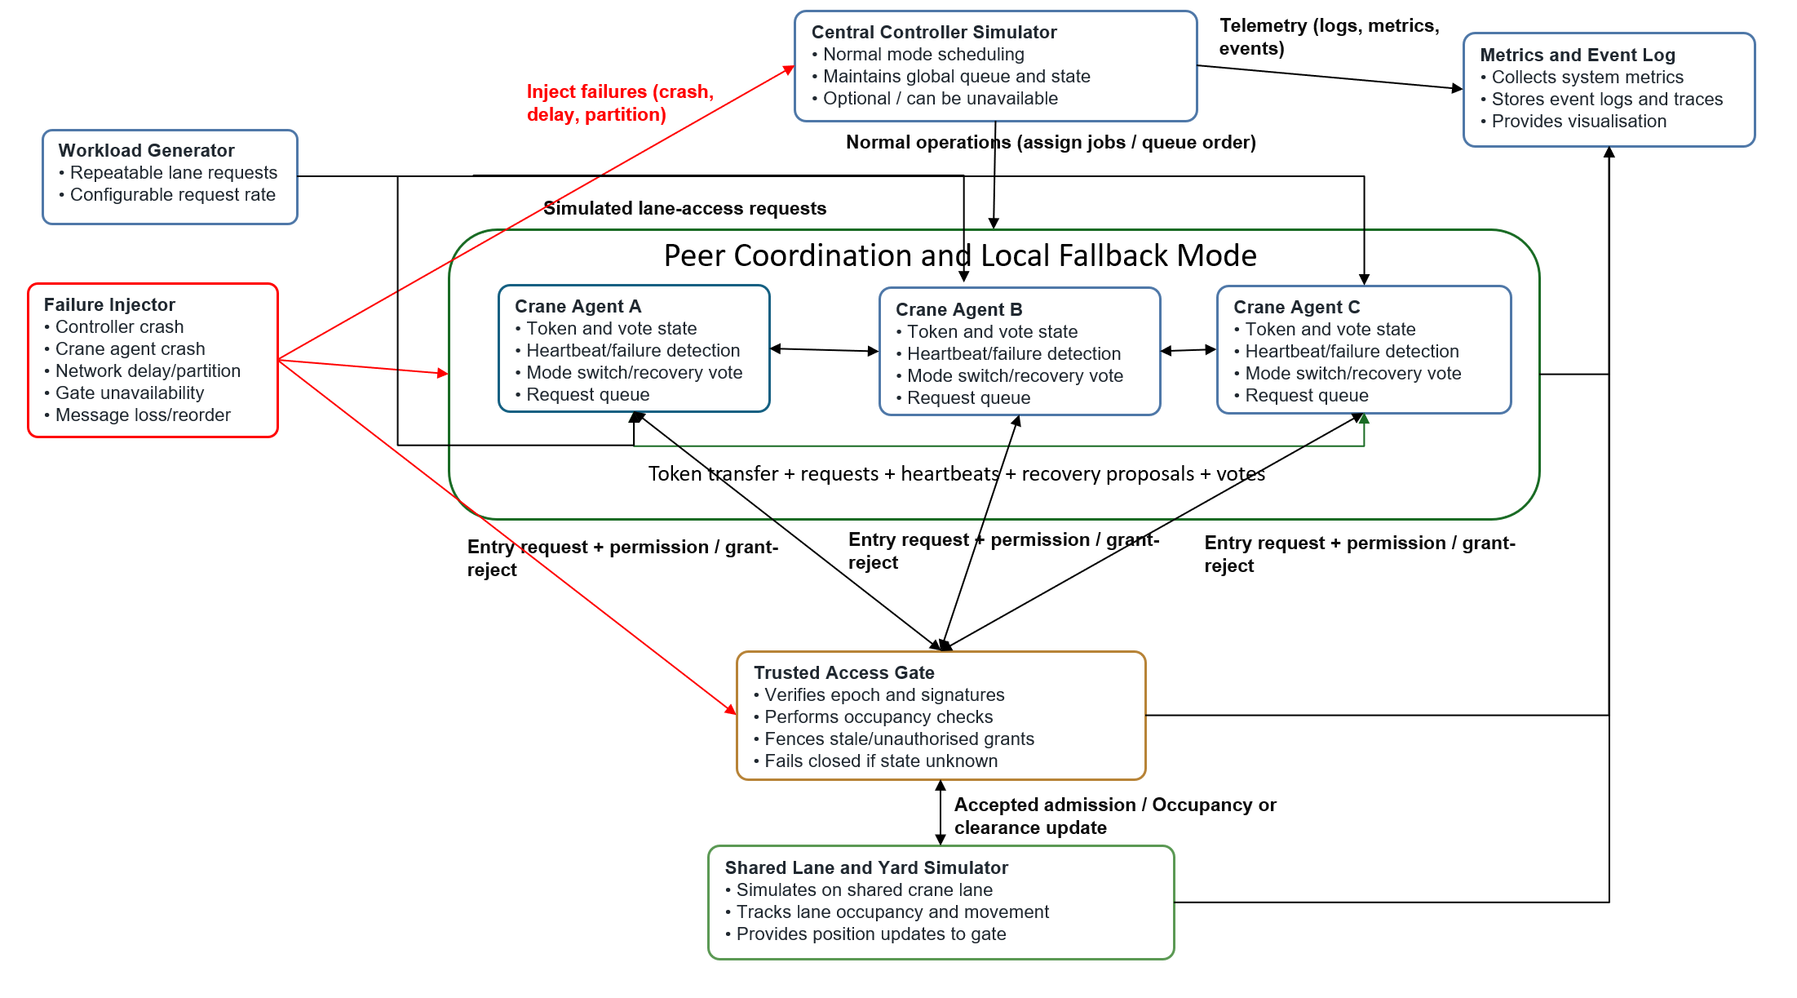
Figure A1: Proposed CraneLock prototype architecture

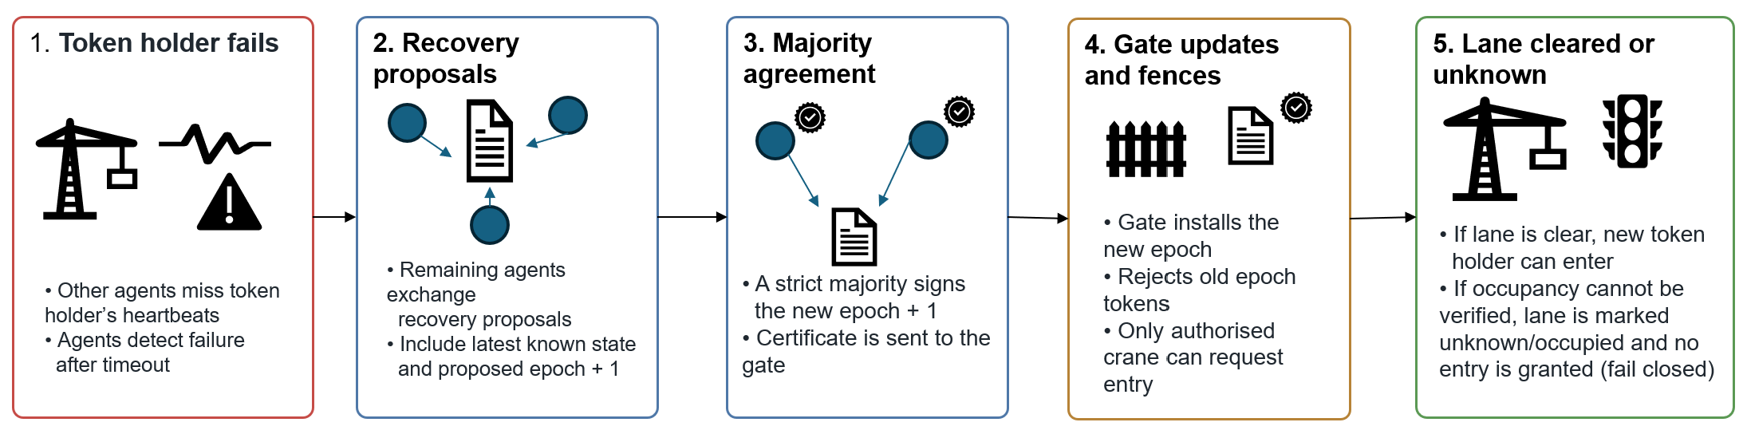Figure A2: Token-loss recovery sequence

Appendix B: Experimental Design

B1: Baselines and Test Scenarios
System or scenario | Purpose | Expected observation
Centralized lock baseline | Measure normal coordination when the central controller manages all lane access. | Coordination is predictable during normal operation. If the controller becomes unavailable, no new access is granted until it recovers.
Basic token baseline | Measure decentralized token passing without holder-failure recovery, fencing, or quorum-based regeneration. | The system can operate without a central controller, but progress may stop if the token holder crashes or becomes disconnected.
CraneLock normal operation | Establish CraneLock behaviour under healthy conditions and provide a reference for performance comparisons. | Access is granted without conflicting permissions, while maintaining reasonable latency, throughput and fairness.
Controller failure | Evaluate the transition from centralized operation to CraneLock local coordination. | Crane agents detect controller loss and switch to local coordination without accepting conflicting permissions.
Token-holder failure before entry | Test recovery when the current token holder fails before entering the lane. | A reachable majority establishes a higher epoch and authorizes a replacement holder. Permissions from the previous epoch are rejected.
Disconnection while occupying the lane | Determine whether CraneLock distinguishes loss of communication from confirmed physical lane clearance. | The lane remains unavailable until occupancy or clearance is confirmed. Network disconnection alone is not treated as proof that the lane is safe.
Crane-agent failure and restart | Test whether a crashed crane agent can restart without reusing stale coordination state or invalid permissions. | The restarted agent reconciles the current epoch and token state before participating again.
Network partition | Evaluate behaviour when crane agents are divided into disconnected groups. | Only a group with a reachable strict majority can establish a new epoch. Stale or minority-issued permissions are rejected by the gate.
Delayed or reordered messages | Test whether old coordination messages can incorrectly change the current state. | Delayed messages containing stale epochs or grants are rejected and do not create conflicting access permissions.
Gate unavailability | Evaluate behaviour when the trusted access gate cannot verify permissions. | The system fails closed and no new crane is admitted until permission verification becomes available again. Safety is preserved at the cost of availability.
Controller recovery | Test the transition from degraded or local operation back to normal controller-managed operation. | The controller reconciles the latest state before issuing new permissions. Conflicting or stale permissions are not accepted.
Increasing number of crane agents | Evaluate scalability as the number of simulated participants increases. | Safety should remain unchanged, while latency, throughput and protocol overhead may vary as contention increases.
Increasing request rate | Evaluate performance when lane-access demand increases. | Higher contention may increase waiting time and coordination latency, allowing the practical limits of the system to be measured.

B2: Measures and Success Criteria
Measure | Definition | Success criterion or interpretation
Safety violations | Number of cases where conflicting lane-entry permissions are accepted simultaneously. | Must remain zero under the stated fault model.
End-to-end access latency | Time from a crane requesting lane access until the gate accepts its entry permission. | Lower latency indicates better responsiveness. Mean and percentile values should be reported.
Failure-detection latency | Time between a component becoming unavailable and the remaining system detecting the failure. | Lower detection latency allows recovery to begin sooner, provided false failure detections are avoided.
Recovery latency | Time between failure detection and the next safe lane-entry permission being accepted. | Lower recovery latency is preferred provided safety remains unchanged.
Throughput | Number of successfully completed lane uses per unit of simulated time. | Higher throughput indicates better operational progress, particularly during degraded operation.
Waiting time | Time from requesting access until entering the lane. | Mean and 95th-percentile waiting time will show both typical and high-delay behaviour.
Availability | Proportion of experiment time during which valid new lane-entry permissions can be issued. | Shows how failures, quorum requirements and fail-closed behaviour affect system availability.
Fairness | Distribution of successful permissions among crane agents and the maximum number of times a request is bypassed. | Used to identify starvation or repeated preference for particular agents.
Safety-stop duration | Total time for which the lane remains blocked because quorum, permission validity or physical occupancy cannot be confirmed. | Quantifies the availability cost of CraneLock's fail-closed safety policy.
Protocol overhead | Number of coordination messages exchanged per successful lane entry. | Lower overhead indicates more efficient coordination if safety and recovery performance remain acceptable.
Scalability | Change in latency, throughput and protocol overhead as the number of crane agents or access requests increases. | CraneLock should continue to preserve safety while showing measurable and explainable performance changes as workload increases.

