Post Earthquake Power Service Recovery in Los Angeles Linking Substation Damage Restoration Logistics and Tract Level Disparities
Resubmission reconstruction from the retained July 23, 2026 manuscript. Coauthor review copy with Stage 7 integration dated October 10, 2026. Unaffected network and restoration findings retain their frozen September 2026 scope; the descriptive four-class candidate is supplied for author review, not formal promotion.

Abstract
Earthquake damage can delay the recovery of electricity service unevenly across urban communities, yet a station repair order that benefits the system average may have different effects on vulnerable tracts. We retain a 92-station, 318-edge abstraction of the Los Angeles transmission network and map its source-connected station availability to 2,315 census tracts. In each of 1,000 physical realizations for each of four hazard fields, damage states and positive repair durations determine tasks and crew occupation; all restoration sequences share the same physical draw. A utility-compatible tract dependency proxy is compared with the submitted mapping and with public Southern California Edison circuit candidates. We decompose cumulative modeled service deficit into station self-damage, functional-threshold loss, and source-path disconnection. Under the 2%-in-50-year hazard and 57 pooled crews, the hospital-first sequence produces 34.306 h of population-weighted modeled burden, including 4.065 h (11.8%) from source-path loss. An impact-first sequence lowers aggregate burden by 0.713 h but raises the source-path component by 0.103 h. A fixed vulnerability-first rule lowers the highest-vulnerability quartile burden by 1.595 h relative to hospital-first, while raising the lowest-quartile burden by 1.269 h and increasing absolute group separation by 2.501 h. Thus targeted benefit, average recovery, and disparity do not move together. The direct community-objective genetic search did not improve its best deterministic incumbent, impact-first. Mapping and gate contrasts distinguish stable aggregate comparisons from more sensitive tract attribution. These are conditional service-availability estimates, not measured customer outages or delivered power.
Keywords: seismic damage; power system recovery; crew scheduling; source connectivity; community burden; social vulnerability; Los Angeles

1 Introduction
Electric power disruption after an earthquake is shaped by more than the count of damaged components. A damaged station can lose its own functionality, interrupt an upstream path to other stations, and affect tracts assigned to those stations through a spatial dependency model. Limited crews, travel, and repair durations then determine when those states change. These linked processes can make the same hazard produce different recovery paths across communities.
Existing studies of earthquake power recovery have advanced fragility, network connectivity, repair scheduling, and community vulnerability analysis. The retained July manuscript reviewed these streams, including community-centered recovery work by Logan and Guikema, Los Angeles earthquake risk studies, and optimization approaches to critical-service restoration. Their combination does not by itself demonstrate community benefit: an early completion objective for stations need not minimize the tract-level deficit created by source disconnection and service dependencies. Nor does a favorable vulnerability-weighted system curve reveal which groups or neighborhoods were delayed. The present comparison evaluates both mechanisms and distributional consequences within one consistent damage, repair, and service model.
Three questions organize the study. First, how do station damage and source-path connectivity propagate to spatially different tract service deficits? Second, how do scarce crews, travel, task duration, and fixed repair priorities alter system and community recovery under identical physical realizations? Third, where do long recovery burdens coincide with vulnerability, built form, economic stock, multi-hazard expected loss, and modeled grid dependency, and who benefits or loses when restoration priority changes? The network is an abstraction and tract assignments are dependency proxies. These boundaries motivate the external candidate benchmark, mapping and gate contrasts, and explicit loss decomposition rather than claims of feeder-level validation or delivered electricity.

2 Methods

2.1 Study network, hazards, and tract dependency
The retained study network contains 92 stations and 318 abstract station-to-station edges, with 14 retained Core upstream source nodes. It is the July submitted graph; no later 310-station topology or invented branch impedance/capacity enters this analysis. The four retained hazard fields are Northridge, San Fernando, Long Beach, and 2pc50. Each hazard has 1,000 independent physical evaluation realizations. Within a hazard, fixed station PGA and the retained fragility definitions determine station damage-state probabilities; realization-specific states are sampled once and shared across all strategies. The 2pc50 scenario also supplies 64 disjoint planning realizations for sequence search.
The submitted mapping uses a tract centroid, nearest eligible access station, shortest path on the retained 92-station graph, total distance, inverse-square weighting, a 0.03 minimum normalized weight cutoff, and renormalization. The revision changes candidate eligibility only: strict SCE tracts use SCE-compatible stations, strict LADWP tracts use LADWP-compatible stations, while mixed or ambiguous tracts keep general eligibility. We call the submitted mapping M0 and this production mapping M1. Both cover 2,315 tracts and 9,066,522 mapped residents. Public SCE circuits and substation names supply external candidate evidence, not customer assignment or load shares. Candidate-supported subset and no-cutoff/0.01 analyses are evaluation contrasts, not replacement production mappings.

2.2 Damage, tasks, and a single repair clock
Damage states DS0–DS4 determine both initial residual functionality and task eligibility. Only DS>0 stations enter a realization’s queue. Each damaged station receives one positive draw from its retained DS-specific repair-duration scenario; DS0 duration is zero. A strategy is a complete ex-ante 92-station order, filtered by deleting DS0 stations without reranking. A crew becomes available at t=0 at its retained yard. Each dispatch uses directed base-to-task or previous-task-to-task road travel. Arrival equals crew availability plus travel; completion equals arrival plus that task’s realized duration. The crew is released and raw station functionality is restored at that same completion event. There is no independent post-schedule continuous recovery clock. Within each physical realization, strategies share DS, durations, crews, roads, graph, sources, and mapping; only their order differs.

2.3 Source-connected availability and cumulative burden
For station i at event time t, let f_i be raw functionality, F_i indicate whether f_i is at least 0.5, and C_i indicate connectivity through functional stations to an active retained Core source. Effective availability is e_i=f_i F_i C_i. We use event-exact left-rectangle integration between distinct completion times. This binary path model does not impose MW balance, thermal ratings, voltage, dispatch, or load shedding. Dynamic source counts, path-disjointness, cuts, bridges, and articulation dependence describe redundancy of the modeled graph; they are not electrical transfer capacities.
The identity 1−e_i=(1−f_i)+f_i(1−F_i)+f_i F_i(1−C_i) separates self-damage, threshold, and source-path losses. Tract known-available mass is the M1-weighted effective station state. Let R_r be resolved candidate mass and A_r(t) the known-available mass of tract r. Its cumulative deficit is B_r=∫[R_r−A_r(t)]dt, and normalized burden is B_r/R_r when R_r>0. Full tract population weighting of normalized burdens and population-times-resolved-mass weighting of B_r are distinct estimands; both are recorded. In this 92-station formal mapping, every one of the 2,315 tracts has positive resolved mass. The same formulas retain an unresolved/NA category for less complete mappings rather than treating missing service as outage or restoration. Population T50/T80 are crossings of modeled resolved availability, not measures of equity or observed supply.

2.4 Restoration decisions and direct community search
The unconstrained trajectory provides a no-crew-competition counterfactual. Seven original fixed rules remain: hospital-first, impact-first, degree-first, closeness-first, betweenness-first, centrality-first, and random. The added vulnerability-first rule orders stations by mapped population in the pre-existing highest NRI-derived SOVI_SCORE quartile, then by total mapped population and station ID. It is explicit Q4 targeting, not an equity optimum. Its sequence is fixed before the evaluation outputs are examined.
The July genetic algorithm ranked station-level weighted early completion, with population, hospital, vulnerability, and network-importance terms and a makespan penalty. Candidate fitness did not run source-gated tract recovery; hence its score need not rank tract T80 or burden. The revised 92-station permutation algorithm retains population 100, 100 fixed generations, crossover probability 0.8, inversion mutation probability 0.2, tournament size 3, and five independent seeds 42–46. For a candidate order π, each of 64 independent 2pc50 planning realizations is fully scheduled and propagated to M1 tract availability; the fitness is minus the mean population-times-resolved-mass cumulative burden. These realizations share the fixed 2pc50 PGA field but have different damage and duration draws and do not overlap the 1,000 evaluation samples. Seven deterministic rules are scored on the same planning samples first. Best-so-far retention prevents the selected solution from falling below the best deterministic incumbent. The best incumbent was impact-first; none of the five search seeds exceeded it, so the retained direct-community sequence is exactly impact-first, not an independent GA improvement.

2.5 Community distribution and descriptive typology
The fixed NRI-derived SOVI_SCORE quartiles label Q1 lowest and Q4 highest vulnerability. For each sequence and physical realization we calculate absolute population-weighted normalized burden in each quartile, signed Q4−Q1 gap, its absolute value, population-weighted tract burden Gini, and paired tract differences relative to a named rule. Improved, near-zero, and worsened tracts use a predeclared ±1 h practical threshold on paired mean effects; unresolved tracts remain separate. This threshold is not statistical significance. Bootstrap and direction-frequency comparisons resample physical realizations, not tracts.
We describe community co-occurrence using the frozen D-model joint typology rather than using community attributes to predict additional earthquake damage. The electricity-model domain contains 2,315 tracts. We retain the existing 2,291-tract residential-typology cohort, of which 2,287 have complete primary coordinates; four tracts with unresolved geometry remain unclassified without imputation. The primary space has five analytical domains: recovery and initial service (B_480_hr and Init_Supply); mapped grid dependence (degree, algebraic-connectivity impact, betweenness, and dependency concentration HHI); built environment (classified-land entropy, roof-outline coverage, and observed pre-1970 building-area share); social vulnerability (SOVI_SCORE); and economic stock and multi-hazard loss (log1p building value and ALR_NPCTL).
The recovery coordinates come from the saved 1,000-realization 2pc50 direct-community sequence at the reference C57_D1 condition with mapping M1 and gate G1. B_480_hr is mean normalized modeled service deficit integrated over 0-480 h, in equivalent complete-service-loss hours. Init_Supply is mean initial modeled service availability, not delivered MW. T80 is reported descriptively as the 80% crossing time of the mean tract trajectory; it is not a primary coordinate or the mean of realization-specific crossing times.
Land-use entropy is derived from the archived SCAG 2019 Annual Land Use service (ALU 2019.1, updated February 2021): -sum(p_j log p_j)/log(11), with p_j the area fraction of each of 11 predeclared exclusive classified-land categories. Unknown classifications, water, gaps, and ambiguous overlaps are outside this denominator, with classified-land coverage reported separately. Building footprint coverage is the union area of archived LARIAC6 2020 roof outlines divided by tract land area; it is not floor area or impervious cover. The age coordinate uses the original LARIAC4 2014 outlines and associated assessor YearBuilt1, dividing valid observed pre-1970 outline area by all valid observed-age outline area. Missing ages are not treated as newer buildings. Mixed acquisition dates, jurisdiction-dependent outline capture, and incomplete age coverage preclude interpreting these records as a complete 2020 building-age census (SCAG, 2021; Los Angeles County, 2014, 2020).
The archived FEMA National Risk Index is version 1.19, March 2023 (FEMA, 2023). Building value is economic building-stock value in 2022 USD, not physical form, household wealth, seismic capacity, or electrical demand. ALR_NPCTL nationally ranks an expected-loss-weighted composite of consequence-specific annual-loss-rate percentiles. It is unadjusted for the Community Risk Factor but remains a multi-hazard expected-loss measure, not pure hazard or a simple total-loss/total-exposure quotient. We retain SOVI_SCORE as the separate social domain. The earlier RISK_SCORE incorporated expected annual loss, social vulnerability, and community resilience and is not retained as an urban-form coordinate.
Each coordinate is standardized using the saved classified-cohort mean and population standard deviation (ddof=0). Only building value is log1p-transformed in the primary model; burden remains in raw hours. Within a domain with p coordinates, each standardized coordinate is multiplied by sqrt(0.20/p), giving every domain 20% of the squared-distance weighting budget. We use the exact saved k=4, seed=42 K-means labels, with original n_init=100 and the Lloyd algorithm (MacQueen, 1967; Lloyd, 1982). No PCA reduction defines this partition. Population density, ACS residential housing age and five-plus-unit share, T80, and EAL_SCORE are descriptive or sensitivity measurements outside the primary space. Cluster summaries weight tracts equally unless population weighting is explicitly identified.
The saved spatial deletion analysis evaluates partition agreement, class retention, purity, and profile-direction stability, not predictive accuracy (Hubert and Arabie, 1985). The joint typology includes modeled recovery outcomes among its inputs, so between-class recovery differences are descriptive and not independent evidence that community attributes caused recovery differences. The new classes do not update the former hotspot score or establish a restoration priority; vulnerability-quartile policy comparisons remain separate from cluster membership.

2.6 Formal evaluation and contrasts
The frozen evaluation contains 1,000 physical realizations for each of four hazards, each with one unconstrained and eight scheduled baseline trajectories, for 36,000 baseline trajectories. The 2pc50 one-factor-at-a-time resource study reuses the same 1,000 samples with C29, C86, C114, and repair-duration scales 0.75, 1.25, and 1.5; C57 and scale 1 are baseline. This adds 48,000 scheduled trajectories. The reviewer-directed vulnerability-first amendment adds 4,000 baseline and 6,000 resource trajectories on the same physical samples, without changing the original 84,000. The common 480 h event horizon covers the frozen schedules. M0/M1 mapping and G0/G1/G2/G3 gate contrasts are offline evaluations of saved station states: G0=e=f, production G1 uses threshold 0.5 and 14 sources, G2 uses 0.05, and G3 uses 0.75. The SCE candidate-supported mapping is restricted to its validation subset. No contrast resamples damage or reoptimizes priority.

Module | Revision baseline | Predeclared contrast | Interpretation
Network and sources | 92 stations; 318 edges; 14 Core sources | No alternate topology | Abstracted source connectivity, not power flow
Hazard and physical uncertainty | Northridge, San Fernando, Long Beach, 2pc50; 1,000 evaluation draws each | 64 disjoint 2pc50 planning draws | DS and positive duration shared across strategies
Mapping | M1 utility-compatible inverse-square, 3% cutoff | July M0; 1%/no cutoff; SCE supported subset | Candidate dependency proxy
Gate | Raw functionality × threshold 0.5 × source connectivity | Ungated; thresholds 0.05 and 0.75 | Availability proxy and loss decomposition
Logistics | C57 pooled crews; directed road time | C29, C86, C114; duration ×0.75/1.25/1.5 | One-factor-at-a-time, 2pc50 only
Optimization | Direct mean community burden; 5 seeds; 100 × 100 budget | Seven deterministic incumbents | Impact-first retained; no search improvement

3 Results

3.1 Damage propagation and spatially unequal initial availability
The four retained hazard fields produce distinct station damage and modeled availability distributions. Their downstream service deficit is not determined by local station damage alone: at each event, a station can be below the functional threshold or above it yet disconnected from every active Core source. In C57 hospital-first runs, source-path loss accounts for 14.9% of cumulative modeled burden in Northridge, 8.7% in San Fernando, 4.3% in Long Beach, and 11.8% in 2pc50. The 2pc50 burden decomposes into 29.278 h self-damage, 0.963 h threshold, and 4.065 h source disconnection, totaling 34.306 h. This mechanism links upstream path failures to tract-level deficits within the network proxy; it does not estimate actual feeder outage geography.
Hazard | Self h | Threshold h | Source path h | Total h | Source share
Northridge | 7.776 | 0.320 | 1.416 | 9.512 | 14.9%
San Fernando | 3.487 | 0.160 | 0.347 | 3.994 | 8.7%
Long Beach | 4.337 | 0.193 | 0.205 | 4.734 | 4.3%
2pc50 | 29.278 | 0.963 | 4.065 | 34.306 | 11.8%
Dynamic path diagnostics show concentration without a universal single-node explanation. For hospital-first, the largest station accounts for a mean 17.5% of 2pc50 source-path loss per realization, versus 36.4–62.5% in the lower-loss historical hazards. Eight static single-path nodes together account for 23.8% of 2pc50 source loss, but their fraction is 43.3–59.2% in historical hazards. A source-connected station with one path is a vulnerability descriptor, not an existing service loss. The COLORADO/RS-K association is a retained graph diagnostic, not evidence of a verified unique electrical supply relation.

3.2 Utility-compatible dependency and robustness of tract attribution
Among the 337 strict-SCE tracts whose public official candidate can be represented in the July 92 stations, any-candidate agreement rises from 320/337 (94.96%) under M0 to 329/337 (97.63%) under M1; top-1 agreement rises from 296 (87.83%) to 302 (89.61%) and top-3 from 317 (94.07%) to 324 (96.14%). Another 480 strict-SCE tracts have no directly representable public candidate. This is conditional external consistency rather than 817-tract accuracy, true service share, or feeder validation. The production 3% cutoff removes 41 of 411 public-supported station relations under M1, including a roughly 1.20%-weight LAX–RS-N relation; the 1% cutoff removes 12. A small supported link can therefore disappear under sparsification.
In 1,000 paired hospital-first samples per hazard, the M1−M0 change in mean population burden is +0.358 h for Northridge, +0.231 h for San Fernando, +0.031 h for Long Beach, and −0.519 h for 2pc50. Under 2pc50, 246 of 2,315 tracts shift by more than 1 h in mean paired absolute burden, affecting 932,194 mapped residents, despite the modest population mean shift. Of the tracts, 193 improve, 2,069 are near zero, and 53 worsen under the ±1 h paired-mean classification. On the common 320 positive-mass SCE validation tracts, hospital-first burden is 30.619 h under M0, 30.611 h under M1, and 30.396 h under the public-candidate-supported subset mapping. This subset result does not establish full-region robustness.

3.3 Crew logistics, sequence choice, and network mechanisms
Under 2pc50/C57/M1/G1, impact-first lowers population burden by 0.713 h and population T80 by 0.719 h relative to hospital-first, but increases source-path burden by 0.103 h. Its gain comes chiefly from shorter local self-damage exposure, not a better source-path outcome. Degree-first lowers the source-path component by 1.647 h but raises total burden by 1.401 h and T80 by 3.539 h. Centrality-first has 1.207 h less source-path loss yet 1.819 h more population burden. These opposing changes explain why network connectivity priority and community burden cannot be represented by one rank. Random adds 5.082 h of population burden; unconstrained recovery, a counterfactual rather than a dispatch policy, reduces it by 2.969 h relative to hospital-first.
Crew scarcity magnifies burden. Hospital-first 2pc50 modeled burden rises from 34.306 h at C57 to 46.951 h at C29. Of the 12.645 h increase, 11.187 h comes from longer station self-loss and 1.049 h from extra source-path loss. C86 and C114 give 31.679 and 31.687 h; discrete depot roster and dispatch effects prevent a strict monotone ordering between these two cases. With C57, duration scales 0.75, 1.25, and 1.5 yield 25.832, 42.781, and 51.255 h, compared with 34.306 h at baseline. The source-path component rises from 3.049 to 5.081 and 6.097 h at the corresponding scales. Resource effects are thus mainly local repair delay with a measurable propagation increment; the source fraction need not rise monotonically.

3.4 Community distribution, targeting, and typology
The 2pc50/C57/M1/G1 hospital-first Q1–Q4 absolute burdens are 36.225, 34.309, 33.295, and 33.618 h. Impact-first lowers all four to 35.332, 33.714, 32.807, and 32.733 h, yet the signed Q4−Q1 gap barely changes (−2.607 versus −2.599 h). Centrality-first worsens every quartile while its Gini decreases from 0.189 to 0.185. A favorable relative dispersion measure can therefore coexist with worse absolute outcomes in every group.
Strategy | Population burden h | T80 h | Hospital tract burden h | Q1 h | Q4 h | Absolute gap h | Gini
Hospital-first | 34.306 | 45.971 | 33.367 | 36.225 | 33.618 | 2.988 | 0.189
Impact-first / direct-community | 33.594 | 45.251 | 33.059 | 35.332 | 32.733 | 2.949 | 0.189
Vulnerability-first | 34.258 | 46.437 | 33.939 | 37.494 | 32.023 | 5.489 | 0.194
Random | 39.388 | 52.863 | 39.924 | 41.468 | 37.520 | 4.101 | 0.189
Vulnerability-first deliberately directs priority toward mapped Q4 population. Relative to hospital-first it lowers Q4 burden by 1.595 h (paired 95% bootstrap interval −1.631 to −1.558), but raises Q1 by 1.269 h and the absolute Q4−Q1 separation by 2.501 h. Population burden differs by only −0.049 h, while T80 increases 0.466 h and hospital-tract burden increases 0.572 h. Relative to impact-first it lowers Q4 by 0.710 h but raises population burden by 0.664 h. Thus the high-vulnerability benefit is real within the model but not an unqualified equity improvement. In the 2pc50 paired-mean tract comparison with hospital-first, 328 tracts (1,325,640 people) improve, 532 (2,104,575) worsen, and 1,455 (5,636,307) are within ±1 h. Within Q4, 551,450 residents are in improved tracts and 139,034 in worsened tracts. These classifications summarize paired mean tract effects, not frequencies of individual earthquake outcomes.
The Q4 targeting tradeoff depends on resources. At C29, vulnerability-first lowers Q4 burden by 6.385 h relative to hospital-first, but adds 1.710 h to population burden, 6.255 h to T80, and 15.268 h to absolute group separation. At C86/C114, policy differences approach zero. Under the three historical hazards, Q4 gains relative to hospital-first are only 0.004–0.015 h; the larger 2pc50 effect cannot be generalized to every hazard.
The four-class joint typology classifies 2,287 residential tracts: C1 contains 850, C2 34, C3 651, and C4 752. Their mapped populations are 3,387,008, 124,158, 2,440,001, and 3,085,986, respectively, totaling 9,037,153. Four residential tracts remain unclassified because of unresolved geometry: 06037189703, 06037301601, 06037301602, and 06037404600, with 12,390 mapped residents. The spatial distribution and standardized joint profiles are shown in Figures 7 and 8; Table 4 retains original units. C1-C4 are membership identifiers, not a priority order.
C1 and C4 both have high mean social vulnerability (SOVI_SCORE 79.16 and 82.87), but differ in classified-land mix and observed building age. Their mean normalized land-use entropies are 0.283 and 0.489, and mean observed pre-1970 building-area shares are 0.840 and 0.691. Mean roof-outline coverage is 0.265 and 0.277. C1 has mean cumulative service loss of 32.42 h and T80 of 43.71 h, compared with 33.89 h and 44.77 h in C4. These are co-occurring profiles, not estimated built-environment effects on restoration.
C3 has the highest mean cumulative service loss (36.34 h) and mean tract T80 (46.78 h), while its mean SOVI_SCORE is substantially lower (31.06) than in C1 and C4. Thus the class with the greatest mean modeled loss is not the class with the highest mean social vulnerability. Its mean classified-land entropy, roof-outline coverage, and observed pre-1970 share are 0.335, 0.231, and 0.688. Its median building stock is approximately 659.0 million 2022 USD, an economic quantity rather than a capacity or damage-resistance measurement.
C2 has relatively greater mean initial modeled availability (0.01815, or 1.815%) and lower cumulative service loss (23.60 h), with mean T80 of 38.50 h. Initial availability nevertheless remains very low in absolute terms, and this 34-member class must not be described as universally resilient. Its mean SOVI_SCORE is 67.99 but its median is 85.04, illustrating heterogeneity that a class mean can conceal. In Figure 8 its initial-service standardized mean is +7.15, beyond the +/-1.5 color saturation limit; the annotation and Table 4 preserve that magnitude.
The saved spatial checks support C3's higher cumulative loss and lower social vulnerability relative to C1/C4, and the C1/C4 contrasts in classified-land mix and observed age. They do not support every minor distinction: C1/C4 degree and impact rankings reverse in 12 of 20 deletion cases, and the small C3/C4 age difference reverses in seven. Median full-cohort ARI is 0.9234 for D and 0.9458 for the EAL alternative; the 20 cases include only 17 unique deletion sets. In the most adverse D case, C2 retains all original 34 members but expands to 92 tracts, with 36.96% purity. Retention therefore does not establish a stable small-class boundary. Supplementary Figure S_STAGE7 documents these distinctions. Agreement with the former five-class partition is low (ARI 0.216624); its old interpretations and cluster-specific hotspot findings are not transferred to the new classes.
Table 4. Frozen four-class original-unit profiles. Panel A reports equal-tract recovery means and mapped population totals. Panel B reports physical/social means and economic/loss-rate medians; stock is million 2022 USD. Fractions use the separate denominators in Methods. These summaries are not intervention priorities.
Panel A
Class | Tracts | Mapped population | B mean (h) | T80 mean (h) | Initial mean (%)
C1 | 850 | 3,387,008 | 32.42 | 43.71 | 0.03379
C2 | 34 | 124,158 | 23.60 | 38.50 | 1.81534
C3 | 651 | 2,440,001 | 36.34 | 46.78 | 0.03663
C4 | 752 | 3,085,986 | 33.89 | 44.77 | 0.02421

Panel B
Class | SOVI mean | Entropy mean | Roof fraction mean | Pre-1970 fraction mean | Stock median | ALR median
C1 | 79.16 | 0.283 | 0.265 | 0.840 | 324.2 | 75.66
C2 | 67.99 | 0.384 | 0.243 | 0.714 | 389.6 | 69.55
C3 | 31.06 | 0.335 | 0.231 | 0.688 | 659.0 | 79.14
C4 | 82.87 | 0.489 | 0.277 | 0.691 | 542.5 | 89.36

3.5 Gate, physical, and optimization boundaries
Under 2pc50 hospital-first, removing the gate yields 29.278 h versus 34.306 h under production. The 5.028 h difference is 0.963 h threshold loss plus 4.065 h genuine source-path loss; calling it all disconnection would be incorrect. Threshold 0.05 and 0.75 yield 34.280 and 34.310 h. The main impact-first versus hospital-first ordering survives these evaluated gates and M0/M1, while some near-tied network-rule ranks swap. The separate no-threshold connectivity test confirms that all saved station functionalities remain positive (minimum 0.03); because the 92-station graph is one source-containing component, letting every f>0 station transmit a path makes C=1 and collapses exactly to the ungated G0 case. A continuous capacity model cannot be obtained by simply deleting the threshold.
The direct community genetic search returned the impact-first incumbent in every seed. This is evidence of no improvement within the fixed five-seed, 100-generation budget, not proof that impact-first is globally optimal. The July surrogate and revised direct fitness solve different objectives and their numeric values are not comparable. Hospital-first can perform differently on hospital-tract burden, population T80, and source-path loss because none is identical to the aggregate mean-burden objective.

4 Discussion
The three study questions have distinct answers. Damage propagates in the abstract network through source-path eligibility as well as local residual functionality. Crew and travel constraints create additional exposure time, and station priorities move both local repair and downstream path recovery. At the community level, a targeted Q4 benefit may accompany delay elsewhere and a wider absolute gap. These are paired decisions under identical modeled earthquake draws, which supports within-model causal comparison of the priority sequence. It does not support claims about measured Los Angeles customer outages, true feeder assignments, or socially optimal allocation.
The utility-compatible mapping improves public candidate agreement where the official candidate can be represented, but 480 strict-SCE tracts lack that representation. Both the candidate inventory and 3% cutoff constrain the meaning of local maps. Aggregate strategy comparisons can retain their direction while tract identities and source-loss attribution shift. Source-connected availability is an upstream reachability proxy: the 14 Core points have audited identities, but generation Pmax, power balance, branch thermal limits, voltage, switching, and load shedding are absent. A local SCE planning facility (OLINDA 66/12) has a reported demand-to-limit ratio near 1.09 in its planning convention, illustrating that connection and adequacy are different questions; the number is not an earthquake overload or a rating for one of the 318 abstract edges. A credible DC/AC benchmark would require a separate real bus/branch case, rather than fabricated impedances on this graph.
The positive repair-duration parameters and pooled C57 crews are scenarios rather than observed earthquake staffing or calibrated task times. Historical earthquake fields are hazard contexts, not validation against historical restoration milestones. The distributional results are normalized modeled service deficits, not resident hours without electricity. The vulnerability-first policy tests one transparent Q4-targeted decision and does not isolate a complete efficiency–equity frontier. The four-class typology is descriptive; the old hotspot conclusions require separate revalidation. These boundaries are material to application: a future operational study would need utility feeder/customer links, switching and demand, crew records, and observed outages before recommending a specific field dispatch order.
The four-class joint typology separates different combinations of modeled recovery, grid dependence, built environment, social vulnerability, and economic stock/multi-hazard expected loss. C1 and C4 share relatively high social vulnerability while differing in classified-land mix and observed age; C3 combines the greatest mean cumulative modeled service loss with substantially lower mean social vulnerability. This descriptive distinction cautions against using either social vulnerability or a single recovery statistic as a complete community characterization. Because recovery enters the clustering space, these differences do not validate a predictive model or identify a causal effect of age, urban form, or vulnerability on recovery.
The equal-domain budget is a transparent analytical convention, not an empirically estimated importance weight. Spatial checks support the principal large-class descriptions but expose sensitivity of small-class specificity and minor grid rankings. C2's 1.815% mean initial availability is only relatively higher, and full retention of its original members can coexist with a 92-member expanded class and 36.96% purity. Neutral C1-C4 identifiers avoid overstating stable archetypes. Land-use entropy is conditional on classified land, roof coverage is not floor area, and 2014 observed building age is incomplete and temporally distinct from 2020 geometry. Although ALR_NPCTL is multi-hazard, earthquakes account for 98.1563% of pooled FEMA expected annual loss in the archived 2,291-tract audit; this is neither a hazard-only measure nor evidence of balanced multi-hazard exposure.
The old five-class hotspot-by-cluster findings require separate revalidation. Neither new membership nor class-level loss establishes an intervention rank, repair allocation, or optimal priority. The fixed SOVI quartiles and paired restoration-policy comparisons remain independent analyses and are not relabeled as cluster effects. Before making location-specific intervention recommendations, any retained hotspot procedure must be audited against its own saved inputs, geography, and scoring definition; that analysis is outside this manuscript-integration task.

5 Conclusions
Using the retained Los Angeles network abstraction and four paired hazard ensembles, the revision makes damage, repair workload, crew release, and station restoration share one event clock. Under 2pc50/C57, source-path disconnection accounts for 4.065 of 34.306 h of population-weighted modeled burden under hospital-first. An impact-first order improves average burden but does not reduce this source component; connectivity-oriented rules can reduce it while worsening community burden. Utility-compatible candidate eligibility improves conditional SCE candidate agreement, though local tract attribution remains mapping-sensitive. Explicit Q4 targeting lowers Q4 absolute burden but delays Q1 and widens absolute Q4–Q1 separation, showing why aggregate burden, targeted benefit, and inequality need separate reporting. The revised direct-objective genetic search retained its impact-first deterministic incumbent. These findings support conditional comparisons of restoration decisions within a transparent service-availability proxy, not predictions of delivered power or a globally optimal policy.

Declarations
CRediT authorship contribution statement
Blinded for peer review.
Funding
This research did not receive any specific grant from funding agencies in the public, commercial, or not-for-profit sectors.
Declaration of competing interest
The authors declare that they have no known competing financial interests or personal relationships that could have appeared to influence the work reported in this paper.
Data availability
The code, processed and derived data, and retained results supporting the findings of this study are publicly available in an online repository. The external source datasets used in the analysis are publicly available from the agencies cited in the manuscript.
The Stage 7 review candidate is traceable to the frozen October 10 integration preview (84d7ac6410a00c83ec01913674f0167ad07551be), feature validation (50df10481815f3dd94c46dc9443f93cfdb1c5014), spatial validation (ecf98c6cbda280914962582a819943fabfa41132), and FEMA version audit (65f388f9710566ffa845808bd7b10503de4da608). Saved GEOID membership, original-unit profiles, source payload hashes and transformation/domain-weight definitions are retained without new simulation or clustering; source geometry failures remain unclassified.
During the preparation of this work, the authors used ChatGPT to assist with language editing and to improve the clarity, readability, and organization of the manuscript. After using this tool, the authors carefully reviewed and edited the content as needed and take full responsibility for the content of the published article.

References
Çağnan, Z., Davidson, R. A., & Guikema, S. D. (2006). Post-earthquake restoration planning for Los Angeles electric power. Earthquake Spectra, 22(3), 589-608.
California Energy Commission. (n.d.). GIS data. Retrieved November 21, 2025, from https://gis.data.ca.gov/
California Health and Human Services Agency. (n.d.). Licensed and Certified Healthcare Facility Listing [Data set]. Retrieved November 21, 2025, from https://data.chhs.ca.gov/dataset/licensed-healthcare-facility-listing
Cavdaroglu, B., Hammel, E., Mitchell, J. E., Sharkey, T. C., & Wallace, W. A. (2013). Integrating restoration and scheduling decisions for disrupted interdependent infrastructure systems. Annals of Operations Research, 203(1), 279-294.
Centers for Disease Control and Prevention/Agency for Toxic Substances and Disease Registry/Geospatial Research, Analysis, and Services Program. (2022). CDC/ATSDR Social Vulnerability Index 2022 Database: California [Data set]. Retrieved November 21, 2025, from https://www.atsdr.cdc.gov/placeandhealth/svi/data_documentation_download.html
Chen, Y., Li, L., Li, W., Yuan, J., & Ji, W. (2025a). Toward community-centered planning of infrastructure restorations by integrating community demographics and public facilities. Journal of Management in Engineering, 41(3), 04025004. https://doi.org/10.1061/JMENEA.MEENG-6331
Chen, Y., Zhou, Z., & Yuan, J. (2025b). Human-centered infrastructure restoration: An integrated framework for demand estimation and resource allocation. Risk Analysis, 46(1), e70169. https://doi.org/10.1111/risa.70169
Cheng, B., Nozick, L., Dobson, I., Davidson, R., Obiang, D., Dias, J., & Granados, M. (2024). Quantifying the earthquake risk to the electric power transmission system in Los Angeles at the census tract level. IEEE Access, 12, 126019-126032. https://doi.org/10.1109/ACCESS.2024.3408797
Dhakal, S., & Zhang, L. (2022). Integrating social equity and vulnerability with infrastructure resilience assessment. In Construction Research Congress 2022: Infrastructure Sustainability and Resilience (pp. 299-309). American Society of Civil Engineers.
Ding, Y., Zhang, L., Zhang, Y., & Zobel, C. W. (2026). Spatial–temporal dynamics of public infrastructure service inequality during disasters. Natural Hazards Review, 27(1), 04025067. https://doi.org/10.1061/NHREFO.NHENG-2507
Esmalian, A., Wang, W., & Mostafavi, A. (2022). Multi-agent modeling of hazard-household-infrastructure nexus for equitable resilience assessment. Computer-Aided Civil and Infrastructure Engineering, 37(12), 1491-1520.
Federal Emergency Management Agency. (2013). Multi-hazard loss estimation methodology: Earthquake model, Hazus-MH 2.1 technical manual. U.S. Department of Homeland Security.
Federal Emergency Management Agency. (2023). National Risk Index Technical Documentation (Version 1.19.0, March 2023). Archived original publication: https://dam.assets.ohio.gov/image/upload/ema.ohio.gov/mip/links/2023/ema-sohmp-AppendixJ.pdf
Federal Emergency Management Agency. (n.d.). National Risk Index data [Data set]. U.S. Department of Homeland Security. Retrieved November 21, 2025, from https://www.fema.gov/about/openfema/data-sets/national-risk-index-data
Fu, X., Guo, D.-E.-R., Li, G., Li, H.-N., & Zhu, D.-J. (2024). Seismic vulnerability assessment of electrical substation system based on the hybrid fragility functions and Bayesian network. Earthquake Engineering & Structural Dynamics, 53(14), 4287–4309. https://doi.org/10.1002/eqe.4219
Homeland Infrastructure Foundation-Level Data. (n.d.). Substations [Data set]. U.S. Department of Homeland Security. Retrieved November 21, 2025, from https://www.dhs.gov/gmo/hifld
Hubert, L., & Arabie, P. (1985). Comparing partitions. Journal of Classification, 2, 193-218. https://doi.org/10.1007/BF01908075
Jiang, L., Yu, D., Xu, R., Tang, T., & Wang, G. (2025). Uncertainty-aware predict-then-optimize framework for equitable post-disaster power restoration. Proceedings of the Thirty-Fourth International Joint Conference on Artificial Intelligence. https://doi.org/10.24963/ijcai.2025/1080
Johnson, B., Chalishazar, V., Cotilla-Sanchez, E., & Brekken, T. K. A. (2020). A Monte Carlo methodology for earthquake impact analysis on the electrical grid. Electric Power Systems Research, 184, 106332.
Li, M., Wei, W., Xu, Y., Zhang, C., & Shi, S. (2026). Post-earthquake restoration of electricity-gas distribution systems with damage information collection and repair vehicle routing. arXiv preprint arXiv:2601.02958.
Li, X., Mostafavi, A., Tian, Y., Ray, I., & Zhang, Y. (2023). Integrated data-driven and equity-centered framework for highway restoration following flood inundation. Journal of Management in Engineering, 39(4), 04023019.
Li, Y., Zhang, C., Jia, C., Li, X., & Zhu, Y. (2019). Joint optimization of workforce scheduling and routing for restoring a disrupted critical infrastructure. Reliability Engineering & System Safety, 191, 106551.
Lin, Y., Wang, J., & Yue, M. (2022). Equity-based grid resilience: How do we get there? The Electricity Journal, 35(5), 107135.
Lloyd, S. (1982). Least squares quantization in PCM. IEEE Transactions on Information Theory, 28(2), 129–137. https://doi.org/10.1109/TIT.1982.1056489
Logan, T. M., & Guikema, S. D. (2020). Reframing resilience: Equitable access to essential services. Risk Analysis, 40(8), 1538-1553. https://doi.org/10.1111/risa.13492
Loggins, R. A., Little, R. G., Mitchell, J. E., Sharkey, T. C., & Wallace, W. A. (2019). CRISIS: Modeling the restoration of interdependent civil and social infrastructure systems following an extreme event. Natural Hazards Review, 20(3), 04019004. https://doi.org/10.1061/(ASCE)NH.1527-6996.0000326
Loni, A., & Asadi, S. (2024). A data-driven approach to quantify social vulnerability to power outages: California case study. International Journal of Disaster Risk Reduction, 100, 104191.
Los Angeles County. (2014). Countywide Building Outlines (LARIAC4_BUILDINGS_2014), associated assessor attributes. https://www.arcgis.com/sharing/rest/content/items/57f5fc977d6a427a978003a6229ab5e7/info/metadata/metadata.xml?format=default&output=html
Los Angeles County. (2020). Countywide Building Outlines (LARIAC6_BUILDINGS_2020, layer 0; mixed acquisition dates). https://services.arcgis.com/RmCCgQtiZLDCtblq/arcgis/rest/services/Countywide_Building_Outlines_%282020%29/FeatureServer/0
MacQueen, J. (1967). Some methods for classification and analysis of multivariate observations. In Proceedings of the Fifth Berkeley Symposium on Mathematical Statistics and Probability (Vol. 1, pp. 281-297).
OpenStreetMap contributors. (n.d.). OpenStreetMap [Data set]. OpenStreetMap Foundation. Retrieved November 21, 2025, from https://www.openstreetmap.org/
Rhoades, S. A. (1993). The Herfindahl-Hirschman Index. Federal Reserve Bulletin, 79, 188-189.
Shahverdi, B., Miller-Hooks, E., & Isaac, S. (2024). Integrating human infrastructure in post-disaster critical lifeline restoration scheduling. Computers & Industrial Engineering, 190, 110073.
Shahverdi, B., Miller-Hooks, E., & Isaac, S. (2025). Decision support for prioritizing critical societal services in optimal post-disaster critical lifeline recovery. OR Spectrum, 47(2), 605–641. https://doi.org/10.1007/s00291-024-00777-9
Shinozuka, M., Dong, X., Chen, T. C., & Jin, X. (2007). Seismic performance of electric transmission network under component failures. Earthquake Engineering & Structural Dynamics, 36(2), 227-244.
Soleimani, N., Davidson, R. A., Davis, C., O’Rourke, T. D., & Nozick, L. K. (2021). Multihazard scenarios for regional seismic risk assessment of spatially distributed infrastructure. Journal of Infrastructure Systems, 27(2), 04021008. https://doi.org/10.1061/(ASCE)IS.1943-555X.0000598
Southern California Association of Governments (SCAG). (2021). 2019 Annual Land Use (archived ALU 2019.1 service, updated February 2021). https://rdp.scag.ca.gov/mapping/rest/services/Housing/2019_Annual_Land_Use/MapServer/0
Thorndike, R. L. (1953). Who belongs in the family? Psychometrika, 18(4), 267–276. https://doi.org/10.1007/BF02289263
Toplu-Tutay, G., Hasenbein, J. J., & Kutanoglu, E. (2024). Impact of power outages depends on who loses it: Equity-informed grid resilience planning via stochastic optimization. Socio-Economic Planning Sciences, 95, 102036. https://doi.org/10.1016/j.seps.2024.102036
U.S. Census Bureau. (n.d.-a). American Community Survey 5-year estimates. Retrieved November 21, 2025, from https://api.census.gov/data.html
U.S. Census Bureau. (n.d.-b). TIGER/Line shapefiles. Retrieved November 21, 2025, from https://www.census.gov/geographies/mapping-files/time-series/geo/tiger-line-file.html
U.S. Geological Survey. (n.d.). ShakeMap. Retrieved November 21, 2025, from https://earthquake.usgs.gov/data/shakemap/
Xie, Q., Liu, X., & Wu, S. (2025). Resilience-based optimisation framework for post-earthquake restoration of power systems. Reliability Engineering & System Safety, 257, 110808. https://doi.org/10.1016/j.ress.2025.110808
Xu, M., Ouyang, M., Du, C., Zhang, H., & Wang, H. (2026). Scheduling repair resources for post-disaster critical infrastructure systems: A review of models and algorithms. Risk Analysis, 46(4), e70220.
Xu, N., Guikema, S. D., Davidson, R. A., Nozick, L. K., Çağnan, Z., & Vaziri, K. (2007). Optimizing scheduling of post-earthquake electric power restoration tasks. Earthquake Engineering & Structural Dynamics, 36(2), 265-284. https://doi.org/10.1002/eqe.623

Figures
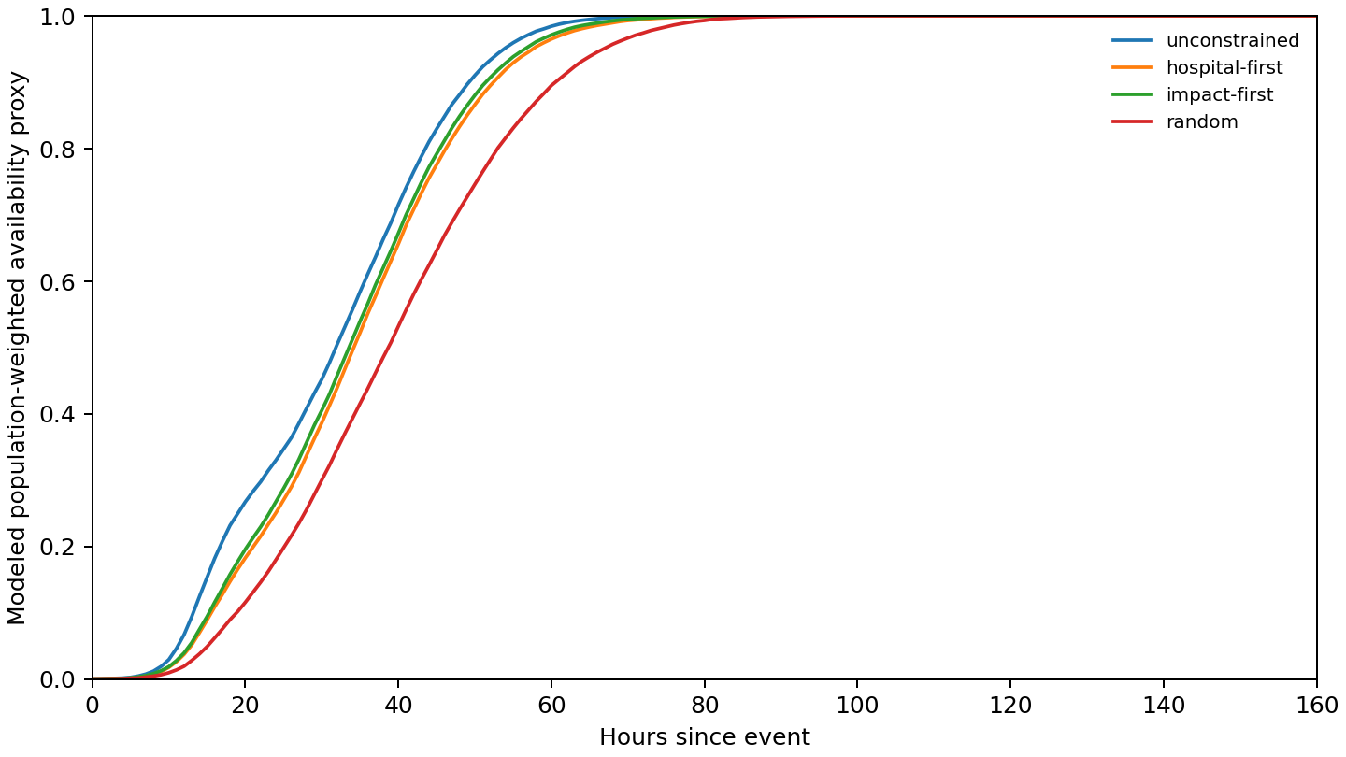
Figure 1. Modeled 2pc50 population availability trajectories under retained restoration sequences. Formal 1,000-realization output.
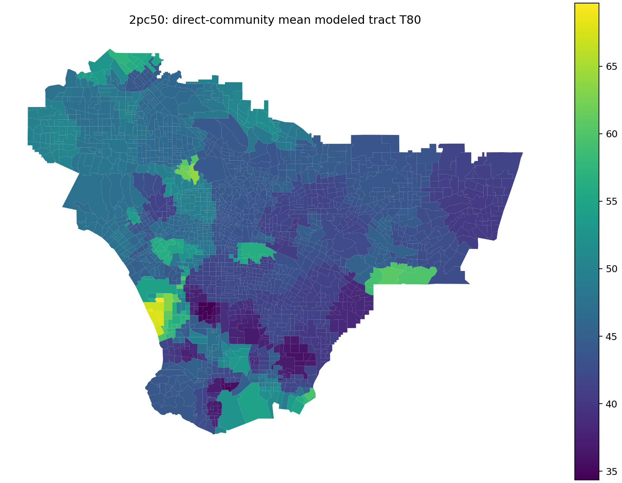
Figure 2. Spatial variation in modeled tract T80 for the formal 2pc50 analysis. Values are service-availability proxy crossings.
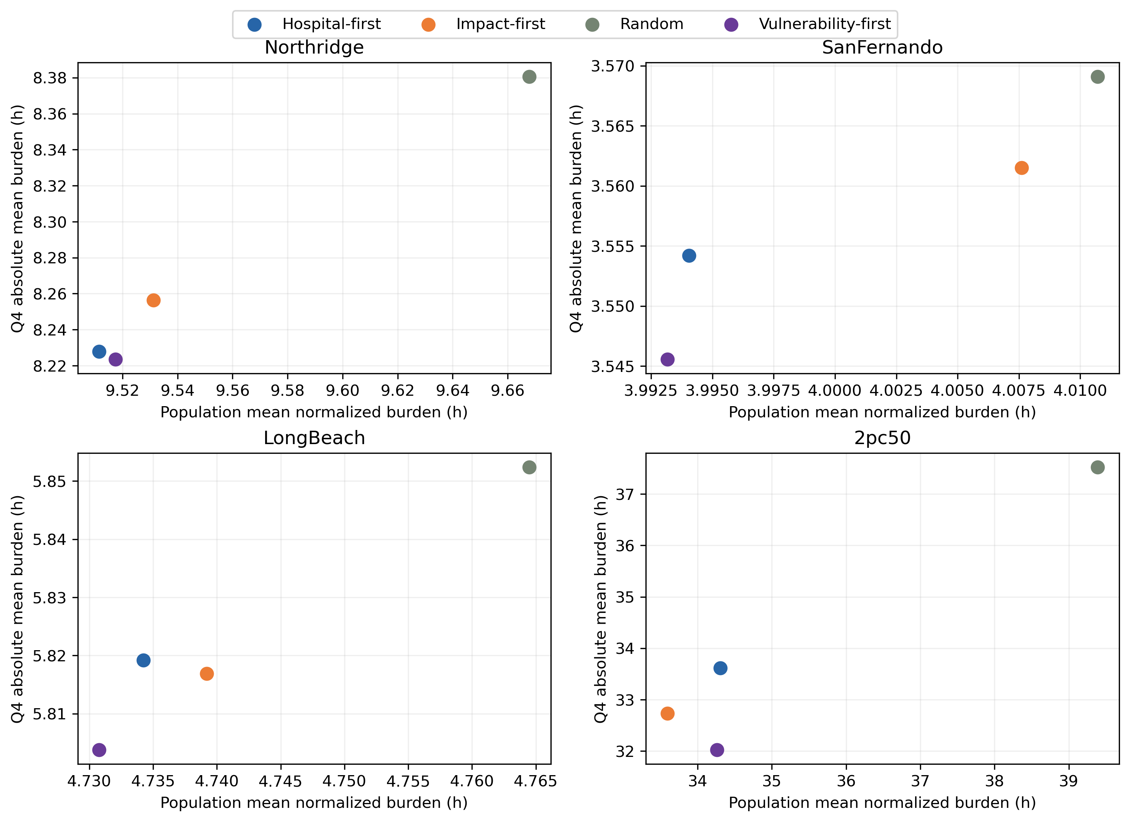
Figure 3. Aggregate population burden versus Q4 absolute burden across hazards and selected strategies.
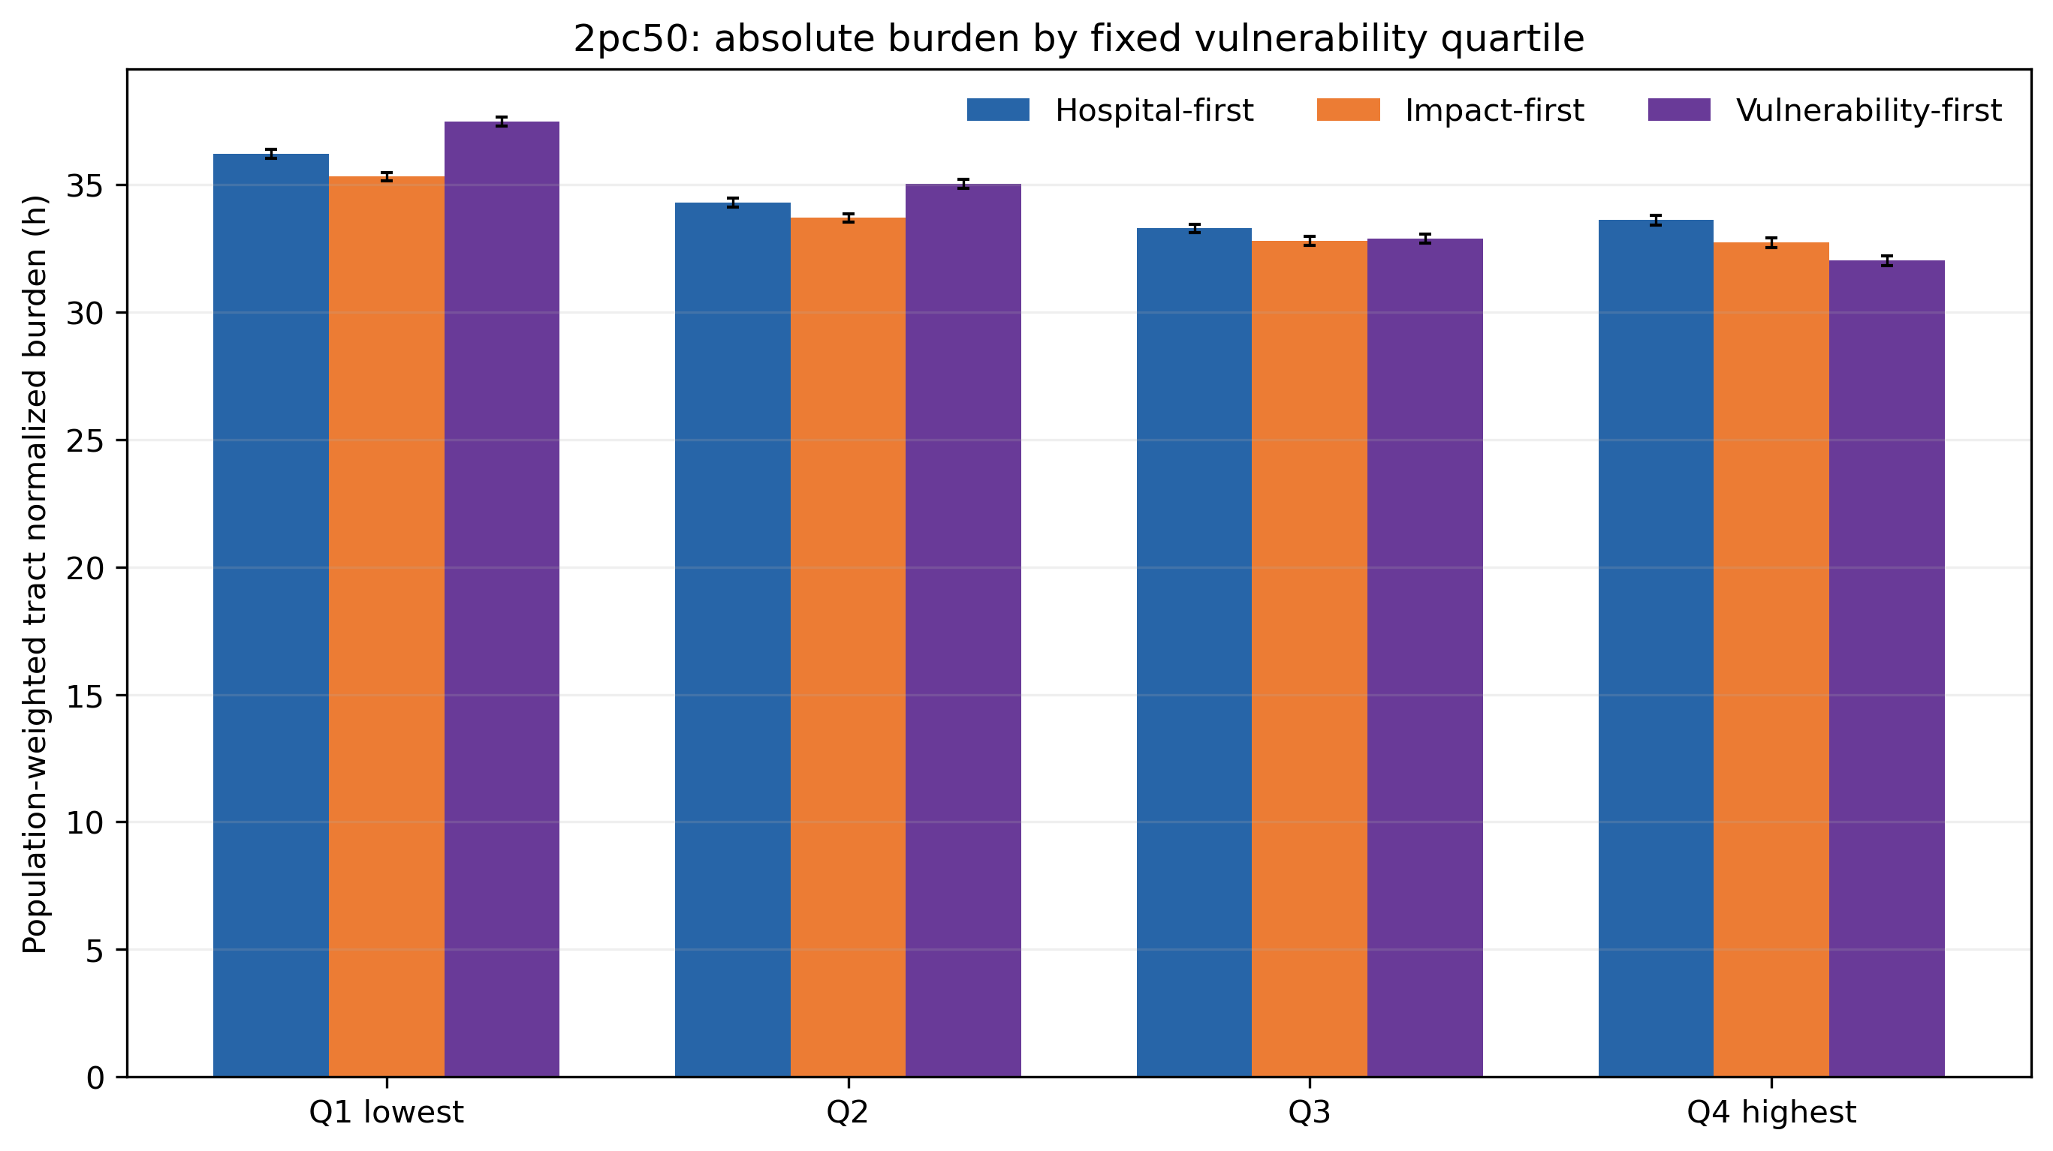
Figure 4. Q1–Q4 absolute modeled burden for 2pc50/C57 with paired-realization uncertainty.
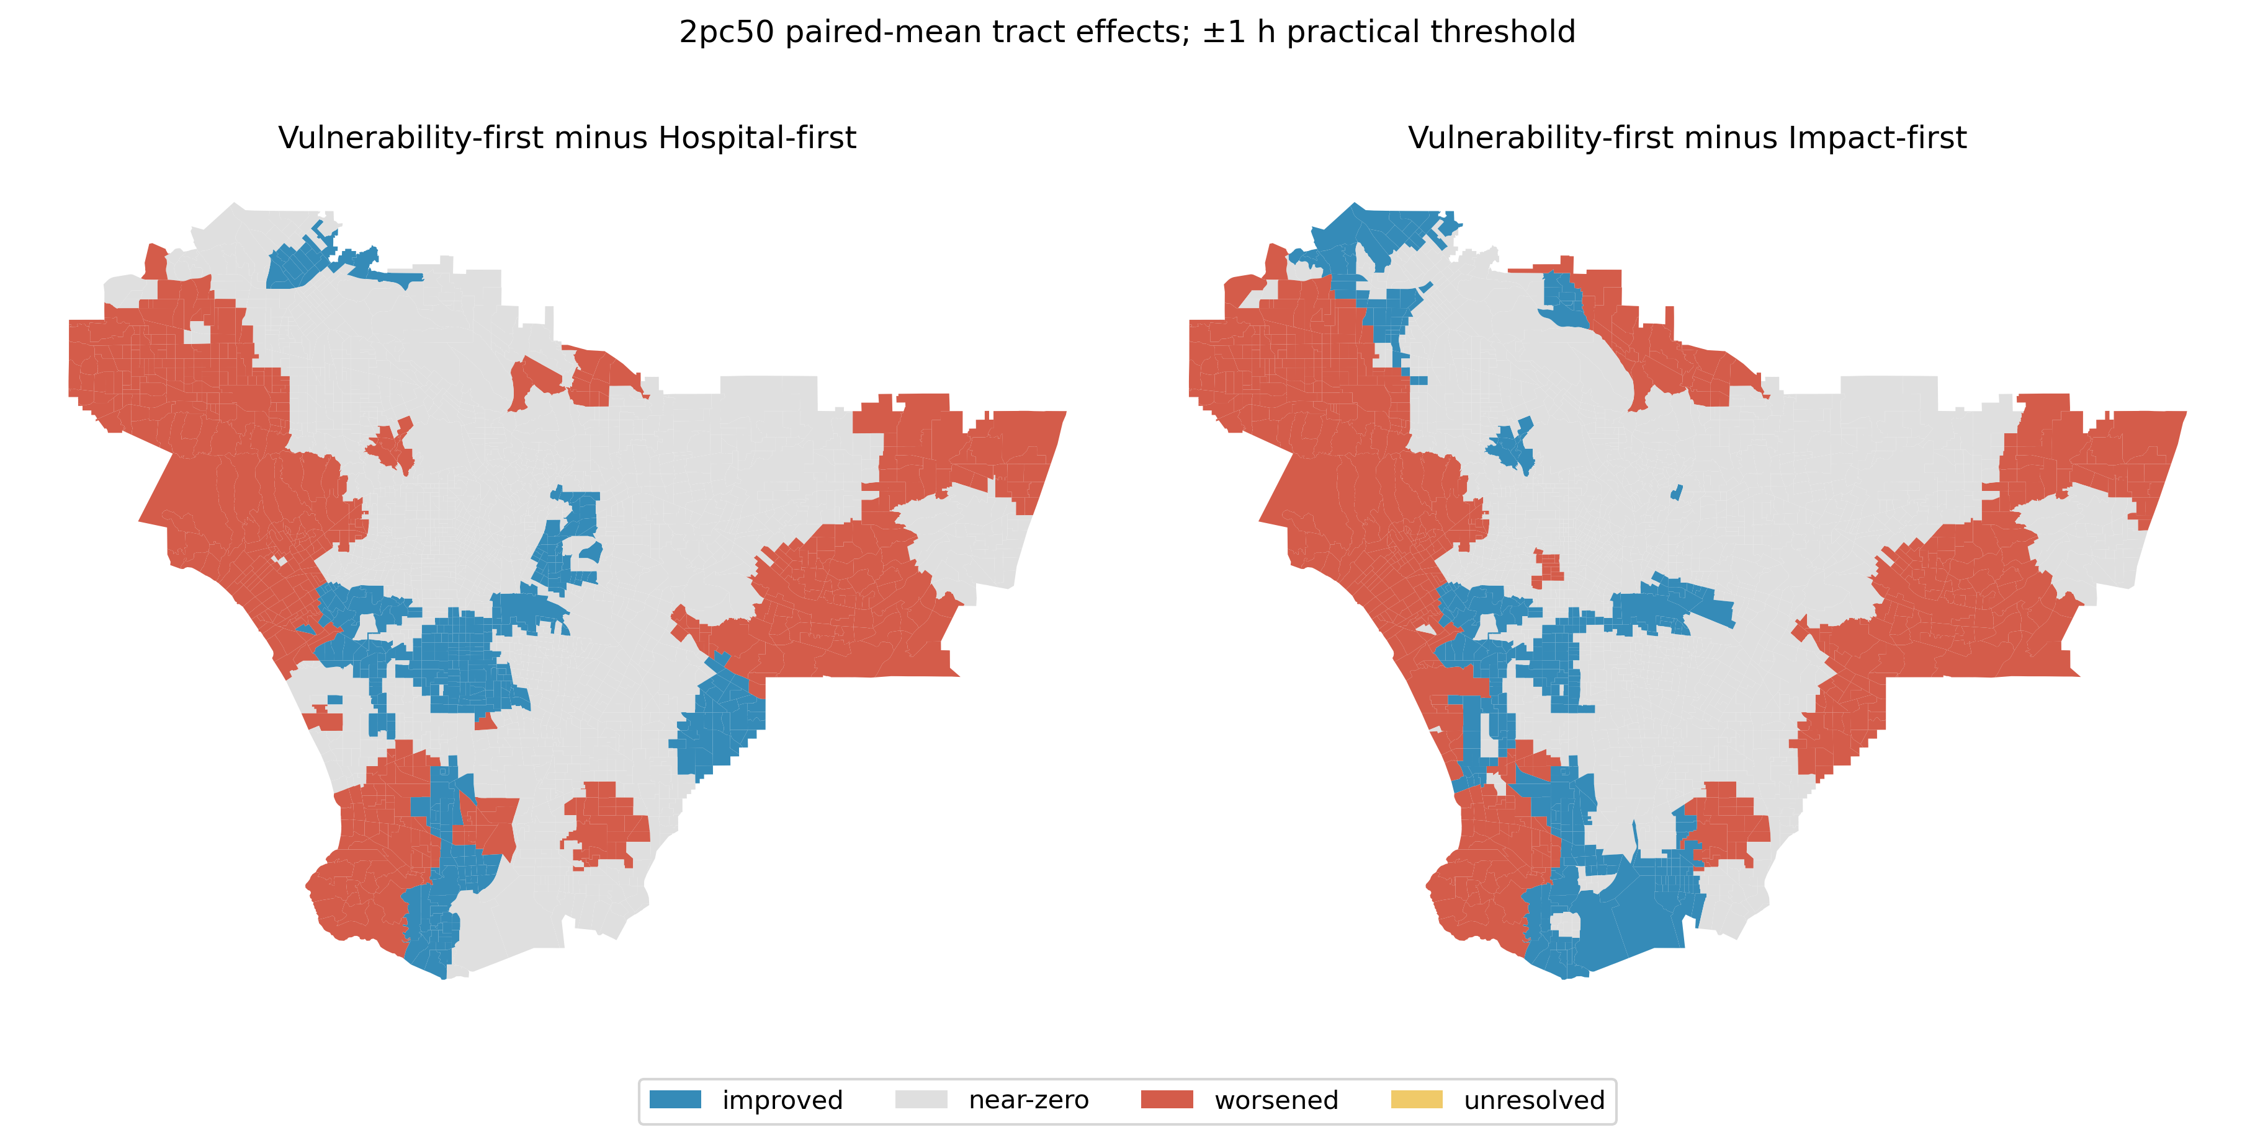
Figure 5. Paired-mean tract changes under vulnerability-first relative to hospital-first and impact-first.
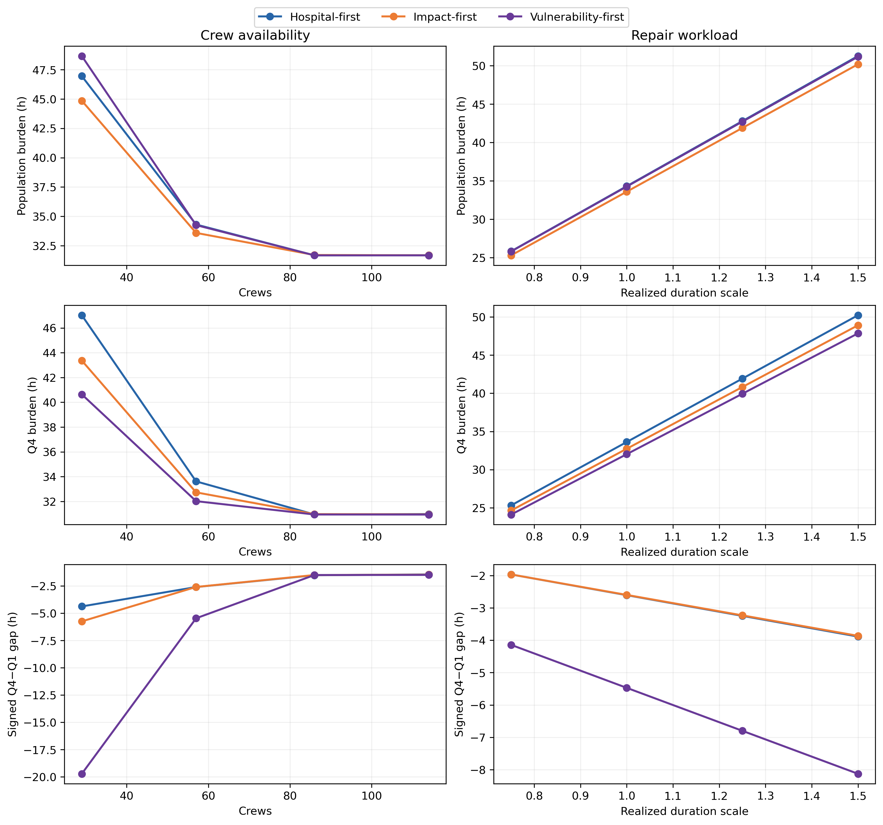
Figure 6. 2pc50 one-factor-at-a-time resource contrasts for population and Q4 burden.
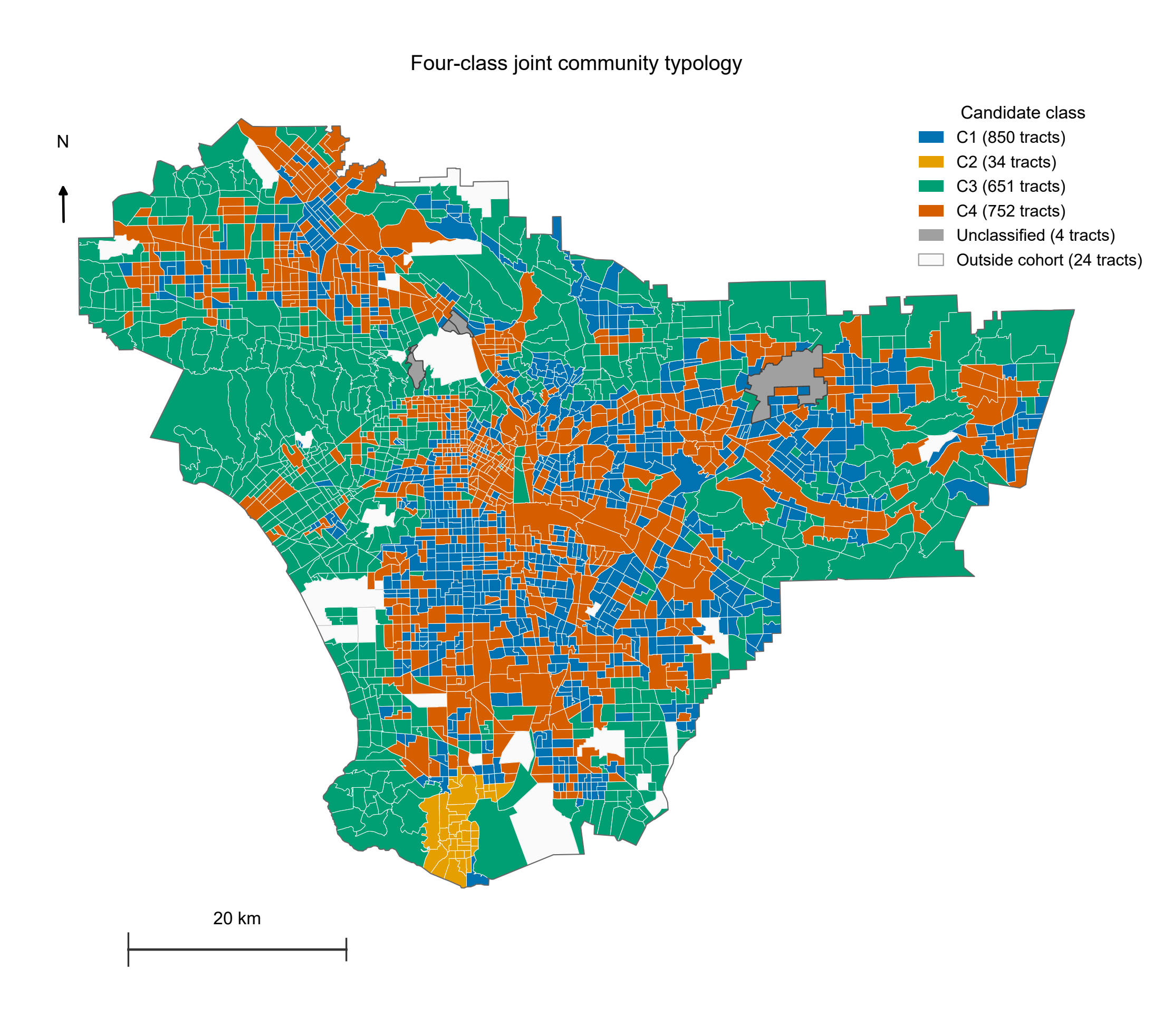
Figure 7. Four-class joint typology of 2,287 complete residential tracts under 2pc50, the reference 57-crew/unit-duration condition and direct-community recovery sequence. Classes use the five equal analytical domains in the Methods; C1-C4 denote saved seed-42 membership and imply no ranking. Four residential tracts with unresolved physical-feature geometry are gray and unclassified. The 24 tracts outside the residential domain are white. Boundaries are archived census-tract polygons within the exact 2,315-tract electricity-model domain, projected in California Albers (EPSG:3310); the outer outline is the study-tract union, not an invented utility boundary. The scale bar is in km and the arrow follows geographic north at its mapped position. This is descriptive spatial classification, not causal attribution or validated intervention priority.
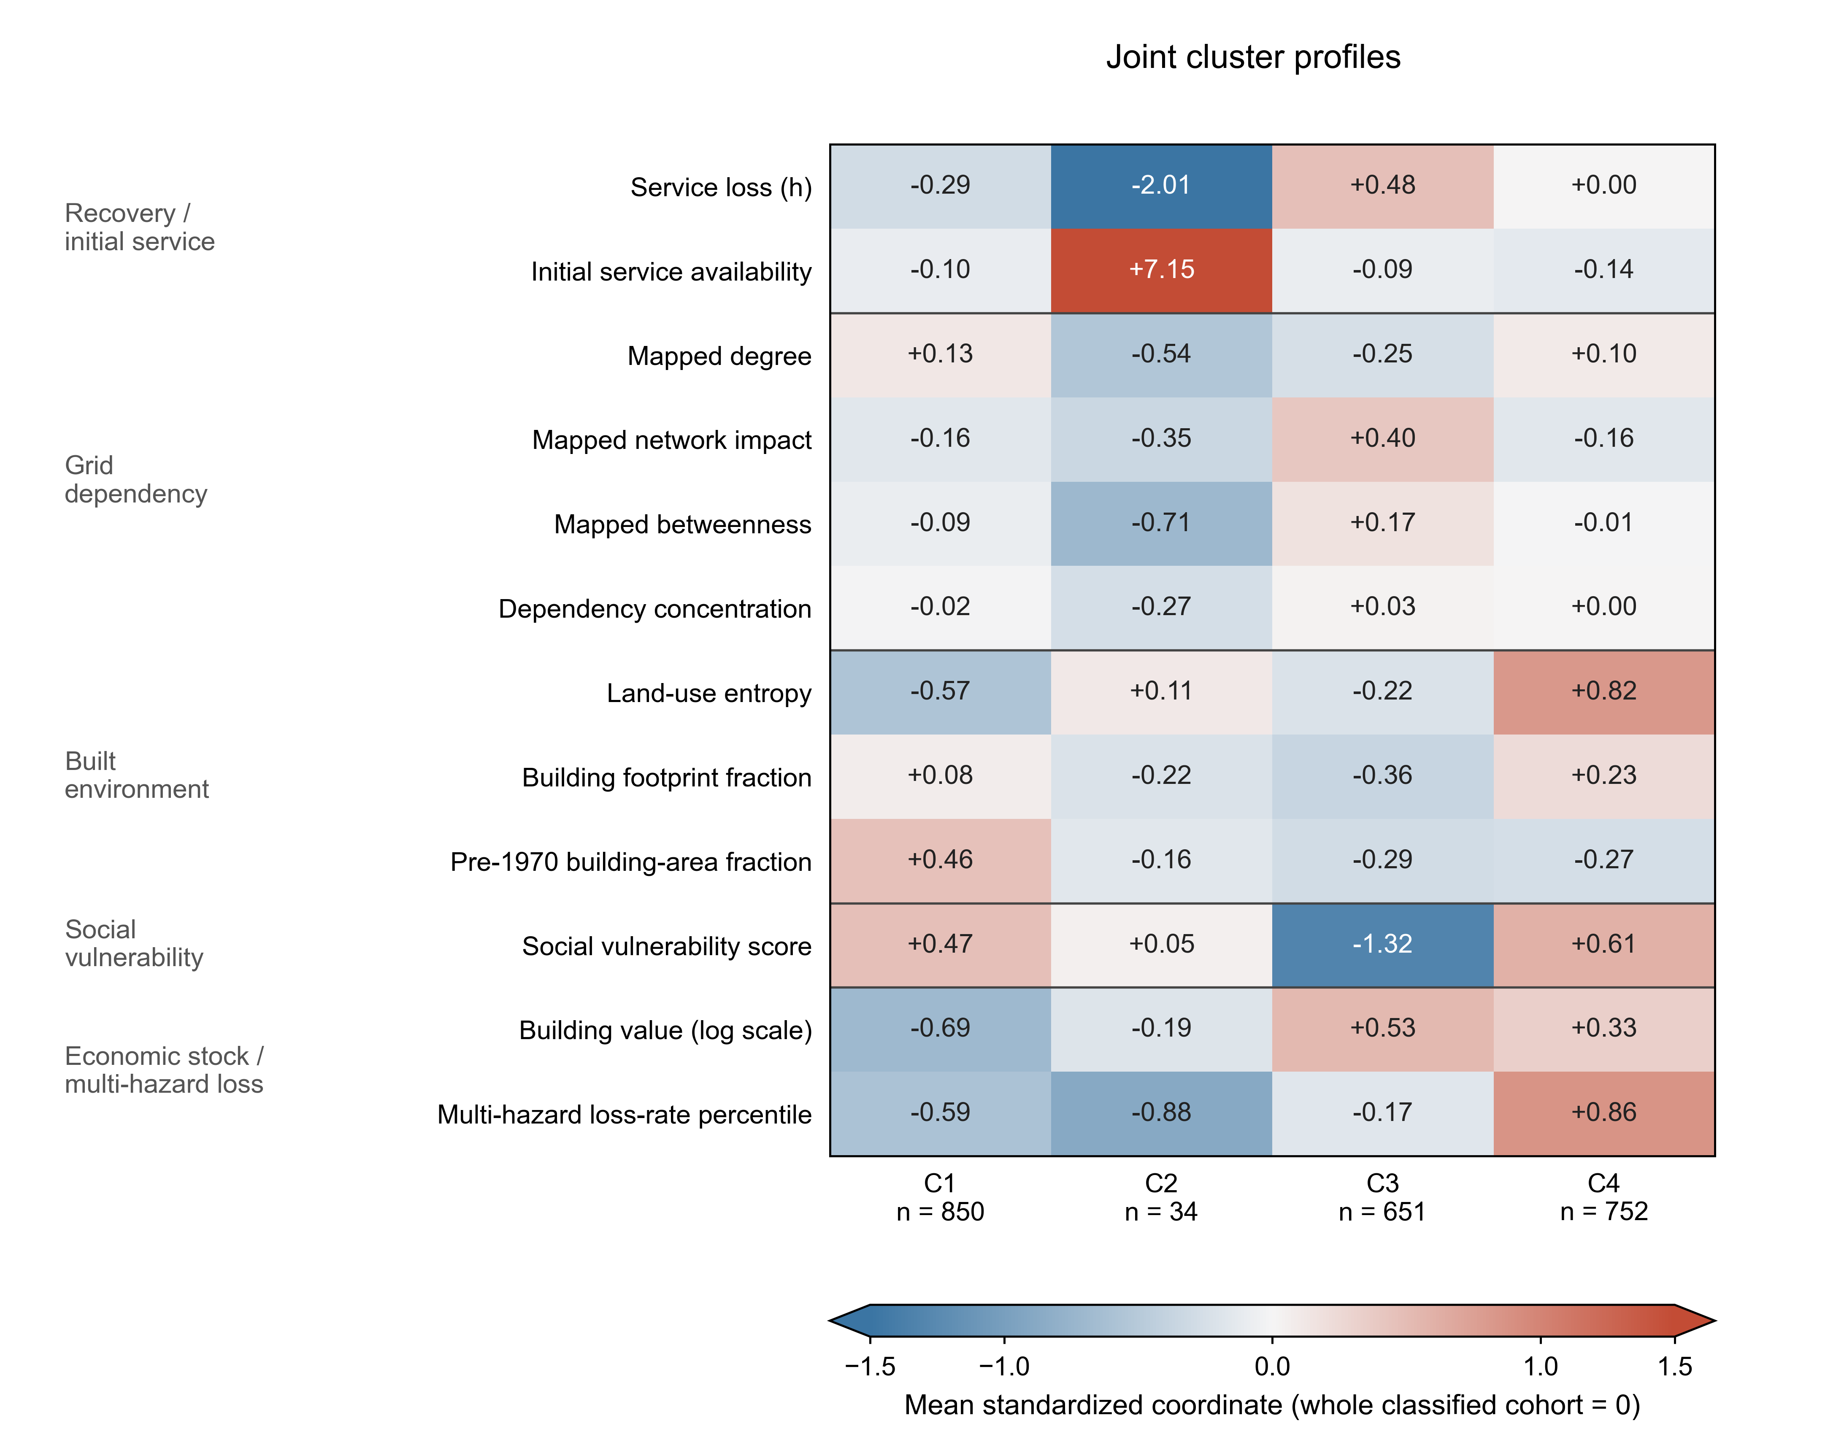
Figure 8. Tract-unweighted means of the 12 primary coordinates after standardization across the same 2,287 classified tracts (whole-cohort mean zero, population standard deviation one). Five grouped row blocks represent recovery/initial service, grid dependency, built environment, social vulnerability and economic stock/multi-hazard loss. The heatmap shows unweighted coordinate z scores for visual comparison, not the sqrt-domain-weighted values used for clustering. Cell annotations retain actual standardized means; colors saturate outside +/-1.5 standard deviations, indicated by colorbar extensions, including the C2 initial-service mean (+7.15). Building stock is log1p-transformed before standardization. Labels identify the underlying measurements; the color scale is dimensionless, not hours, fractions or dollars. Raw means, medians, units and observation coverage are in the companion profile tables. T80 and population density are descriptions outside the primary coordinates.

