Implementation of an Inertial Navigation System with Focus toward GPS Integration

By
Matt Guibord

Executive Summary:

Inertial navigation systems (INS) are becoming increasingly popular. Such systems make use of an inertial measurement unit (IMU) that is based on accelerometers and gyroscopes. Using the acceleration and rotational velocity data, one can track their speed, position, and attitude. One problem with such a system is the fact that errors in the accelerometers and gyroscopes are double integrated over time. For this reason, IMU’s are very accurate over short distances, but require some external calibration such as from a GPS unit to remain accurate over long periods of time.

Keywords: INS, Inertial Navigation, Accelerometers, Gyroscopes, Navigation Equations.
- Introduction

An inertial navigation system uses inertial measurements to navigate around the globe. As learned in calculus courses, if one takes acceleration and integrates it, the output will be velocity. Similarly, integrating velocity will yield position. The system becomes much more complicated when rotations have to be taken into account. These rotations are in the roll, pitch, and yaw direction of the user or vehicle and will vary how the accelerations and velocities interact. Later, the navigation equations will be discussed that relate the rotations to directional travel around Earth.

- Objective

The objective of this note is to present a novel approach to creating an inertial navigation system. The required hardware will be discussed as well as the mathematical equations needed to navigate using inertial measurements. Implementation of the navigation equations on a microprocessor will be reviewed.

- Background Information

The main components of an inertial measurement unit are accelerometers and gyroscopes. Accelerometers measure the acceleration of a mass within the sensor. When the mass is accelerated, it creates an electrical signal that is proportional to the acceleration. Often, a single accelerometer chip can measure accelerations in x, y, and z simultaneously. Similarly, gyroscopes use a vibrating crystal that can sense rotational velocities. The sensor outputs a voltage that is proportional to the rotational velocity experienced by the crystal. Gyroscopes measure rotational velocities in the roll, pitch, and yaw directions. Commercial gyroscopes usually read only one or two of the directions within the same chip, but new three axis gyroscopes are starting to appear. By using these two sensors one can then keep track of their position as they move. The question is: how can one make use of accelerometers and gyroscopes to navigate around the globe?

- Useful Coordinate Frames

First, it is important to describe the different coordinate systems that are used in practice as presented by Shin (p. 8-9):

  - Body Frame

The first is the body coordinate frame. This frame has its origin at the center of mass of the body of the user. The x-axis or heading, points straight ahead of the user. The z-axis points straight up and the y-axis points to the side to complete the right-handed orthogonal frame. Rotations in this frame are called pitch, roll and yaw. Where pitch is a rotation about the y-axis, roll is about the x-axis, and yaw is about the z-axis.

  - Navigation Frame

The second coordinate frame is the navigation frame, which in our case will be the North, East, Down (NED) frame. In this frame, the origin is shared with that of the body frame. The positive x-axis points north, the positive z-axis points down, and the positive y-axis points east. This frame is also called the tangential plane frame because the system forms a plane that is tangential to the surface of the Earth as can be seen in figure 1. The East, North, Up (ENU) frame is also used in practice, but the NED frame is more popular.

  - Earth-Centered Earth-Fixed Frame

The third frame is the Earth-centered Earth-fixed (ECEF) frame. This frame has its origin at the center of the earth. The x-axis points toward the prime meridian, the z-axis is parallel to the axis of rotation of the Earth, and the y-axis completes the right-hand orthogonal frame. Positions in the frame are measured as latitude (), longitude () and height (h). This is the frame that global position systems (GPS) use. Thus, this frame will be useful when integrating INS and GPS systems together.
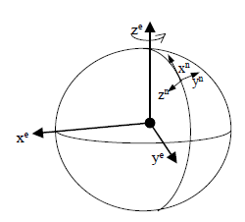
Figure 1: NED frame and ECEF frame (Shin, 10)

  - Inertial Frame

Finally, there is the inertial frame which has axes that are independent of the rotation of the earth. The origin is at the center of the Earth as in the ECEF frame. The x-axis points toward the mean vernal equinox, the z-axis is parallel with the rotation of Earth, and the y-axis completes a right-handed orthogonal frame.

- Coordinate Frame Transformations

The transformation from the body frame to the navigation frame requires the rotation about three axes. A convenient way of describing these rotations is using a direction-cosine matrix (DCM). If one defines three angles, , and as the yaw, pitch, and roll of the body, respectively, with referenced to the navigation frame, one can define a DCM to rotate from the body to the navigation frame. Hence, once the three separate rotation matrices have been multiplied out, the final DCM is given as (Shin, p. 12):

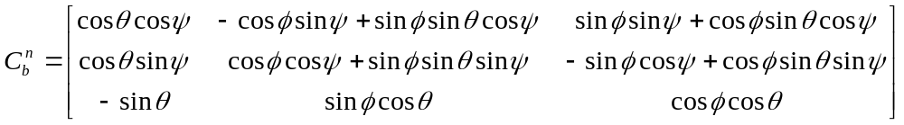

To rotate velocities or accelerations from the body to the navigation frame, one would then use (Stovall, p. 4):

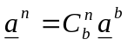

where a^{x} represents the acceleration or velocity vector in the x-frame.
It is worth noting that the common method of implementation of the rotational matrix is to use quaternions. A quaternion is a four part complex number which can describe a three-axis rotation as a rotation about a single axis. This method is commonly used because the implementation of quaternions does not require the use of trigonometric functions which greatly reduces the computational complexity (Shin, p.18-19).

- Navigation Equations

The navigation equations used in our project are a slight variation of those presented by Shin (p. 20):

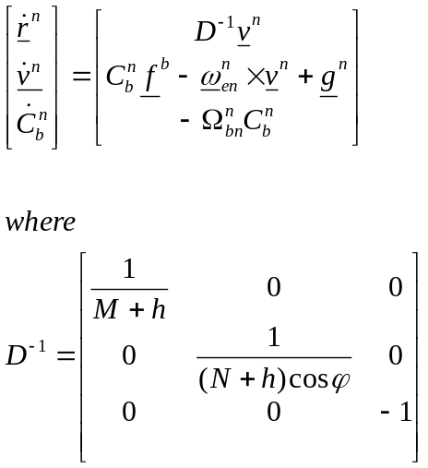

The most notable difference is the equation for the time derivative of the velocity. The term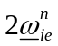 can be ignored from the cross product because this term is determined by the rotation rate of the Earth, which is 7.2921158x10⁻⁵ rad/s (Stovall, p. 33). This value is smaller than the resolution of the inexpensive sensors used, thus the error due to the crudeness of the sensors will overshadow the error due to ignoring this term.
A second difference is the time derivate of the DCM from body to navigation frames where we have chosen to use 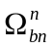, which is the skew symmetric matrix form of 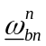defined by Rogers (p. 74) rather than 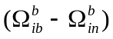. In our case, 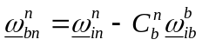 where 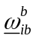 is the outputs of the gyroscopes. Since the accelerometers used are inaccurate, 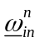 can be approximated by 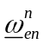 which was defined by Shin as:

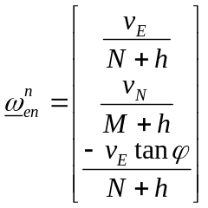

where v_{X} denotes the velocities in the navigation frame. The term defines the rotation rate of the navigation frame with respect to the ECEF frame projected into the navigation frame.
M and N as seen in D⁻¹ and are defined as (Shin, p. 14):

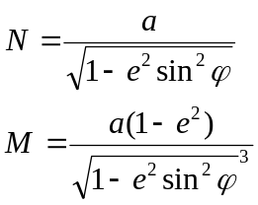

Where a=6378.1370 km and e=0.016710219 and are defined as the semi-major axis and linear eccentricity of the Earth, respectively.
The term 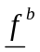 is the output of the accelerometers. At rest, the accelerometers will output the acceleration of gravity (-9.81m/s), thus we can add the acceleration due to gravity back into the time derivative of v in the navigation frame where 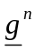 is purely in the down direction (Stovall, p. 6). This will cancel out the force on the mass at rest and thus not affect the use of the accelerometers.

- Implementation

  - Required Hardware

In order to implement the above equations, one needs to sample the inertial measurement unit at a reasonable rate. Since the ultimate goal of the project is to integrate the INS with GPS, where the GPS updates every second, we will use a 100Hz sampling rate to interpolate between GPS fixes. Thus a microcontroller needs to use an analog to digital converter to get the accelerations and angular velocities output by the IMU. This ADC should have a high resolution to get the most accurate data, preferably at least 12-bits.

  - Initialization

The INS needs an initial position so that it can determine where the user is heading. This can be done using only accelerometers and gyroscopes, but it requires very sensitive and precise equipment. One such way is to use the rotation of the earth to determine the user’s heading, and the force of gravity to determine their attitude. Unfortunately, precise equipment is very expensive and is often not a feasible solution.
A relatively inexpensive solution is to use a magnetometer to determine heading. The magnetometer can be used to determine ones heading from north. Once the heading is know, the roll and pitch of the user can be estimated by use of gravity, such as (Farrell, p. 228):

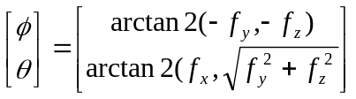

This is of course assuming that the user is stationary. One problem with this method is the bias drift of the accelerometers. It is impossible to know from standalone accelerometers what the drift is, thus this method can only be used to get an estimate. Once heading, pitch, and roll have been determined, one can then calculate the initial direction-cosine matrix to rotate from the body frame to the navigation frame.
Two more variables that need to be initialized are M and N from section V. These variables are based on the semi-major axis and linear eccentricity of the Earth as well as the current latitude. M and N do not change widely over small changes in latitude, thus we can calculate initial values based off the latitude reading from a GPS receiver and use these constant values as estimates in our implementation. This will help reduce the computational overhead during each sampling period.

  - Differential Equations

To solve the differential equations presented in the navigation equations, one can simply use the well known Euler approximation method. Although more complex estimation methods could be used to improve accuracy and convergence time, these would require more complex computations. Using the Euler method, the solution of the differential equation:

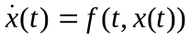

With initial condition 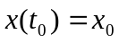, can be expressed as:
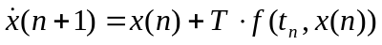

Where n represents the sample number and T represents the sampling time. This method uses a simple discrete time integration that will fulfill the needed accuracy and computational complexity of our project.

  - Accuracy Improvements

One problem with implementing an INS is that the double integration of the acceleration will accumulate errors over time. One way to improve this is to integrate the short-term accuracy of the INS with the long term reliability of GPS. This can be done in a couple different ways, where all of the accurate methods require the use of Kalman filtering. The loosely coupled approach updates the INS position and velocities by using the estimated values from the Kalman filter, which will correct for any error accumulated over time. The tightly coupled approach updates both the INS and GPS states to yield better accuracy (Farrell, p. 248-250). The problem with the tightly coupled approach is the use of commercial GPS receivers that do not allow directly setting the GPS position and velocity values.
Secondly, one could simply use a Kalman filter with only the INS. This requires a good noise model of the sensors such that the Kalman filter can reject the errors presented by noise. The Kalman filter would improve the long-term reliability and fix the bias drift of the sensors. Bias drift can also be compensated in the GPS/INS integration approach discussed above.

- Conclusion

This implementation of an inertial navigation unit is a simplistic method of inertial navigation. The use of low cost hardware limits the accuracy and functionality of the system. The accelerometers and gyroscopes are of a low grade and reduce the accuracy of initialization and navigation because of their low sensitivity. Using more precise and complex sensors would greatly improve the accuracy of the system, but with a tremendous increase in cost. Further, extra hardware such and pendulums and magnetometers, could be used to improve functionality and accuracy.
An improvement in sensors would also result in an improvement in the mathematical models used. Due to the crudeness of the sensors used, many engineering approximations were made that could actually be implemented with better sensors. One such approximation was that the rotation of the Earth was considered to be negligible, but with better sensors, this rotation could actually be measured and used. Since the error of the system is double integrated and thus builds over time, these improvements would also improve the reliability of the system over longer periods of time.
- References
Stovall, Sherryl H. Basic Inertial Navigation. China Lake, CA: Naval Air Warfare Center Weapons Division, 1997. Print.

Farrell, Jay A., and Matthew Barth. The Global Positioning System & Inertial Navigation. New York: McGraw-Hill, 1999. Print.

Shin, Eun-Hwan. Accuracy Improvement of Low Cost INS/GPS for Land Applications. MA thesis University of Calgary, Calgary, 2001.

Rogers, R. M. Applied Mathematics in Integrated Navigation Systems. American
Institute of Aeronautics and Astonautics, Inc, 2000.

